**Project Mom and Pop - Consolidated Deployment Guide**

**Deployment Instructions............................................................................. 2**

1. **Organization of Submission................................................ 2**
2. **Application Setup..............................................................… 2**
3. **Configuration........................................................................ 2**
4. **Database Setup..................................................................... 12**
5. **Third party tools setup......................................................... 15**
6. **Deployment Instructions...................................................... 16**
7. **Verification............................................................................. 18**
8. **Resource Contact List.......................................................... 22**

# **Deployment Instruction**

# **Organization of Submission**

**mom_api** – the source code for nodejs API

**mom_mobile** – the source code for mobile angular application

**mom_frontend** – the source code for desktop angular application

# **Application Setup**

- Nodejs <https://nodejs.org/>

- MongoDB <https://www.mongodb.org/>

- Grunt <http://gruntjs.com/getting-started>

Run [sudo] npm install -g grunt-cli

- http-server https://www.npmjs.com/package/http-server

Run [sudo] npm install -g http-server

- qrcode module

Install required software in [https://github.com/soldair/node-qrcode#installation](https://github.com/soldair/node-qrcode" \l "installation)

Run sudo apt-get install libpixman-1-dev libcairo2-dev

See<http://cairographics.org/download/> for installation in other operation systems

And this https://github.com/Automattic/node-canvas/wiki

If you use Ubuntu, it also needs to install following packages.

sudo apt-get install libpango1.0-dev libjpeg-dev libgif-dev

1. **Configuration**

**Configuration for mom_api**

**API application**

The configuration for API application is in ***config/default.js***

|  |  |  |
| --- | --- | --- |
| **Name** | **Description** | **Sample value** |
| MONGODB_URL | The mongodb url | mongodb://localhost:27017/project-mom |
| VERIFY_EMAIL_URL_PREFIX | The prefix for verify email address link. This should be a valid URL on which application is running | http://localhost:3500 |
| SALT_WORK_FACTOR | The factor for generating encryption salts. | 1 |
| SESSION_TOKEN_DURATION | The session duration in milliseconds. | 50000000 |
| OFFER_EXPIRATION_DAYS | Default offer expiration days | 90 |
| GIFT_EXPIRATION_DAYS | Default gift expiration days | 30 |
| MAX_QUANTITY | Maximum transaction amount per transaction | 2000 |
| USER_EMAIL_EXPIRATION_DAYS | No of days in which the verify email is expired | 30 |
| GIFT_DELIVERED_DAYS | days in which gift is delivered | 1 |
| JOB_GIFTS_INTERVAL | Interval for gift card job | 10 * 60 * 1000 |
| JOB_GIFT_CARD_OFFER_INTERVAL | Internal for gift card offer | 24 * 60 * 60 * 60 * 1000 |
| USER_EMAIL_VERIFIED_INTERVAL | Interval for email verified | 24 * 60 * 60 * 60 * 1000 |
| DESKTOP_APP_URL | Application url for Desktop url | http://localhost:3500 |
| MOBILE_APP_URL | Application url for mobile | http://localhost:3500 |
| DEFAULT_TOKEN_SIZE | The length of the token. | 32 |
| OFFER_EXPIRATION_DAYS | The expiration in days for gift offers | 1 |
| PROFILE_IMAGE_FOLDER | The path for image upload | ./uploads |
| TEMP_DIRECTROY | The path for temporary files | ./temp |
| WEB_SERVER_PORT | The port to listen | 4040 |
| BRAINTREE_GATEWAY_CONFIG. environment | The Braintree environment | Sandbox |
| BRAINTREE_GATEWAY_CONFIG. merchantId | The Braintree merchant id | ny6gyyt78bps3pqb |
| BRAINTREE_GATEWAY_CONFIG.publicKey | The Braintree public key | xf72q3xmc6ywk55k |
| BRAINTREE_GATEWAY_CONFIG.privateKey | The Braintree private key | 3660ba0f71ee6ad0ea5923723d65a89b |
| BRAINTREE_MERCHANT_ACCOUNT_ID | The braintree merchant account id. | s9wkmf6n7hqwph8y |
| TWITTER_CONSUMER_KEY | The twitter consumer key | HCXijRV8yZLry5pTS24FQ |
| TWITTER_CONSUMER_SECRET | The twitter consumer secret | mE1TXYmh89ctPTPI4txcPOodPBaoGNvsxJafmKC04cg |
| DEFAULT_SORT_BY | The default sort field | id |
| DEFAULT_SORT_ORDER | The default sort order | Ascending |
| DEFAULT_PAGE_SIZE | The default page zie | 5 |
| GEOCODER_PROVIDER | The geocoder provider | google |
| BRAINTREE_SUBSCRIPTION_PLANID | The Braintree subscription plan | SubscriptionPlan |
| GEOCODER_HTTPADAPTER | The geocoder adapter | http |
| SMTP_HOST | The smpt host for email service | smtp.mailgun.org |
| SMTP_PORT | The smtp port | 587 |
| SMTP_USERNAME | The smtp username | postmaster@sandbox887c4e0dc269436a89772766aaaec086.mailgun.org |
| SMTP_PASSWORD | The smtp password | dedd54c3343ac1e161763a80ca989c85 |
| CONFIG_EMAIL | The email address of email sender from which auto mail to be sent | noreply@momandpop.com |
| SITE_ADMIN_EMAIL | The admin of the site. This is the email address of the portal admin. The feedback will be sent to this email. Configure some real email address here to see the email to your inbox | someemail@example.com |
| QR_CODE_SIZE | The qr code size | 16 |
| QR_CODE_FILE_DIR | Default QR code file dir | public/i/qrcode/ |
| TWILIO_ACCOUNT_SID | SID for twilio account | somesid |
| TWILIO_AUTH_TOKEN | Auth token for twilio account | token |
| TWILIO_FROM_NUMBER | From number for twilio | Twilio from number |
| AWS | Amazon AWS Credentials |  |
| AWS_BUCKET_NAME | S3 Bucket name for image uploads |  |
| AWS_PHOTOS_PREFIX | Prefix for uploaded image files | photos |
| MOCK_LOCALHOST_IP | Geolocalization is IP based, but it doesn’t work for localhost IPs. Set this setting to overwrite localhost IP. | 199.16.159.8 (IP from San Francisco) |
| GIFT_OFFER_DISTANCE  _SEARCH_RANGES | Ranges for gift card offers that are displayed in groups.  Each value represents distance in meters.  Example from sample settings:  There will be 3 groups  1st will be in range 0 – 10km  2nd will be in range 10km – 50km  3rd will be in range 50km – Infinity | [10000, 50000] |
| IP_LOCATION_CACHE  _SECONDS | Interval in seconds for ip to location cache | 1000 |
| BUSINESS_CONDITION | The default platform conditions for Gift Card Offers |  |

**Desktop Frontend application**

The configuration for mom frontend application is in ***mom_frontend/app/js/config.js***

|  |  |  |
| --- | --- | --- |
| **Name** | **Description** | **Sample value** |
| SHARE_THIS_PUBLISHER_KEY | The publisher key for sharethis | 9b91d21e-3600-4e8d-b2d6-0eab4575e8c8 |
| REST_SERVICE_BASE_URL | The URL for backend API | http://localhost:4040 |
| FRIEND_INVITATION_MESSAGE_TEMPLATE | The template when inviting the user | message |
| HOW_IT_WORKS_URL | The wordpress permalinks for how it works page. | http://192.168.1.104/?p=4 |
| PRIVACY_POLICY_URL | The wordpress permalinks for privacy policy page. | http://192.168.1.104/?p=4 |
| COPYRIGHT_URL | The wordpress permalinks for copyright page. | http://192.168.1.104/?p=4 |
| FAQ_URL | The wordpress permalinks for FAQ page. | http://192.168.1.104/?p=4 |
| BLOG_URL | The wordpress permalinks for blog page. | http://192.168.1.104/?p=4 |
| ABOUT_URL | The wordpress permalinks for about page. | http://192.168.1.104/?p=4 |
| TERMS_AND_CONDITIONS_URL | The wordpress permalinks for terms and conditions page. | http://192.168.1.104/?p=4 |
| LOAD_MORE_ITEM_COUNT | Load more item configuration value. | 4 |
| OAUTH_PUBLIC_KEY | The public key from oauth.com | Qd4rmfZpA_Ph09NaHKL3Y2goA9o |
| MOBILE_SERVICE_BASE_URL | The URL for mobile version | http://localhost:3501 |
| FAKE_NONCE | true if set always fake nonce when purchase the shopping cart | true |
| PASSWORD_LENGTH | minimum password length | 7 |
| DEFAULT_BUY_NOW_VALUE | default value of gift card for Buy Now purchase | 100 |
| MIN_BUY_NOW_VALUE | Min value for gift cards | 10 |
| OFFER_CONDITIONS_MAX_CHARS | Maximum length in characters allowed for offer specific conditions | 110 |

**Mobile Frontend application**

The configuration for mom mobile application is in ***mom_mobile/components/config.js***

|  |  |  |
| --- | --- | --- |
| **Name** | **Description** | **Sample value** |
| FB_APP_ID | The app id for facebook | 435002143324161 |
| REST_SERVICE_BASE_URL | The URL for backend API | http://localhost:3000 |
| MOBILE_SERVICE_BASE_URL | The URL for mobile version |  |
| OAUTH_PUBLIC_KEY | Public key of oauth account | picfZapCpsDuMkfLUR4uWoD6elc |
| TWITTER_VIA | Twitter id of foundershare | FounderShare |
| PASSWORD_LENGTH | minimum password length | 7 |
| MAX_QUANTITY | Maximum price in a single transaction | 2000 |
| OFFERS_PER_PAGE | Number of offers to get in a single api call. | 8 |
| OFFERS_HOME_PAGES | Number of pages of offers to show in the home page. | 2 |
| HISTORY_ITEMS_PER_PAGE | Number of history records to get in a single api call. |  |
| HISTORY_HOME_PAGES | Number of pages of history records to show in the home page. |  |
| FORCE_QR_FILE_UPLOAD | Use this to show only a file input for QR code (not camera) useful to test in non-mobile devices | false |
| DEFAULT_BUY_NOW_VALUE | Default value of gift card for Buy Now purchase | 100 |
| MIN_BUY_NOW_VALUE | Min value for gift cards | 10 |

**Note:** Change **REST_SERVICE_BASE_URL** to your external machine API (e.g. 192.168.x.x). Mobile devices won’t be able to use app if urls are from localhost domain.

# **Database Setup**

No specific setup is required for configuring database schema.

**Generate sample data**

You can use ***test_files/insert-data.js*** to insert the data available in the ***test_files/data*** **or** use ***test_files/create-data.js*** to create and insert the data.

From the ***mom_api*** directory run the following command:

*node test_files/insert-data.js*

**Note**: The following setups are required for mom_frontend (desktop)

**Email setup**

**Wordpress Setup**

**Payment setup**

**Email setup for mom_frontend**

Register your account in [www.mailgun.com](http://www.mailgun.com/).

In control panel, it could get SMTP user name and password in domain detail page.

**Wordpress Setup for mom_frontend**

* **Install MySQL**

Download MySql 5.6 from <http://dev.mysql.com/downloads/mysql/>

Install the MySql 5.6.

In mysql bin directory, run ***mysql client*** to create database and setup user.

mysql -u root -p

CREATE DATABASE wordpress;

CREATE USER wordpressuser@localhost IDENTIFIED BY 'password';

GRANT ALL PRIVILEGES ON wordpress.* TO wordpressuser@localhost;

CREATE USER 'wordpressuser'@'%' IDENTIFIED BY 'password';

GRANT ALL PRIVILEGES ON *.* TO 'wordpressuser'@'%';

FLUSH PRIVILEGES;

exit

* **Install Apache**

For installing the Apache in Ubuntu 14, please refer the <http://httpd.apache.org/docs/2.4/install.html> for other platforms installation.

sudo apt-get install apache2 php5 libapache2-mod-php5 php5-mysql

ps -ef | grep apache

sudo a2enmod headers

sudo service apache2 restart

Make sure the port 80 is accessible. Open the URL through the port 80, for example, http://192.168.1.104/ it'll open the page.

* **Install wordpress**

Please see,<https://codex.wordpress.org/Installing_WordPress> for more detail.

cd ~/software

wget http://wordpress.org/latest.tar.gz

tar xzvf latest.tar.gz

Update database and user name

cd ~/software/wordpress

cp wp-config-sample.php wp-config.php

vi wp-config.php

Update following items:

define('DB_NAME', 'wordpress');

define('DB_USER', 'wordpressuser');

define('DB_PASSWORD', 'password');

define('DB_HOST', '192.168.1.101');

Copy the file to html directory.

sudo cp -r * /var/www/html

* **Fix the CORS issue**

In ***/var/www/html*** directory, create ***.htaccess*** file which contains following:

DirectoryIndex index.php

<ifModule mod_headers.c>

Header always set Access-Control-Allow-Origin: "*"

Header always set Access-Control-Allow-Methods "POST, GET, PUT, DELETE, OPTIONS"

Header always set Access-Control-Allow-Headers "X-Requested-With, content-type"

</ifModule>

Delete the ***index.html in /var/www/html*** directory.

In ***/etc/apache2/apache2.conf***, update the followings:

<Directory /var/www/>

Options Indexes FollowSymLinks

AllowOverride All

Require all granted

</Directory>

Restart apache through

sudo service apache2 restart

* **Setup Wordpress in page**

Open ***http://localhost/wp-admin/install.php***, please replace ***localhost*** with your url.

Enter the necessary fields.

Click install button to install wordpress.

Open ***http://localhost/wp-login.php*** to login with input **username** / **password**.

In admin dashboard page, click **Posts** > **Add New** menu in left side. Enter the **page title** and **content**, click **Publish** button to publish it.

The published screen is displayed.

It’s same published screed add the following pages in the wordpress.

Add the following content in the published screen to change the theme for better look and feel and to fit the page layout in Mom and Pop page.

* VerifyPDFForm
* FAQ
* Blog
* AboutUs
* HowItWorks
* PrivacyPolicy
* TermsAndConditions
* CopyRight
* Privacy
* Terms
* PrivacyB
* TermsB
* TermsNoLogged

# **Third party tools setup**

**Third party tools setup for mom_api**

Please refer to Desktop assembly deployment guide to refer how to setup **Email**, **Braintree**, and **Wordpress**.

Please follow the steps to setup the following items:

* **Enable AVS and CVV checking in Braintree**.

Log into the **Control Panel**.

Click **Settings** > **Processing** > **Basic Credit Card Fraud Tools** > **AVS** or **CVV**.

Click **Edit**.

Select the **AVS** or **CVV** rejection criteria

You have the options to apply the rules for all the transactions or only to the specific card types, amounts, or merchant accounts.

Click **Save**.

* **Get Braintree master merchant account id**

In **Braintree** console, click **Setting** > **Processing** menu.

Click **New Button** to create an item in **Merchant Accounts** section.

* **Get Sharethis API key**

Register in<http://www.sharethis.com/> to get the api key in account setting page.

**Third part setup for mom_mobile**

You can use the third party setup available in the application.

For manual setup, you can refer the setup for **desktop deployment guide** and **deployment guide** steps available in this document.

Apart from the tools mentioned in the other deployment guide, you need **oauth.io** setup and **facebook** apps in your mobile with registerd user account.

Get the oauth api key from **oauth.io**. While setting the **oauth.io** apps account, you have to update the **founder share twitter client_id** and **client_secret** in the **integrated API** sections.

Get the facebook app id from **developers.facebook.com**. Update the **config.js** file. Please update the url of the site from which the request has been placed.

**Twilio Setup**

* Create your account in [twilio](https://www.twilio.com/try-twilio).
* Add your sender number (`TWILIO_FROM_NUMBER`) [here](https://www.twilio.com/user/account/phone-numbers/incoming), make sure SMS & MMS are enabled for that number.
* Add and verify your number [here](https://www.twilio.com/user/account/phone-numbers/verified). In try account you may only send SMS to verified numbers.
* Get `TWILIO_ACCOUNT_SID` and `TWILIO_AUTH_TOKEN` from [here](https://www.twilio.com/user/account/settings) and update configuration

**Mailgun setup**

* Create your account in [mailgun](https://mailgun.com/signup)
* Click on domain details in [domain list](https://mailgun.com/app/domains/)
* Update configuration `Default SMTP Login` -> `SMTP_USERNAME` and `Default Password` -> `SMTP_PASSWORD`
* Update webhooks [here](https://mailgun.com/app/webhooks)
* Set `Delivered messages` hook to address `http://YOUR_IP:3000/webhook/mailgun/message/delivered`.

NOTE: You must have a public IP.

# **Deployment Instructions**

**Run under api directory**

npm install

npm start

npm worker

**Run under mom_mobile directory**

npm install

npm start

Mobile app listens on port 3501.

Open your external IP to access to e.g. **http://localhost:3501**

**Run under mom_frontend directory**

npm install

npm start

Desktop app listens on port 3500.

Open your external IP to access to e.g. **http://localhost:3500**

**Note**: if you want to debug and do not want to concat and minify javascript files, it can be achieved using the 'dev' task in grunt. To use dev task run the below command from the **mom_mobile** directory.

*grunt dev && http-server dist -p 3501*

1. **Verification**

The verification steps comprises of following steps:

1. Go to the following link [Founder Share QA Link](http://www.qa.foundershare.com/).

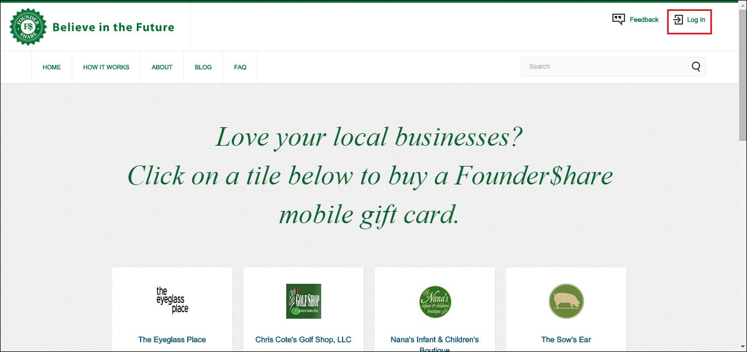

1. Click **Log In**. The login page is displayed.

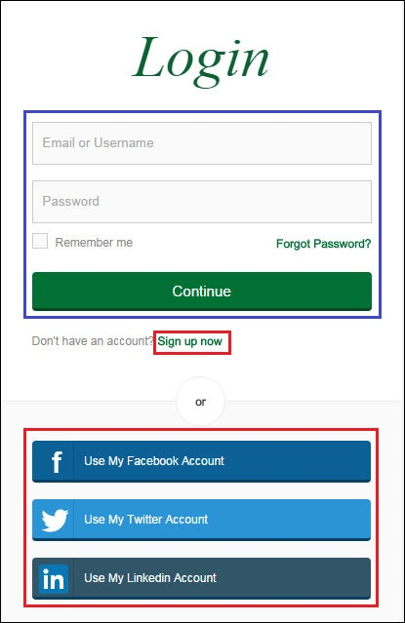

If the user is **Registered** member,

* 1. In the **Email or Username** field, enter the valid mail id or username.
  2. In the **Password** field, enter the valid password.

**Note**: You may click **Remember me** to remember your email or username and password for the next login.

* 1. Click **Continue**, to login to the Founder Share.

1. The new user can select the followings options to register the account in **Founder Share**:
   1. **Sign up now** - To register with a valid mail id.
   2. **Use My Facebook Account** - To register with your facebook account.
   3. **Use My Twitter Account** - To register with your twitter account.
   4. **Use My Linkedin Account** - To register with your linkedin account.
2. Click **Sign up now**. The **Register** screen is displayed.

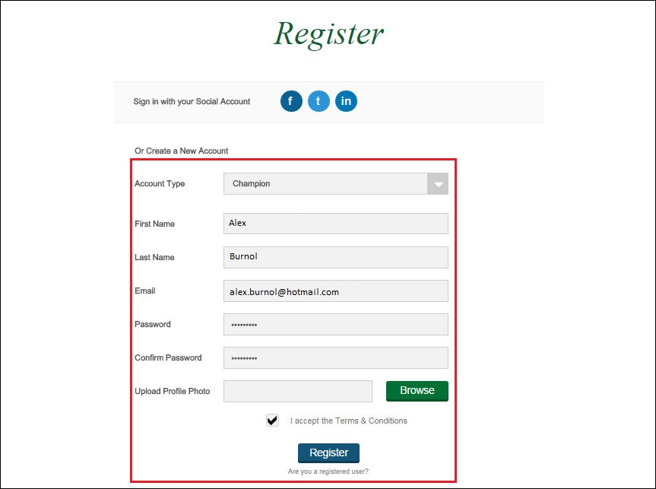

1. In the **Create a New Account** section,
   1. In the **Account Type** field select from the followings:
      1. **Champion** - if you are creating the account for champion.
      2. **Business Owner** - if you are creating the account as a business owner.
   2. In the **First Name** field, enter your first name.
   3. In the **Last Name** field, enter your last name.
   4. In the **Email** field, enter the a valid email id.
   5. In the **Password** field, enter the password.

**Note**: The password must contains both numbers and alphabets.

* 1. In **Upload Profile Photo** field to select a photo, click **Browse**.

**Note**: A new window to select the photo is displayed, select your photo to upload.

* 1. To confirm the acceptance of term and conditions for **I accept the Terms and Conditions**, click on select button.
  2. Click **Register**.

1. A message for successful **Complete Registration** is displayed. Click **Done**.

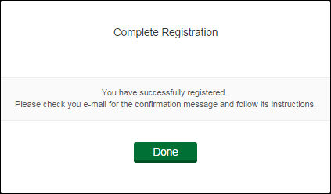

1. Goto your registered **email** id.

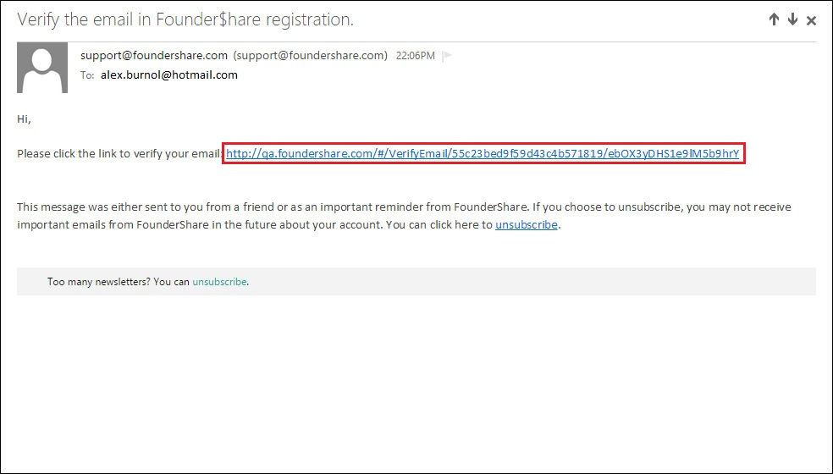

1. Click the link in your mail to verify the account, you will be redirected to the **Founder Share** account.

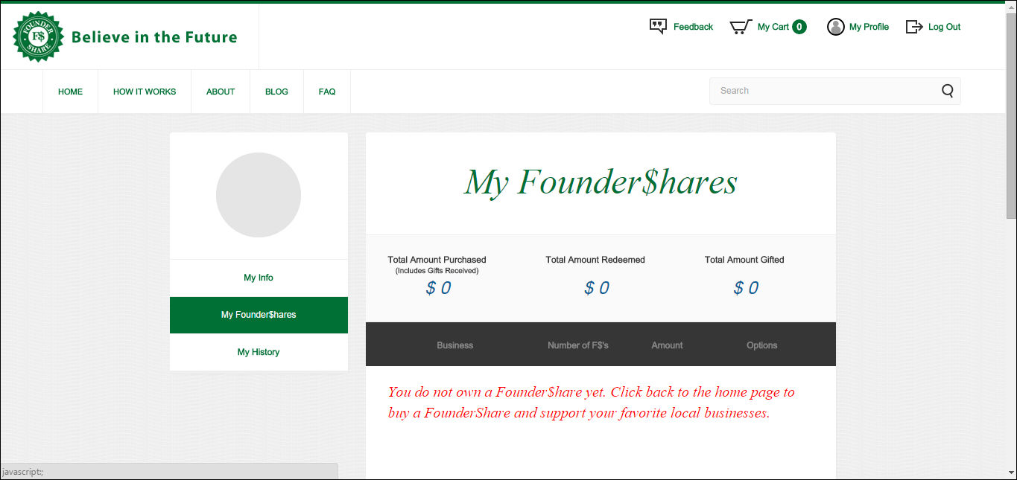

# **Resource Contact List**

|  |  |
| --- | --- |
| **Name** | **Resource Email** |
| TCSASSMELBER | contact via topcoder messaging system |