**Project Mom and Pop - Front-end Desktop Misc**

**Deployment Guide**

Revision History

|  |  |  |
| --- | --- | --- |
| **Author** | **Revision Number** | **Date** |
| TCSASSEMBLER | 1.0 | 2015-04-10 |
|  |  |  |

Deployment Instructions 3

1. Organization of Submission 3

2. Application Setup 3

3. Configuration 4

4. Database Setup 6

5. Email setup. 6

6. Payment setup 6

7. Wordpress Setup 7

7.1. Install MySql 7

7.2. Install Apache 8

7.3. Install wordpress 8

7.4. Fix the CORS issue 9

7.5. Setup Wordpress in page 9

8. Deployment Instructions 13

9. Verification 14

9.1. HistoryCtrl 14

9.2. ProfileCtrl 14

9.3. FeedbackCtrl 18

9.4. BusinessEmployeesCtrl 19

9.5. FoundersStatusCtrl 19

9.6. ShoppingCartCtrl 20

9.7. PaymentCtrl 20

9.8. ReportAbuseCtrl 22

9.9. Wordpress 23

10. Resource Contact List 23

# Deployment Instructions

# Organization of Submission

mom_api – the source code for nodejs API

mom_frontend – the source code for angular application

DeploymentGuide.docx – this file

# Application Setup

* Nodejs <https://nodejs.org/>
* MongoDB https://www.mongodb.org/
* Grunt <http://gruntjs.com/getting-started>

Run [sudo] npm install -g grunt-cli

* http-server https://www.npmjs.com/package/http-server

Run [sudo] npm install -g http-server

* qrcode module

Install required software in <https://github.com/soldair/node-qrcode#installation>

Run sudo apt-get install libpixman-1-dev libcairo2-dev

See <http://cairographics.org/download/> for installation in other operation systems

If you use Ubuntu, it also needs to install following packages.

sudo apt-get install libpango1.0-dev libjpeg-dev libgif-dev

# Configuration

API application

Config is located under config/default.json

You can edit production.json to override default settings

|  |  |  |
| --- | --- | --- |
| Name | Description | Sample value |
| MONGODB_URL | The mongodb url | mongodb://localhost:27017/project-mom |
| SALT_WORK_FACTOR | The factor for generating encryption salts. | 1 |
| SESSION_TOKEN_DURATION | The session duration in milliseconds. | 50000000 |
| JWT_SECRET | The secret for signing the jwt. | somesecret |
| DEFAULT_TOKEN_SIZE | The length of the token. |  |
| ACTIONS_INDIVIDUAL_USER | The list of permissions for individual user. | users,giftCardOffers,revokeToken,resetPassword,giftCards,refreshToken,invitations |
| ACTIONS_BUSINESS_EMPLOYEE | The list of permissions for business employee | users,giftCards,giftCardOffers,refreshToken,businesses,businessEmployee,invitations |
| ACTIONS_BUSINESS_ADMIN | The list of permissions for business admin | users,giftCards,giftCardOffers,refreshToken,businesses,businessAdmin,invitations |
| ACTIONS_CLIENT | The list of permissions for client | users, giftCards,giftCardOffers,refreshToken |
| ACTIONS_PLATFORM_EMPLOYEE | The list of permissions for platform employee | users,giftCards,giftCardOffers,refreshToken |
| OFFER_EXPIRATION_DAYS | The expiration in days for gift offers | 1 |
| PROFILE_IMAGE_FOLDER | The path for image upload | ./uploads |
| PROFILE_IMAGE_BASE_URL | The base url for server where images are hosted. | http://localhost:4040/ |
| TEMP_DIRECTROY | The path for temporary files | ./temp |
| WEB_SERVER_PORT | The port to listen | 4040 |
| MERCHANT_ID | The Brain tree merchant id | ny6gyyt78bps3pqb |
| PUBLIC_KEY | The Brain tree public key | xf72q3xmc6ywk55k |
| PRIVATE_KEY | The Brain tree private key | 3660ba0f71ee6ad0ea5923723d65a89b |
| TWITTER_CONSUMER_KEY | The twitter consumer key | HCXijRV8yZLry5pTS24FQ |
| TWITTER_CONSUMER_SECRET | The twitter consumer secret | mE1TXYmh89ctPTPI4txcPOodPBaoGNvsxJafmKC04cg |
| DEFAULT_SORT_BY | The default sort field | id |
| DEFAULT_SORT_ORDER | The default sort order | Ascending |
| DEFAULT_PAGE_SIZE | The default page zie | 5 |
| GEOCODER_PROVIDER | The geocoder provider | google |
| BRAINTREE_SUBSCRIPTION_PLANID | The Braintree subscription plan | SubscriptionPlan |
| GEOCODER_HTTPADAPTER | The geocoder adapter | http |
| SMTP_HOST | The smpt host for email service | smtp.mailgun.org |
| SMTP_PORT | The smtp port | 587 |
| SMTP_USERNAME | The smtp username | postmaster@sandbox887c4e0dc269436a89772766aaaec086.mailgun.org |
| SMTP_PASSWORD | The smtp password | dedd54c3343ac1e161763a80ca989c85 |
| CONFIG_EMAIL | The email address of email sender | noreply@momandpop.com |
| SITE_ADMIN_EMAIL | The admin of the site | sangwan.ritesh@yahoo.in |
| QR_CODE_SIZE | The qr code size | 16 |

Frontend application

File app/config.js

|  |  |  |
| --- | --- | --- |
| Name | Description | Sample value |
| LINKEDIN_APP_ID | The app id for linkedin | 75bfedn3v85xvw |
| FACEBOOK_APP_ID | The app id for facebook | 435002143324161 |
| TWITTER_CONSUMER_KEY | The The app id for twitter | HCXijRV8yZLry5pTS24FQ |
| SHARE_THIS_PUBLISHER_KEY | The publisher key for sharethis | 9b91d21e-3600-4e8d-b2d6-0eab4575e8c8 |
| REST_SERVICE_BASE_URL | The URL for backend API | http://localhost:4040 |
| FRIEND_INVITATION_MESSAGE_TEMPLATE | The template when inviting the user | message |
| SESSION_TOKEN_REFRESH_PERIOD | The session refresh interval in seconds | 1800 |
| HOW_IT_WORKS_URL | The wordpress permalinks for how it works page. | http://192.168.1.104/?p=4 |
| PRIVACY_POLICY_URL | The wordpress permalinks for privacy policy page. | http://192.168.1.104/?p=4 |
| COPYRIGHT_URL | The wordpress permalinks for copyright page. | http://192.168.1.104/?p=4 |
| FAQ_URL | The wordpress permalinks for FAQ page. | http://192.168.1.104/?p=4 |
| BLOG_URL | The wordpress permalinks for blog page. | http://192.168.1.104/?p=4 |
| FORUMS_URL | The wordpress permalinks for forums page. | http://192.168.1.104/?p=4 |
| ABOUT_URL | The wordpress permalinks for about page. | http://192.168.1.104/?p=4 |
| TERMS_AND_CONDITIONS_URL | The wordpress permalinks for terms and conditions page. | http://192.168.1.104/?p=4 |

# Database Setup

No setup is needed to configure database schema.

**Generate sample data**

Open console under api directory and run

node test_files/initialDB.js

Run script after you configure and deploy the app in mom_api directory.

# Email setup.

Register the account in [www.mailgun.com](http://www.mailgun.com).

In control panel, it could get SMTP user name and password in domain detail page.

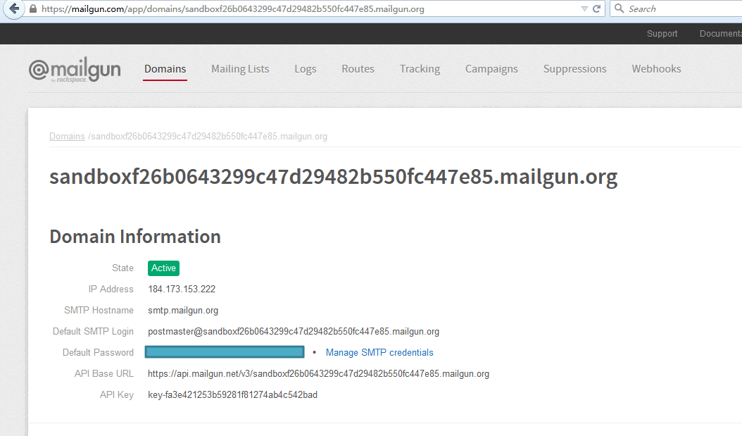

# Payment setup

Register account in <https://www.braintreepayments.com/> sandbox.

In dashboard page, click Account -> My User -> API Keys -> View, it could get the Merchant ID / Public Key / Private Key.

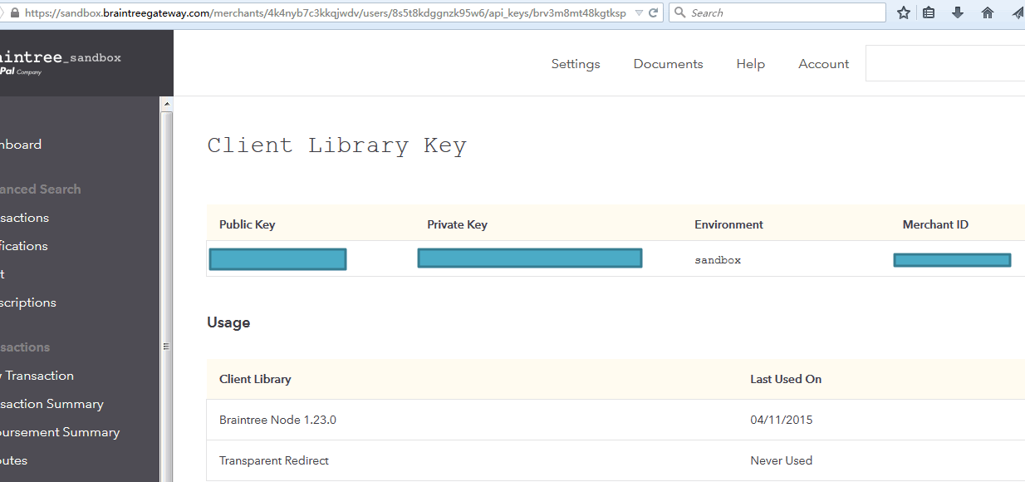

Click Plays menu on left side to create a plan.

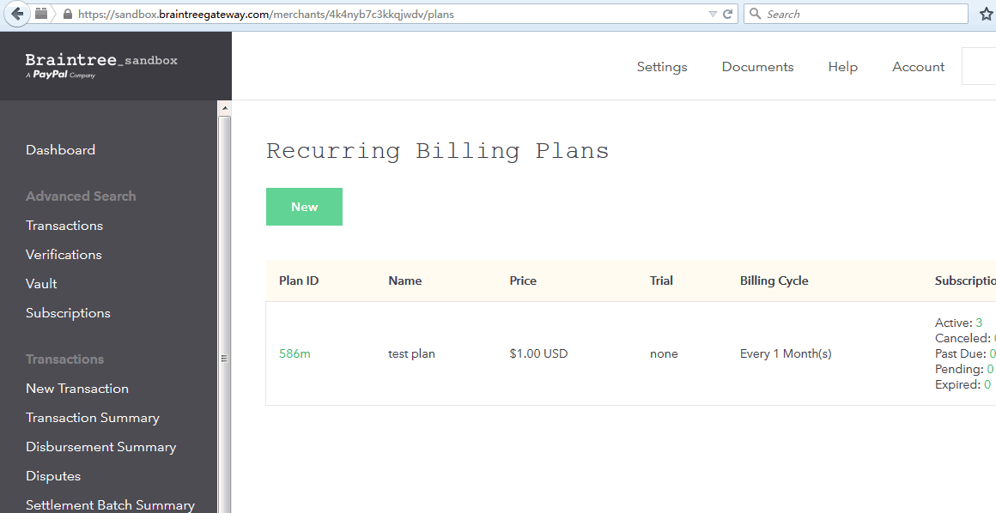

# Wordpress Setup

# Install MySql

Download MySql 5.6 from http://dev.mysql.com/downloads/mysql/

Install it.

In mysql bin directory, run mysql client to create database and setup user.

mysql -u root -p

CREATE DATABASE wordpress;

CREATE USER wordpressuser@localhost IDENTIFIED BY 'password';

GRANT ALL PRIVILEGES ON wordpress.* TO wordpressuser@localhost;

CREATE USER 'wordpressuser'@'%' IDENTIFIED BY 'password';

GRANT ALL PRIVILEGES ON *.* TO 'wordpressuser'@'%';

FLUSH PRIVILEGES;

exit

# Install Apache

Here is taking Ubuntu 14 for example, please refer to http://httpd.apache.org/docs/2.4/install.html for other platforms installation.

sudo apt-get install apache2 php5 libapache2-mod-php5 php5-mysql

ps -ef | grep apache

sudo a2enmod headers

sudo service apache2 restart

Make sure the port 80 is accessible. Open url in 80 port, for example, http://192.168.1.104/ it'll open the page.

# Install wordpress

Please refer to <https://codex.wordpress.org/Installing_WordPress> for more detail.

cd ~/software

wget http://wordpress.org/latest.tar.gz

tar xzvf latest.tar.gz

Update database and user name

cd ~/software/wordpress

cp wp-config-sample.php wp-config.php

vi wp-config.php

Update following items:

define('DB_NAME', 'wordpress');

define('DB_USER', 'wordpressuser');

define('DB_PASSWORD', 'password');

define('DB_HOST', '192.168.1.101');

Copy the file to html directory.

sudo cp -r * /var/www/html

# Fix the CORS issue

In /var/www/html directory, create .htaccess file which contains following:

DirectoryIndex index.php

<ifModule mod_headers.c>

Header always set Access-Control-Allow-Origin: "*"

Header always set Access-Control-Allow-Methods "POST, GET, PUT, DELETE, OPTIONS"

Header always set Access-Control-Allow-Headers "X-Requested-With, content-type"

</ifModule>

And delete the index.html in /var/www/html directory.

In /etc/apache2/apache2.conf, update the following value.

<Directory /var/www/>

Options Indexes FollowSymLinks

AllowOverride All

Require all granted

</Directory>

Restart apache.

sudo service apache2 restart

# Setup Wordpress in page

Open <http://192.168.1.104/wp-admin/install.php>, please replace 192.168.1.104 with your url.

Fill the necessary fields.

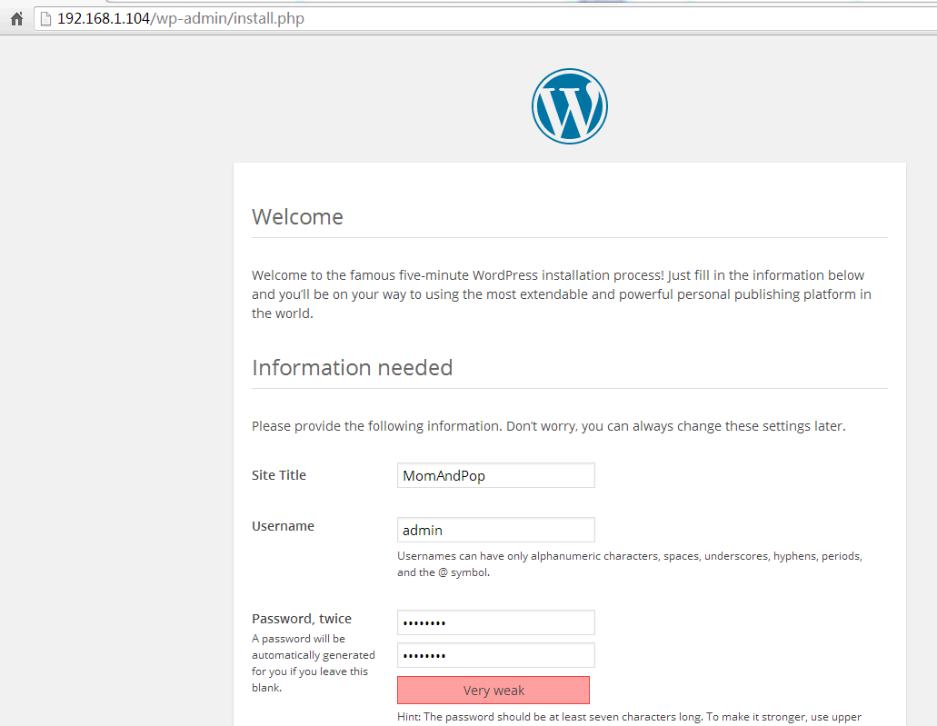

Click install button to install wordpress.

Open <http://192.168.1.104/wp-login.php> to login with just input username / password.

In admin dashboard page, click "Posts -> Add New" menu in left side. Input the page title and content, click Publish button to publish it.

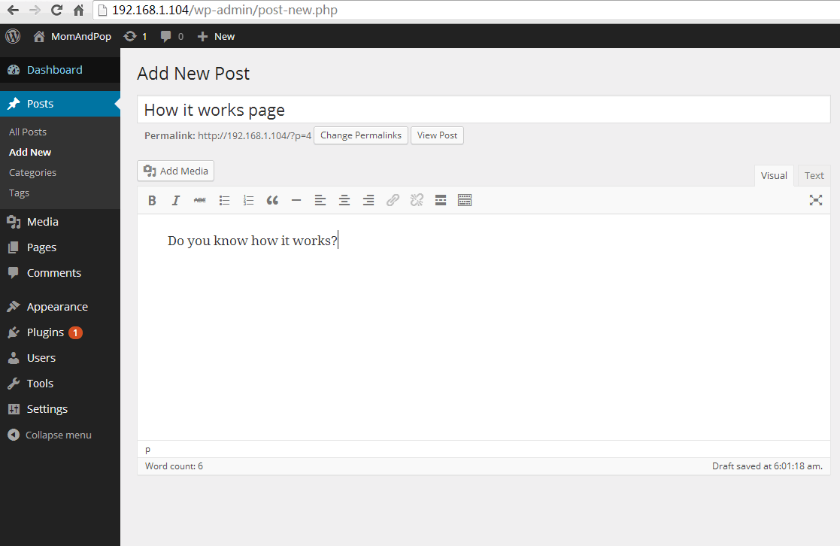

Then you can see it’s published.

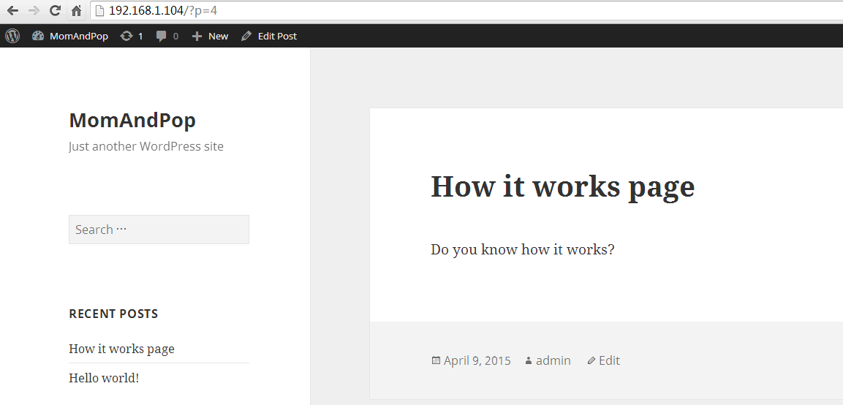

It’s same to add following pages to wordpress. And it could change the theme to better fit the page layout in Mom and Pop page.

* VerifyPDFForm
* FAQ
* Blog
* AboutUs
* HowItWorks
* PrivacyPolicy
* TermsAndConditions
* CopyRight
* Privacy
* Terms
* PrivacyB
* TermsB
* TermsNoLogged

# Deployment Instructions

Run under api directory

npm install

node app

Run under frontend directory

npm install

grunt

cd app

http-server -p 3500

# Verification

Open <http://192.168.1.104:3500> please replace 192.168.1.104 with your IP address.

# HistoryCtrl

Login with [test@test.com](mailto:test@test.com) / password. Click My History menu, it’ll show the history data.

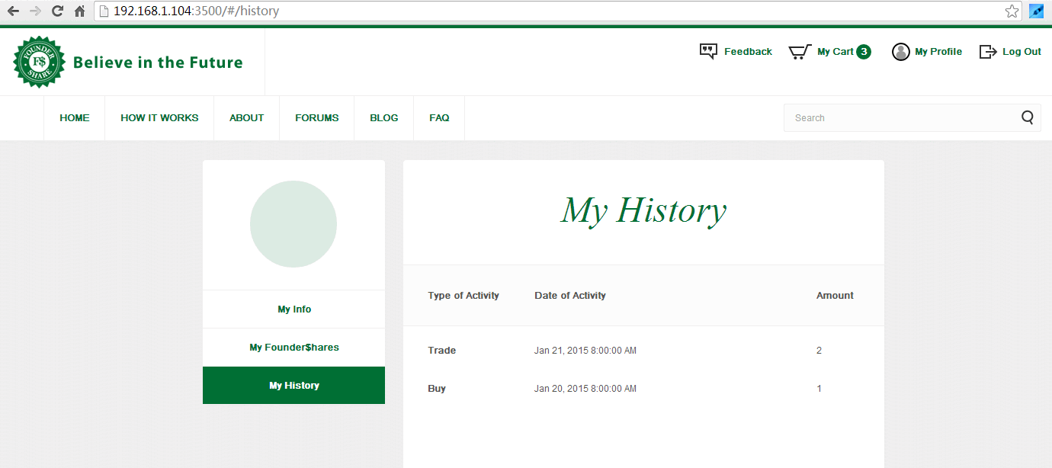

# ProfileCtrl

**Test contact information**

Login with [test@test.com](mailto:test@test.com) / password. Click My info menu, you can see the contact information fields.

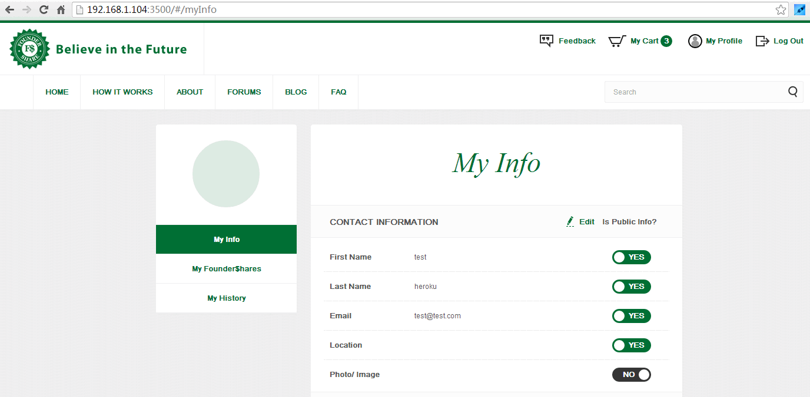

Click the edit link and it could edit the page.

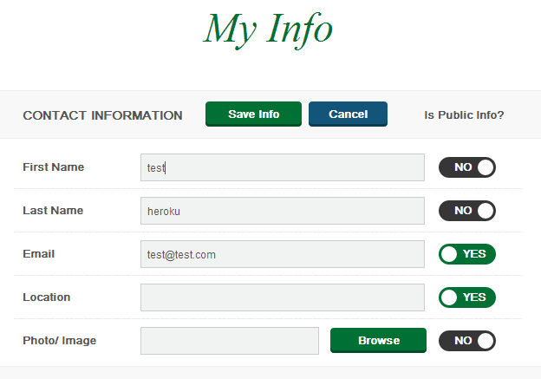

**Test business information**

Login with [buz@test.com](mailto:buz@test.com) / password, click my info menu, it’ll show the business information section.

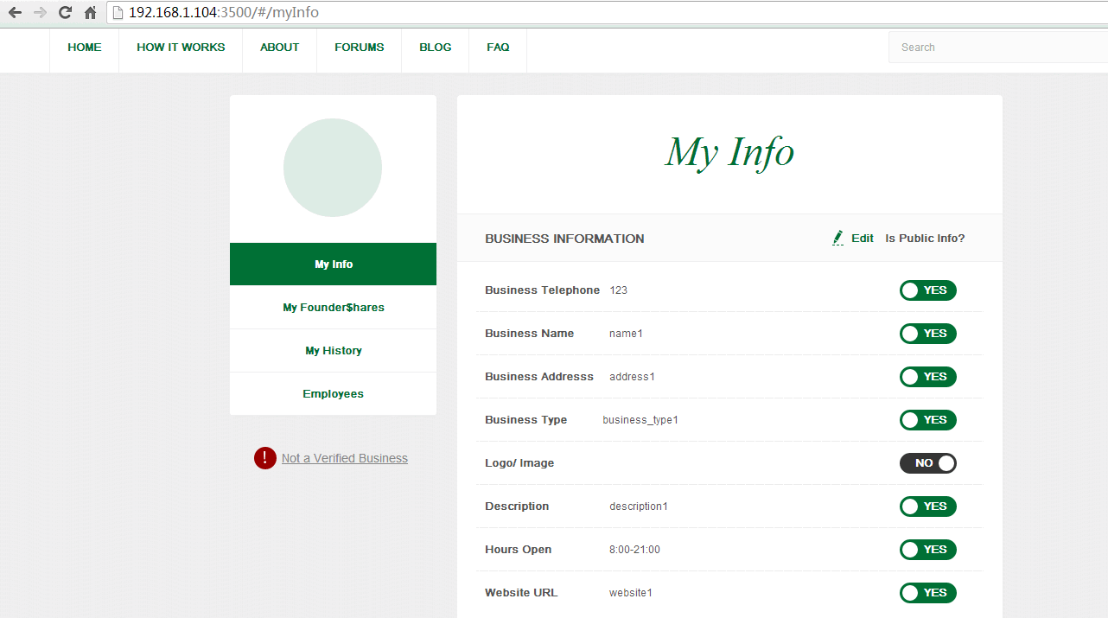

Click the edit link and it could edit the page.

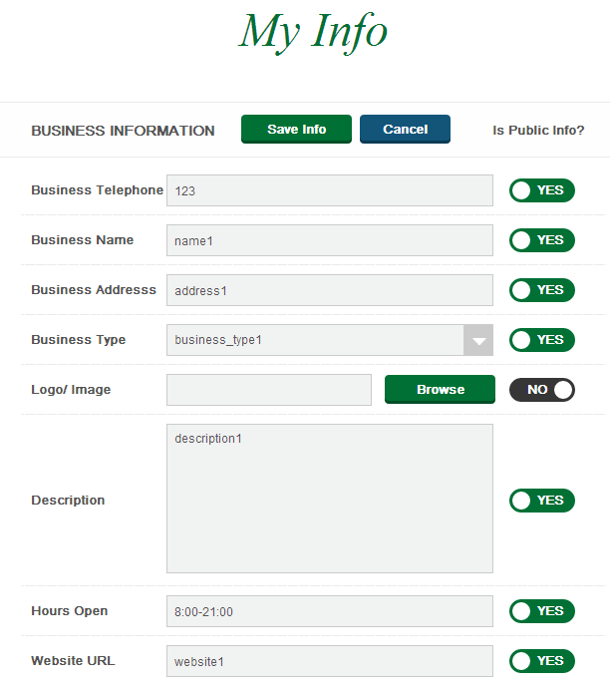

**Test Reset password.**

Login with [buz@test.com](mailto:buz@test.com) / password, click my info menu, click change password link. Fill the fields and it could change the password.

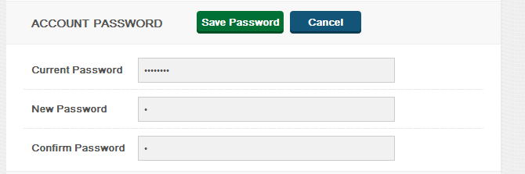

# FeedbackCtrl

Login with [test@test.com](mailto:test@test.com) / password. Click Feedback menu on top, it’ll show the feedback page. Fill the fields and click send button, it’ll send the mail to configure email.

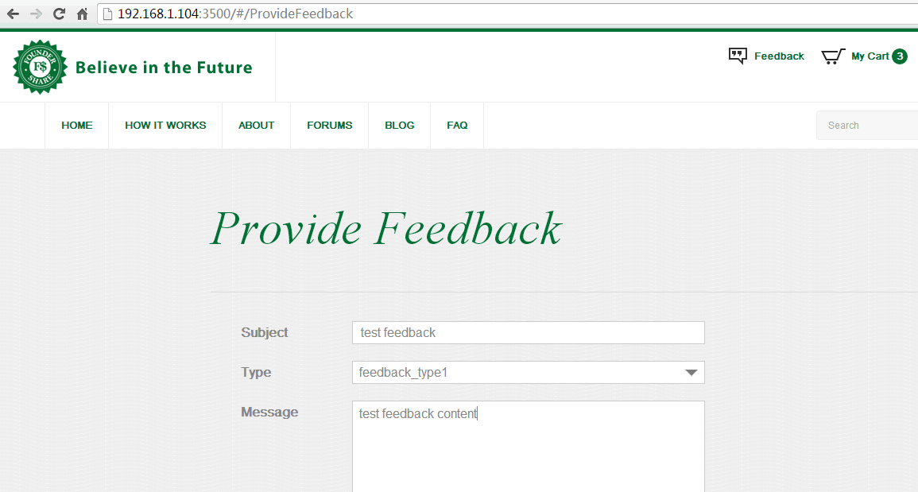

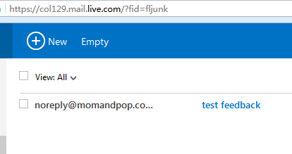

# BusinessEmployeesCtrl

Login with [buz@test.com](mailto:buz@test.com) / password, click Employees menu, it could add / update / delete items.

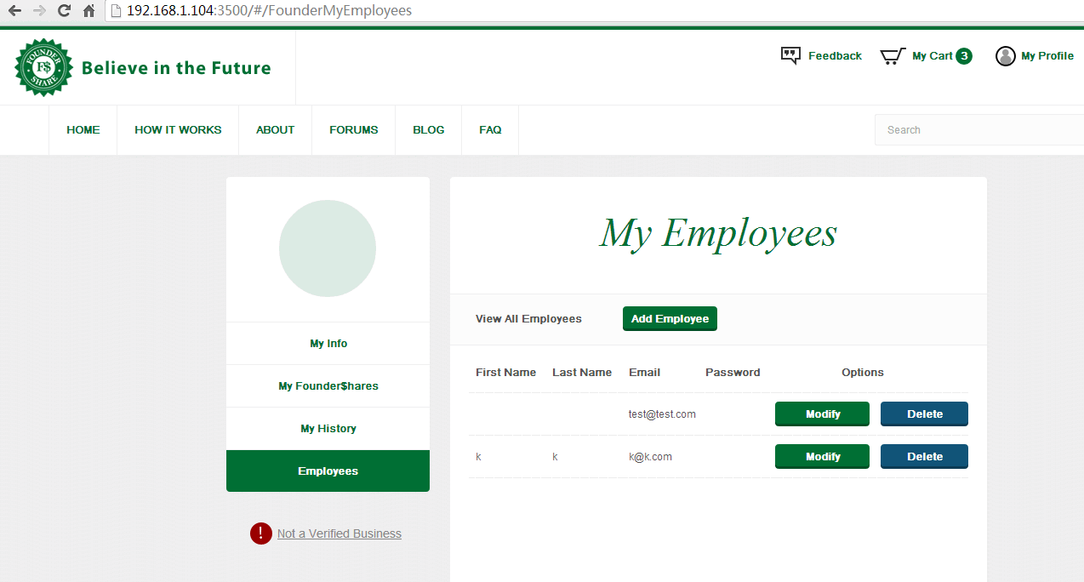

# FoundersStatusCtrl

Login with [plat@test.com](mailto:plat@test.com) / password, it’ll show the founder status page. It’s a readonly page.

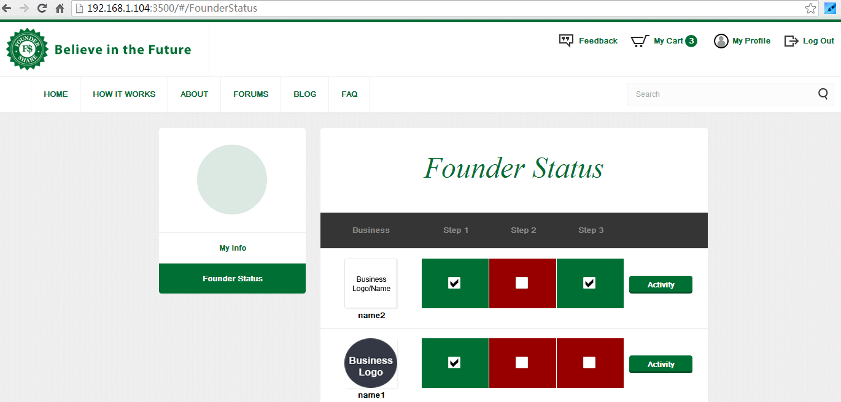

# ShoppingCartCtrl

Login with [buz@test.com](mailto:buz@test.com) / password, in home page, click one item and add to cart. It’ll show the shopping cart page. Input the number in total value field.

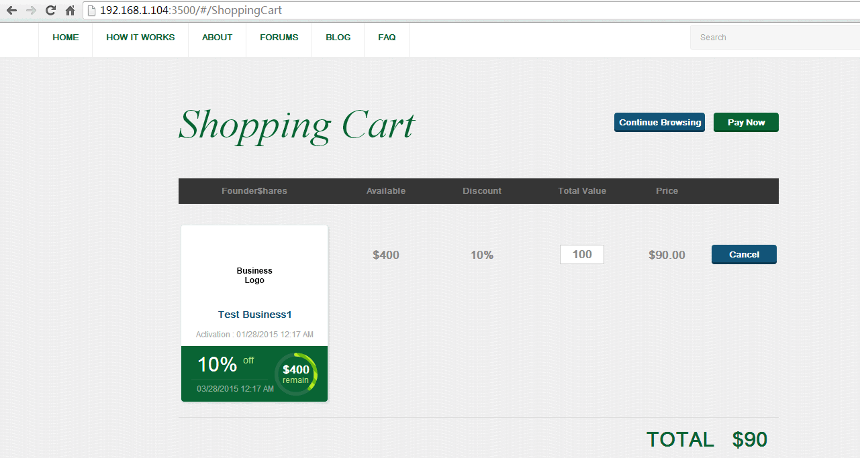

# PaymentCtrl

**Test payment**

In shopping cart, click the pay now button, it’ll go to payment page.

Test with card number 4005 5192 0000 0004 and ccv number 123. Click the pay button and it could pay.

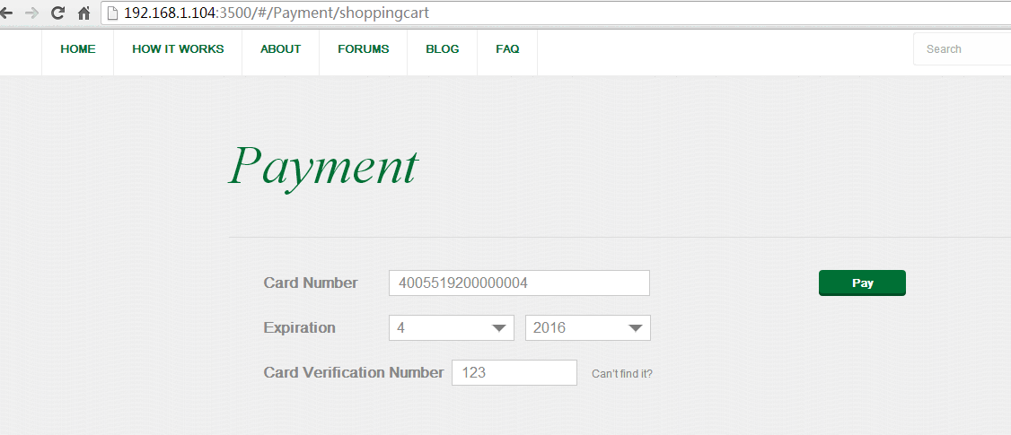

**Test verification**

Login with [buz@test.com](mailto:buz@test.com) / password, click “Not a Verified Business” link and subscribe now button, it’ll go to verify page. Test with card number 4005 5192 0000 0004 and ccv number 123. Click pay button and it could verify.

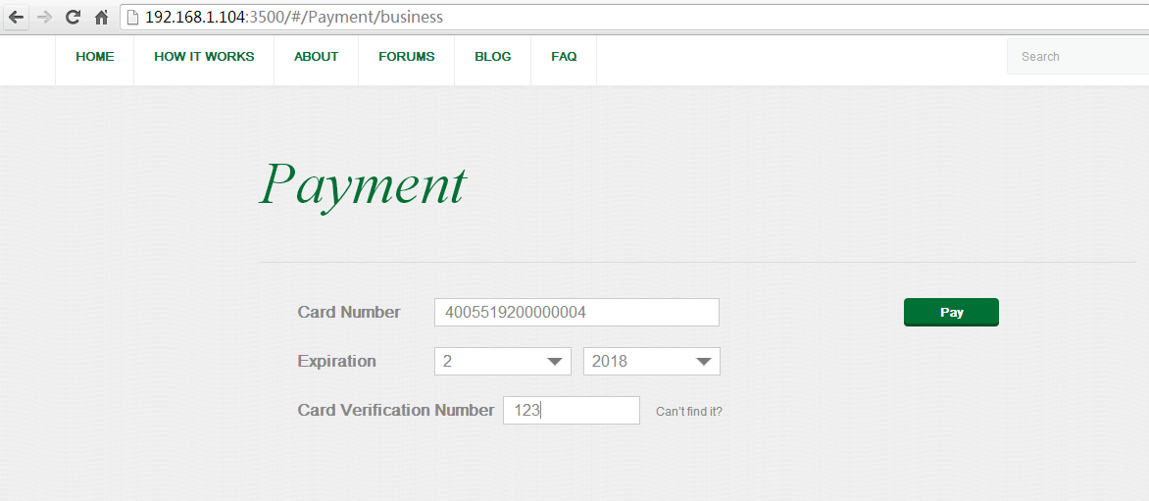

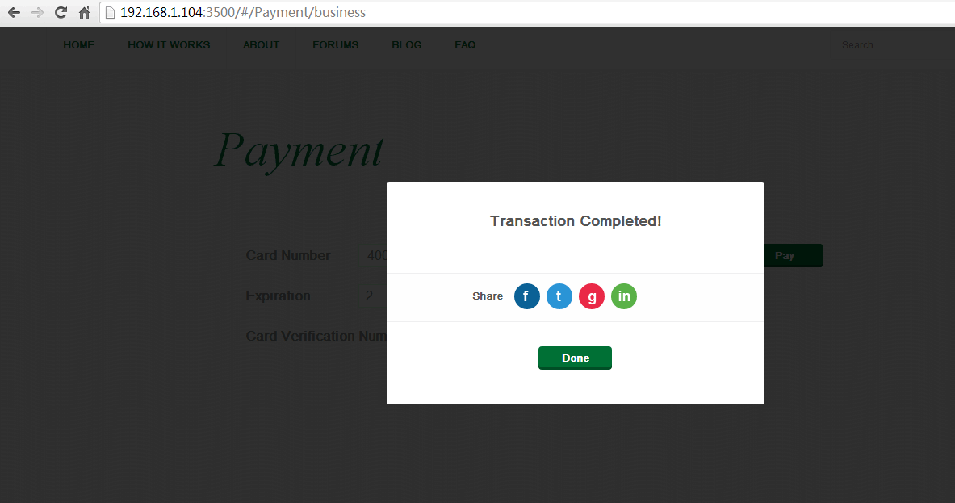

# ReportAbuseCtrl

Login with [test@test.com](mailto:test@test.com) / password. In home page, click an item and click “Report Abuse” link, it’ll show the report abuse page, fill the fields and click Send button. It’ll send the email.

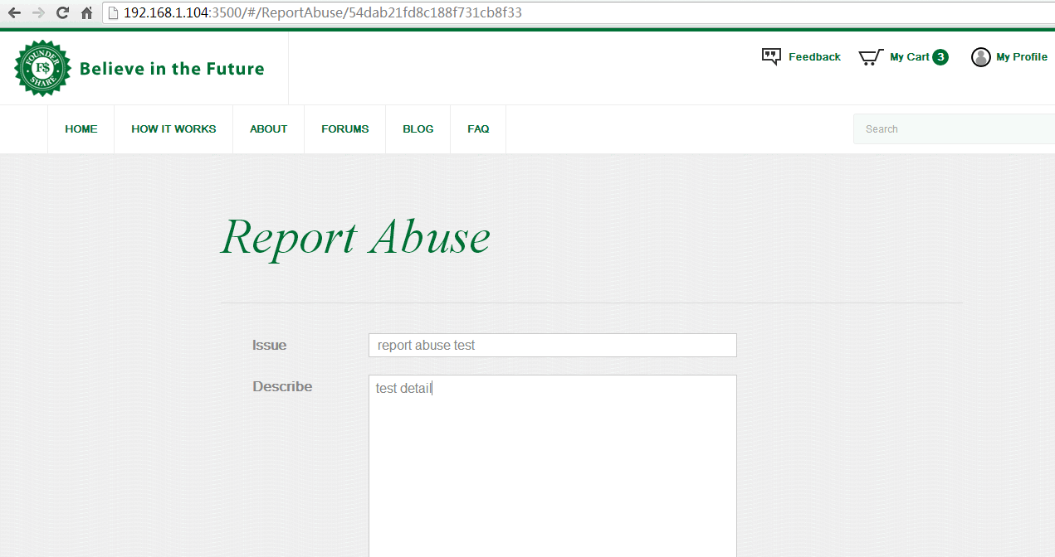

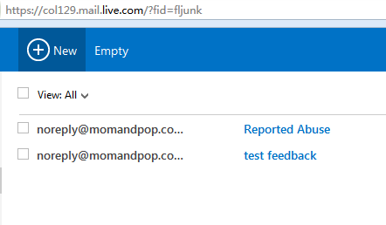

# Wordpress

Click the link such as “How it works”, it’ll show the wordpress link in page. It could change the page layout in wordpress theme configuration page.

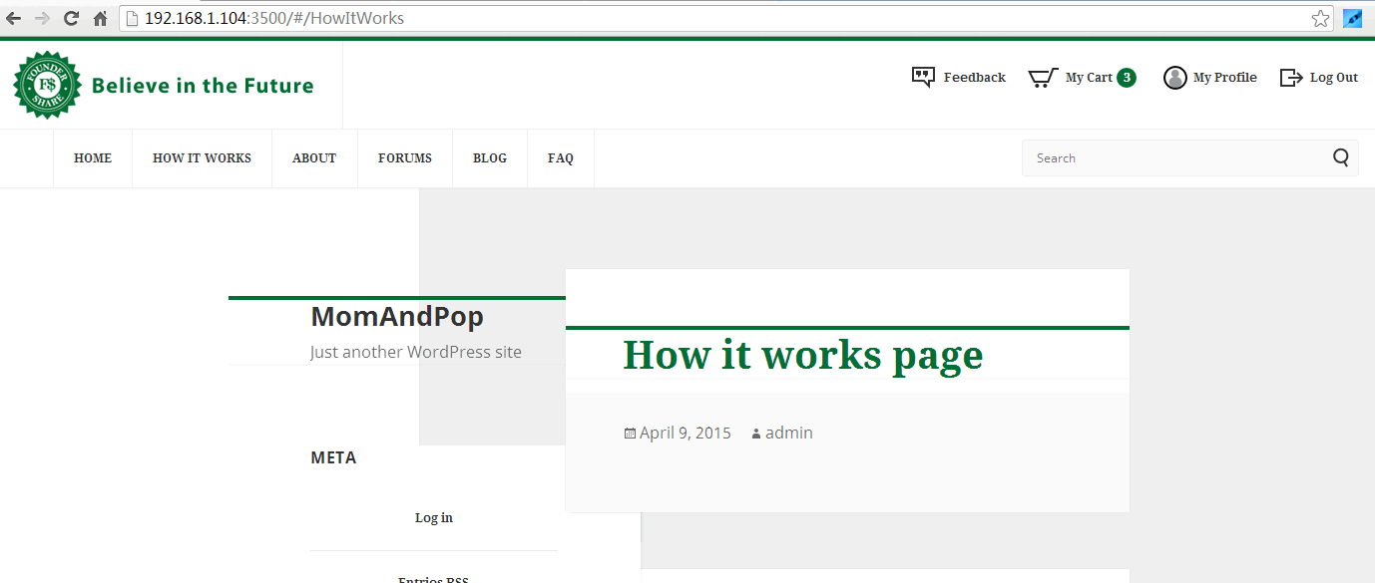

# Resource Contact List

|  |  |
| --- | --- |
| **Name** | **Resource Email** |
| TCSASSMELBER |  |