**Project Mom and Pop Founder$hares Management**

**Deployment Guide**

Revision History

|  |  |  |
| --- | --- | --- |
| **Author** | **Revision Number** | **Date** |
| TCSASSEMBLER | 1.0 | 2015-03-28 |
|  |  |  |

Deployment Instructions 3

1. Organization of Submission 3

2. Application Setup 3

3. Configuration 4

4. Database Setup 5

5. Deployment Instructions 6

6. Verification 7

7. Resource Contact List 16

# Deployment Instructions

# Organization of Submission

mom_api – the source code for nodejs API

mom_frontend – the source code for angular application

DeploymentGuide.docx – this file

# Application Setup

* Nodejs <https://nodejs.org/>
* MongoDB https://www.mongodb.org/
* Grunt <http://gruntjs.com/getting-started>

Run [sudo] npm install -g grunt-cli

* http-server https://www.npmjs.com/package/http-server

Run [sudo] npm install -g http-server

* qrcode module

Install required software in <https://github.com/soldair/node-qrcode#installation>

Run sudo apt-get install libpixman-1-dev libcairo2-dev

See <http://cairographics.org/download/> for installation in other operation systems

# Configuration

API application

Config is located under config/default.json

You can edit production.json to override default settings

|  |  |  |
| --- | --- | --- |
| Name | Description | Sample value |
| MONGODB_URL | The mongodb url | mongodb://localhost:27017/project-mom |
| SALT_WORK_FACTOR | The factor for generating encryption salts. | 1 |
| SESSION_TOKEN_DURATION | The session duration in milliseconds. | 50000000 |
| JWT_SECRET | The secret for signing the jwt. | somesecret |
| DEFAULT_TOKEN_SIZE | The length of the token. |  |
| ACTIONS_INDIVIDUAL_USER | The list of permissions for individual user. | users,giftCardOffers,revokeToken,resetPassword,giftCards,refreshToken,invitations |
| ACTIONS_BUSINESS_EMPLOYEE | The list of permissions for business employee | users,giftCards,giftCardOffers,refreshToken,businesses,businessEmployee,invitations |
| ACTIONS_BUSINESS_ADMIN | The list of permissions for business admin | users,giftCards,giftCardOffers,refreshToken,businesses,businessAdmin,invitations |
| ACTIONS_CLIENT | The list of permissions for client | users, giftCards,giftCardOffers,refreshToken |
| ACTIONS_PLATFORM_EMPLOYEE | The list of permissions for platform employee | users,giftCards,giftCardOffers,refreshToken |
| OFFER_EXPIRATION_DAYS | The expiration in days for gift offers | 1 |
| PROFILE_IMAGE_FOLDER | The path for image upload | ./uploads |
| PROFILE_IMAGE_BASE_URL | The base url for server where images are hosted. | http://localhost:4040/ |
| TEMP_DIRECTROY | The path for temporary files | ./temp |
| WEB_SERVER_PORT | The port to listen | 4040 |
| MERCHANT_ID | The Brain tree merchant id | ny6gyyt78bps3pqb |
| PUBLIC_KEY | The Brain tree public key | xf72q3xmc6ywk55k |
| PRIVATE_KEY | The Brain tree private key | 3660ba0f71ee6ad0ea5923723d65a89b |
| TWITTER_CONSUMER_KEY | The twitter consumer key | HCXijRV8yZLry5pTS24FQ |
| TWITTER_CONSUMER_SECRET | The twitter consumer secret | mE1TXYmh89ctPTPI4txcPOodPBaoGNvsxJafmKC04cg |
| DEFAULT_SORT_BY | The default sort field | id |
| DEFAULT_SORT_ORDER | The default sort order | Ascending |
| DEFAULT_PAGE_SIZE | The default page zie | 5 |
| GEOCODER_PROVIDER | The geocoder provider | google |
| BRAINTREE_SUBSCRIPTION_PLANID | The Braintree subscription plan | SubscriptionPlan |
| GEOCODER_HTTPADAPTER | The geocoder adapter | http |
| SMTP_HOST | The smpt host for email service | smtp.mailgun.org |
| SMTP_PORT | The smtp port | 587 |
| SMTP_USERNAME | The smtp username | postmaster@sandbox887c4e0dc269436a89772766aaaec086.mailgun.org |
| SMTP_PASSWORD | The smtp password | dedd54c3343ac1e161763a80ca989c85 |
| CONFIG_EMAIL | The email address of email sender | noreply@momandpop.com |
| SITE_ADMIN_EMAIL | The admin of the site | sangwan.ritesh@yahoo.in |
| QR_CODE_SIZE | The qr code size | 16 |

Frontend application

File app/config.js

|  |  |  |
| --- | --- | --- |
| Name | Description | Sample value |
| LINKEDIN_APP_ID | The app id for linkedin | 75bfedn3v85xvw |
| FACEBOOK_APP_ID | The app id for facebook | 435002143324161 |
| TWITTER_CONSUMER_KEY | The The app id for twitter | HCXijRV8yZLry5pTS24FQ |
| SHARE_THIS_PUBLISHER_KEY | The publisher key for sharethis | 9b91d21e-3600-4e8d-b2d6-0eab4575e8c8 |
| REST_SERVICE_BASE_URL | The URL for backend API | http://localhost:4040 |
| FRIEND_INVITATION_MESSAGE_TEMPLATE | The template when inviting the user | message |
| SESSION_TOKEN_REFRESH_PERIOD | The session refresh interval in seconds | 1800 |

# Database Setup

No setup is needed to configure database schema.

**Generate sample data**

Open console under api directory and run

node test_files/initialDB.js

Run script after you configure and deploy the app in section 6.

# Deployment Instructions

Run under api directory

npm install

node app

Run under frontend directory

npm install

grunt

cd app

http-server -p 3500

# Verification

Open <http://localhost:3500>

**Functionality from merging existing applications**

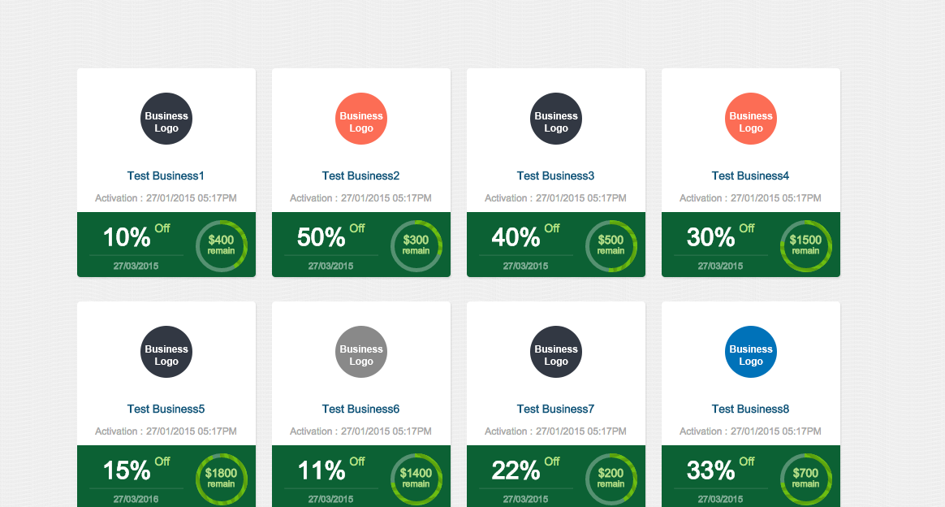

Click on first offer

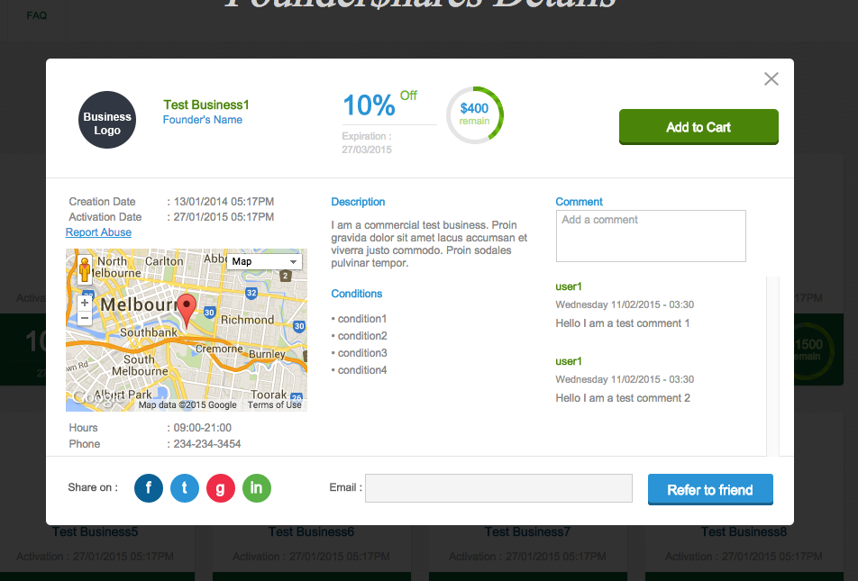

Click on social icons to share this page.

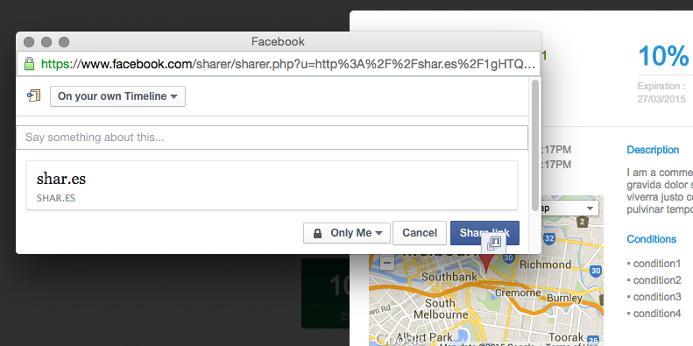

I changed it to show popup instead of redirecting user to full page.

Close popup.

Open <http://localhost:3500/#/Login>

And login as

[buz@test.com](mailto:buz@test.com) // password

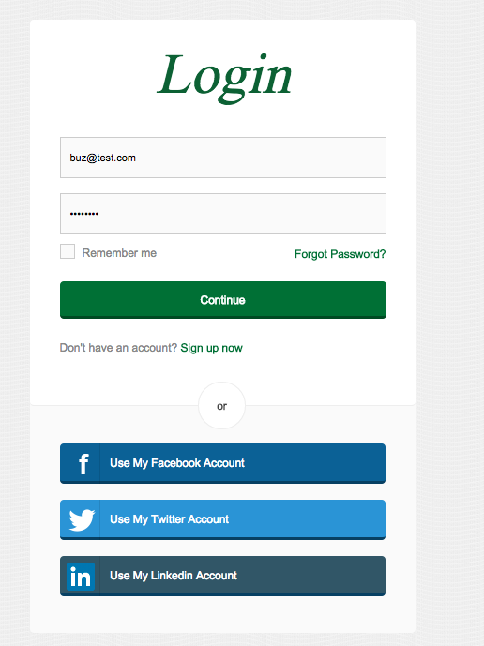

Go back to home page

<http://localhost:3500/#/>

Click on offer again

Write comment and press enter

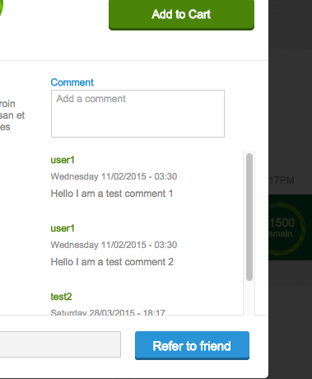

Enter your email and click Refer to friend.

Check your email. There is an existing issue and link is not properly encoded.

Click logout button.

Click sign up now.

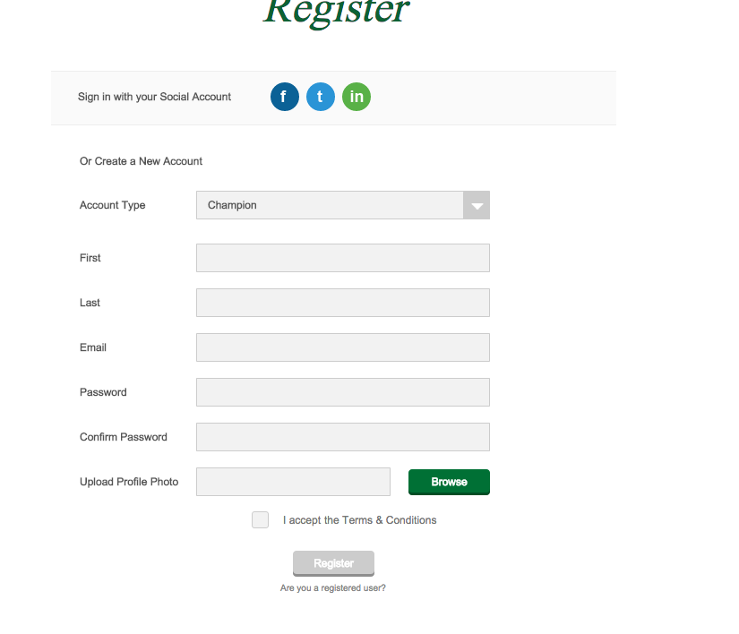

Register without social network and with social network. Test both account types.

Total number of possible combinations is 8.

After registration you must login manually.

Email address must be unique. If your social accounts have same email address, try to reset the database.

After you create an account with your real email address, go to login page and click Forgot Password

Enter email and click submit

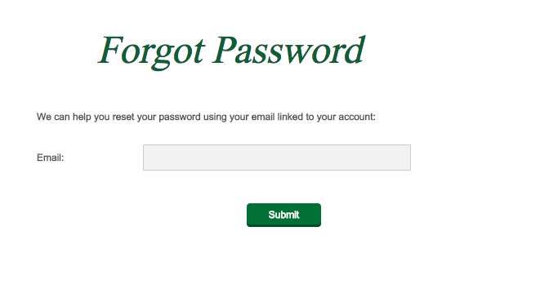

Go to your email and open reset password link

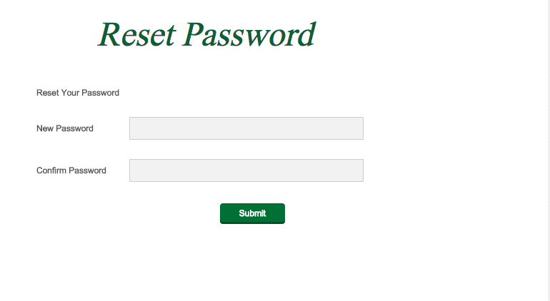

Reset your password and login with new password.

**New functionality**

Open <http://localhost:3500/#/Login> and login as

[buz@test.com](mailto:buz@test.com) // password

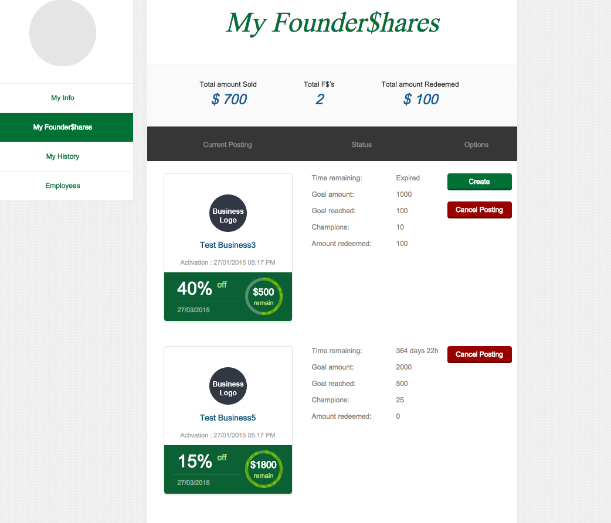

click Create

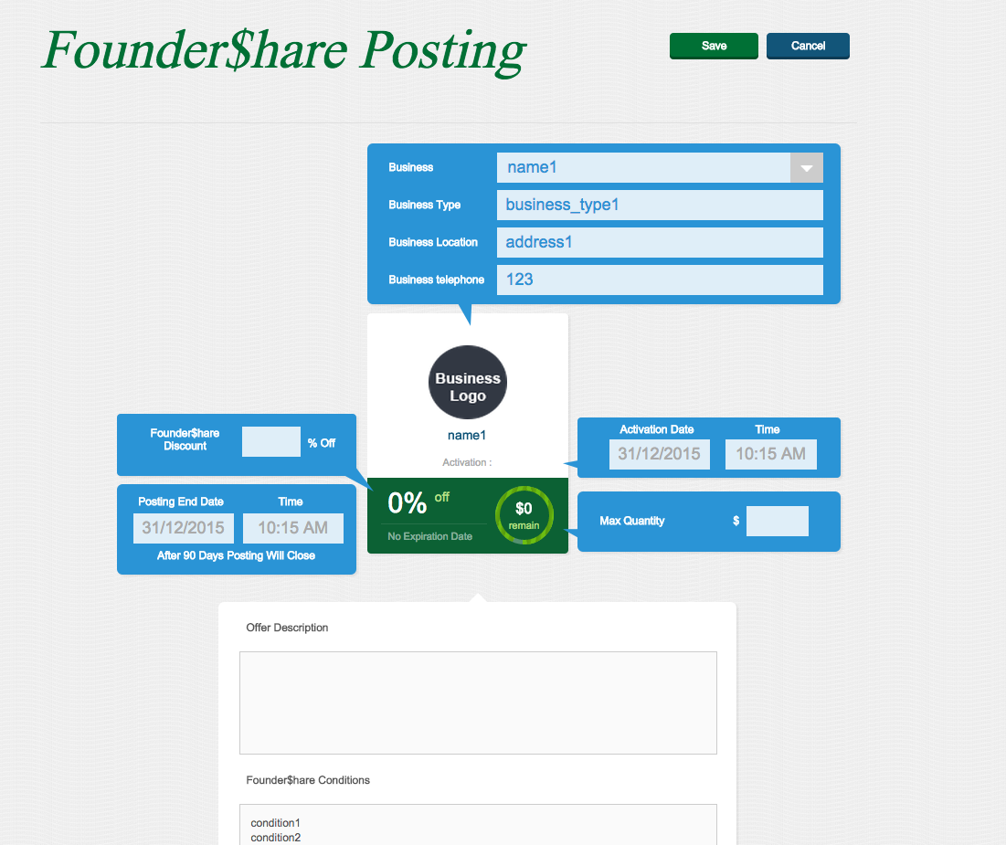

fill form

placeholders show expected value for date and time fields

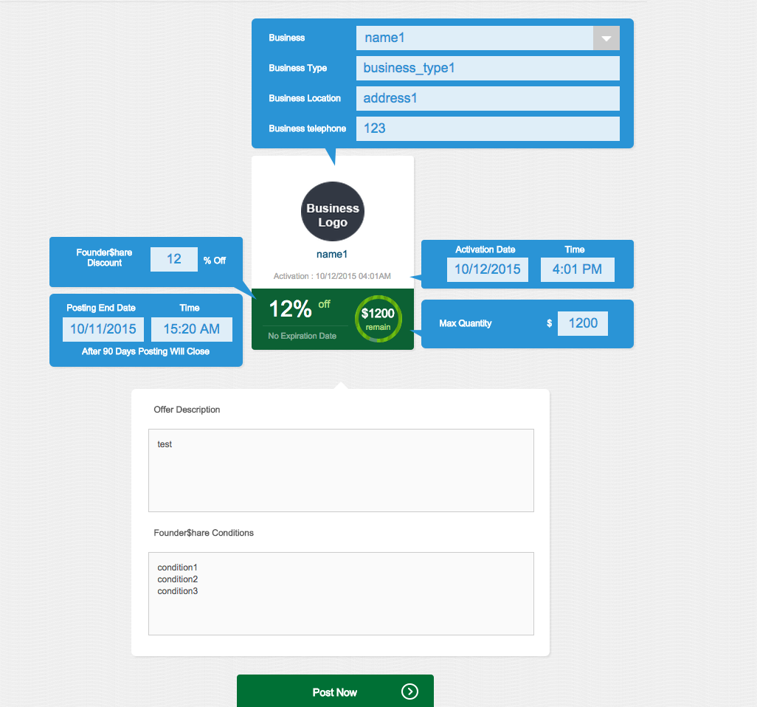

Click Post Now

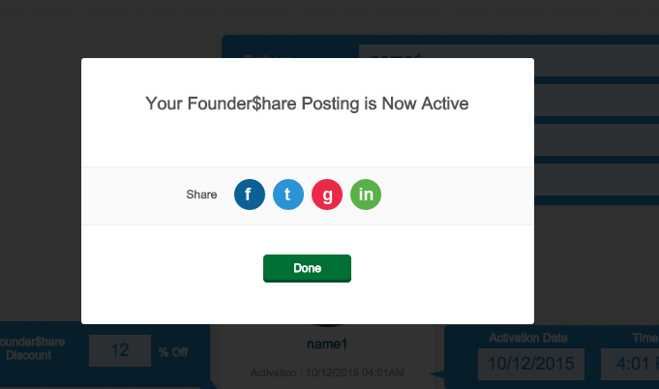

Offer is now active. If you create new offer and click Save. Offer will still have Draft status.

Social networks icons work in similar way to icons from home page.

Click done

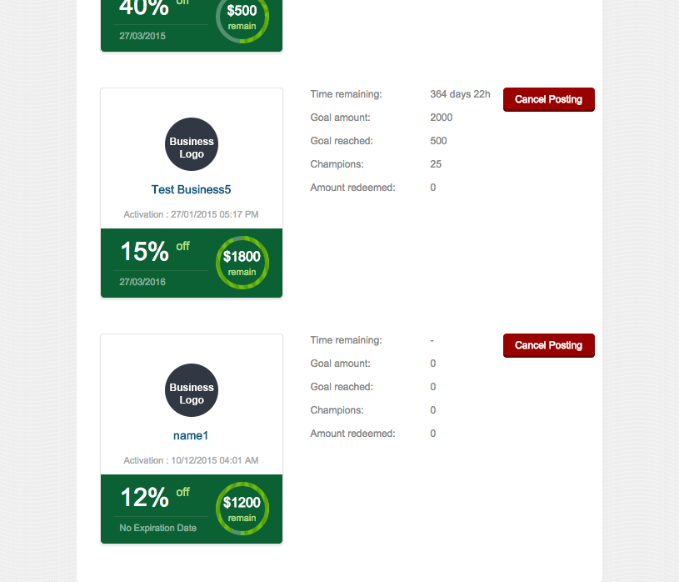

Click on created offer.

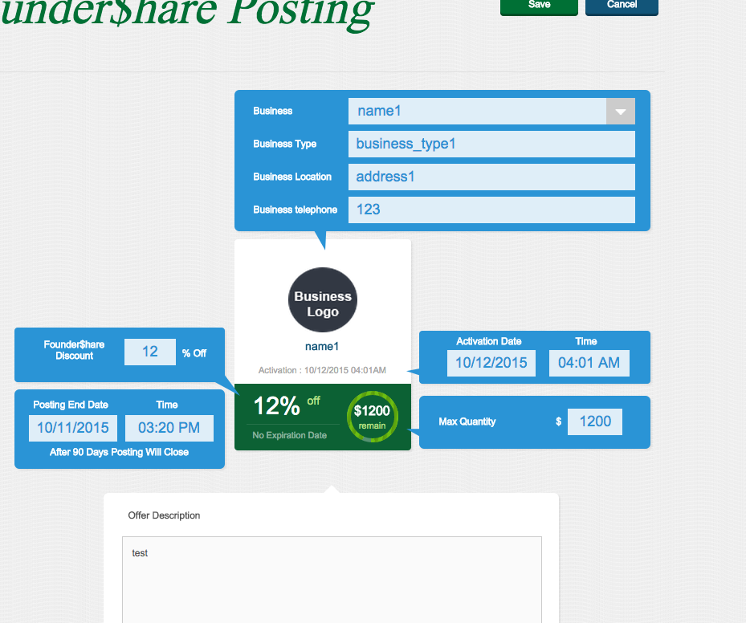

It should show same values.

Click Save.

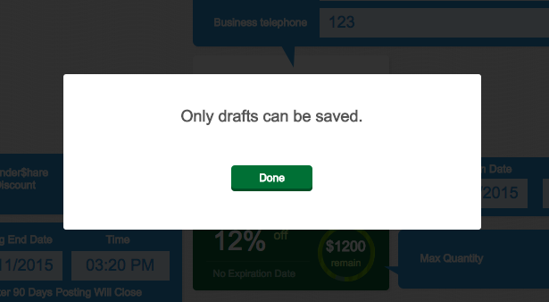

# Resource Contact List

|  |  |
| --- | --- |
| **Name** | **Resource Email** |
| TCSASSMELBER |  |