ARTICLE INFORMATION
Article title: A Multi-Sensor Armature-Current, Vibration and Acoustic Dataset of a Brushed DC Servo Motor for Condition Monitoring
Authors: Marin Zhilevski a,*, Nikolay Yordanov a, Mikho Mikhov a, Merve Ertarğın b, Mihriban Gunay b
Affiliations: a Faculty of Automatics, Technical University of Sofia, 8 Kliment Ohridski Blvd., 1000 Sofia, Bulgaria
b University of Munzur, Department of Electrical and Electronics Engineering, Tunceli, Türkiye
Corresponding author’s email address: mzhilevski@tu-sofia.bg
Keywords: Armature current; AV-160B vibrometer; Smartphone microphone; Thyristor converter; Speed estimation; Foundation looseness; Fault diagnosis; Machine learning
Abstract:
This article presents a multi-sensor condition-monitoring dataset recorded from a brushed permanent-magnet DC servo motor (3PI12.12; 625 W, 110 V DC, 12.5 A, 5.4 N·m, 2000 rpm) driven by a four-quadrant thyristor (SCR) converter with armature voltage and current control. The machine was operated, with no external mechanical load, across up to thirteen speed setpoints (1, 2, 5, 10, 20, 30, 40, 50, 60, 70, 80, 90 and 100 % of rated speed) under 8 operating conditions that combine four control/mechanical states — normal operation, a detuned speed-regulator gain, a detuned speed- and current-regulator gain, and a deliberately loosened foundation — each recorded without and with periodic direction reversal. For every operating point, four sensors were recorded separately under the same operating conditions: the armature current with a Rigol MSO5074 oscilloscope (native binary waveforms), the true vibration waveform from the AC output of an AV-160B piezoelectric vibrometer (44.1 kHz, 16-bit stereo WAV), the airborne sound from a budget Android smartphone microphone placed about 1 m away (AAC/M4A), and AV-160B spot readings of velocity, acceleration and displacement (XLS). The repository is published as raw, untransformed recordings and comprises 386 files (98 BIN, 98 WAV, 98 M4A, 91 XLS, 1 STP), together with a per-file metadata index (sample rate, duration, channels, bit depth and file size), a 3-D CAD model of the test rig, a README and a CC BY 4.0 licence. The dataset supports speed estimation, operating-condition classification, direction-reversal and converter-ripple analysis, and benchmarking of low-cost smartphone audio against instrument-grade current and vibration references.

SPECIFICATIONS TABLE
Subject | Electrical and Electronic Engineering
Specific subject area | Condition monitoring and fault diagnosis of brushed DC servo motors from armature-current, vibration and acoustic signals, including a smartphone-versus-instrument sensing comparison.
Type of data | Raw armature-current waveforms (.bin); raw vibration waveforms (.wav); raw acoustic recordings (.m4a); vibration spot readings (.xls); metadata index (.csv); 3-D CAD model (.stp); tables and figures. Data are Raw (untransformed).
Data collection | Recorded on a laboratory test rig comprising a brushed PM DC servo motor (3PI12.12) driven by a four-quadrant thyristor (SCR) converter with no external mechanical load (the motor runs unloaded). Armature current was captured with a Rigol MSO5074 oscilloscope; the vibration waveform and spot readings (per ISO 2954) were taken with an AV-160B vibrometer; airborne sound was recorded with a budget Android smartphone at ~1 m. Each sensor was recorded separately under the same operating conditions.
Data source location | Technical University of Sofia, Sofia, Bulgaria.
Data accessibility | Repository name: Mendeley Data. Data identification number: DOI to be assigned. Direct URL to data: to be provided upon publication. Instructions: the dataset will be publicly available through the Mendeley Data repository under a CC BY 4.0 licence, organised as described in this article.
Related research article | None.

VALUE OF THE DATA
- The dataset provides raw, matched-condition multi-sensor recordings (armature current, vibrometer vibration waveform, smartphone audio and vibrometer spot readings) of a brushed DC servo motor across a wide speed range, giving ready-made regression (speed setpoint, % of rated speed) and classification (operating condition) labels.
- Because the smartphone microphone is recorded at ~1 m under the same operating conditions as the instrument-grade current and vibration references, the data enable a direct benchmark of whether low-cost smartphone audio can substitute for invasive or specialised diagnostic equipment.
- The data can be reused by researchers in electrical machines, condition monitoring, predictive maintenance and signal processing to develop and validate feature-extraction, machine-learning and sensor-fusion methods, and as a benchmark for comparing diagnostic algorithms.
- Four operating states (normal, two levels of controller detuning, and a loose foundation) combined with two reversal modes support studies of control-tuning effects, foundation-looseness detection and direction-reversal transients that are rarely available together in public datasets.
- Publishing the recordings raw and untransformed, with an exact per-file metadata index and a CAD model of the rig, lets users apply their own preprocessing and generate application-specific representations (spectrograms, Mel-spectrograms, scalograms, and current-signature or envelope spectra) and reproduce the acquisition geometry.

BACKGROUND
Condition monitoring of electrical drives traditionally relies on invasive or specialised instrumentation such as current probes and contact vibrometers, which can be costly or impractical to deploy widely [1,2]. Airborne sound captured by ubiquitous smartphones is an attractive low-cost, non-contact alternative, but its diagnostic value must be assessed against instrument-grade references acquired under the same operating conditions [3]. This dataset was compiled to enable that comparison for a brushed permanent-magnet DC servo motor driven by a four-quadrant thyristor converter — a drive whose armature current carries a characteristic 300 Hz (6 × 50 Hz) six-pulse converter ripple in addition to commutation signatures. The motor was exercised across a broad speed range under normal operation, two levels of controller detuning and a loosened-foundation condition, each without and with periodic direction reversal, while four sensors were recorded separately under matched conditions. The resulting raw recordings allow researchers to compare models trained on smartphone audio against those trained on current and vibration signals, and to study speed estimation, foundation-looseness detection, direction-reversal transients and converter/commutation signatures. The data are released raw and untransformed so that users can apply their own preprocessing pipelines [4].

DATA DESCRIPTION
The dataset contains raw multi-sensor recordings acquired from a single brushed permanent-magnet DC servo motor on a laboratory test rig. It is published as byte-for-byte raw recordings organised by operating condition, sensor and speed setpoint, together with a per-file metadata index, a 3-D CAD model of the rig, a README descriptor and a licence file. In total the repository contains 386 files (98 BIN, 98 WAV, 98 M4A, 91 XLS, 1 STP). Table 1 lists the top-level organisation of the repository.
Table 1. Organisation of the dataset repository.
Folder / File | Description | Format
data/ | Raw recordings organised as <condition>/<sensor>/speedNNN_sensor.ext | Folder
cad/ | 3-D CAD model of the test rig (1v_3v0.stp) | STP
metadata.csv | One row per file with acquisition parameters and traceability fields | CSV
README.md | Dataset descriptor (machine, conditions, sensors, methods, coverage) | Markdown
LICENSE.txt | Creative Commons Attribution 4.0 (CC BY 4.0) licence | TXT
The machine under test is a brushed permanent-magnet DC servo motor with a commutator and graphite brushes. Its rated parameters are given in Table 2. The armature current is unipolar DC with ripple; the prominent 300 Hz component (6 × 50 Hz) is the six-pulse converter ripple of the drive, i.e. a drive signature rather than a fault.
Table 2. Rated parameters of the machine under test.
Parameter | Value
Type | Brushed PM DC servo (commutator + graphite brushes)
Designation | 3PI12.12
Rated power | 625 W
Rated voltage | 110 V DC
Rated current | 12.5 A
Rated torque | 5.4 N·m
Rated speed | 2000 rpm
Drive | Four-quadrant thyristor (SCR) converter, armature voltage/current control
The recordings span 8 operating conditions, each a folder under data/ formed by combining an operation state with a reversal mode (without or with periodic direction reversal). Table 3 lists the conditions and the speed setpoints (% of rated speed) present for each. Naming note: the detuned-speed-regulator condition uses a non-optimal speed-regulator gain, whereas the detuned speed-and-current-regulator (RT) condition additionally uses a non-optimal current-regulator gain.
Table 3. Operating conditions and available speed setpoints.
Folder (data/) | Operation | Reversal | Speed setpoints (%) | No.
normal_no_reversal | Normal operation | No | 1, 2, 5, 10, 20, 30, 40, 50, 60, 70, 80, 90, 100 | 13
normal_with_reversal | Normal operation | Yes | 1, 2, 5, 10, 20, 30, 40, 50, 60, 70, 80, 90, 100 | 13
suboptimal_control_no_reversal | Detuned speed regulator | No | 1, 2, 5, 10, 20, 30, 40, 50, 60, 65 | 10
suboptimal_control_with_reversal | Detuned speed regulator | Yes | 1, 2, 5, 10, 20, 30, 40, 50, 60, 65 | 10
suboptimal_control_rt_no_reversal | Detuned speed + current regulator | No | 1, 2, 5, 10, 20, 30, 40, 50, 60, 70, 80, 90, 100 | 13
suboptimal_control_rt_with_reversal | Detuned speed + current regulator | Yes | 1, 2, 5, 10, 20, 30, 40, 50, 60, 70, 80, 90, 100 | 13
loose_foundation_no_reversal | Loose foundation | No | 1, 2, 5, 10, 20, 30, 40, 50, 60, 70, 80, 90, 100 | 13
loose_foundation_with_reversal | Loose foundation | Yes | 1, 2, 5, 10, 20, 30, 40, 50, 60, 70, 80, 90, 100 | 13
Each condition folder contains up to four sensor sub-folders. The sensors, instruments and file formats are summarised in Table 4. The sound_vibrometer WAV and the vibration XLS spot readings both originate from one AV-160B portable vibrometer (Amittari) with an external piezoelectric accelerometer probe (ranges 0.1–400 m/s² / 0.1–400 mm/s / 0.001–4 mm, accuracy ±5 % + 2 digits, acceleration bandwidth up to 10 kHz, 2.0 V AC analog output recorded as the WAV).
Table 4. Sensor channels, instruments and formats.
Sub-folder | Quantity | Instrument | Format | Sampling / notes
current/ | Armature current | Rigol MSO5074 oscilloscope | .bin | 1 MSa/s (native RG01 binary), ~20 s
sound_vibrometer/ | Vibration waveform | AV-160B vibrometer (AC output) | .wav | 44100 Hz, 16-bit, stereo, 20.1–34.6 s
sound_phone/ | Airborne sound | Android smartphone microphone (~1 m) | .m4a | AAC (lossy)
vibration/ | Velocity, acceleration, displacement (spot) | AV-160B vibrometer (display mode) | .xls | BIFF spreadsheet, ISO 2954 spot readings
Files follow the naming scheme speedNNN_sensor.ext, where NNN is the zero-padded speed setpoint (e.g. speed020 = 20 % of rated speed); the speed prefix denotes the commanded speed and the motor runs unloaded. The metadata.csv index has one row per file; its fields are described in Table 5.
Table 5. Fields in metadata.csv.
Field | Description
condition | Canonical condition key (operation + reversal); matches the data/ sub-folder
operation | Mechanical/control state (normal, loose_foundation, suboptimal_control, suboptimal_control_rt)
reversal | Periodic direction reversal (yes/no)
speed_percent | Speed setpoint as a percentage of rated speed (2000 rpm)
sensor | Sensor channel (current, sound_vibrometer, sound_phone, vibration)
format | File format (bin, wav, m4a, xls, stp)
sample_rate_hz | Sampling rate (current and WAV only)
duration_s | Recording duration in seconds (current and WAV only)
channels | Number of audio channels (WAV only)
bit_depth | Bits per sample (WAV only)
file_size_bytes | File size in bytes
new_path | Path of the file within the repository
original_name | Original raw file name (traceability)
original_path | Original raw folder path (traceability)
Table 6 gives the number of files available per operating condition and sensor. Coverage is near-complete on the nominal speed grid; the detuned-control conditions reach only a ~65 % top speed setpoint because the detuned controller trips above that speed, the vibration spot readings omit the near-zero-speed points where vibration is negligible, and a few individual speed points may be absent in a branch. The 385 sensor recordings listed in Table 6 are complemented by the CAD model, giving 386 files in total.
Table 6. File counts per operating condition and sensor.
Condition | current | sound_vibrometer | sound_phone | vibration | Total
normal_no_reversal | 13 | 13 | 13 | 11 | 50
normal_with_reversal | 13 | 13 | 13 | 12 | 51
suboptimal_control_no_reversal | 10 | 10 | 10 | 8 | 38
suboptimal_control_with_reversal | 10 | 10 | 10 | 10 | 40
suboptimal_control_rt_no_reversal | 13 | 13 | 13 | 13 | 52
suboptimal_control_rt_with_reversal | 13 | 13 | 13 | 13 | 52
loose_foundation_no_reversal | 13 | 13 | 13 | 11 | 50
loose_foundation_with_reversal | 13 | 13 | 13 | 13 | 52
Total | 98 | 98 | 98 | 91 | 385
Figure 1 illustrates the overall organisation of the repository. Figures 2–4 present representative raw data from one operating point (normal operation, no reversal, 50 % speed setpoint): the armature current and its amplitude spectrum, the vibrometer vibration waveform and its spectrogram, and the trend of the AV-160B spot readings with speed. The figures illustrate the types of raw data included in the dataset without any additional interpretation.
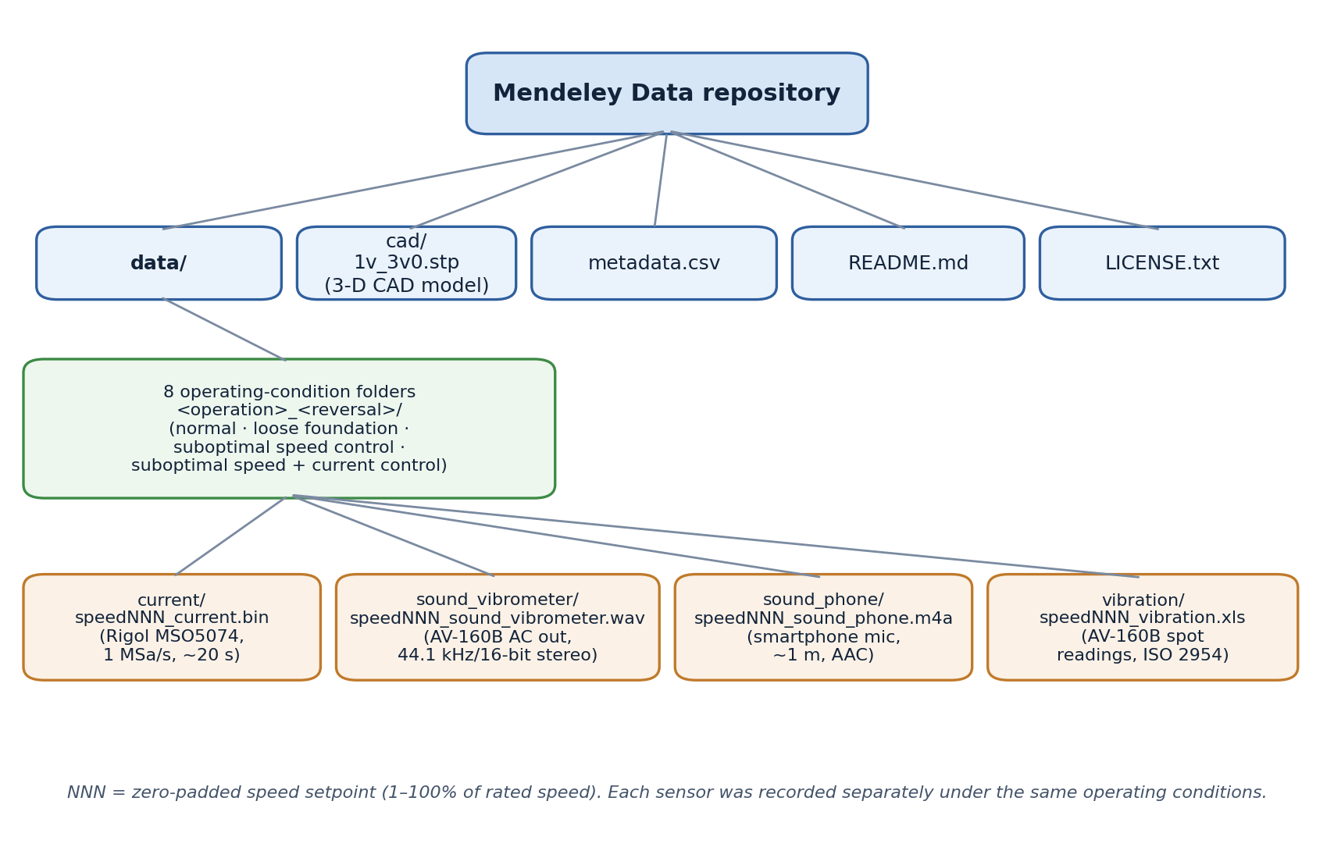
Fig. 1. Organisation of the multi-sensor dataset repository, showing the top-level files, the eight operating-condition folders and the four sensor sub-folders with their file formats.
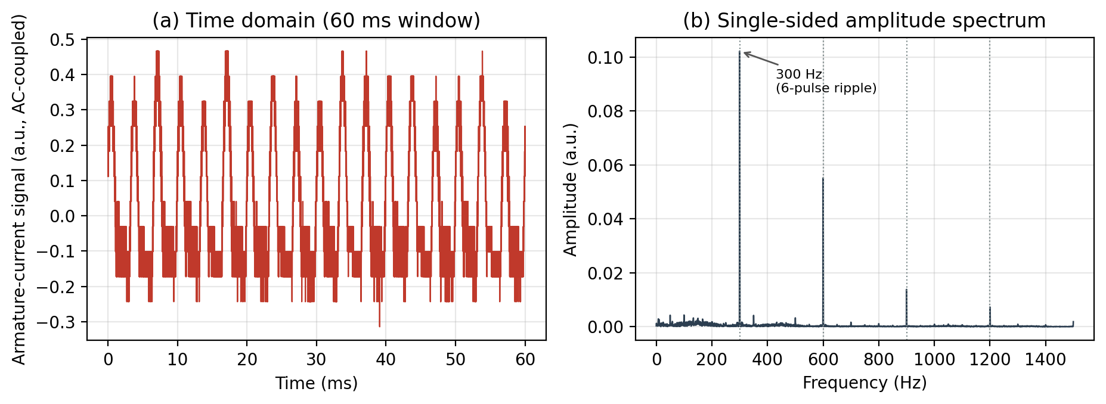
Fig. 2. Representative armature-current recording (normal operation, no reversal, 50 % speed setpoint): (a) a 60 ms window of the AC-coupled waveform and (b) its single-sided amplitude spectrum, showing the 300 Hz six-pulse converter ripple and its harmonics.
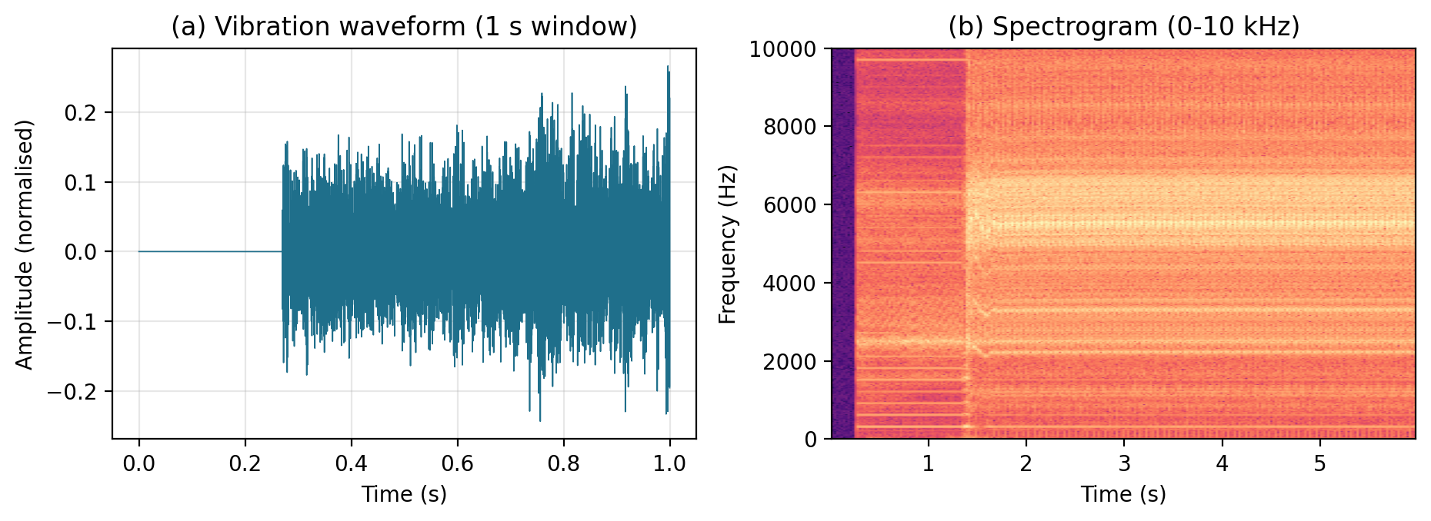
Fig. 3. Representative vibrometer vibration recording (normal operation, no reversal, 50 % speed setpoint): (a) a 1 s window of the waveform and (b) its spectrogram up to 10 kHz.
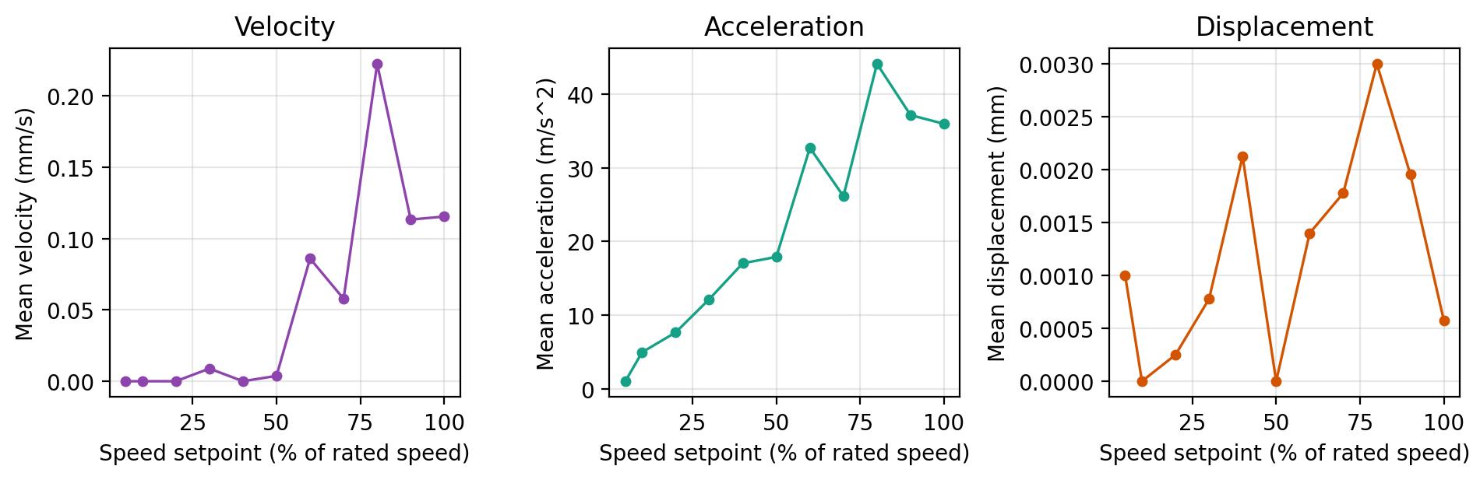
Fig. 4. AV-160B vibration spot readings (mean velocity, acceleration and displacement) as a function of speed setpoint (% of rated speed) for the normal, no-reversal condition.

EXPERIMENTAL DESIGN, MATERIALS AND METHODS
Test rig. The brushed PM DC servo motor described in Table 2 was driven by a four-quadrant thyristor (SCR) converter providing armature voltage and current control. No external mechanical load was applied — the motor ran unloaded — and the drive was commanded to a speed setpoint of 1, 2, 5, 10, 20, 30, 40, 50, 60, 70, 80, 90 and 100 % of rated speed (2000 rpm; a reduced top speed applies to the detuned-control conditions, as noted below).
Operating conditions. The speed sweep was repeated for each operating condition. Normal operation uses the nominal controller tuning. The two detuned-control conditions use a non-optimal speed-regulator gain (suboptimal_control) and, additionally, a non-optimal current-regulator gain (suboptimal_control_rt). The loose-foundation condition uses a deliberately loosened mechanical foundation. Each condition was recorded both without and with periodic direction reversal.
Acquisition (each sensor recorded separately, under the same operating conditions, not simultaneously). Armature current was captured with a Rigol MSO5074 oscilloscope and saved as native binary waveforms (.bin); the sample rate and scaling are stored in each file header. The vibration waveform was obtained from the 2.0 V AC analog output of an AV-160B vibrometer external piezoelectric probe and recorded as 44.1 kHz / 16-bit stereo WAV. Vibration spot readings (velocity, acceleration and displacement per ISO 2954) were logged from the same AV-160B in display mode to XLS. Airborne sound was recorded with a budget Android smartphone microphone placed approximately 1 m from the machine and saved as M4A (AAC).
Procedure. For each condition and speed setpoint the motor was brought to steady state, and then each sensor was recorded in turn. The equipment used is summarised in Table 7.
Table 7. Measurement equipment.
Equipment | Model | Purpose
Brushed PM DC servo motor | 3PI12.12 (625 W, 110 V, 12.5 A, 2000 rpm) | Machine under test
Power converter | Four-quadrant thyristor (SCR) converter | Armature voltage/current control drive
Oscilloscope | Rigol MSO5074 | Armature-current waveform acquisition
Vibrometer | AV-160B (Amittari) with piezoelectric probe | Vibration waveform (AC out) and spot readings
Smartphone | Budget Android phone | Airborne acoustic acquisition (~1 m)
Curation. Raw files were copied byte-for-byte from the acquisition folders into a publishable tree with English names and the sortable speedNNN_sensor.ext scheme, and indexed in metadata.csv (including sample rate, duration, channels, bit depth, file size and the original name/path for traceability). No signal transformation was applied. The complete dataset described in this article has been deposited in the Mendeley Data repository [4].

LIMITATIONS
The four sensors were recorded separately under the same operating conditions rather than simultaneously; recordings are therefore aligned by operating condition and speed setpoint, not sample-synchronously. The detuned-control conditions reach only a ~65 % top speed setpoint because the detuned controller and DC-link protection trip above that speed. The vibration XLS files are spot readings rather than waveforms, and the near-zero-speed points are absent where vibration is negligible. The smartphone audio is lossy AAC and is intended for qualitative use; the vibrometer WAV is recommended for spectral work. The armature current is captured with the oscilloscope’s 8-bit ADC, and a few individual speed points may be missing in a branch. All data come from a single machine and rig, so the dataset does not capture unit-to-unit or design variation, and the loose-foundation condition represents one induced severity. These characteristics should be considered when reusing the dataset or comparing it with data from other machines or setups.

ETHICS STATEMENT
The authors confirm that they have read and followed the ethical requirements for publication in Data in Brief. The current work does not involve human participants, animal experiments, or any data collected from social media platforms. The dataset was acquired exclusively from laboratory experiments on a brushed permanent-magnet DC servo motor.

CRediT AUTHOR STATEMENT
Marin Zhilevski: Conceptualization, Methodology, Investigation, Resources, Data Curation, Writing – Original Draft, Writing – Review & Editing, Supervision. Nikolay Yordanov: Investigation, Data Curation, Formal Analysis, Visualization, Writing – Original Draft. Mikho Mikhov: Conceptualization, Methodology, Resources, Supervision, Writing – Review & Editing. Mihriban Gunay: Investigation, Data Curation, Validation, Writing – Review & Editing. Merve Ertarğın: Investigation, Data Curation, Validation, Writing – Review & Editing.

ACKNOWLEDGEMENTS
The authors would like to thank the Research and Development Sector at the Technical University of Sofia for the financial support.

DECLARATION OF COMPETING INTERESTS
The authors declare that they have no known competing financial interests or personal relationships that could have appeared to influence the work reported in this paper.

REFERENCES
[1] L. Li, S. Liao, B. Zou, J. Liu, Mechanism-based fault diagnosis deep learning method for permanent magnet synchronous motor, Sensors 24 (2024) 6349. https://doi.org/10.3390/s24196349.
[2] L. Ding, H. Guo, L. Bian, Convolutional neural networks based on resonance demodulation of vibration signal for rolling bearing fault diagnosis in permanent magnet synchronous motors, Energies 17 (2024) 4334. https://doi.org/10.3390/en17174334.
[3] H. Uzel, Y. Özüpak, F. Alpsalaz, E. Aslan, I. Zaitsev, Acoustic-based fault diagnosis of electric motors using Mel spectrograms and convolutional neural networks, Scientific Reports 16 (2026) 3379. https://doi.org/10.1038/s41598-025-33269-z.
[4] M. Zhilevski, N. Yordanov, M. Mikhov, M. Ertarğın, M. Gunay, Multi-sensor condition-monitoring dataset of a brushed DC servo motor, Mendeley Data (2026). DOI: to be assigned.

