ЗАДАЧА ЗА ПЛАНЕТИ – ДЕМОНСТРАЦИЯ НА STATIC

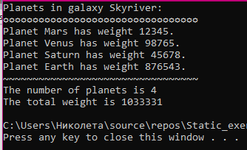
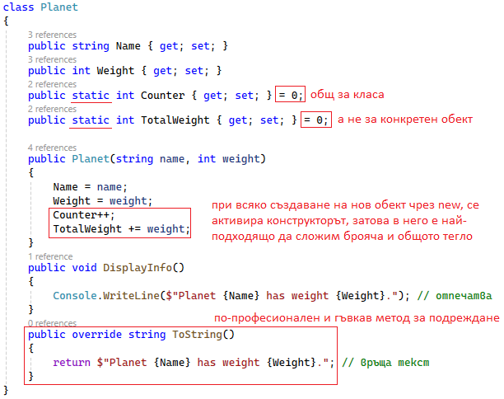
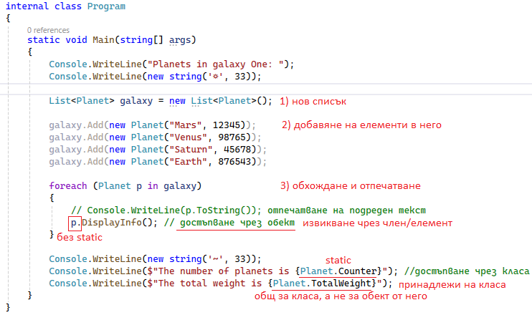
Целият код:
namespace _03_task
{
internal class Program
{
static void Main(string[] args)
{
Console.WriteLine("Planets in galaxy Skyriver: ");
Console.WriteLine(new string('☼', 33));

List<Planet> galaxy = new List<Planet>();

galaxy.Add(new Planet("Mars", 12345));
galaxy.Add(new Planet("Venus", 98765));
galaxy.Add(new Planet("Saturn", 45678));
galaxy.Add(new Planet("Earth", 876543));

foreach (Planet p in galaxy)
{
// Console.WriteLine(p.ToString()); отпечатване на подреден текст
p.DisplayInfo(); // достъпване чрез обект
}

Console.WriteLine(new string('~', 33));
Console.WriteLine($"The number of planets is {Planet.Counter}"); //достъпване чрез класа
Console.WriteLine($"The total weight is {Planet.TotalWeight}");
}
}

class Planet
{
public string Name { get; set; }
public int Weight { get; set; }
public static int Counter { get; set; } = 0;
public static int TotalWeight { get; set; } = 0;

public Planet(string name, int weight)
{
Name = name;
Weight = weight;
Counter++;
TotalWeight += weight;
}
public void DisplayInfo()
{
Console.WriteLine($"Planet {Name} has weight {Weight}."); // отпечатва
}
public override string ToString()
{
return $"Planet {Name} has weight {Weight}."; // връща подреден текст
}
}
}

