ТЕСТВАНЕ НА БД С ИЗКУСТВЕН ИНТЕЛЕКТ

Действително БД Persons, а не People.
https://ai2sql.io
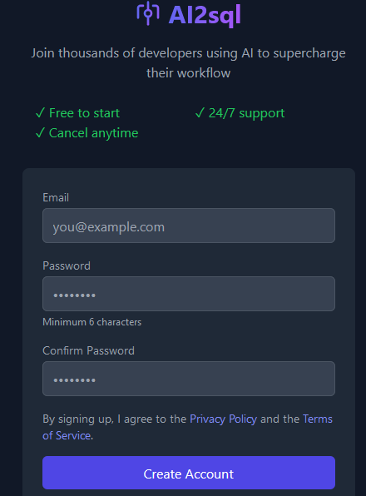
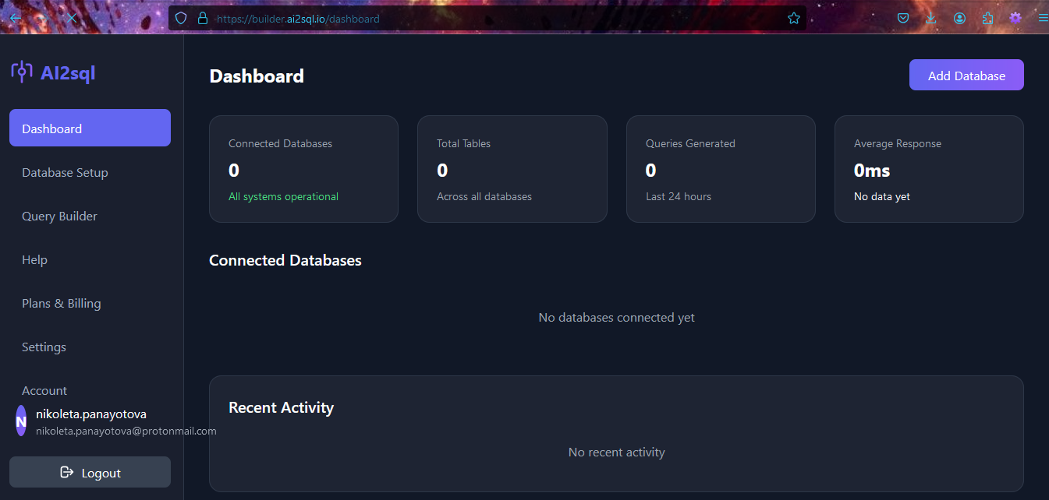
СУБД СУРБД
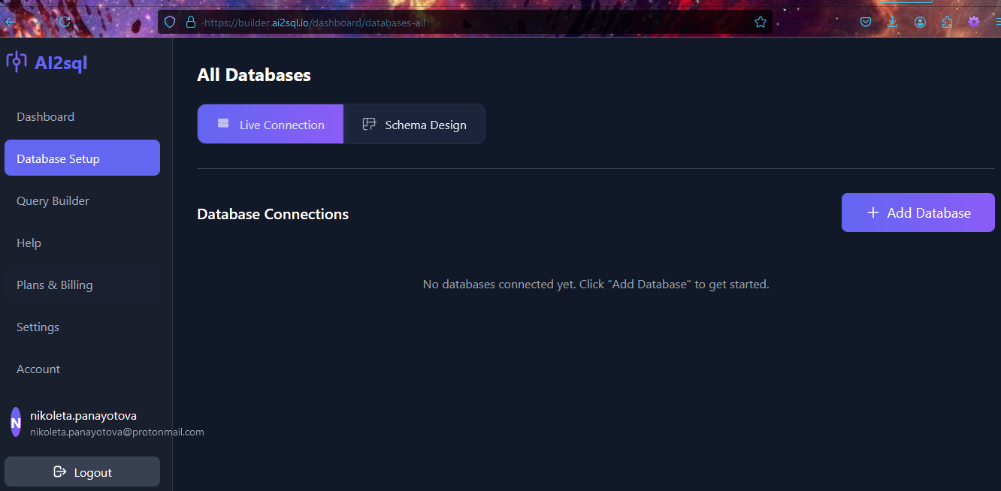
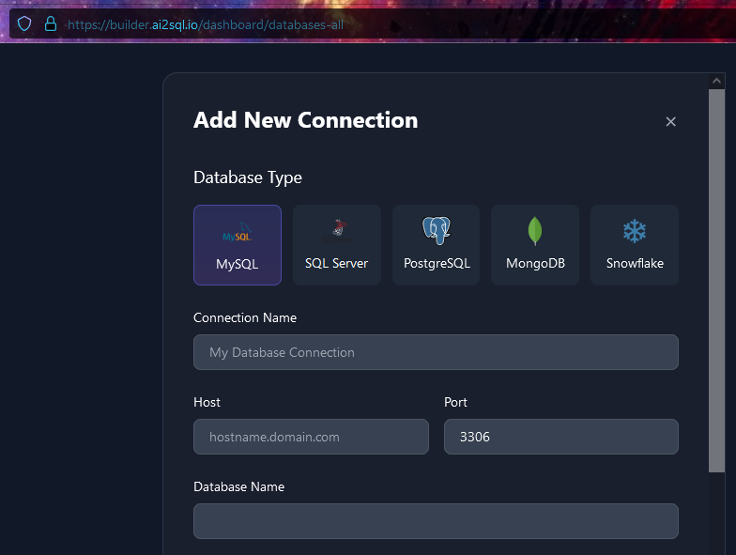
Данните за попълване са същите, които виждаме в Workbench при създаване на нова конекция. Винаги първо я тестваме, а после потвърждаваме.
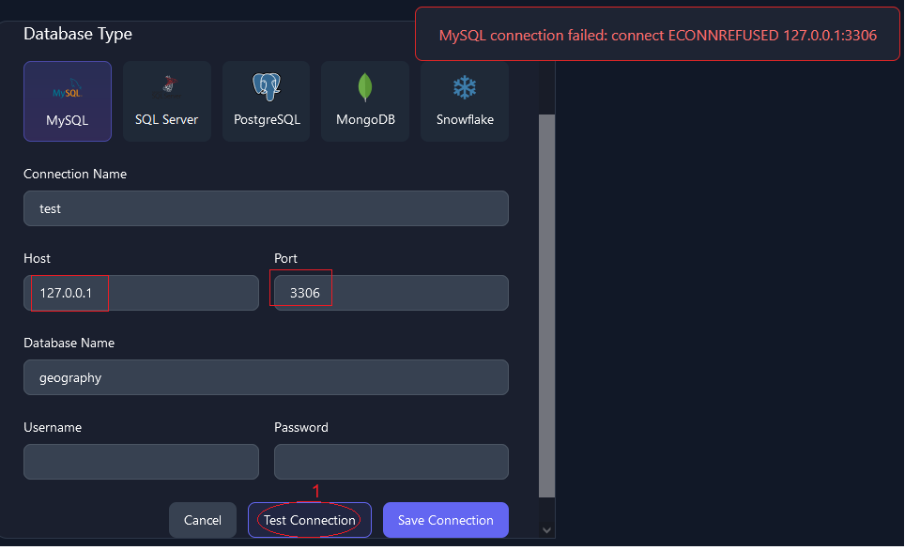
За всеки случай погледнах адреса – действително това не е нашият ip:
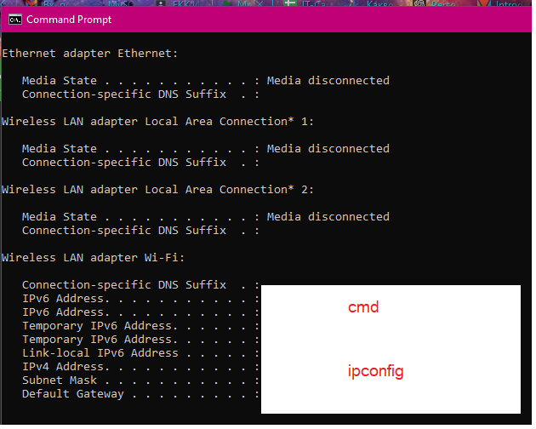
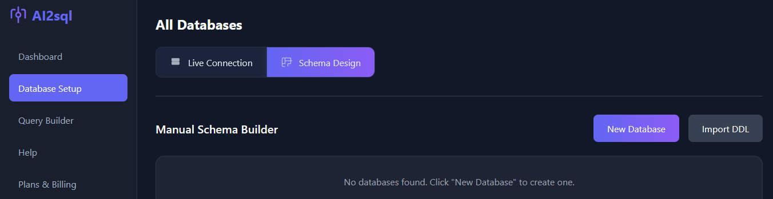
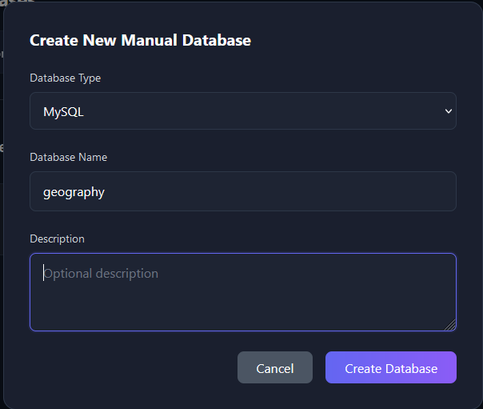
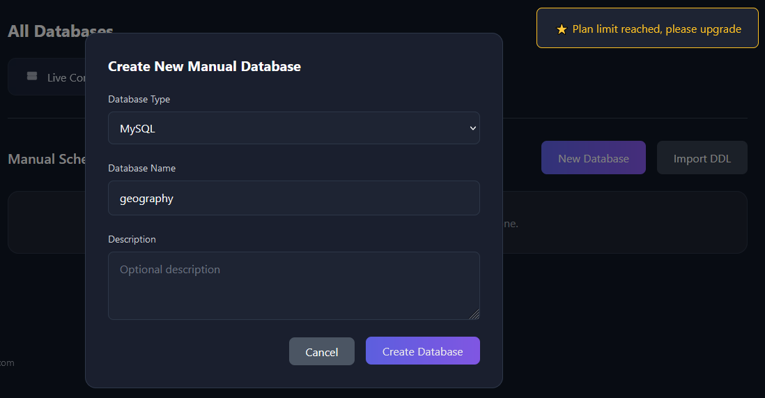

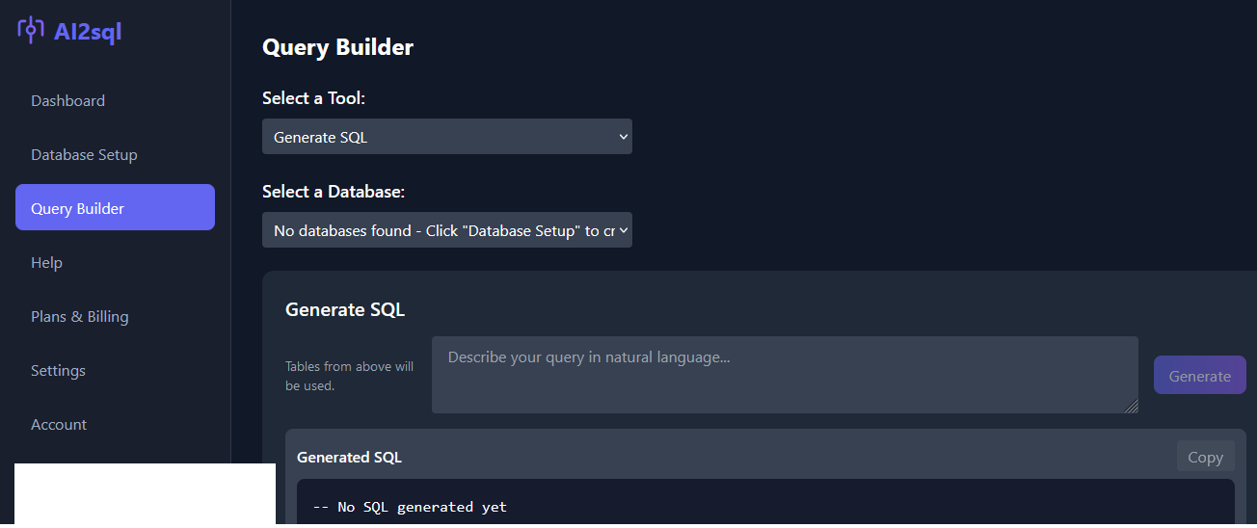
По същия начин както в WorkBench, винаги първо тестваме нова връзка, а после я запазваме:
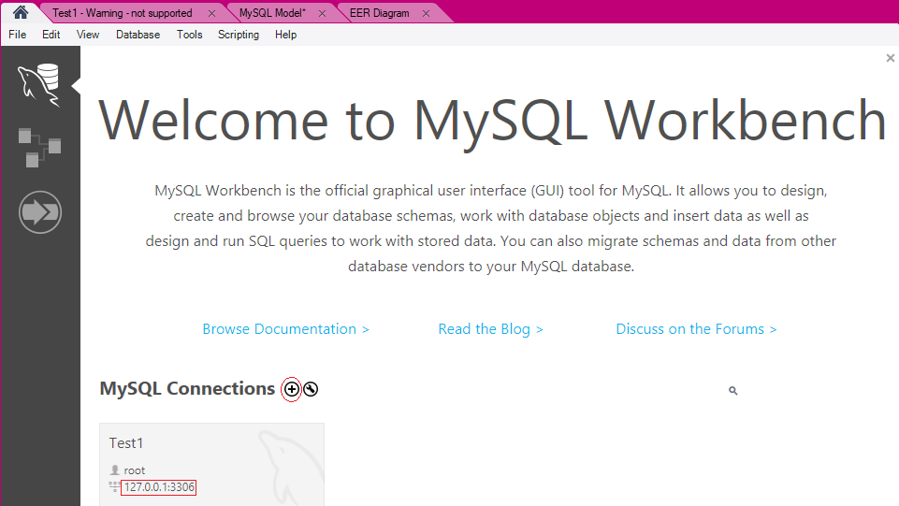
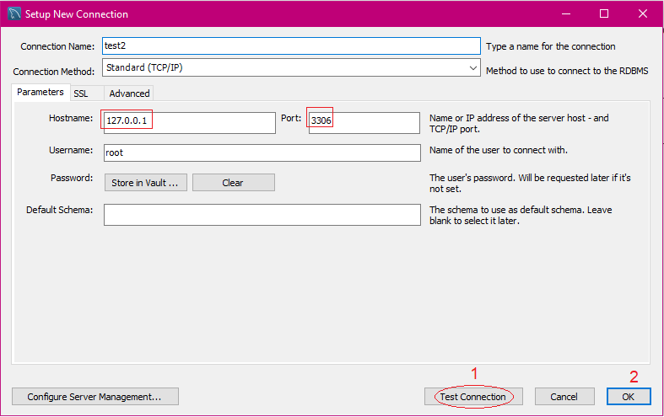
https://ai2sql.crisp.help/en/article/troubleshooting-ai2sql-connector-issues-1u8156b/
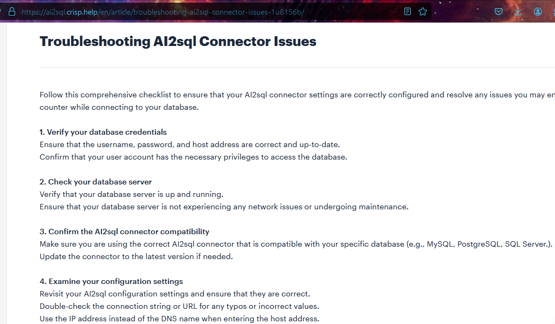
Реално предоставяш достъп на ИИ до лични/служебни данни.
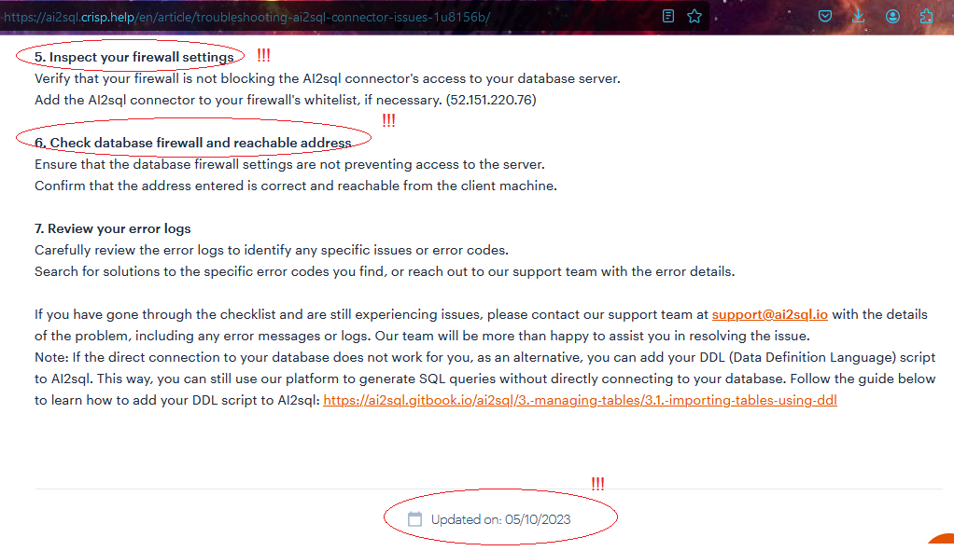
https://cybersecuritynews.com/deepseek-database-leaked/?fbclid=IwY2xjawIJU31leHRuA2FlbQIxMQABHYttKVu6aynT3jEjhP0uV7xAHkLapGbRpGK07jg6lc0rp1HouCbbhEiu8Q_aem_oMgSzWefc1TCNrqbwdVthg

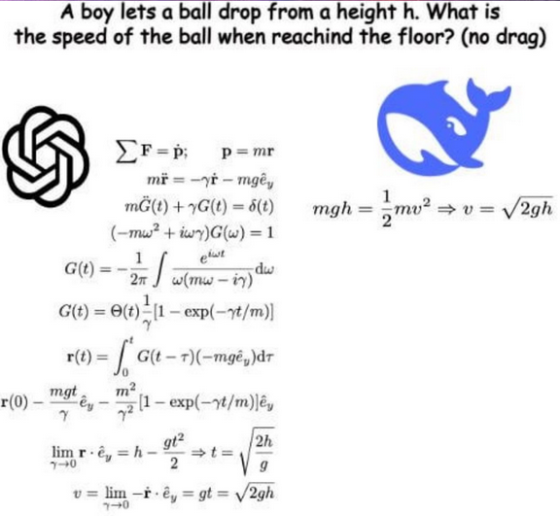
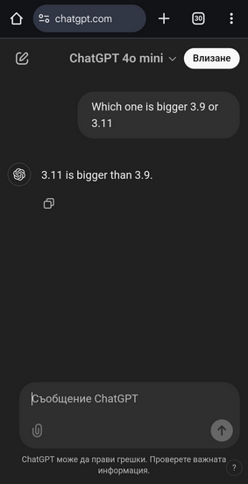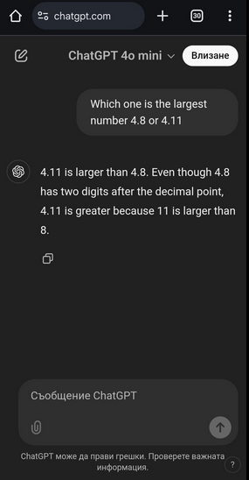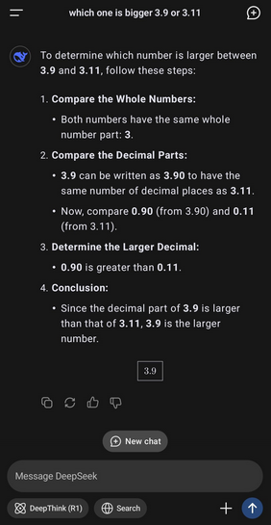

SQL Beginner-Level Test

Basic SQL Concepts
- What does SQL stand for?
  - A. Structured Question Language
  - B. Simple Query Language
  - C. Structured Query Language
  - D. Systematic Query Language
Answer: C
- Which SQL statement is used to retrieve data from a database?
  - A. FETCH
  - B. SELECT
  - C. GET
  - D. RETRIEVE
Answer: B
- Which keyword is used to filter the results in a SQL query?
  - A. FILTER
  - B. ORDER
  - C. WHERE
  - D. GROUP
Answer: C
- Which clause is used to sort the results in ascending or descending order?
  - A. GROUP BY
  - B. ORDER BY
  - C. SORT
  - D. ARRANGE
Answer: B
- Which symbol is used as a wildcard to match any number of characters in SQL?
  - A. %
  - B. _
  - C. *
  - D. ?
Answer: A

Data Definition Language (DDL)
- Which SQL statement is used to create a new table?
  - A. INSERT
  - B. CREATE TABLE
  - C. NEW TABLE
  - D. ADD TABLE
Answer: B
- Which command is used to remove a table from a database?
  - A. REMOVE TABLE
  - B. DELETE TABLE
  - C. DROP TABLE
  - D. CLEAR TABLE
Answer: C
- How do you add a new column to an existing table?
  - A. MODIFY TABLE
  - B. ALTER TABLE ADD COLUMN
  - C. UPDATE TABLE
  - D. ADD COLUMN TO TABLE
Answer: B
- Which SQL statement is used to remove all records from a table without deleting its structure?
  - A. DELETE
  - B. DROP
  - C. TRUNCATE
  - D. CLEAR
Answer: C
- Which of the following data types is used to store textual data in SQL?
  - A. INT
  - B. VARCHAR
  - C. FLOAT
  - D. BOOLEAN
Answer: B

Data Manipulation Language (DML)
- Which SQL statement is used to insert new records into a table?
  - A. ADD
  - B. INSERT INTO
  - C. NEW RECORD
  - D. UPDATE
Answer: B
- How do you update existing data in a table?
  - A. MODIFY
  - B. CHANGE
  - C. UPDATE
  - D. SET
Answer: C
- Which SQL statement is used to remove specific records from a table?
  - A. REMOVE
  - B. DELETE
  - C. DROP
  - D. CLEAR
Answer: B
- What happens if you run DELETE FROM employees; without a WHERE clause?
  - A. It deletes only the first row
  - B. It deletes the last inserted row
  - C. It deletes all rows in the employees table
  - D. It gives an error
Answer: C
- Which SQL keyword is used to group rows that have the same values?
  - A. ORDER BY
  - B. GROUP BY
  - C. SORT
  - D. AGGREGATE
Answer: B

Joins and Relationships
- Which SQL clause is used to combine rows from two or more tables based on a related column?
  - A. JOIN
  - B. UNION
  - C. MERGE
  - D. CONNECT
Answer: A
- What type of join returns only matching records from both tables?
  - A. LEFT JOIN
  - B. RIGHT JOIN
  - C. INNER JOIN
  - D. FULL OUTER JOIN
Answer: C
- Which SQL clause is used to remove duplicate rows from a result set?
  - A. DISTINCT
  - B. UNIQUE
  - C. NO DUPLICATES
  - D. CLEAN
Answer: A
- Which SQL function is used to return the total number of rows in a table?
  - A. COUNT()
  - B. SUM()
  - C. TOTAL()
  - D. NUM()
Answer: A
- Which of the following statements about primary keys is true?
  - A. A table can have multiple primary keys
  - B. A primary key can contain duplicate values
  - C. A primary key uniquely identifies each record
  - D. A primary key is optional in a table
Answer: C
………………………………………..
Here’s a Medium-Level SQL Test with 20 multiple-choice questions covering queries, joins, indexing, transactions, and more.

SQL Intermediate-Level Test

Advanced Queries and Functions
- Which SQL function is used to get the current date and time?
  - A. CURRENT_DATE
  - B. GETDATE()
  - C. NOW()
  - D. Both B and C
Answer: D
- Which SQL statement retrieves unique department names from the "employees" table?
  - A. SELECT DISTINCT department FROM employees;
  - B. SELECT UNIQUE department FROM employees;
  - C. SELECT DIFFERENT department FROM employees;
  - D. SELECT department FROM employees GROUP BY department;
Answer: A
- What will happen if you execute the following query?


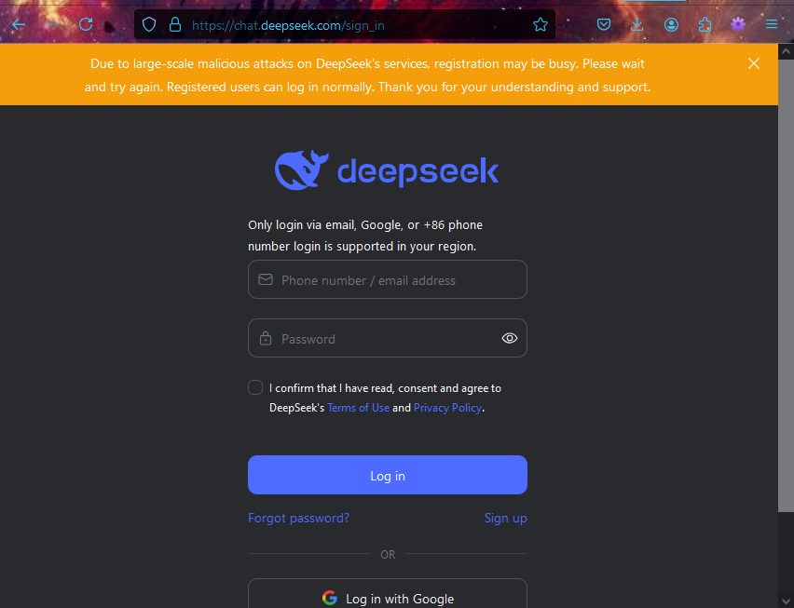
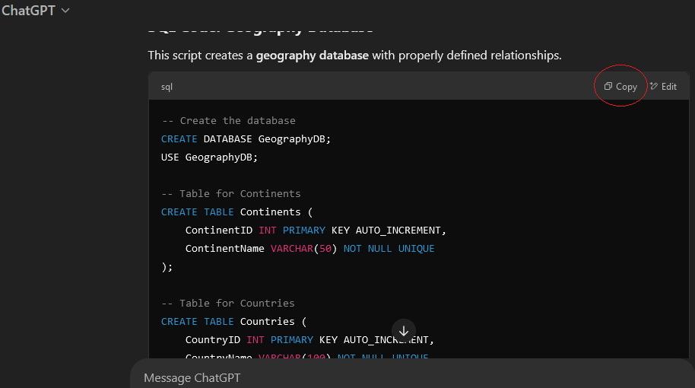
-- Create the database
CREATE DATABASE GeographyDB;
USE GeographyDB;

-- Table for Continents
CREATE TABLE Continents (
ContinentID INT PRIMARY KEY AUTO_INCREMENT,
ContinentName VARCHAR(50) NOT NULL UNIQUE
);

-- Table for Countries
CREATE TABLE Countries (
CountryID INT PRIMARY KEY AUTO_INCREMENT,
CountryName VARCHAR(100) NOT NULL UNIQUE,
Capital VARCHAR(100),
Population BIGINT,
Area DECIMAL(10,2), -- Area in square kilometers
ContinentID INT,
FOREIGN KEY (ContinentID) REFERENCES Continents(ContinentID)
);

-- Table for Cities
CREATE TABLE Cities (
CityID INT PRIMARY KEY AUTO_INCREMENT,
CityName VARCHAR(100) NOT NULL,
Population BIGINT,
CountryID INT,
IsCapital BOOLEAN DEFAULT FALSE,
FOREIGN KEY (CountryID) REFERENCES Countries(CountryID)
);

-- Table for Regions (e.g., states, provinces)
CREATE TABLE Regions (
RegionID INT PRIMARY KEY AUTO_INCREMENT,
RegionName VARCHAR(100) NOT NULL,
CountryID INT,
FOREIGN KEY (CountryID) REFERENCES Countries(CountryID)
);

-- Table for Rivers
CREATE TABLE Rivers (
RiverID INT PRIMARY KEY AUTO_INCREMENT,
RiverName VARCHAR(100) NOT NULL UNIQUE,
Length DECIMAL(10,2), -- Length in kilometers
Source VARCHAR(100),
Mouth VARCHAR(100)
);

-- Table for Mountains
CREATE TABLE Mountains (
MountainID INT PRIMARY KEY AUTO_INCREMENT,
MountainName VARCHAR(100) NOT NULL UNIQUE,
Height DECIMAL(10,2), -- Height in meters
Location VARCHAR(100)
);

-- Table for Lakes
CREATE TABLE Lakes (
LakeID INT PRIMARY KEY AUTO_INCREMENT,
LakeName VARCHAR(100) NOT NULL UNIQUE,
SurfaceArea DECIMAL(10,2), -- Area in square kilometers
Depth DECIMAL(10,2), -- Maximum depth in meters
CountryID INT,
FOREIGN KEY (CountryID) REFERENCES Countries(CountryID)
);

-- Table for Borders (Country-to-Country relationships)
CREATE TABLE CountryBorders (
BorderID INT PRIMARY KEY AUTO_INCREMENT,
Country1ID INT,
Country2ID INT,
BorderLength DECIMAL(10,2), -- Length in kilometers
FOREIGN KEY (Country1ID) REFERENCES Countries(CountryID),
FOREIGN KEY (Country2ID) REFERENCES Countries(CountryID),
CONSTRAINT unique_border UNIQUE (Country1ID, Country2ID)
);

-- Table for Oceans
CREATE TABLE Oceans (
OceanID INT PRIMARY KEY AUTO_INCREMENT,
OceanName VARCHAR(100) NOT NULL UNIQUE,
Area DECIMAL(15,2) -- Area in square kilometers
);

-- Table for Seas
CREATE TABLE Seas (
SeaID INT PRIMARY KEY AUTO_INCREMENT,
SeaName VARCHAR(100) NOT NULL UNIQUE,
Area DECIMAL(15,2),
OceanID INT,
FOREIGN KEY (OceanID) REFERENCES Oceans(OceanID)
);
Тестваме кода в WorkBench – най-добре директно с ER-диаграма.
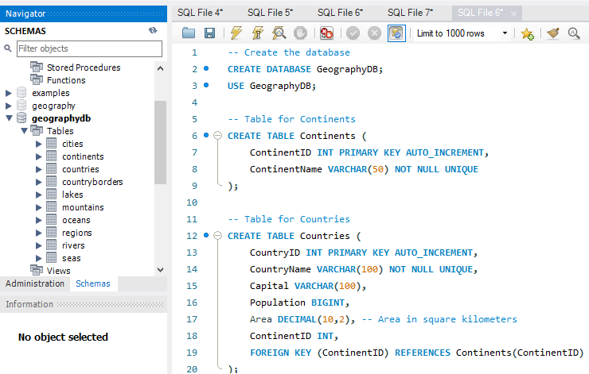
Оказва се, че има много грешки – липсват връзки между таблиците, също неправилна таблица за границите (може направо да се изтрие, вместо да има само 2 граници). Между таблици държави-планини, трябва да има 3-та средна, която държи външните ключове за връзка n:n и т.н. Тези неща е важно да се коригират, преди да се попълват с данни, както можеше да стане, ако се бях предоверила на ChatGPT и просто бях поискала да ги запълни със записи. Корекцията после щеше да е много трудна.
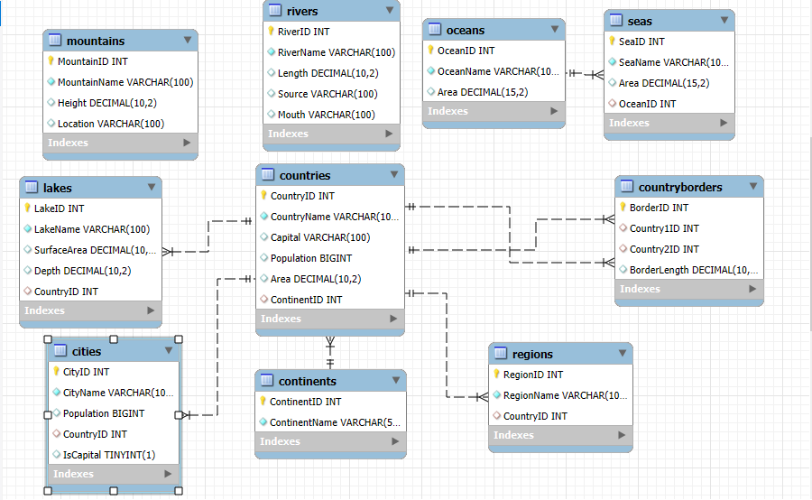

Специализиран AI-генератор на БД: https://fabricate.mockaroo.com
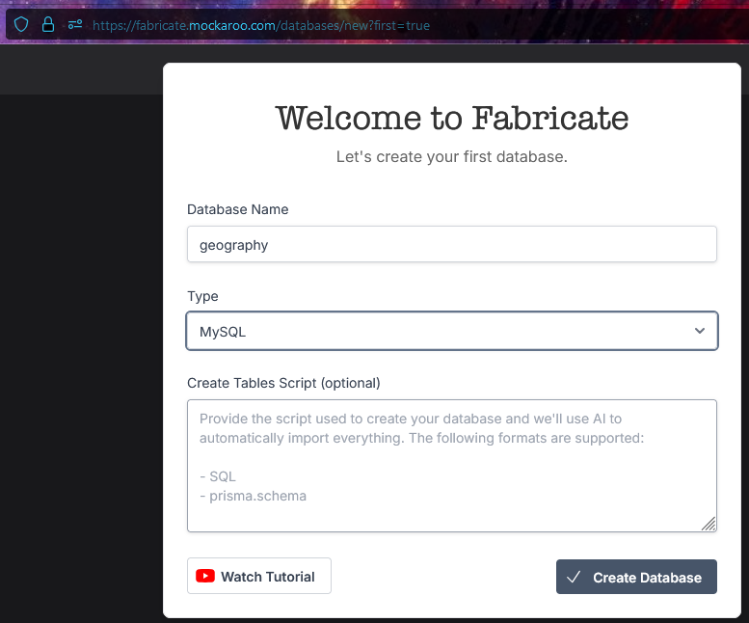
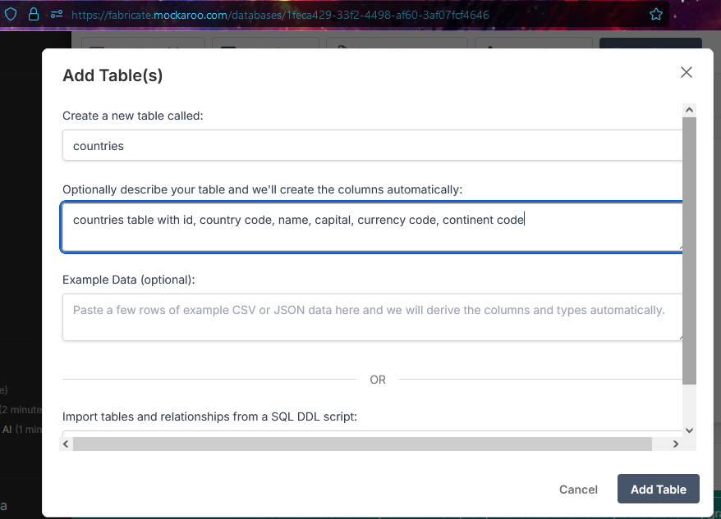
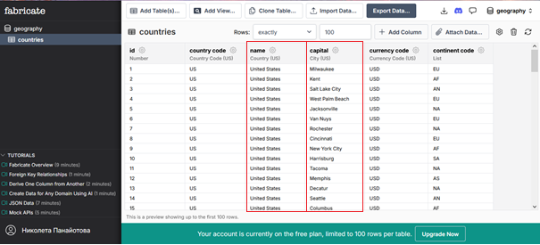

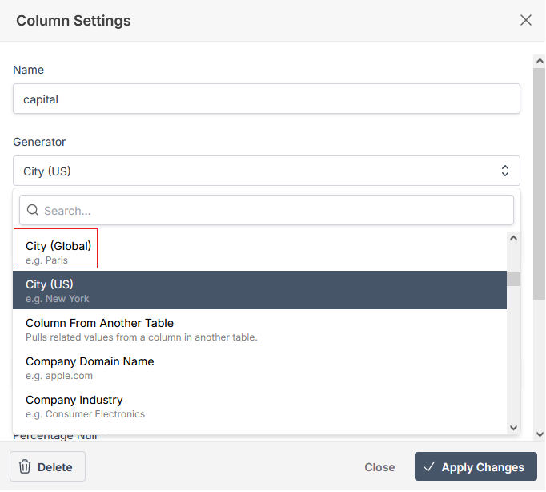
Друг много мощен ИИ – https://app.chat2db.ai/workspace
