POWERSHELL

ISE = integrated scripted environment – можем да пишем свои скриптове

2 modes = CLI + ISE
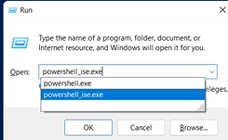

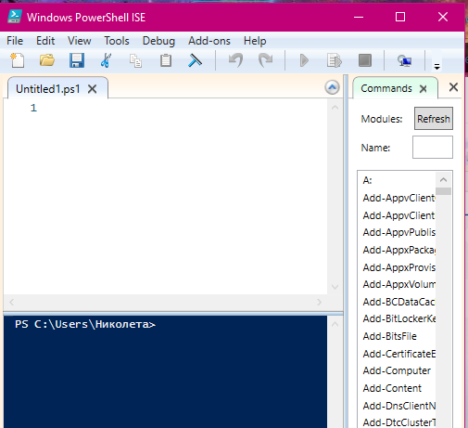
$ = string character
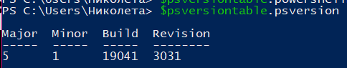

$psversiontable.psversion – проверяваме версията

Можем remote да ъпдейтнем едновременно много машини.

Можем да изеглим windows management framework 5.1

В ISE можем да разглеждаме съдържанието на текушата директория с ls = list
Десния команден панел се използва като търсачка или по модул, или по дума. Можем да подадем параметри и от бутон Insert да вмъкнем командата

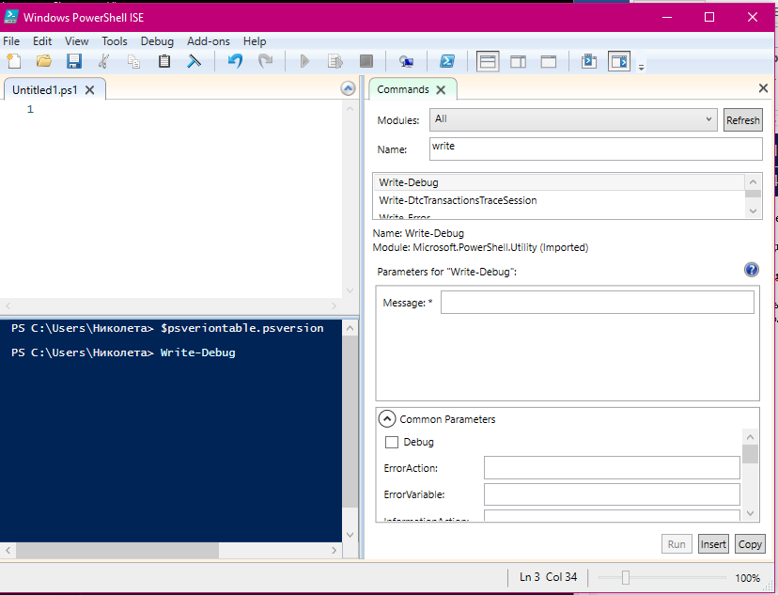

Show-Command ‘cd’ – показва параметрите, които могат да се подадат
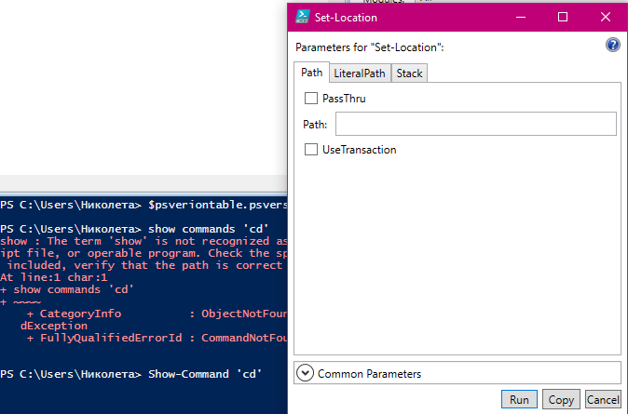

PowerShell in VisualStudio Code – инсталираме приставка

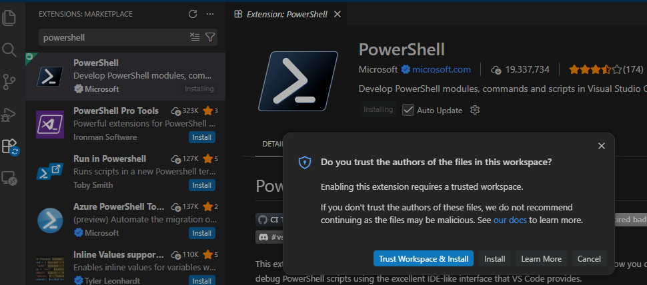

Прави същото като CMD, локално
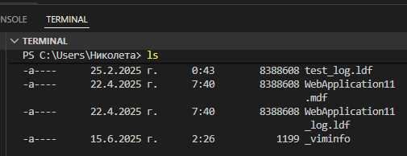

Правим добавката видима в страничния панел

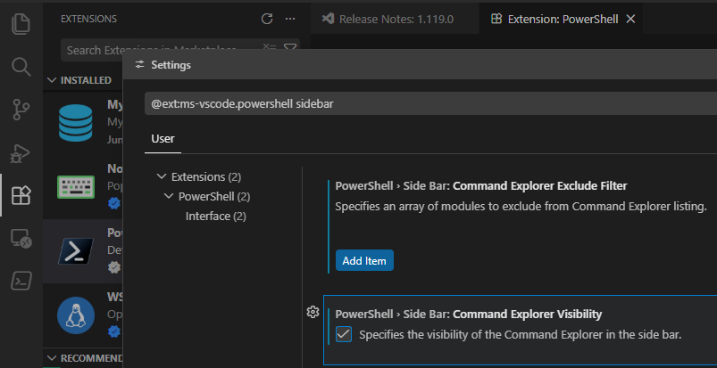

Вляво можем да търсим команди
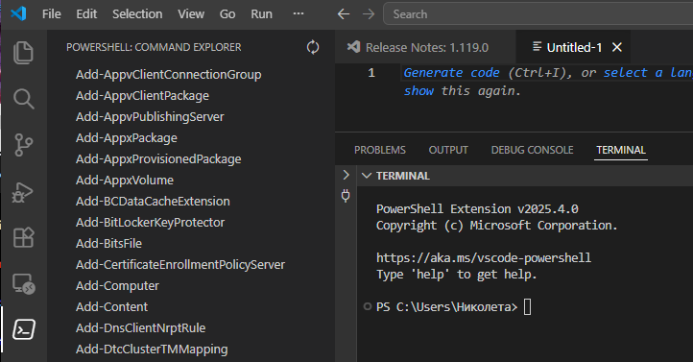
Можем да добавяме Breakpoint
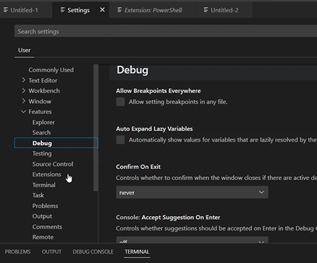

Powershell = OOP, не е Key Sensitive!!

Commandlet = не се използват самостоятелно
Verb – noun pair = като move – item, new – item…

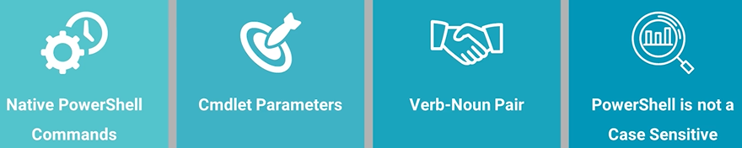

Командите са специални класове .net, написани на високо ниво езици и се компилират в .dll, за да бъдат изпълнени. Могат да бъдат извикани по време на Runntime от API. Commandlets могат да имат променливи и стойности, които да бъдат прикачени. Могат да бъдат задължителни или не.

Write-host – написва съобщение, commandlet + value = “hello”
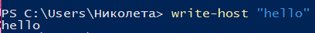
Може да се използва Tab за дописване, подреждането е по азбучен ред. Със стрелка нагоре използваме команди от сесията.
-ForegroundColor без параметър връща грешка.
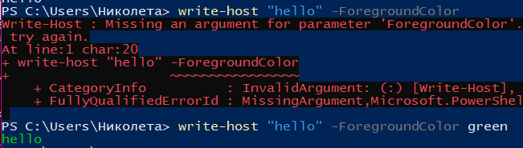

get-command – изписва всички команди, а списъкът е огромен
get-command write-* - изписва всички, които започват с write
get-command *server – всичкикоманди, които завършват със server
get-help *msol* - намира всички, които съдържат msol
get-help update-azrouteserver – връща пълно описание и синтаксис на параметрите
clear – почиства екрана
get-location – къде се намираме
cd .. = връщаме се 1 директория нагоре
new-item –name [име] – създаваме нова папка
remove-item [име]
copy-item
move-item
rename-item
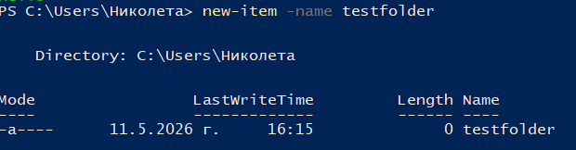
Get-process – колко много процеси изписва
Get-process [име] – показва конкретен процес (+ id), а ако объркаме името, ще изведе грешка
Stop-process –id [номер]
Gpupdate /force = най-често използваната команда, ъпдейтва
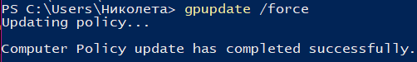

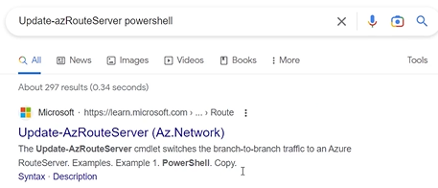
Ctrl + F търсим конкретен параметър
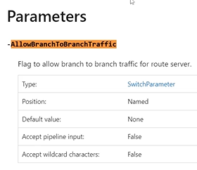
Ако напишем само командата като Update-AzRouteServer без задължителни параметри, PW ще ни поиска да я допишем, но ние трябва да напишем още веднъж целия синтаксис с нея включително, а не само тя, например Update-AzRouteServer –ResourceGroupName testgroup –RouteServerName testserver

Имаме и позиционни и непозиционни параметри

Get-Help Get-EventLog – можем да потърсим и информация за конкретен параметър от командата като Before

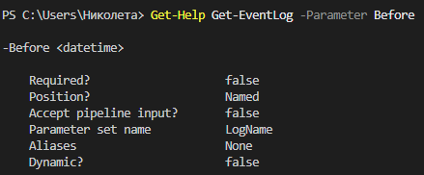

Update-Help – ъпдейтваме help менюто, което е желателно периодично, но отнема време

Exercise 01: Executing and Analyzing PowerShell Commands in Windows 10 Environment
* PowerShell ISE: Click on the New Script icon which is shown in the image. A new script page appears where you can type a script.
* To check the PowerShell version, type $psversiontable.psversion and press Enter.
* You can see in the table the Major value is 5 and Minor value is 1. Thus, the version of PowerShell is 5.1. The advantage of the 5.1 version is backward compatibility which means all actions as operations can be performed without any changes.
* If the PowerShell version is below 5.1, then one can download it via Google. Minimize the Windows PowerShell. Click on the Google Chrome icon on the desktop.
* Google Chrome opens. If the What's New tab is open, then click on New Tab.
* In the URL search bar, type windows management framework 5.1 and press Enter. The search result appears.
* Click on the Microsoft link in your page, to open the official website to download framework version 5.1.
* The Download tab appears as shown. Scroll down to Windows Management Framework 5.1.
* Scroll down and click on System Requirements. It gives the list of machines in which the framework can be downloaded. You can see in the IMPORTANT section that WMF 5.1 requires Microsoft.NET Framework 4.5 or above.

Exercise 02: Launching and Navigating Windows PowerShell ISE: Exploring Command Modules and Installing PowerShell in Visual Studio Code
* Type ls in the PowerShell console pane and press Enter. The result gives the list of files in your current working directory.
* On the right-hand side of the PowerShell console, you can see the Commands window. It shows all the available commands. If the Commands section is not visible, then click on Show Command Add-on which is present at the last of the toolbar.
* In the Modules, click on scroll down icon. Click on any available module. Here AppvClient module is selected. It gives the list of commands associated with that module.
* Check for the commands of other modules. Click on downs scroll again. Here AppLocker module is selected. You can see the list of commands available for that module.
* Now, set it back to default, by selecting All modules.
* Type write in the Name section. You can see the list of commands having the word write in it. You can use the Name section when you don't know with which specific module the command is associated.
* Click on Write-Debug. You will get additional information about it. Click on Common Parameters present at the bottom. You can see various parameters you can use.
* At the bottom click on the Insert button as shown in the image. You can see in the PowerShell console pane that Write-Debug is typed automatically.
* Remove the Write-Debug in console. Click on thepy button at the right bottom of the page, as shown in the image.
* Move the cursor to the console section and give it a click. Press Ctrl+V to paste it. You can see that Write-Debug is pasted.
* Remove it and type cd as shown in the image. Do not press Enter.
* Click on the Show Command Window tool which is shown in the image. You can see a pop-up with available parameters with check boxes of that command.
* In the parameter pop-up, you can see Run, Copy, and Cancel buttons are available. Click on Cancel as you will not be running or copying the command.
* Click on the Show Command Window tool which is shown in the image. You can see a pop-up with available parameters with check boxes of that command.
* In the parameter pop-up, you can see Run, Copy, and Cancel buttons are available. Click on Cancel as you will not be running or copying the command.
* Minimize the Windows PowerShell. Click on the Google Chrome icon on the desktop.
* Now, you will learn how to install Powershell in Visual Studio Code. For that first, you must download Visual Studio Code. So, type visual studio code in the Google search bar and press Enter.
* Click on the Extensions icon. In the Search Extensions in Marketplace, type powershell. Then click on the Install of the first option. (…)

Exercise 03: Executing Basic PowerShell Commands in Windows 10
* Type write-host "hello" and press Enter. You can see the output result as hello. write-host allows you to show the output to the information stream.
* Now, just type write-h and press Tab. You can see the command is autocompleted, but it is not executed. ppend it with the "first try" input value. The entire command would be Write-Host "first try". Then press Enter. It gives the output as shown.
* Now, just type w. Then press Tab. Each time you press Tab, the PowerShell will suggest different commandlets starting from "w".
* Delete the command. Press Upper arrow from the keyboard. You can see it is auto-filled with the last executed command. Press Enter to execute it.
* Type Write-Host "first try" -f. Then press Tab. The entire command will be Write-Host "first try" -ForegroundColor. Then press Enter.
* Instead of output, you will get an error. That is because ForegroundColor is a parameter to which you must give an argument.
* Now, type Write-Host "first try" -ForegroundColor green and press Enter. You can see the output is green color.
* Type get-command and press Enter. You will get a list of PowerShell commands that are pre-installed. The list has the name of the command, its type, version, and source.
* As you can see the page is overfilled, type clear and press Enter. You can see that the page is cleared.
* Now, type get-location and press Enter. You can see the current directory of the current PowerShell run space.
* To get the list of files and directories in your current directory, type ls and press Enter.
* To change the directory path type cd .. and press Enter. You can see the path has changed.
* Type ls and press Enter to see the content of the current directory.
* To move back to the older directory path, type cd Admin and press Enter.
* To add a new item to the current directory, type new-item -name NEWITEM and press Enter. new-item is used to create a new item and set its value. Here the value is NEWITEM.
* Type ls and press Enter. You can see the NEWITEM is added.
* To remove the item, type remove-item NEWITEM and press Enter.
* Type ls and press Enter. You can see the item is deleted from the list.
* Type get-process and press Enter. get-process is used to get the processes on a local or remote computer.
* Type get-process wordpad and press Enter. You will get an error as the CPU is not yet allotted to it.
* Minimize the Windows PowerShell. Click on the Search icon in the toolbar. Type word. Click on WordPad.
* Once the WordPad is opened, the processor will be allotted to it in the back end. Minimize the WordPad. Re-open the Windows PowerShell from the desktop toolbar.
* Press the Upper arrow from the keyboard to autofill the previously executed command. Then press Enter. You can see the output as shown. See the Id value assigned to wordpad is 2340. It might vary in your lab. You can also see the WordPad icon in the toolbar as it is running.
* Type stop-process -Id 2340 and press Enter. The command will stop the process for WordPad. You can see that Wordpad has been removed from the taskbar. Type the Id value that you got in your lab.

Exercise 04: Explore and Identify PowerShell Commands and Their Parameters
* Type get-command and press Enter. As a result, you will get a list of commandlets of PowerShell.
* To get the list of commandlets that start with write. Type the following command and press Enter. get-command write-*
* get-help *client*
* get-command *server
* Type get-help Update-AutologgerConfig and press Enter. You can see in the SYNTAX section has two values given. It means that the command can be used in two ways with the parameters as given in syntax. The parameters in square brackets indicate that they are optional.
* If one does not know the parameters used in the syntax, one can understand it via Google search. Minimize the Windows PowerShell and click on Google Chrome on the desktop.
ISE:
* Type update-auto, you can see that the Update-AutologgerConfig command is recommeneded.
Type get-help get-eventlog and press Enter. The information about get-eventlog will be shown.
If you want to get information about the parameter of the command within PowerShell, use -parameter. To check it, type get-help get-eventlog -parameter before and press Enter.
Remote Server Management
PowerShell Remote should be enabled
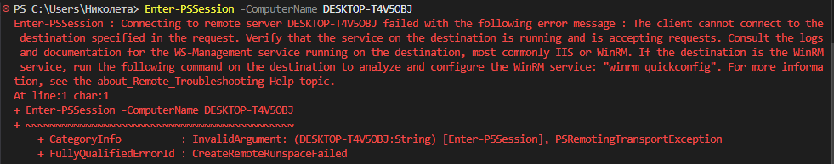
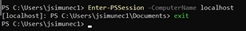
+ exit of the session
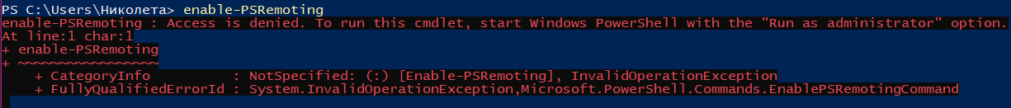
Windows Defender Firewall ->Advanced -> Inbound Rules -> New Rule -> Windows Remote Management, Port 5985
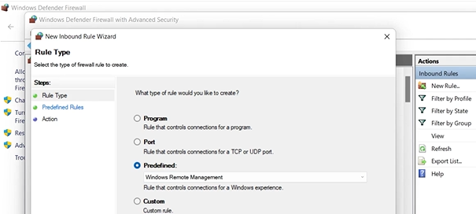
Group Policy – може да включим remote management на много машини наведнъж. Обикновено, remote е 1:1, а не 1:n.
Remote WS to Linux/Mac -> edit system wide configuration file /etc/ssh/sshd_config + edit /user/bin/pwsh
Notepad.exe може да се отвори като нормална програма с GUI локално, но ако се опитаме да я отворим по време на remote сесия, не отговаря, защото терминала я отваря, но виси без интерфейс.
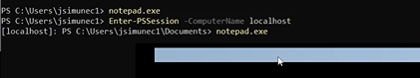
Exit 2 пъти – излиза от сесия + затваря терминала. Имаме и по-конкретен Exit-PSSession
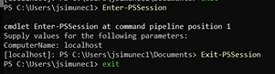
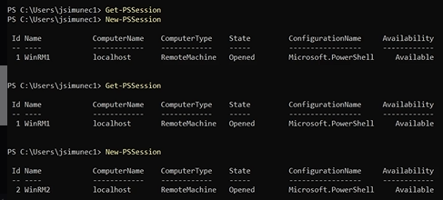
Създаваме нови сесии с new-pssession, проверяваме с get-pssession. При затваряне на терминала, всички сесии се затварят, но има и друга команда: Disconnect-PSSession –id 3 (спира конкретно 3-та сесия). Включваме с Connect-PSSession –id 3
Remote Tasks to perform
Test-connection google.com –Quiet
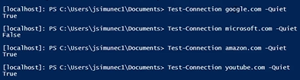
Result true/false
Автоматизиране на скрипт:
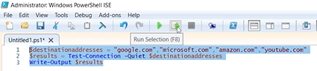
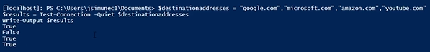
За над 100 адреса, този скрипт е полезен.
“random text” > testfile.txt – създаваме нов текстов файл със съдържание
$var = New-PSSession localhost – създаваме нова локална сесия
Копираме файла върху локалния сървър в C:\
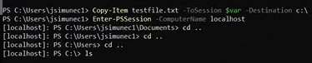
Могат да се конвертират PS outputs -> excel files.
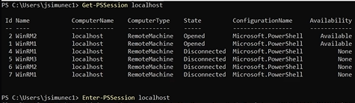
Бъркаме в регистъра:
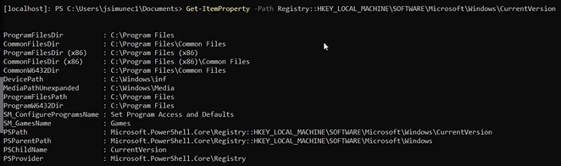
При сравнение с регистъра, съдържанието е еднакво
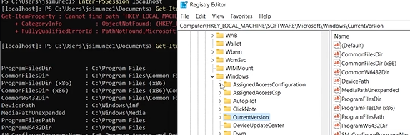
Вместо localhost, може да стои името на друга remote машина.
Script Examination using PSScriptAnalyzer
Създаваме нова папка в C:\ -> md scripts = make directory
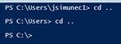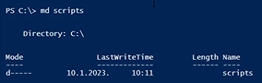
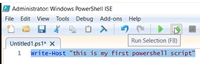
cls – скрива кода и показва само изхода
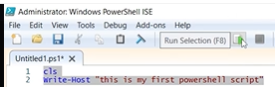
File->Save As -> firstscript.ps1
Може да се затвори сесията и отидем в директорията, която е скрипта и го стартираме
Install-Module -Name PSScriptAnalyzer –Force
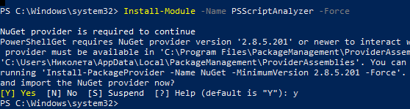
-Force не е задължително, но забързва процеса
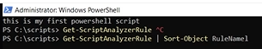
Резултатът е огромни данни
С допълнителните pipe показва по-малко данни, които са по-четими.
За да анализираме скрипт, трябва да се позиционираме в директорията на скрипта и извикаме Analyzer,
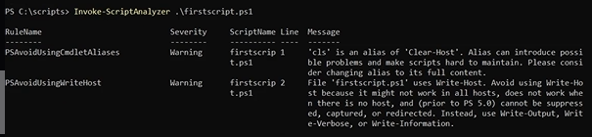
Има 2 warnings, cls е по-добре да се замени с clear-host и прави същото и предупрежденията ще изчезнат.
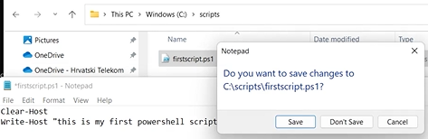
$ - променлива, текст в кавички, а числа директно
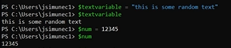
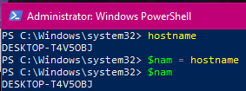
Последователност:
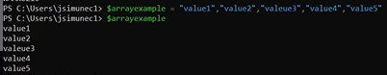
Pipe | - мощен инструмент на последователност
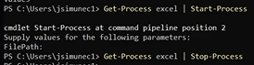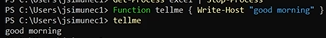
Функциите също са много мощен инструмент, а и циклите.
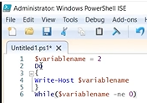
-ne = not equal
Безкраен цикъл, който спираме с Ctrl + C.
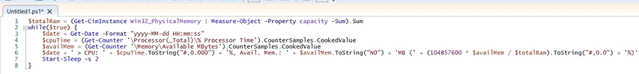
Първо трябва да се уверим, че скриптът е безопасен и да го дебъгнем.
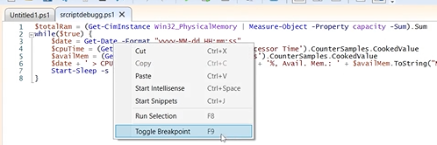
Run -> Step over
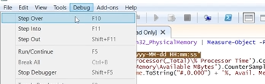
Step into + Step over изглеждат еднакви, но разликата е, че след изпълнението на текущата команда, into спира на следващата. Over също спира на следващата, но ако там е друга функция или скрипт, ще ги изпълни целите и тогава ще спре. Прилича на дебъгера на VS.

Exercise 01: Demonstrate Secure Remote Management Using PowerShell on Windows 10
* Firstly, change the current location to C:\Users\Admin. Type cd .. and press Enter. Run the command twice.
* Type cd Users and press Enter to changes the current location to C:\Users..
* Type cd Admin and press Enter to change the current location to C:\Users\Admin. Thus, you have reached the required location.
* To check whether PSSession is pre-enabled, type enter-pssession -computername localhost and press Enter. You can see the error. You will get an error because it is not pre-enabled. enter-possession will start the session with a single remote computer. -computername parameter is used to specify to which remote computer you want to connect. localhost is the remote computer you will connect to.
* To enable it, type enable-psremoting and press Enter. enable-psremoting is a built-in command, to enable PSRemoting. It enables all session configurations by setting enables property of all session configuration's value to True.
* Now, press above arrow from the keyboard twice. The command enter-pssession -computername localhost will be auto-filled. Press Enter. This will start the session with the localhost.
* You can end the session by typing exit as shown in the image.
* If one wants to enable PowerShell remote server management for more machines at once, one could use Group Policy to do it. That might be found in some corporate environments behind firewalls. It is necessary to make sure that Windows Firewall is opened for Windows Remote Management on that machine. Now, minimize the Administrator: Windows PowerShell. Keep the cursor on the search icon in the taskbar.
* Type firewall. Select Windows Defender Firewall from the result. The Windows Defender Firewall application opens as shown. Click on use recommended settings to start the firewall. If the firewall is already on, then skip this step.
* Click on Advanced settings. The Windows Defender Firewall with Advance settings opens as shown. Click on Inbound Rules. The list of Inbound Rules will be shown. Under Actions, click on New Rule. A pop-up called New Inbound Rule Wizard appears as shown. (…)
$destinationaddresses = "google.com", "microsoft.com", "youtube.com"
$result= Test-Connection -Quiet $destinationaddresses
Write-Output $result
$var = new-pssession localhost
enter-pssession -computername localhost
get-pssession localhost
get-itemproperty -path Registry::HKEY_LOCAL_MACHINE\SOFTWARE\Microsoft\Windows\CurrentVersion
cls
Write-Host "This is my first script"
Get-ExecutionPolicy is used to get the execution policy for the current session.
Get-ScriptAnalyzerRule | Sort-Object RuleName1 - The command is used to get the list of PSScriptAnalyzer rules with details about each rule.
Get-ScriptAnalyzerRule | Sort-Object RuleName1 | Select-Object CommonName
Invoke-ScriptAnalyzer .\firstscript.ps1
Clear-Host
Write-Host "This is my first script"
$textvariable = "This is a random text"
$arrayexample = "value1","value2","value3","value4"
get-process notepad | start-process
get-process notepad | stop-process
Function tellme { Write-Host "good morning" }
$variablename = 2
Do
{
Write-Host $variablename
}
While($variablename -ne 0)
Press Ctrl+C to stop it.
Select the entire script and press F8 = Run
$totalRam = (Get-CimInstance Win32_PhysicalMemory | Measure-Object -Property capacity -Sum).Sum
while($true) {
$date = Get-Date -Format "yyyy-mm-dd HH:mm:ss"
$cpuTime = (Get-Counter '\Processor(_Total)\% Processor Time').CounterSamples.CookedValue
$availMem = (Get-Counter '\Memory\Available MBytes').CounterSamples.CookedValue
$date + ' > CPU: ' + $cpuTime.ToString("#,0.000") + '%, Avail. Mem.: ' + $availMem.ToString("N0") + 'MB (' + (104857600 * $availMem / $totalRam).ToString("#,0.0") + '%)'
Start-Sleep -s 2
}
Press F5 to run the script.

Exercise 01: Apply and Verify DSC Configuration with PowerShell
Get-DscResource will retrieve the PowerShell DSC resources present in the system. Type Get-DscResource and press Enter.
DSC resources are the properties that can be configured on the target machine. In the output, you can see File at the top of the list, which means files and folders can be managed on the system. You also have Archive resource which means archives can be unzipped in .zip format at a particular path. You also have Environment resource which means system environment variables can be managed.
DSC = Desired State Configuratin чрез Push + Pull. Чрез Push конфигурираме remote компютри. Когато сме готови, минаваме към Pull – създава се master server = Pull server. Когато remote-компютри се свържат с него, той ги конфигурира, т.е. те се pull-ват от него. В реална ситуация, при много машини, първо push-ваме конфигурации за малко от тях, защото може да има и такива, които не са свързани с мрежата в дадения момент, когато админът е на разположение и иска да направи конфигурацията. После правим всички достъпни да pull-ват. При стотици и хиляди компютри, това е много по-удобно, защото трябва да конфигурираме само 1 сървър, за да pull-ват останалите, когато имат възможност, вместо ние да push-ваме всеки поотделно. Push = тест за надеждност на конфигурациите, а когато видим, че е успешна, pull за останалите.
Get-DscResource
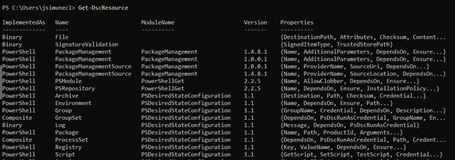
Виждаме File = файлове и папки могат да се конфигурират на тази машина. По-надолу виждаме възможност за архивиране в .zip и съответно разархивиране. Environment – системната среда може да се управлява. Log – може да се пишат съобщения за събития message events log. Може да инсталираме и деинсталираме Package, също да управляваме ключовете на регистъра без HKEY_USERS и т.н. Сходни са и при Linux. За да ги има, първо трябва да присъстват на сървъра, а после да ги дадем на компютрите. Може да изтеглим още ресурси от MS gallery за допълнителни конфигурации.
Get-DscLocalConfigurationManager
AllowModuleOverWrite = False, т.е. на машината не може да се смени с нов.
ConfigurationMode = ApplyAndMonitor – инсталира и периодично наблюдава. Ще се създават събития в EventLog. Ако беше ApplyOnly, конфигурацията щеше да се приложи само веднъж.
C: -> dsc.ps1:
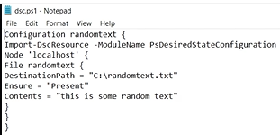
Този файл е в нашето C и ще го създадем на друга машина описанието на скрипта – файл в нейния C:\randomtext.txt, който съдържа „this is random text”. Коя машина – в нашия случай е написано Node ‘localhost’, но може да е на друга или други. Трябва да го конвертираме в .mof. Отиваме в дестинацията
. C:\dsc.ps1 – има точка и интервал пред C и създаваме папка randomtext. Създава се там localhost.mof
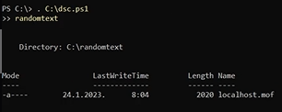
Start-DscConfiguration –Path C:\randomtext –Verbose -Wait
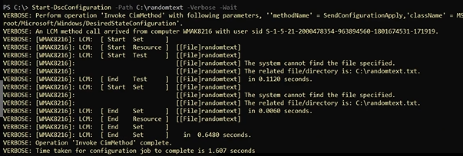
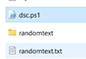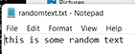
JEA = Just Enough Administration – да не се дават повече права на потребителите, отколкото са им необходими.
Session configuration file – създава environment за потребителите със специфични настройки на машината.
Get-PsSessionConfiguration – стартираме сесия, след което създаваме нов файл
New-PsSessionConfigurationFile –Path ‘C:\jeaconffile.pssc’
# - коментар за ред.
Променяме Default -> RestrictedRemoteServer както е препоръчително.
Нека си представим, че имаме ActiveDirectoryGroup, която се казва helpdesk и тя съдържа потребители, които трябва да приложат тази конфигурация.
За RoleCapabilities вместо SqlAdministration -> слагаме името на групата helpdesk -> Save. Създаваме нова папка RoleCapabilities -> трябва да я попълним с роли.
New PSRoleCapabilityFile Path ‘C:\RoleCapabilities\helpdesk.psrc’ и го отваряме в notepad
Ctrl + F -> VisibleExternalCommands, изтриваме # за реда, изтриваме Item1,2 и на тяхно място изписваме ‘C:\Windows\System32\cmd.exe’, като по този начин, тази група има възможност да стартира само външни external commandlets и всичко останало става забранено за тях. След това го активираме чрез Register –PSSessionConfiguration и рестарт на WindowsRemoteManagement service.
Administring Active Directory Using PS: Run As Administrator ->
Import-Module ActiveDirectory
Активираме ги от Settings -> Apps -> Optional Features -> Add -> RSAT tools + Ligtweight +
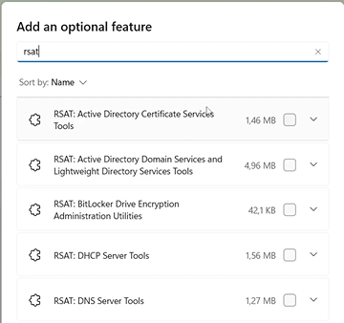
или от Add –WindowsCapabilityCommandlet –Name + името на функционалността.
Има 147 ActiveDirectory module commandlets
(Get-Command –Module ActiveDirectory).Count – преброява командите в модула. Без ().Count ги изброява.
Ако искаме повече информация за конкретна команда:
Get-AdDomain
Можем да създадем нов потребител както на отделния компютър, така и дистанционно чрез new–aduser –name име
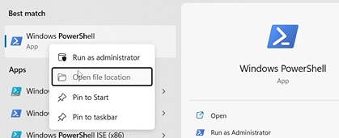
Shift + д.б. ->Show more options -> Run as different user
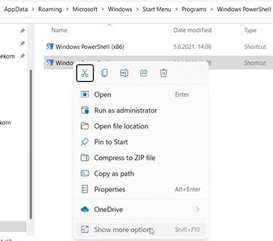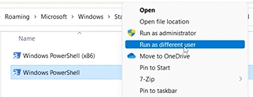
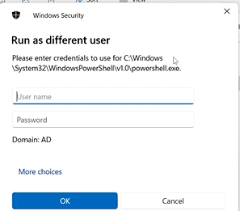
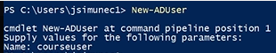
Добавихме име, но не и парола за новият потребител – това е от особеностите на ActiveDirectory. Нека го изтрием:
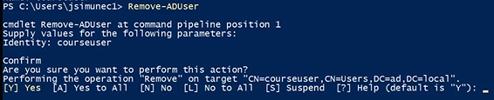
Можем да добавим и параметри на потребителя като атрибути, например, surname, department, country… Могат да се направят и много потребители наведнъж – bulk user accounts – трябва да имаме предварително подготвена информация за потребителите в .csv формат, вкарана в променлива. Променливата се извика от new-aduser и нейните параметри. Има и достъпни скриптове, които го правят. Могат да се променят и параметрите на конкретен потребител с –enable –adaccount или –disabel –addaccount.
Създаването на компютърен акаунт е по-трудно от създаването на потребителски акаунт, защото админа трябва първо да присъедини компютърните акаунти към домейн и тогава акаунтите се създават автоматично. След това админа премества компютърния акаунт от контейнера по подразбиране към желаната организационна общност. Това работи за малки организации, но за големи се използва New-AdComputer –name и Set-AdComputer за смяна на настройките, new-adGroup – и adGroup –member, new-GPO = group policy, new-GPLink добавя линк към организации, а организации могат да се създават с new-AdOrganizationalUnit.
Powershell Multithreading - нова функционалност, позволяваща стартиране на повече от една команда наведнъж, чрез асинхрона система, сложна и много бърза за голям брой машини, но и изисква повече ресурси.
New-AdGroup – една от най-често използваните команди. Ако искаме поединично да създадем групи за 500 компютъра, по 2 секунди за всеки, това са 1000 сек. Ако обаче използваме multithreading, стартираме 50 и те разпръскват още 10, което ще скъси процеса. Така се подобрява и ускорява кода, а и се избягват излишни цикли.
Get-Command *-Job – имаме и stop job, remove job, completed job, failed job – на заден план работят.
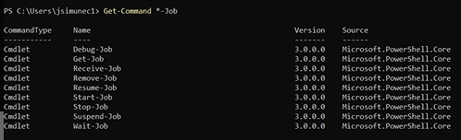
Start-Job –ScriptBlock (hostname ) – Вместо hostname може да се подаде сложен скрипт, който засегне голям брой компютри. Иначе трябва многократно и поединично да подаваме Start-Job и проверяваме с Get.
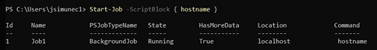
Ipconfig – можем да видим също кои са background jobs, дали работят или са спрени
Get-Job -Id 1 – Проверяваме конкретен
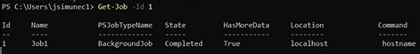
| Receive-Job – връща нашата машина в случая.

Exercise 01: Apply and Verify DSC Configuration with PowerShell
* Get-DscResource will retrieve the PowerShell DSC resources present in the system. Type Get-DscResource and press Enter. DSC resources are the properties that can be configured on the target machine. In the output, you can see File at the top of the list, which means files and folders can be managed on the system. You also have Archive resource which means archives can be unzipped in .zip format at a particular path. You also have Environment resource which means system environment variables can be managed.
* To check the configuration of the local machine, type Get-DscLocalConfigurationManager and press Enter. In the result, you can see AllowModuleOverWrite value is set to False. It means modules present in the system cannot be overwritten by new modules. The ConfigurationMode value is ApplyAndMonitor which means configuration is going to be applied and monitored.
* Type, notepad and click on Notepad.
Configuration randomtext {
Import-DscResource -ModuleName PsDesiredStateConfiguration
Node 'Localhost' {
File randomtext {
DestinationPath = "C:\randomtext.txt"
Ensure = "Present"
Contents = "this is some random text"
}
}
}
It is the configuration script that is going to create a file named randomtext.txt with the text value This is some random text. -> Save
* Create New Folder Scripts in C:\ Type dsc.ps1 as File name and click on Save. This file will be created in a C drive location on a targeted machine. Here we will consider localhost as a targeted machine.
* C drive is the directory where the configuration file exists. Thus to change the current location, type cd .. and press Enter. Run the command two times. To list the folders of the current location, type ls and press Enter. Now, you must change the current location to the script folder. Type cd script and press Enter. Type ls and press Enter. You can see the dsc.ps1 configuration file that is needed.
* Type clear and press Enter to clear the screen. To check the status of execution, type get-executionpolicy and press Enter. get-executionpolicy is used to get the execution policy for the current session. You can see it is restricted.
* Type set-executionpolicy remotesigned and press Enter to set the execution permission. Type Y and press Enter when the confirmation for change in execution policy appears. set-executionpolicy is used to change the user preferences to execute Windows PowerShell policy.
* To check the status of execution, type get-executionpolicy and press Enter. You can see it is RemoteSigned.
* Type cls and press Enter to clear the screen. To configure the file on the targeted machine, it must be compiled into a mof file. Type . c:\script\dsc.ps1 and press Enter to execute the dsc.ps1 file.
* Type randomtext and press Enter. You can see the Localhost.mof is generated in a randomtext file. Type ls and press Enter. You can see the randomtext folder in the list which has files in it. The configuration must be applied to those files on a targetted machine.
* Type enable-psremoting and press Enter. It enables the PSRemoting to connect to the machine.
* Type Start-DscConfiguration -path C:\script\randomtext -verbose -Wait and press Enter. Thus, the DSC is applied to the targeted machine.
* To verify it, you must open the randomtext.txt file. Minimize the Windows PowerShell CLI. Click on the File Explorer icon. Under Quick access, click on This PC. Double-click on randomtext.txt to open it. You can see the randomtext.txt -Notepad appears with the content as this is some random text. This concludes the demonstration of Apply and Verify DSC Configuration with PowerShell.

Exercise 02: Configure and Customize PowerShell Session and Role Capabilities
* Type enable-psremoting and press Enter. It enables the PSRemoting to connect to the machine.
* Type get-executionpolicy and press Enter. It displays RemoteSigned. Run the commands mentioned below if you have not set the execution policy.
set-executionpolicy remotesigned
get-executionpolicy
* Type Get-PSSessionConfiguration and press Enter. It gives the session configurations registered on the local machine. A session configuration file is one in which the specified setting on the local machine is going to define the environment for the upcoming PowerShell sessions that will be created when other users connect to the PowerShell on that particular machine. That configuration file will be specific for a specific machine.
* C -> new folder name as jea and press Enter. jea is the folder in which you will save the session configuration file via the PowerShell cmdlet.
* To create your own configuration file, type New-PSSessionConfigurationFile -path 'C:\jea\jeaconffile.pssc' and press Enter. jeaconffile.pssc is the name of the new configuration file that will be created.
* Minimize the Windows PowerShell window. Navigate back to the File Explorer from the taskbar. Double-click on the jea folder in which the file is saved via cmdlet.
* You can see a text file jeaconffile.pssc is saved. Double-click on it to open. For how do you want to open this file? Select on Notepad and click on OK.
* The script will open in a Notepad as shown. In the script, anything written after # will be considered as comment.
* You can make changes according to your needs, concerning user privilege. Change the SessionType assigned value from Default to Restricted RemoteServer. The above-made changes will provide the ability to execute a few key cmdlets.
* Assume that you have an active directory group named helpdesk which contains users that will need to apply this configuration. Change the RoleCapabilities assigned value from SqlAdministrattion to helpdesk.
* Press Ctrl+S to save the changes. Then click on the Close icon to close it.
* Now, you have to create a folder in C: drive to save roles that will be detected by PowerShell. Click on the back arrow in the File Explorer to back by one step. Right-click on the page. Under New select Folder. Type the folder name as RoleCapabilities and press Enter.
* .psrc extension file has to be created to configure the members of the helpdesk group in the active directory. Go back to the Windows PowerShell from taskbar. Type New-PSRoleCapabilityFile -path 'C:\RoleCapabilities\helpdesk.psrc' and press Enter.
* Minimize the Windows PowerShell. In the File Explorer window double-click on the RoleCapabilities folder to open it. You can see a file is saved. Double-click to open it. For How do you want to open the file?, click on More apps. Select Notepad and press OK.
* The script text file opens as shown. The changes that will be made in it will restrict the members of the local directory group helpdesk in such a way that they will be able to run only certain cmdlets.
* Find the line #VisibleExternaleCommands = 'Item1','Item2' to change its assigned value. Remove the # and assign the value as given below. According to the changes, members of the help group will be able to execute only the external command named cmd.exe.
* This way you can whitelist or backlist the cmdlets for the users.

Exercise 03: Implement and Manage Active Directory User Accounts using PowerShell
* Run the command Import-Module ActiveDirectory to import Active Directory.
* Run the command (Get-Command -Module ActiveDirectory).Count. This will give you the total number of commands.
* Run the command Get-Command -Module ActiveDirectory. This will display the list of commands.
* To create a new account in the active directory, run the command New-ADUser. It will ask for a name, type courseuser, and press Enter.
* Now to remove this account, run the command Remove-ADUser.
* It will ask for Identity, type courseuser and press Enter.
* It will ask for confirmation, press the Y key to continue. The account will be removed from the active directory.
* This concludes the demonstration of Implement and Manage Active Directory User Accounts using PowerShell.

Exercise 04: Analyze and Manage Background Jobs in PowerShell
* Type the below command and press Enter. You will get a list of cmdlets that end with -Job.
Get-Command *-job
Specific cmdlet is used for specific functions. Start-Job is used to start the background job, Get-Job is used to get the list of background jobs running, and Remove-Job will delete the background job. And the background jobs can be in various states which define how PowerShell is handling and defining the job.
* Type Start-Job -ScriptBlock { hostname } and press Enter. You can see in the result that the PS Job type is BackgroundJob and the State is Running. Start-Job will start a background job on a machine. ScriptBlock is a parameter of Start-Job cmdlet. In the place of hostname one will enter the script that has to be run in the background so that other cmdlets can be executed in the foreground.
* Once you start a background job, try to run a cmdlet in the foreground. Type ipconfig and press Enter. You can see that the command is executed.
* To check the status of the background job, type Get-Job -id 1 and press Enter. You can see it is completed. 1 was the ID that the system assigned to the background job.
* As the background job is completed, you can check the result. Type Get-Job -id 1 | Receive-Job and press Enter.
* One can run complicated scripts simultaneously in the background. Type Start-Job -ScriptBlock { hostname } and press Enter. A new background job will get started. Practically, a different script will be written instead of hostname.
* To run another background job,type Start-Job -ScriptBlock { hostname } and press Enter. A new background job will get started. Running multiple background jobs at once leads to an increase in the use of system resources.
* To get the list of backgrounds, type Get-Job and press Enter. Get-Job command will list all the background jobs in the present session.
* This concludes the demonstration of Analyze and Manage Background Jobs in PowerShell.
Edit group policy
- Group policy module installed
Get-Command –Module [име по избор]
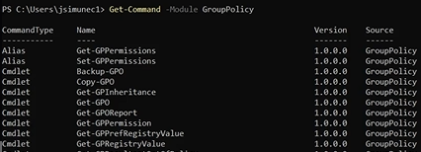
Виждаме New-GPO = new group policy object
New-GPLink = new existing group policy link
Get-GPResultantSetOfPolicy – изкарва рапорт за политиките
Creating our own PS Commandlet -
Модулите са групи от команди .psm1, а стандартните скриптове .ps1
Error Handling –
Можем да си държим кода локално на машината, а може и да го споделим в GitHub, където може да проследяваме с commit. Създаваме публичен акаунт, безплатен, за студенти, без лиценз, но никой не би използвал нашия код, ако няма лиценз, така че е хубаво да слагаме.
Имаме инструменти и долу вдясно – gitignore
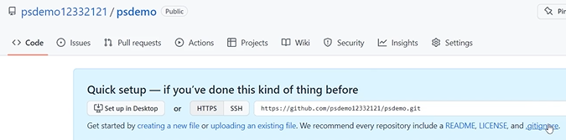
Github desktop download е синхронизиран с браузерния – клониране = изтегляне локално
Създаваме файл, избираме го в десктоп версията -> reposigory -> pull
За редакция д.б. -> Open with default program, след редакция changes, history, update…push to origin
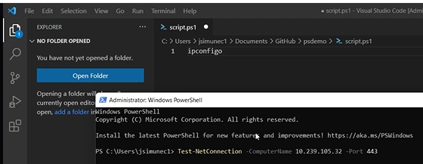
Test-NetConnection –ComputerName 10.239.105.32 –Port 443
Просто тест, свързването е неуспешно
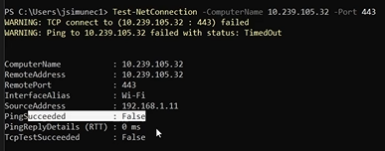
Създаваме файл test.txt с няколко ip адреса за по-бързо
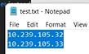
$ = променлива
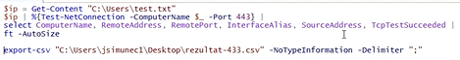
Извличаме адресите от файла – запазваме файла, после
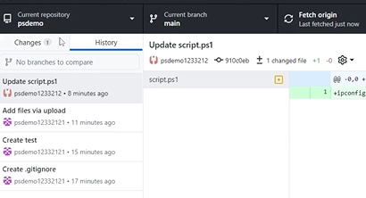
Fetch origin, commit changes to main -> histori
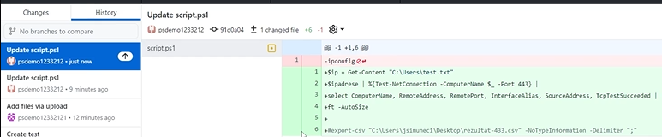
Резултатът трябва да се изведе в конкретен файл на десктопа.
PS logging, auditing and recording
Logging with transcripts = най-простият метод за вписване: извличат се всички commandlets и изходи, които се генерират по време на сесия. При затварянето на сесията, се затваря и транскриптът. За да се включи подобна транскрипция, може да се редактира регистъра ръчно за 1 машина или за огромен брой машини чрез group policy. При старт се правят записвания capture – показва ни се къде и името на файла, а при stop се вкарват в регистъра.
Start-Transcript
Stop-Transcript
Между start – stop се записват команди и действия, които искаме. Ако напишем Get-Command, ще запише хилядите команди. Ако запишем hostname – името на компютъра.

Exercise 01: Analyze and Implement Group Policy Management Using PowerShell Cmdlets
* Firstly, you must change the current location to C:\Users\Admin. So type cd .. and press Enter. Run the command twice as shown in the image. Type cd Users and press Enter to change the current location to C:\Users. Type cd Admin and press Enter to change the current location to C:\Users\Admin. Thus, you have reached the required location.
* Type Get-Command -Module GroupPolicy and press Enter. You might not get the result of a list of cmdlets for GroupPolicy if the group policies are not configured on the system.
* You can see the list of cmdlet information in Google. Minimize the Windows PowerShell. Click on the Google Chrome icon on the desktop. Type GroupPolicy module in the URL search bar and press Enter. Click on the official link of Microsoft GroupPolicy Module. It is highlighted in the image.
* In the list of GroupPolicy cmdlets, click on New-GPO. The New-GPO detailed information will be shown. Scroll down and read the information given about New-GPO. [!note] The New-GPO command is used to create a completely new group policy object. The New-GPOLink command can be used to link the existing group policy object to the targeted organizational unit.
* On the left side of the page you can see the list of cmdlets. Click on Get-GPO. It gives information about one or all GPOs of the target.
* In the list of cmdlets on the left side of the page, click on Remove-GPO.
* In the list of cmdlets on the left side of the page, click on Invoke-GPUpdate. The cmdlet is used to update group policy settings on the targeted remote machine or all the machines in the organizational unit. The information about the Invoke-GPUpdate cmdlet will be shown.

Exercise 02: Analyze and Implement Script Version Control with GitHub and PowerShel
* The Administrator: Windows PowerShell ISE appears as shown below. Click on New Script icon. A new PowerShell script page appears as shown in the image.
* Other than the local machine, one can also save the scripts in GitHub. For that firstly, you must create a GitHub account. Minimize the Windows PowerShell ISE. Click on the Google Chrome icon on the desktop.
* The Welcome to GitHub page appears. For How many team members will be working with you? select Just me. Select Student. Then click on Continue. Then What specific features are you interested in using? option appears. Scroll down and click on Continue. The GitHub recommended plans option appears. As you need free GitHub, scroll down and click on Continue for free. Your GitHub account dashboard appears.
* To Start a new repository type the repository name and make it Public. Then click on Create a new repository. Here the new repository name given is jcdemo. GitHub contains public and private repositories. One can keep the code by oneself in a private repository or can keep it in a public repository to share it with other people and receive reviews for your code from other people. The newly created repository opens as shown below. By default, the Code section will be opened. You can see a list of tabs available - Code, Issues, Pull requests, Actions, Projects, Wiki, Security, Insights, and Settings.
* Click on gitignore. The gitignore file appears, where you can type the content of your wish.
* Type test and click on Commit changes. Again under the pop-up, click on Commit changes.
* You can see .gitignore file becomes the branch under main jcdemo repository. You can add multiple branches of your wish.
* You can add a code file to your repository. Click on Add file. Then select Create a new file.
* In the Name your file input section type test as the file name. Type hostname as the content of the file. Then click on Commit changes. Here hostname is the cmdlet. Instead of typing long code, you will be using this cmdlet as a simple code for demonstration. For the pop-up, again click on Commit changes. You can see the test file has been added to your repository.
* Now, you will be downloading the GitHub desktop version. Click on the + icon to open a new tab. Once the new tab opens, type github desktop download in the search bar and press Enter. To authorize the GitHub Desktop web browser will open automatically. Click on Authorize desktop. The Configure Git appears. Check the Name and Email. Click on Finish.
* The add repository option appears. Under Your repositories, you will get the name of the repository that you created. Select the repository and click on Clone. For the Clone a repository pop-up, click on Clone. Thus the GitHub Desktop repository is created successfully.
* Now, you will learn how to add a script file from the local host to the GitHub account. Minimize the GitHub Desktop and the browser. Click on File Explorer. Firstly, you will create a folder in which the script text document will be saved. Select This PC, then double click on Local Disk (C:). Right-click and select New. Then click on Folder. Type script as a folder name and press Enter. Minimize the File Explorer. Click on the search icon. Type notepad. Click on Notepad. The notepad file appears as shown. Press Crtl+S to save the empty demo file. Select This PC and double click on Local Disk (C:).
* Double-click on script. Type File name as script.ps1 and click on Save.
* Click on your GitHub repository tab as shown. Click on Add file and select Upload files. Select This PC and double click on Local Disk (C:), script folder, script.ps1 and click on Open. You can see that script.ps1 is uploaded. Scroll down and click on Commit changes. You can see in the repository that script.ps1 is added.
* Click on Repository in the tool section. Select Pull. Wait until the fetching is completed.
* Click on the History section which is shown in the image. To the left side of the page, you can see the list of actions you performed. Click on Add files via upload. You can see the script.ps1 file to its right side. It is the file that you uploaded. You can see that The file is empty.
* Minimize GitHubDesktop. And re-open the minimized Web Browser. Click on script.ps1 file in the repository. You can see that it is empty. Thus, you can say that the GitHub repository account is synchronized.
* You can also open and edit the files. Right-click on script.ps1. Select Open with default program. The file will open in Notepad. Type ipconfig and press Ctrl+S to save the content added to the file. Close the Notepad and then click on Changes section.
* The changes made to script.ps1 is shown. To save the changes made in your repository, click on Commit to main.
* Again click on History section. Select Upload script.ps1.
* To your right-hand side, you can see the content that was added to the file. Click on Push origin to push the changes made to your GitHub repository.
* To check whether the made changes are synchronized in the cloud, minimize GitHub Desktop and re-open minimized Google Chrome.
* Click on jcdemo which is the main branch. Then click on script.ps1.
* You can see that changes were made to the script.ps1 file content in the GitHub Desktop are reflected successfully.
* You can also open and edit the script files in other programs like Visual Studio Code. For that firstly, you must download Visual Studio Code. Click on the + icon to open a new tab.
* Select VisualStudioCode as the application to view the file and click on OK. Select script.ps1. Right-click on it and select open with default program. The file Script.ps1 will be opened in VisualStudioCode. Thus, it is clear that you can open the file in other applications where you can modify the content.
* Type powershell and click on Windows PowerShell to open it.
* Type Test-NetConnection -ComputerName 10.239.105.32 -Port 443 and press Enter. You can see in the result that the TCP connection failed. Here, you will test for network connection with a parameter computer name with a certain IP address and for HTTPS port 443.
* Once the Notepad opens. Type the below IP addresses as the content.
10.239.105.32
10.10.1.13
* Press Ctrl+S to save it. Under This PC double click on Local Disk (C:). Double-click on the script folder. Type test.txt as the file name and click on Save.
* In VSCode:
$ip = Get-Content "C:\script\test.txt"
$ip | %{Test-NetConnection -ComputerName $_ -Port 443} |
select ComputerName, RemoteAddress, RemotePort, InterfaceAlias, SourceAddress, TcpTestSucceeded |
ft –AutoSize
export-csv "C:\Users\Admin\Desktop\rezultat-433.csv" -NoTypeInformation -Delimiter ";"
In this code, the Ip address in the text.txt file will be read to check for the network connection and display the result. It also created a rezultat-433.csv file.
* To save the changes made, click on File tab and select Save. Now check whether the same changes made in VisualStudioCode are reflected in the GitHub Desktop repository. Minimize the VisualStudioCode. Re-open GitHub Desktop.
* Select script.ps1. Then click on Fetch origin.
* Then click on Changes section. Then click on Commit to main.
* Then select the History section and click on Update script.ps1. The file content will be updated as shown.
* Now, you will run the same script in the Windows PowerShell ISE. Minimize the GitHub Desktop and re-open VisualStudioCode. Select the script as shown and press Ctrl+C to copy it.
* Minimize VisualStudioCode. Click on the Windows PowerShell ISE icon from the desktop tool. Press Ctrl+V to paste the script. Select the content and press F8. to run the selected script.

Exercise 03: Create and Document a PowerShell Session Using Start-Transcript and Stop-Transcript
* The Administrator: Windows PowerShell appears as shown below. Firstly, you must change the current location to C:\Users\Admin. So type cd .. and press Enter. Run the command twice as shown in the image. Type cd Users and press Enter to change the current location to C:\Users. Type cd Admin and press Enter to change the current location to C:\Users\Admin. Thus, you have reached the required location. Type hostname and press Enter. It gives the name of your host.
* Minimize the File Explorer and click on Windows PowerShell icon again to re-open it. Type Start-Transcript and press Enter. Start-Transcript will create a record of the powershell session to a text file.
* Type hostname and press Enter. Type Get-Command and press Enter. The result will be the list of commands of PowerShell that are installed on the system.
* Type Stop-Transcript and press Enter. Minimize the Windows PowerShell. Click on File-Explorer to re-open it. You can see a text file is saved in the Documents folder. Double-click on it to open the text file. You can see the entire session between Start-Transcript and Stop-Transcript is saved in the file.
................................................................................
It is mandatory to understand
You need to consider
Nevertheless – въпреки това
It’s big advantage
Simultaneous – едновременно
Intended – предназначен
We are going to choose the first page that pops out
I will erase this command
Whatever version suits your machine
Couple of more seconds
The download is over
This installation is straightforward
Plus = + плАс
Commandlet auto suggestion
It is time to dive in
Invoke – призовавам
Fetch – донасям
Occupied – зает
Our screen is occupied with this very long list
Proficient – умел, опитен
To be proficient in navigating in
Besides – освен това
Beside – до, покрай
In certain matters
[] – square brackets
Widely used
That should be known to everyone dealing with
Allotted – разпределен
As we have mentioned before
This is very benefitial for
Granting – предоставяне
Examination – преглед
Repetitive – повтарящ се
Severity – тежест
Let’s close quotations
If you try to… you would not be able to do so
You could notice the error
Let’s confirm that – нека го потвърдим/докажем
As you can conclude
Toggle – превключвател
In order to see…
Visually behaved similarly
Deploy - разположи
Enact – приемам
Verbose – многословен
As it is usually for most of the things –
Prerequisite – предпоставка
Enumerate – изброявам
# = hash, hashes
Embedded comment
Will be regarded – ще бъде считан
Deployment – внедряване
Bulk – насипно състояние
Threading – резба
MultiThreading – многонишково четене
Adjust – коригирам
Foreground – преден план
In following way – по следния начин
Inside the brackets I will put – () – между скобите
Simultaneously - едновременно
Anomaly – анОмали
deviation – отклонение
derive – извличам – дерАйв
derived – извлечен
derivative – производно – деривЪтив
Commit – ангажирам, поверявам, въвличам
Error handling – Обработка на грешки
handling – боравене
Contribute – допринасям, сътруднича
Which I have previously created on my C drive
It may execute very slowly depending on bandwidth and other network parameters

