I група ТЕСТ № 5 – НЕРАВЕНСТВА

8.04.14. Име:.................................................................................................., №......., 7^{б} клас
1 зад: Кое от неравенствата не е вярно?
а) 1,103<1,301; б) 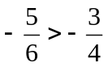; в) -3,303<-0,301; г) 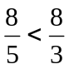.
2 зад: Кое от твърденията е вярно?
а) 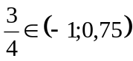; б) 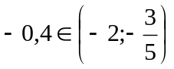; в) 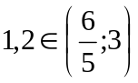; г) 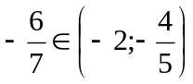.
3 зад: Кои двойки неравенства са еквивалентни?
а) х<2 и -х>2; б) 3<х и х<3; в) х<1 и -х>-1; г) х<1 и -х<-1.
4 зад: Решенията на неравенството 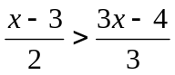са:
а) 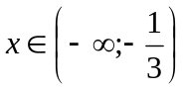; б) 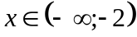; в) 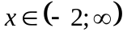; г) 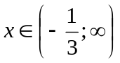.
5 зад: Решенията на неравенството 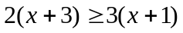са изобразени с интервала:
6 зад: Намерете най-малкото цяло число, което е решение на 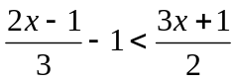.
............................................................................................................................................................................................................................................................................................................................................................................................................................................................................................................................................................................................................................
............................................................................................................................................................................................................................................................................................................................................................................................................................................................................................................................................................................................................................
.......................................................................................................................................................
7 зад: С каква скорост трябва да се движи камион, за да измине за час и половина поне 90 km?
............................................................................................................................................................................................................................................................................................................................................................................................................................................................................................................................................................................................................................
............................................................................................................................................................................................................................................................................................................................................................................................................................................................................................................................................................................................................................
..............................................................................................................................................................................................................................................................................................................

II група ТЕСТ № 5 – НЕРАВЕНСТВА

8.04.14. Име:.................................................................................................., №......., 7^{б} клас
1 зад: Кое от неравенствата не е вярно?
а) 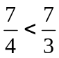 б) -0,21>-0,22; в) 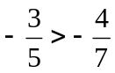; г) 1,102>1,092.
2 зад: Кое от твърденията е вярно?
а) 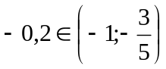; б) 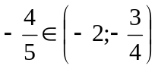; в) 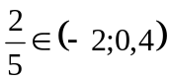; г) 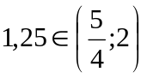.
3 зад: Кои двойки неравенства са еквивалентни?
а) х<5 и 5<x; б) х<1 и -х>1; в) х<2 и -х<-2; г) х<3 и –х>-3.
4 зад: Решенията на неравенството 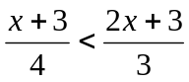са:
а) 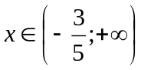; б) 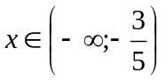; в) ; г) .
5 зад: Решенията на неравенството 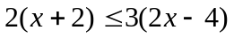са изобразени с интервала:
6 зад: Намерете най-голямото цяло число, което е решение на 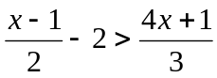.
............................................................................................................................................................................................................................................................................................................................................................................................................................................................................................................................................................................................................................
............................................................................................................................................................................................................................................................................................................................................................................................................................................................................................................................................................................................................................
.......................................................................................................................................................
7 зад: С каква скорост трябва да се движи кола, за да измине за час и половина поне 120 km?
............................................................................................................................................................................................................................................................................................................................................................................................................................................................................................................................................................................................................................
............................................................................................................................................................................................................................................................................................................................................................................................................................................................................................................................................................................................................................
..............................................................................................................................................................................................................................................................................................................

