α |  |  | 0° | 30° |  | 45° |  | 60° | 90°
sin α |  |  | 0 |  |  |  |  | 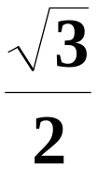 | 1
cos α |  |  | 1 |  |  |  |  |  | 0
tg α |  |  | 0 | 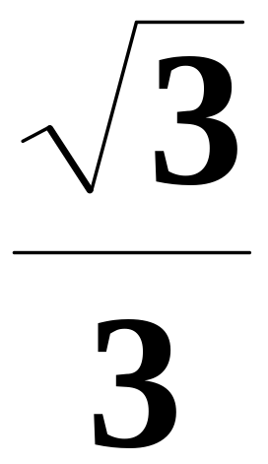 |  | 1 |  | 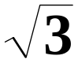
cotg α |  |  |  | 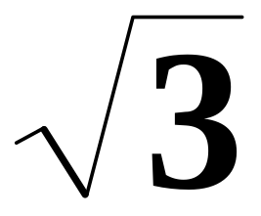 |  | 1 |  | 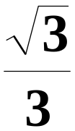 | 0
 | 60° | 90° |  |  | 120° |  | 150°
 |  | 1
 |  | 0 |  |  | - |  | -
 |  |  |  |  | - |  | -
 |  | 0 |  |  | - |  | -

