**Online Appendix**

**Appendix A:** Notations of Mathematical Formulations

***Indices and Sets***

 Index and Set of Salmon Farm respectively, 

 Index and Set of Slaughterhouse respectively, 

 Index and Set of Primary Processing Plant respectively, 

 Index and Set of Secondary Processing Plant respectively, 

 Index and Set of Wholesaler respectively, 

 Index and Set of Retailer respectively, 

 Index and Set of Time Period respectively, 

 Index of Live Salmon product

 Index of HOG fish

 Index of fresh HOG salmon products

 Index of Whole Fillet products

 Index of Salmon by-products (it includes blocks, loins and portions, off-cut trimming   
belly flaps, head, tailbone, and skin)

***Parameters – Related to Storage Capacity and Transportation Capacity***

 Available capacity of Live Salmon product  at Salmon Farm  in period 

 Maximum storage capacity of HOG product  at Slaughterhouse  in period 

 Maximum storage capacity of fresh HOG salmon products  at Primary Processing Plant  in period 

 Maximum storage capacity of Whole Fillet product  at Secondary Processing Plant   
 in period 

 Maximum storage capacity of By-product of salmon  at Secondary Processing Plant   
  in period 

 Maximum storage capacity of fresh HOG salmon products  at Wholesaler  in period 

 Maximum storage capacity of Whole Fillet product  at Wholesaler in period 

 Maximum storage capacity of Salmon by-product  at Wholesaler in period 

 Capacity of the transportation mode for the shipment of Live Salmon product  from   
 Salmon Farm  to Slaughterhouse  in period 

 Capacity of the transportation mode for the shipment of Hog product  from   
 Slaughterhouse  to Primary Processing Plant  in period 

 Capacity of the transportation mode for the shipment of fresh HOG salmon products  from Primary Processing Plant  to Secondary Processing Plant  in period 

 Capacity of the transportation mode for the shipment of fresh HOG salmon products  from Primary Processing Plant  to Wholesaler  in period 

 Capacity of the transportation mode for the shipment of fresh HOG salmon products d from Wholesaler  to Retailer  in period 

 Capacity of the transportation mode for the shipment of Whole Fillet product  from   
 Secondary Processing Plant  to Wholesaler  in period 

 Capacity of the transportation mode for the shipment of Salmon by-product  from Secondary Processing Plant  to Wholesaler  in period 

 Capacity of the transportation mode for the shipment of Whole Fillet product  from   
 Wholesaler  to Retailer  in period 

 Capacity of the transportation mode for the shipment of Salmon by-product  from   
 Wholesaler  to Retailer  in period   ***Parameters – Related to Demand and Cost Components***

 Demand for fresh HOG salmon product  at Retailer  in period 

 Demand of Whole Fillet product  at Retailer  in period 

 Demand of Salmon by-product  at Retailer  in period 

 Transportation cost for the shipment of per unit Live Salmon  from Salmon Farm    
 to Slaughterhouse  in period 

 Transportation cost for the shipment of per unit Hog Product  from Slaughterhouse   
  to Primary Processing Plant  in period 

 Transportation cost for the shipment of per unit fresh HOG salmon product  from   
 Primary Processing Plant  to Secondary Processing Plant  in period 

 Transportation cost for the shipment of per unit fresh HOG salmon product  from   
 Primary Processing Plant  to Wholesaler  in period 

 Transportation cost for the shipment of per unit fresh HOG salmon product  from   
 Wholesaler  to Retailer  in period 

 Transportation cost for the shipment of per unit Whole Fillet product  from   
 Secondary Processing Plant  to Wholesaler  in period 

 Transportation cost for the shipment of per unit Salmon by-product  from   
 Secondary Processing Plant  to Wholesaler  in period 

 Transportation cost for the shipment of per unit Whole Fillet product  from   
 Wholesaler  to Retailer  in period 

 Transportation cost for the shipment of per unit Salmon by-product  from   
 Wholesaler  to Retailer  in period 

 Inventory holding cost per unit of Hog product  at Slaughterhouse  in period 

 Inventory holding cost per unit of fresh HOG salmon product at Primary Processing Plant  in period 

 Inventory holding cost per unit of fresh HOG salmon product  at Wholesaler  in period 

 Inventory holding cost per unit of Whole Fillet product  at Secondary Processing   
 Plant  in period 

 Inventory holding cost per unit of Salmon by-product  at Secondary Processing   
 Plant  in period 

 Inventory holding cost per unit of Whole Fillet product  at Wholesaler  in period 

 Inventory holding cost per unit of Salmon by-product  Wholesaler  in period 

 Processing cost for per unit of Hog product  at Slaughterhouse  in period 

 Processing cost for per unit of fresh HOG salmon product  at Primary Processing Plant  in period 

 Processing cost for per unit of Whole Fillet product  at Secondary Processing Plant  in period 

 Processing cost for per unit of Salmon by-product  at Secondary Processing Plant  in period 

 Residual cost for per unit of residual amount obtained after processing Live Salmon   
 product  at Slaughterhouse  in period 

 Residual cost for per unit of residual amount obtained after processing Hog product    
 at Primary Processing Plant  in period 

 Residual cost associated with per unit of residual amount obtained after processing   
 fresh HOG salmon product  at Secondary Processing Plant  in period  ***Parameters - Fuel Consumption, Distance, Fuel Price and Carbon Emission Coefficient***

 Fuel consumed (in litres per unit distance per unit product) in shipping Live Salmon   
  via certain mode of transport from Salmon Farm  to Slaughterhouse 

 Fuel consumed (in litres per unit distance per unit product) in shipping Hog product  
  via certain transport mode from Slaughterhouse  to Primary Processing Plant 

 Fuel consumed (in litres per unit distance per unit product) in shipping fresh HOG salmon product  via certain transport mode from Primary Processing Plant  to Secondary Processing Plant 

 Fuel consumed (in litres per unit distance per unit product) while shipping fresh HOG salmon product via certain mode of transportation from Primary Processing Plant  to Wholesaler 

 Fuel consumed (in litres per unit distance per unit product) while shipping Whole Fillet product  via certain mode of transportation from Secondary Processing Plant  to Wholesaler 

 Fuel consumed (in litres per unit distance per unit product) while shipping Salmon by-product  via certain mode of transportation from Secondary Processing Plant  to Wholesaler 

 Fuel consumed (in litres per unit distance per unit product) while shipping fresh HOG salmon product  via certain mode of transportation from Wholesaler  to Retailer 

 Fuel consumed (in litres per unit distance per unit product) while shipping Whole Fillet product  via certain mode of transportation from Wholesaler  to Retailer 

 Fuel consumed (in litres per unit distance per unit product) while shipping Salmon by-product  via certain mode of transportation from Wholesaler  to Retailer 

 Fuel price (Euro per litre) in period 

 Carbon emission coefficient associated with the fuel

 Maximum allowable carbon emission limit

 Distance from Salmon Farm  to Slaughterhouse **;**   
 Distance from Slaughterhouse  to Primary Processing Plant **;** Distance from   
 Primary Processing Plant  to Secondary Processing Plant **;** Distance from Primary   
 Processing Plant  to Wholesaler **;** Distance from Secondary Processing Plant  to   
 Wholesaler **;** Distance from Wholesaler  to Retailer  respectively

***Continuous Variables – Related to the Processed Amount and Wastage Amount***

 Total processed amount of Hog product  at Slaughterhouse  in period 

 Processed amount of fresh HOG salmon product  at Primary Processing Plant in period 

 Processed amount of Whole Fillet product  at Secondary Processing Plant  in period 

 Processed amount of Salmon by-product  at Secondary Processing Plant  in period 

 Amount of residual obtained after processing Live Salmon product  at Slaughterhouse  in period 

 Amount of residual obtained after processing Hog product  at Primary Processing Plant  in period 

 Amount of residual obtained after processing fresh HOG salmon product  at Secondary Processing Plant  in period 

***Continuous Variables – Related to the Inventory Level***

 Inventory of Hog product  at Slaughterhouse  in period 

 Inventory of fresh HOG salmon product at Primary Processing Plant in period 

 Inventory of fresh HOG salmon product at Wholesaler  in period 

 Inventory of Whole Fillet product  at Secondary Processing Plant  in period 

 Inventory of Salmon by-product  at Secondary Processing Plant  in period 

 Inventory of Whole Fillet product  at Wholesaler  in period 

 Inventory of Salmon by-product  at Wholesaler  in period  ***Integer Variables – Related to Amount Transported***

 Total amount of Live Salmon  transported from Salmon Farm  to Slaughterhouse   
  in period 

 Total amount of Hog product  transported from Slaughterhouse  to Primary   
 Processing Plant in period 

 Total amount of fresh HOG salmon product  transported from Primary Processing Plant  to Secondary Processing Plant  in period 

 Total amount of fresh HOG salmon product  transported from Primary Processing Plant  to Wholesaler  in period 

 Total amount of Whole Fillet product  transported from Secondary Processing Plant   
  to Wholesaler  in period 

 Total amount of Salmon by-product  transported from Secondary Processing Plant   
  to Wholesaler  in period 

 Total amount of fresh HOG salmon product  transported from Wholesaler  to Retailer  in period 

 Total amount of Whole Fillet product  from Wholesaler  to Retailer  in period 

 Total amount of Salmon by-product  transported from Wholesaler  to Retailer  in period *t*

**Appendix B:** Transportation capacity related constraints and non-negative integers:

Equations (B1) and (B2) state that the number of products flowing at each transportation link from salmon farms to slaughterhouses and from slaughterhouses to primary processing plants should be less than or equal to the maximum transportation capacity. Moreover, there would be no transportation of products between any two stakeholders if there is no possible transportation capacity available on the route.

  (B1)

  (B2)

Equations (B3) and (B4) state that the number of fresh HOG salmon product flowing through the transportation route linking the primary to the secondary processing plants and wholesalers, should be less than or equal to the maximum transportation capacity of each of the transportation links. Although, if no transportation capacity is available with the designated routes, then no shipment of products takes place on the transportation links.

  (B3)

  (B4)

Equations (B5) and (B6) are the transportation capacity constraints of the proposed mathematical formulation. They state that the number of whole fillets and salmon by-products flowing at each of the transportation links between secondary processing plants and wholesalers should be less than or equal to the maximum transportation capacity available on each of the transportation links. Moreover, there would be no transportation of specific products between secondary processing plants and wholesalers, if there is no possible transportation capacity available on the route.

  (B5)

  (B6)

Equations (B7) – (B9) depict that the number of products (fresh HOG, whole fillets, salmon by-products) flowing through transportation routes linking wholesalers and retailers should be less than or equal to the maximum transportation capacity. If there is no possible transportation capacity available on any particular route, then no shipments occur.

  (B7)

  (B8)

  (B9)

  (B10)

  (B11)



 (B12)

Equations (B10) – (B12) presents the non-negative integers.

**Appendix C:** Figures related to problem instance 1

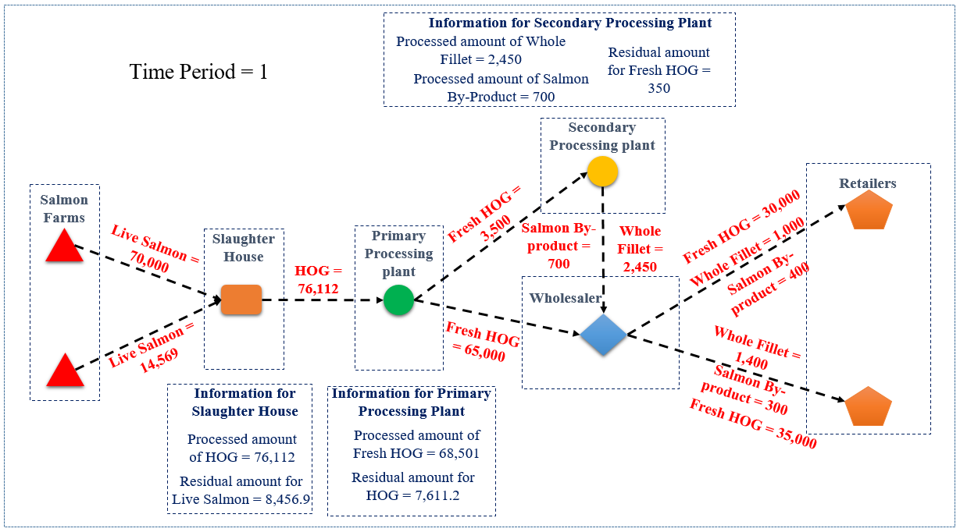

Figure C1: Solution obtained for problem instance 1 related to time period 1

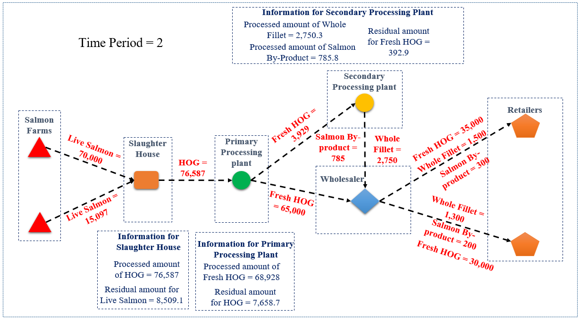

Figure C2: Solution obtained for problem instance 1 related to time period 2

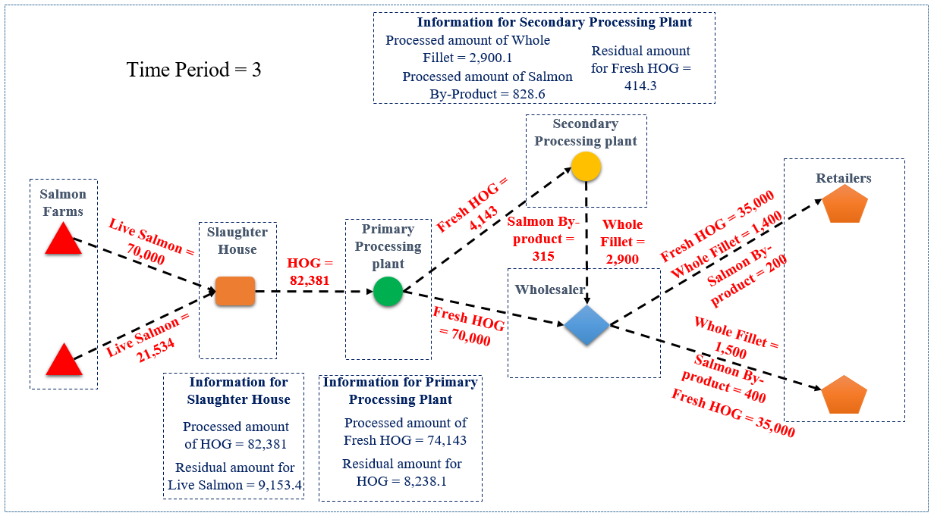

Figure C3: Solution obtained for problem instance 1 related to time period 3