**KT on Overview about Machine Learning by Nikolle Nascimento**

This document contains the key information the was presented at the KT presentation as well as the answers for some questions.

______________________________________________________________________________

**What is Machine Learning?**

Machine learning is a field of artificial intelligence that focuses on the development of algorithms and computer models that can learn and make decisions based on data, without explicit programming. It is widely used to make predictions, and improve system performance.

There are three main classifications of machine learning:

1. **Supervised Learning**: In this type of learning, models are trained with a dataset that contains pairs of input and corresponding output. The goal is to learn to map inputs to outputs and subsequently make predictions or classifications based on that knowledge.
2. **Unsupervised Learning**: In unsupervised learning, models are trained with data that lacks output labels. The primary goal is to find patterns, structures, or clusters in the data, which can be useful for tasks such as clustering and dimensionality reduction.
3. **Reinforcement Learning**: In this paradigm, models learn by making sequential decisions in an environment and receive rewards or penalties based on the actions they take. The goal is to learn actions that maximize rewards over time, commonly applied in games, robotics, and resource optimization.

**Deep Learning**

Deep learning is a subarea of machine learning that focuses on deep neural networks, which are machine learning models composed of multiple layers of interconnected units known as artificial neurons. Here are some characteristics and classifications related to deep learning:

1. **Deep Neural Networks**: In deep learning, the term "deep" refers to the use of neural networks with many layers, often known as deep neural networks. These networks are capable of learning complex hierarchical representations of data.

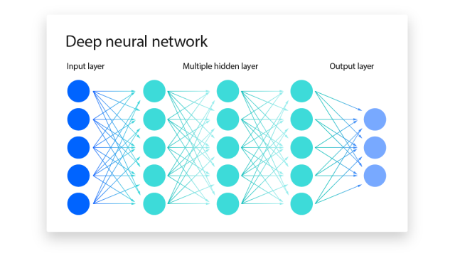

1. **Convolutional Neural Networks (CNNs):** CNNs are a class of deep neural networks designed to process grid data, such as images. They use convolutional layers to identify relevant features in 2D or 3D data.

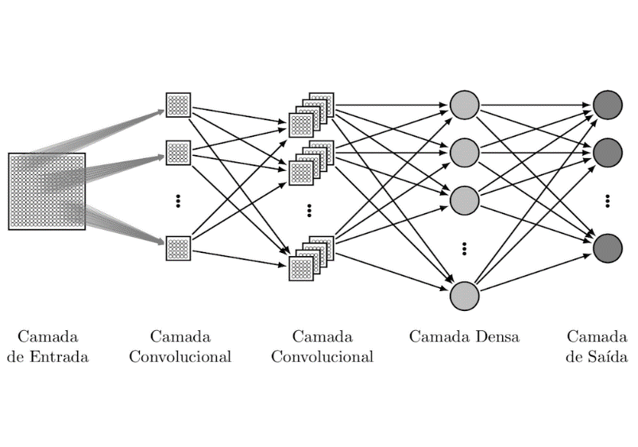

1. **Recurrent Neural Networks (RNNs):** RNNs are designed to work with sequential data, such as time series and natural language. They have recurrent connections that allow previous information to affect the current output.
2. **Generative Adversarial Networks (GANs):** GANs are a type of deep learning model that aims to generate data resembling a training dataset. They consist of a generator and a discriminator that compete during training.

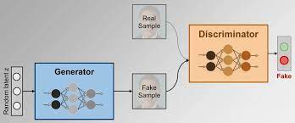

Deep learning is particularly effective in tasks related to computer vision, natural language processing, speech recognition, and many other complex applications. Its ability to learn high-level data representations makes it a powerful choice for various research and development areas.

Use cases for each Network:

1. **Feedforward Neural Network (FNN):**

- This is the most basic neural architecture. Neurons are organized in layers, with directed connections from the input layer to hidden layers, and finally to the output layer.

- It is often used in classification and regression tasks.

1. **Convolutional Neural Networks (CNNs):**

- Designed to process grid data like images and videos.

- Use convolutional layers to identify patterns and features in 2D or 3D data.

- Widely used in computer vision tasks such as object recognition and image classification.

1. **Recurrent Neural Networks (RNNs):**

- Used for sequential data, such as time series and natural language.

- Have recurrent connections that allow past information to affect future predictions.

- Used in tasks like machine translation, sentiment analysis, and time series forecasting.

1. **Generative Adversarial Networks (GANs):**

- Comprise two networks, a generator and a discriminator, competing with each other.

- The generator creates fake data to try to fool the discriminator, which tries to distinguish between real and fake data.

**How they work?**

In general, the network works like this:

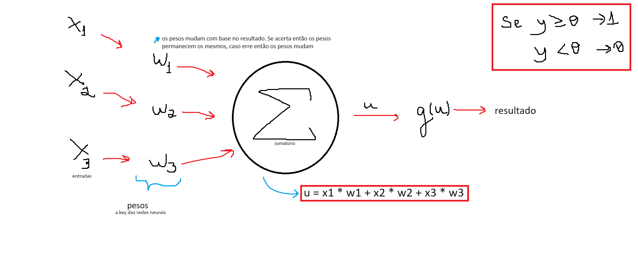

X -> input

W -> weight