

SureService Best Practices for Manual Patching

For internal use only

Salas, Jorge [AUTOSOL/PWS/CR]

2022

**CONTENTS**

Introduction 4

Purpose 4

Why is patching important? 4

Testing and Distribution 4

Guide To Download Patches from Guardian 7

Ovation Guardian Portal 7

Before downloading patches from the Guardian website 7

To find out which version of Windows is being used 7

To find out which version of Ovation and Third-party software version is being used 7

Guide To Download Patches 8

Download Microsoft updates 8

Download Antivirus updates 8

Download Third-party updates 9

Download Ovation updates 9

Patch types 10

Installation 10

Accessing patches 10

Before Manual Installation 11

1. Create a database back up, and consideration for Oracle updates 11

2. Run a System Registration Utility report 11

3. Run NIC Deletion Test, if applicable (for MS patching only) 11

4. Make note of previous issues with Ovation or specific computers and servers 12

5. Review the last patch cycle applied to the system 13

A) For Microsoft patches 13

B) For Ovation patches (including OPH) 14

C) For Oracle patches 15

6. Check for critical errors in Event Viewer 15

7. Patching timeliness 16

8. Prerequisites for patching 16

9. Coordinate with the customer when patching a system 16

Guide for manual installation of updates 17

Steps to install MS Security Patches 17

Updating Oracle Updates 18

Installation of Ovation patches 19

Order of installation 19

Rules for patch installation 19

General procedure for Ovation patch installation 21

Ovation Process Historian Patches 22

Controller Patching 23

General post-processing installation procedures by Ovation component 23

Post-processing for ALL Controller components 24

Post-processing for ALL I/O module firmware components 25

Post-processing for ALL Developer Studio components installed on a Database Server 26

APPENDIX 27

Crossroads URL link 27

Running Backup / Restore utility 27

Running a System Registration Utility report 27

NIC Driver Deletion Test 28

Copy Files to Endpoint 28

Run Test 28

Review Output 28

Pass Condition Output Examples 29

Fail Condition Output Examples 29

Reviewing mini dump files for Windows 30

Windows Event Logs 30

Information for a specific patch, where it is installed, affected components, dependency, Standard Post Processing Instructions, and Additional Instructions 31

Guidance on the installation of patches on Windows OS for Windows Server 2008 R2 and Windows 7 to evade issues with the machines 32

# Introduction

This document is intended to provide general guidelines and best practices for manual software patching. The main audience for this document is the SureService group, which is the first line of support for customers and field engineers deploying patches.

Patching is a major task to keep distributed control systems current with the latest operating system, Ovation, and other software updates. It has security implications that must be carefully observed to comply with industry standards. This document aims at delivering helpful tips and instructions to make the patching process easier to support and follow.

## Purpose

The purpose of this document is to provide a general guide to Ovation users that require to update their system. This document is set to include a guide on how to obtain patches, a guide on how to install them that includes a revision on what is recommended to be performed before doing any patches, and notes to consider after installations are complete.

It’s always recommended to read thoroughly the readme files before installing patches, but this document includes what is recommended before patching any part of the system and instructions for updating Ovation patches, Windows, and Oracle patches both for Ovation.

## Why is patching important?

Ovation uses a combination of different software applications to perform specific activities across the system. Keeping these applications with the most current updates is a critical task that ensures reliability, compliance, and security against vulnerabilities, security gaps, and system flaws. Patches are also important because they add new features, remove outdated features, and deliver enhancements to software applications. Because of this, patching has become a major responsibility for customers and engineers supporting plant operations across the world.

Running a distributed control system that is not current with the latest software updates might pose a serious risk to the plant operations and its integrity. Therefore, Emerson dedicates several resources to evaluate patches that are publicly released so that when rolled out, all operations are safely updated.

## Testing and Distribution

Depending on the software application, software patches are distributed at different rates. This also depends on how often each manufacturer releases patches to the public, so they can be previously tested, validated, and distributed by Emerson.

Testing is carried out by installing patches from a known vendor or source in a test bed. This is done by the product validation team. Testbed systems emulate the standard and validated Ovation system where patches will be implemented.

Each test bed is supposed to have at least the following major drops:

* Domain controller
* Database server
* Controller
* Operator workstation
* Ovation Process Historian
* Network switch

Test sessions will reproduce the following basic operations from an Ovation system:

* Domain controller functions
* Engineering – Developer Studio functions
* Operator functions
  + Alarm system
  + Point information system
  + Graphics display system
  + Signal diagram/control builder
  + Trend display system
  + Point review and point viewer
  + Error log windows
  + System status
  + General system response

Once patches are validated for release, they are distributed to the Ovation users by following the schedule in the below table:

|  |  |  |
| --- | --- | --- |
| **Patched Software** | **Patch Frequency** | **Impacted System** |
| Microsoft Windows Server 2019 | Monthly | Ovation 3.8, Ovation 3.7 |
| Microsoft Windows 10 IoT Enterprise 2019 LTSC | Monthly | Ovation 3.7, 3.8 |
| Microsoft Windows 10 Iot Enterprise 2016 LTSB | Monthly | Ovation 3.7, 3.8 |
| Microsoft Windows Server 2016 | Monthly | Ovation 3.7, 3.8 |
| Microsoft Windows Server 2012 R2 | Monthly | Ovation 3.6.0 |
| Microsoft Windows Server 2008 R2 SP1 | Monthly | Ovation 3.5.x |
| Microsoft Windows Server 2008 SP2 | Monthly | Ovation 3.4.0, 3.3.x |
| Microsoft Windows Server 2003 SP2 | No longer provided by Microsoft | Ovation 3.2.0, 3.1.3, 3.0.4 |
| Microsoft Windows 10 | Monthly | Ovation 3.6.0 |
| Microsoft Windows 10 Enterprise 2016 | Monthly | Ovation 3.6.0, 3.7 |
| Microsoft Windows 7 SP1 | Monthly | Ovation 3.5, 3.4.0, 3.3.x |
| Microsoft Windows XP SP3 | No longer provided by Microsoft | Ovation 3.2.0, 3.1.3, 3.0.4 |
| Oracle 19.3.0.0.0 | Quarterly | Ovation 3.8 |
| Oracle 12.2.0.1 | Quarterly | Ovation 3.7 |
| Oracle OSP12c.102 | Quarterly | Ovation 3.6.0 |
| Oracle OSP11g.204 | Quarterly | Ovation 3.5.0, 3.5.1 |
| Oracle OSP11g.203 | No longer provided by Oracle | Ovation 3.5.0, 3.5.1 |
| Oracle OSP11g.107 | No longer provided by Oracle | Ovation 3.3.1, 3.4.0 |
| Adobe (Reader and Flash Player) | Monthly when available | W7-SP1, WS2008-SP2, WS2008-R2-SP1, WS2012-R2, Win10  Ovation 3.3.x, 3.4.0, 3.5.x, 3.6.0 |
| Java Runtime Environment (JRE) | Monthly when available | W7-SP1, WS2008-SP2, WS2008-R2-SP1, WS2012-R2  Ovation 3.3.x, 3.4.0, 3.5.x, 3.6.0 |
| Microsoft Word, Excel* | Monthly when available | Microsoft Word, Excel, 2007, 2010, 2013 |
| VxWorks 6.9.4.8 - 7.0 | Quarterly | Virtual Ovation 3.7, Power and Water Cybersecurity Suite 3.5 |
| VMWare 5.5 | Quarterly | Virtual Ovation 3.5.1, Ovation Security Center 3.3 |
| VMWare 6.0 | Quarterly | Virtual Ovation 3.6.0, Ovation Security Center 3.4 |
|  |  |  |

*\*Internet Explorer patches are included in the Microsoft operating system update patches*

**Note**: There is no set release frequency for the Ovation patch as they are released on demand to address all the enhancements requests and issues reported by the user’s community. Typically, they respond to previously submitted System Deviation Reports (SDRs) and Issues Under Investigation (IUIs) that made it to the latest stages of development and testing before they are released to the public. If needed, the expected or actual release patch for a specific Ovation patch can be viewed from the Release Status section in Crossroads (Folder path: *Crossroads > Product Development: Release Status: Ovation Patch Status*. URL can be consulted from the Appendix section)

Regarding distribution, patch downloads were moved to the Guardian portal on April 1st, 2019. If a DVD is needed with patches for any software (Windows, Ovation, etc.), they can still be requested from the Ovation Users Group website by filling out the online form. Also, SureService can be contacted should a customer need access to the patches.

As an important reminder, every customer looking for recent patches must have the Software Updates module in their SureService contract. Otherwise, we will need to check in the Exception List for any applicable exceptions or contact the AfterMarket sales representative in charge of the account, to confirm if the customer is planning on purchasing or renewing the Software Updates module (if expired).

Likewise, Guardian Support for Ovation module must be active in the customer’s contract, should they need to download patches directly from the Guardian portal. Otherwise, the standard route of them contacting SureService to request updates must be followed.

# Guide To Download Patches from Guardian

Ovation Guardian Portal (<https://guardian.emerson.com/Login/>)

As stated before, each customer entitled to Software Update and Guardian Support for Ovation module can have access to the Ovation Guardian portal. This portal gives a centralized source for updates, which can be easily accessed for download, or requested via physical delivery. Guardian comprises the same software updates that were uploaded to the Box website back in the day.

## Before downloading patches from the Guardian website

To download the correct patches that are required is recommended to review the software version you currently possess before updating such software. This is applicable for Windows OS, Third Party Software, and Ovation patches.

### To find out which version of Windows is being used

To find out which version of Windows your device is running, press the **Windows logo key + R**, type ***winver*** in the Open box, and then select OK. A pop-up window should appear with the About information for the Windows version.

### To find out which version of Ovation and Third-party software version is being used

To find out which version of Ovation and Third-party software version is being used go to *Control Panel < All Control Panel Items < Programs and Features*. Search for the desired software version to be reviewed inside this list.

To determine which is the last patch cycle applied to the system, there is a segment with instructions below on 5. Review the last patch cycle applied to the system

## Guide To Download Patches

### Download Microsoft updates

* Microsoft updates can be found under the tab *Downloads > Self-Service Updates > Microsoft Updates*. Product Line must be set to ‘*Ovation*’. Select the corresponding Operating System and Software Revision (for Ovation). **NOTE:** We recommend using the “***Full Set Patches***” versions.
  + The example below is selecting the Operating System as “*Windows 10 Enterprise 2016 LTSB (64-bit)*” and Software Version “*v3.7.0*”

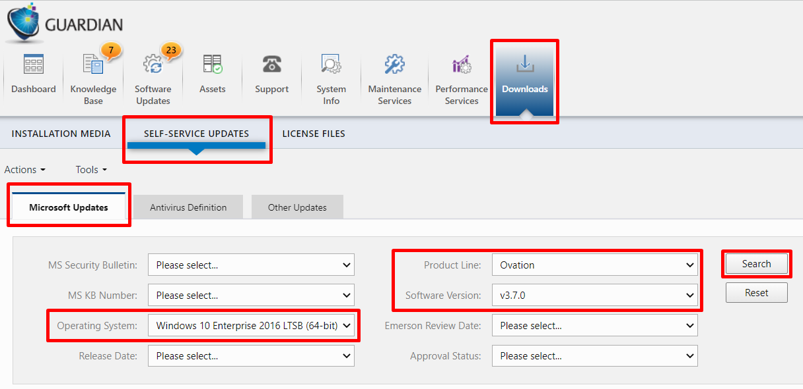

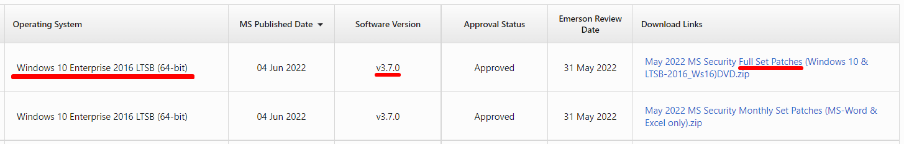

### Download Antivirus updates

* Antivirus updates can be found under *Downloads > Self-Service Updates > Antivirus Definitions*. Product Line must be set to ‘*Ovation*’. Antivirus software updates available are McAfee. Kaspersky and Lumension are listed, keep in mind that Ovation now utilizes McAfee as the validated Antivirus.

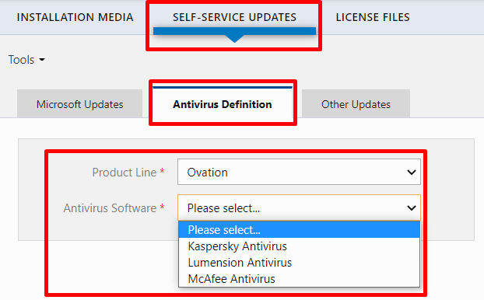

### Download Third-party updates

* Third-party updates can be found under *Downloads > Self-Service Updates > Other Updates*. Product Line must be set to ‘*Ovation*’. Third-party software updates available are Adobe, Cisco, Java, and Oracle.

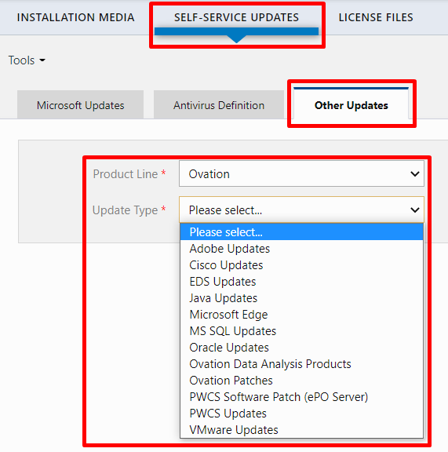

### Download Ovation updates

* Ovation updates can be found under *Downloads > Self-Service Updates > Other Updates*. Product Line must be set to ‘*Ovation*’. On the Update Type menu, select ‘Ovation Update’.

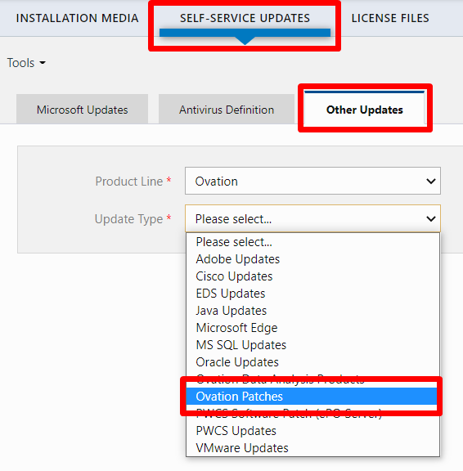

## Patch types

The patches distributed by Emerson via the above channels can be listed as follows:

* Ovation Patches
* Power and Water Cybersecurity Suite (PWCS) Updates and Hotfixes (Including PWCS Import Tool and latest .cab file)
* Microsoft Operating System Updates
* Adobe Patches
* Oracle Patches
* Java Updates
* Cisco Updates
* Antivirus Definition Updates: Kaspersky, McAfee, and Lumension*
* VMWare Updates

*\*Note: Kaspersky and Lumension updates have limited support*

# Installation

This section will summarize the most useful techniques and practices when patching a system. The scope will be limited to the most important applications and software platforms. From a procedural perspective, the following section will include relevant guidelines and instructions to do patching and have a better understanding of how the process works.

***Note:*** As a rule, it is strongly recommended to review the “Read Me“, “Instructions” and “Contents” text files before installing patches. These files will guide what to do in preparation for installing the patches, and what adverse effects can be prevented if the patches are installed incorrectly.

The *Read Me* file provides general guidelines for patch installation, whilst the *Instructions* file provides very specific installation steps for every patch, mostly for Ovation updates. The *Contents* files list all patches contained in every single patch set to be applied.

## Accessing patches

Patches can be accessed via several methods. We must ensure the right patches are provided to ensure healthy installation, which does not compromise any of the operations, and that they have been previously validated by Emerson. If previously released patches are needed, a request must be submitted to *R PWS SWLicensing* ([USPITSWLicensing@Emerson.com](mailto:USPITSWLicensing@Emerson.com)) to obtain the patches. Once the correct patches are delivered, their installation must be planned to avoid software crashing or processes conflicts.

## Before Manual Installation

### Manual Installation requires several considerations so that patching is performed successfully. Here is a summary of the recommended steps for installing patches:1. Create a database back up, and consideration for Oracle updates

The Database server is one of the most critical drops, hence a consistent backup routine is always a good practice. Before patching a system, a full backup is recommended to be generated:

First, confirm if scheduled backups are programmed in Developer Studio and take note of the last backup available in any of the DBS directories. You may need to consult with the customer where the backups are being stored and make copies if necessary (the default location is *C:\Temp* or *C:\tmp* folder).

To learn how to run the backup / restore utility, you may refer to the Appendix section at the end of this document: Running Backup / Restore utility

Secondly, if we are going to patch a system with Oracle updates, we can make sure to review the patches installed on it with commands on the desired machine. And we can make sure to back it up with the instructions on the same part of the appendix Running Backup / Restore utility, on the bullet point number

### 2. Run a System Registration Utility report

System Registration Utility (SRU) provides a comprehensive list of installed hardware and software components, as well as how drops and devices are defined and allocated in a specific system. Therefore, an SRU report provides a baseline of the existing software patching level, before any new patches are applied. This is important for the following reasons, among others:

* To avoid falling behind the existing patching level, if the system is already up to date with the latest updates.
* To understand what installed patches may be superseded, or if any dependency needs to be installed before loading the patches.

For instructions on how to run this report, refer to the Appendix section at Running a System Registration Utility report

### 3. Run NIC Deletion Test, if applicable (for MS patching only)

After the March 2018 MS patch set was released, an issue was identified which could potentially affect how the NIC drivers are loaded into the system during the booting process. In general, the issue could manifest in Ovation as follows:

* NICs missing from the Network Connections screen.
* Device Manager reports several unknown devices in other devices while Network Adapters are missing devices.
* Drop fails to communicate on the Ovation network.

As of the writing of this document, Microsoft has **not provided or developed a permanent solution** for this issue. If the issue manifests and is not detected before Microsoft patching, the appropriate course of action would be to uninstall Ovation, reboot, unbind OHI for both NICs, reboot, then uninstall OHI. With OHI out of the picture, the overall impact of this patch on an Ovation HMI is substantially less.

Please note that the issues concerning NIC driver’s removal are reported only for Windows 7 SP1 (32 or 64-bit) and Windows Server 2008 R2.

For more instructions on how to run the NIC Deletion Test, refer to the Appendix Section NIC Driver Deletion Test

**Note**: There are two additional files needed to run the PS scripts while performing the NIC Deletion Test. These files are **CheckPCI.ps1** and **Start-Collection.ps1** which need to be copied locally per instructions from Appendix. If not available, they can be downloaded from *Q:\ProductDevelopment\Share\MikeMMD\Microsoft\201807* (*Q:* refers to \\uspit-fp05\ shared drive). However, they can be proactively accessed from the patch folder.

**Note**: If your system uses Application Control, please ensure all endpoints are in Update Mode. Return them to Enabled Mode after patching is complete.

### 4. Make note of previous issues with Ovation or specific computers and servers

As a general practice for patching HMIs, it is recommended to check for previous issues that may have occurred on a specific machine. The occurrence of those issues may make the computer more vulnerable to adverse effects after patching is complete.

These issues can be logged in the Windows Event logs, as well as mini dump files that might be available in the machine’s directories. Mini dumps consist of files that are saved to the computer, each time the computer stops or crashes unexpectedly. They are generated as *.dmp files and depending on the Windows version, they can be in different directories. Mini dump files are usually located in *C:/Windows/Minidump/*.dmp* and the full memory dump in *C:/Windows/MEMORY.dmp*.

If a minidump file needs to be opened to review its content, you may need to use a Debugging Tool to read the .dmp file contents. If further instructions are needed to read these files, refer to the Appendix section.

Several Windows Event logs can be reviewed as well so that any critical error can be acknowledged. This will be discussed in detail in a later section.

### 5. Review the last patch cycle applied to the system

Understanding and acknowledging when the latest patches were applied is necessary before loading more recent patches. Failing this step can lead to issues due to patching inconsistencies, missing dependencies, or patches superseded by newer updates. Bear in mind that both workstations and servers must have the same patching level between each other, especially when any machine needs to be rebuilt.

#### For Microsoft patches

The easiest way to retrieve patching information is by going to *Start > Programs > Programs and Features > View Installed Updates*. The image below shows this path and a representation of how the Microsoft Windows updates appear.

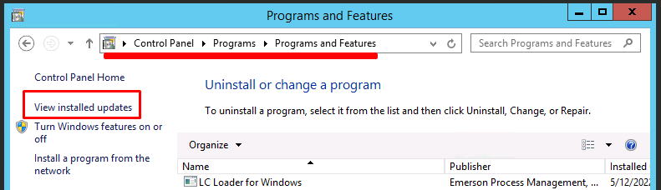

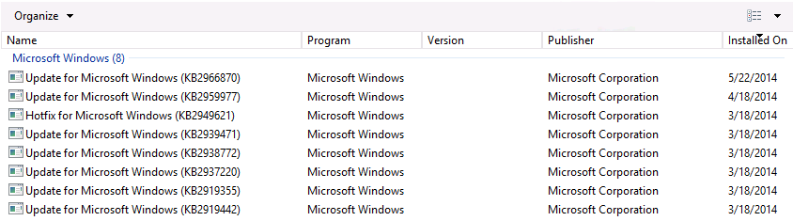

Microsoft patch installation scripts follow the below notation:

***OS_yymm_Patches.bat***

Where OS stands for the actual operating system and processor capacity, *yymm* stands for the year and month of release. Additionally, we have three different sets which may concentrate on several monthly rollup scripts from the past, which are usually noted as:

* ***OS_L3_Patches.bat***: install the patches for the last 3 rolling months
* ***OS_L6_Patches.bat***: install the patches for the last 6 rolling months
* ***OS_All_Patches.bat***: loads all the released patches up to date. This is needed for all new computers, and for those where patching lapsed for more than 6 rolling months.

Alternatively, you can run the following command from an elevated command prompt and check if it returns a list of installed MS patches in your system: **SYSTEMINFO**

This command locates information from the computer, we need to locate in the results the “KB” followed by numbers, usually under the “Hotfix(s)” section. These are the MS updates. The images below show the result of the command and the patches in the system, they are the same numbers.

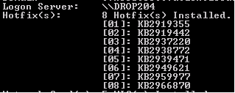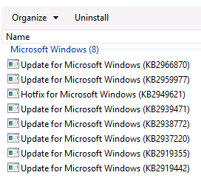

#### For Ovation patches (including OPH)

Go to *Start > Programs > Programs and Features > View Installed Updates*. They are usually listed at the bottom of the installed updates section.



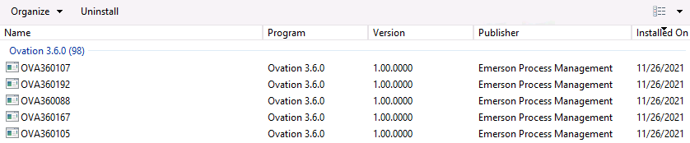

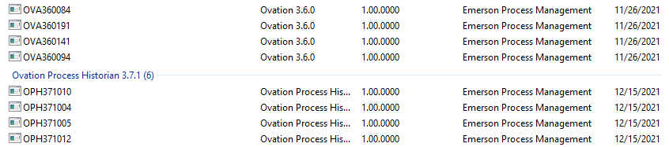

#### For Oracle patches

To check the Oracle version, open the command prompt and run the command SQLPLUS, below we can see an example of it.

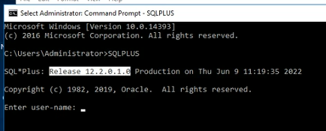

Run the following commands which will print out a list of Oracle patches in both the command prompt screen and a text file:

* Open Command Prompt in the machine where you need to check the Oracle patches.
* Type *cd %ORA_HOME%\OPatch* (Note: Typically, *%ORA_HOME%* refers to *C:\Oracle\Ora11g* or *C:\Oracle\Ora12c* for newer Oracle installations)
* Type *set ORACLE_HOME=%ORA_HOME%*
* Type *opatch lsinventory*
* A file will be generated on the screen. Also, the same list will be exported to an Oracle directory, which is printed out in the command results as well.

### 6. Check for critical errors in Event Viewer

Same as for mini dumps, it is recommended to gather Windows Event logs to anticipate any issue that has been critical to a specific machine, as well as identify machines that are most likely to fail during patching. If any critical error is spotted while reviewing the different logs, it is recommended to take note of it. Common sense dictates that running event logs for all machines in a system can be time-consuming and tedious. Therefore, it is recommended to check with the customer which machines have had the most issues in the past as well as which ones are more critical to the operations and run Windows Event logs on those machines.

The most relevant event log types are *Application*, *System,* and *Security* logs. *Directory Service*, *DNS Server,* and *File replication* exist only on Domain may not be relevant to patching.

Below is a summary of these logs:

|  |  |
| --- | --- |
| **Event Log Type** | **Description** |
| Application Log | Any event logged by an application. These are determined by the developers while developing the application. Eg.: An error while starting an application gets recorded in Application Log. |
| System Log | Any event logged by the Operating System. Eg.: Failure to start a drive during startup is logged under System Logs |
| Security Log | Any event that matters about the security of the system. Eg.: valid and invalid Logins and logoffs, any file deletion, etc. are logged under this category. |

For this, we can follow the instructions located in the appendix Windows Event Logs to learn how to collect and review these 3 types of Windows Event logs.

### 7. Patching timeliness

Patching requires intervention on HMIs and controllers; therefore, it is recommended to be done while the plant is in an outage. This applies specifically to when a complete patch set needs to be loaded into a system.

There are cases when a single patch needs to be loaded to address an issue. In those cases, all the necessary precautions need to be taken, especially for critical drops. Otherwise, the patch can be loaded safely, as criticality permits.

As explained before, consultation with the customer is advisable to understand criticality, for example, in presence of trip prevention mechanisms or auxiliary systems running in the plant while patching is being performed.

One important milestone is the feature pack figure. Emerson has introduced the concept of feature packs to the distribution and software lifecycle methodologies. The feature patch philosophy has been implemented for the most recent platform releases. The main concept comprises several different updates in one single package, which is intended to not be disruptive. Nonetheless, each feature pack installation will require a controller reboot to take effect, therefore a preventive plan is needed before installing any feature pack.

### 8. Prerequisites for patching

As stated before, it is necessary to reduce the impact on the system when patching. Therefore, all the documentation available with the patch set media needs to be carefully reviewed to take preventive actions and understand if any dependency or prerequisite needs to be previously installed. Instructions and *readme.txt* files need to be checked. For example, certain Ovation and Microsoft patches require .NET Framework to be previously or simultaneously installed.

Also, we encourage you to actively check for ongoing *Issues Under Investigation* (IUIs) that could potentially affect the system undergoing a patching cycle.

### 9. Coordinate with the customer when patching a system

When patching a system, it is recommended to review with the customer which machines may pose a risk of failure during and after patching. Those machines should be treated as critical (for example, machines located in the control rooms are often the most critical), while the ones that do not seem to be impacted can be patched and rebooted first.

## Guide for manual installation of updates

### Steps to install MS Security Patches

This procedure uses a script file to install the patches. The Patch files can be loaded from the Monthly CD (MSSP-mmyy) or downloaded from the section Download Microsoft updates

**A note for first-time installation**

Some Microsoft patches require an immediate reboot before other patches could be installed. On a new installation of the MS Operating System (OS) it is recommended to run the Full patch script twice to ensure all active patches are installed.

**Script Event Log**

On these Microsoft patches, we run scripts so we can review the log to know the status and review that this is working correctly. Every time a Script is run, it is logged in the Client drop Event Viewer Application log as Event ID = 201, Source = "PWS Windows Patch BAT" and the Date & Time the script run started.

**The selection of the proper Script file (XXX.bat) depends on**

* 1. The OS version loaded on the Workstation (where, OS = Ws12R2, W10-LTSB(1607), W10-LTSC(1803), Ws16, Ws19)
  2. Patches on the Workstation were updated in the previous month or earlier.
  3. No Patches were previously loaded on the drop.

Additionally, we have three different sets which may concentrate several monthly rollup scripts from the past, these correspond to the usual name format of these patches, which are usually noted as:

* ***OS_L3_Patches.bat***: install the patches for the last 3 rolling months
* ***OS_L6_Patches.bat***: install the patches for the last 6 rolling months
* ***OS_All_Patches.bat***: loads all the released patches up to date. This is needed for all new computers, and for those where patching lapsed for more than 6 rolling months.

**1. If loading directly from the Microsoft Security CD (MSSP-mmyy):**

Insert the MSSP-mmyy CD in the CD Drive (Say, E:\)

In the Microsoft Explorer window, Select the E:\ drive

Load Patches

* 1. Run the monthly Load Script on drops to install only the latest patches.

OS_yymm_Patches.bat

* 1. Run the L6 Load Script on drops to install the patches of the last 6 rolling months.

OS_L6_Patches.bat

* 1. Run the OS Load Script on new drops to load all the patches.

OS_All_Patches.bat

**2. If loading from the WEB site:**

Create a Patch directory on a Server or Local PC and Download the monthly Patch file on Workstation - Patches directory = C:\MS_Security\Patches

mkdir C:\MS_Security\Patches

Download MS-Patches_MMMyy.zip into C:\MS_Security\Patches

**3. Unzip the Monthly Patch directory** (be sure to unzip via "Extract" to maintain the proper folder structure for this month's patches.)

**4. Load Patches**

Insert the cd MS_Patches_MMMyy

Run the monthly Load Script on drops to install only the latest patches.

Run the OS_yymm_Patches.bat

**5. Reboot the drop**

**Note:** All the patches are installed with a /norestart flag. After the last patch is installed, a shutdown command forces the drop to restart at the end of the patch installation.

### Updating Oracle Updates

For the Oracle patches, before downloading them you can go to the command prompt and run the command “SQLPLUS” to check the ORACLE version. Once they are downloaded and before doing updates, the file should contain a README file that includes the steps to back up the Oracle database and instructions on detailed versions and how to install them. It is highly recommended to review the README file, as some additional steps could always be included depending on the ORACLE version we are trying to update.

**Word of caution:**

1. If the Database server also has OPC Server software or OPC Client software, installing this patch would initially stop the services of OPC. This might affect the OPC data operation at that time. After patch installation, those services which were stopped will be restarted and restored to the original status.
2. During patch installation the services linked with Oracle shall be restarted, in turn, the Ovation applications linked with those services may get affected only for the period of patch installation.
3. This process might take quite a long time to update, be mindful that this updating event could even take up to 2 to 3 hours.

Generally, the steps are on the read me file, but we recommend first doing a backup of the Oracle database, this is also a highly recommended action to do before any updates, this would be to backup the Oracle Database, the Oracle binaries (found under %ORACLE_HOME%), and the Oracle inventory under C:\Program Files\Oracle before applying these patches.

These next steps apply to the Oracle updates we can download with the instructions in the section Download Third-party updates. These patch instructions are a general guide, they are not meant to be an anytime guide, they are to provide an example of what is usually required. For every patch, is recommended to review the ReadMe file inside.

### Installation of Ovation patches

For Ovation updates, we need to make sure to establish the recommended order of patch installation within the Ovation architecture, there is an order of installation, recommendations during the actual installation, and the post-processing steps.

**NOTE:** For the patches downloaded from Guardian called ***“Ovation Patch for 3.X.X”*** is recommended to always **review the README file** inside before the actual installation.

To download these patches, you can follow the guide onDownload Ovation updates

#### Order of installation

The recommended order of installation is to:

1. Starting with the **Database Server**
2. Followed by the **Operator Station**
3. The **Base Stations** are next.
4. After these, you can load patches on any **non-Ovation drops** in your system, if applicable.

**NOTE:** Remember to reboot each drop when finished.

Inside these patches, they also sometimes mention another specific order to installation, but this order is for the first deployment of the Ovation software in a system, or when rebuilding a machine. So when we are initially installing Ovation or rebuilding a machine, the correct order they recommend performing this is:

1. First, prepare the Windows system for Ovation installation by configuring the Ovation NIC configuration (OHI, NIC Teaming, Net Bridge).
2. Install the Ovation software
3. After installation is complete, Ovation monthly patches can be installed.
4. Only after installing the Ovation patches, you can proceed to install the Microsoft patches and Security patches.

#### Rules for patch installation

Use the following rules when installing patches to confirm a correct installation:

* Before installing a new update, check for and remove any Preliminary Patches, for example, OVAREL###-Preliminary, that was previously installed on your system.
* Before you execute any installation, open **the README file** and read it. This file allows you to familiarize yourself with the contents of the update and the installation requirements of the various patches.
* The Ovation Update should be installed on **every** Ovation drop in your system.
* Some Ovation versions like 3.6 and 3.7 include Feature packs, usually, these have to be installed before installing monthly patches.
* You have the option to install only certain patches; however, Emerson **strongly recommends** that you select the **Install ALL** option.
* There will be patches that do not apply to your system or a certain drop type. **Continue to install all patches on all drops**. The Update checks the applicability of a patch to a drop type and automatically skips it if the patch does not belong. It then goes on to the next patch.

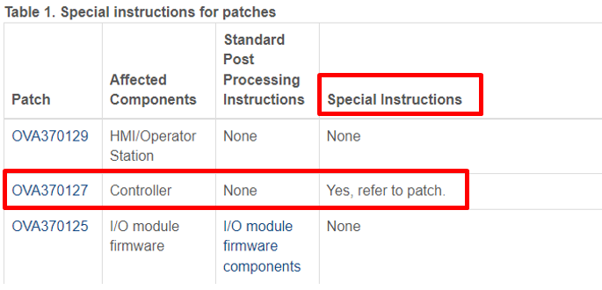

* Be aware that certain patches have dependencies and may need to be loaded in a particular order.
* If your Primary Domain Controller is a combination Ovation Security Server (OSS)/Database Server (DBS) drop, start the installation with the Database Server. However, if the Primary Domain Controller is a standalone Ovation Security Server (OSS) drop, you must load the Security Server drop first, and then proceed to the Database Server drop followed by the Operator Stations and Base Stations
* **Reboot** the drop after the update installs. You can delay the reboot for later, but you **must** reboot the workstation before resuming the Ovation operation.
  + Certain patches require a forced reboot in the middle of the installation process. To review the information on these patches, within the files there should be a list of these patches describing the machine that they belong to be installed and the order. Perform the reboot if it is required. When the machine finishes the reboot, it begins where it left off in the install procedure.
* After you install the update, reboot, and login for the first time, a window appears showing which patches were loaded on the drop. Depending on the patch and the Ovation component it pertains to, you will perform standard post-processing procedures. Refer to General post-processing installation procedures by Ovation component.
* When a patch is installed, the installer automatically takes the new files and puts them in the correct location on your C:\ drive. The old files are put in a backup directory where they are kept in case you need to return them at a later time. Do **not** manually delete the backup files.
* If you want to remove Ovation, use the Windows **Add/Remove** program.

#### General procedure for Ovation patch installation

If there are pre-requisites before the installation, the readme files mention them, for example, Ovation 3.7 has a prerequisite that you must install Feature Pack 1 or ESP before installing the current month's patches.

Remember that this guide is meant to be a general procedure for the installation of these patches, the steps we are recommending for performing this installation are as follow:

1. Obtain the applicable patch update files. You can refer to Download Ovation updates
2. **Starting with the Database Server**, perform one of the following steps:
   1. Insert the CD/DVD into the Database Server disk drive.

OR

* 1. Insert the USB drive into the Database Server's USB port.

1. Open the README file and read it so you are familiar with the contents of the update.
2. Double-click the **Update.exe** file. The installation process begins.
3. Accept the terms of the license agreement and click **Next**.
4. Select the option to **Install All** (recommended).
5. The patch installs. When complete, **reboot** the drop
   1. **If you encounter patches that require a forced reboot in the middle of the install update procedures, perform the reboot. When the machine finishes the reboot, it begins where it left off in the update.**

**Wait 3 - 5 minutes before you first log on to the Database Server to allow Oracle processes to start in the correct order.**

1. Repeat **Steps 2 - 7 t**o load patches on each **Operator Station** in your system. Remember to reboot each drop when finished.
2. Repeat **Steps 2 - 7** to load patches on each **Base Station** in your system. Remember to reboot each drop when finished.
3. Repeat **Steps 2 - 7** to load patches on any **non-Ovation drops** in your system, if applicable. Remember to reboot each drop when finished.
4. After you install the update, reboot, and login for the first time, a window appears showing which patches were loaded on the drop. Depending on the patch and the Ovation component it pertains to, you will perform standard post-processing procedures. Refer to General post-processing installation procedures by Ovation component
5. In addition, certain patches require additional steps.

##### Ovation Process Historian Patches

These instructions apply to the patches with program version OPH3.X.X-MM-YYYY found on the Guardian Website. Refer to Download Ovation updates. We are providing general patch installation instructions below, to determine the patch level we can use For Ovation patches (including OPH).

These next steps are a general OPH guide for patches installation:

* Read through the instructions for each specific patch.
* Emerson strongly recommends that you install every patch in the Update CD using the Install All option.
* After installation of the selected patches, you will be prompted to reboot the Workstation.

You can delay the reboot for later, but you must reboot the Workstation before resuming Ovation operations.

Inside the README file of these Ovation Process Historian patches, there is a detailed part for the installation notes for them, below we are adding an example of OPH 3.7.1

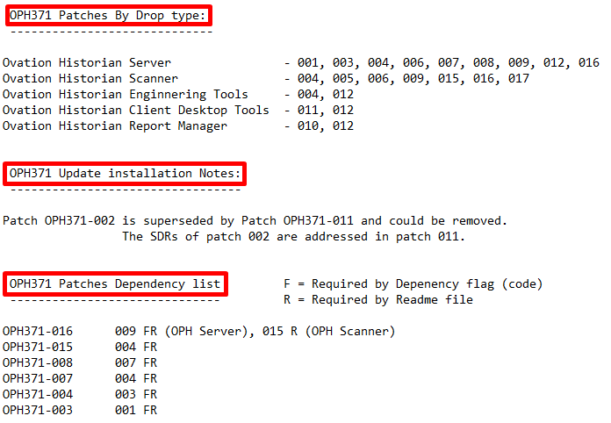

For specific patch instructions, see the Information for a specific patch, where it is installed, affected components, dependency, Standard Post Processing Instructions, and Additional Instructions

##### Controller Patching

Patching a controller needs special attention as well, since this may involve specific updates to I/O firmware. Usually, VxWorks does not need to be patched since every controller is manufactured with the latest updates available.

When patching a controller, a download reboot must follow the patches applied. It is recommended to reboot by the controller switch rather than performing a soft reboot. Some updates require a hard power cycle; this is highly recommended when the plant is offline to diminish any impact.

Also, installing controller-related patches is done from the actual database server.

If it is necessary to confirm whether a reboot was done preceding the download of a controller, Controller Diagnostics can be checked to easily view the patching status. To do so, go to Controller Diagnostics and select the controller pair that needs to be checked. Under *Controller Information*, search for Controller Patch and Kernel Patch. If the controller was effectively rebooted, both the Controller and Kernel patch should match. If not, Kernel Patch should not have been updated. Please note the above applies to Ovation 3.5 and later only.

#### General post-processing installation procedures by Ovation component

Each version of patches includes a new post-patching process, some of these instances might not be covered below as every new control or graphics fix and/or enhancement might need a specific step.

This is clearer to note in HMI/Operator Station as they are listed as an affected Ovation component in the individual patch topics. Typically, there are no standard post-processing instructions for HMI/Operator Station components. For the infrequent occasions where post-processing is necessary, the steps will be listed as **Additional Instructions or Special Instructions**. An example of this is below:



You should perform the post-processing instructions after you complete the initial installation instructions. The following list shows the functions that require general post-processing:

* For ALL Controller components.
* For ALL I/O module firmware components.
* For ALL Developer Studio components installed on a Database Server.

The following post-processing instructions apply to patches that are applied to these three previous points and have Standard Post Processing Instructions with NO Additional Instructions.

To determine if the specific patch has only standard Post Processing Instructions or if it includes additional Instructions, we can refer to the following section in the appendix Information for a specific patch, where it is installed, affected components, dependency, Standard Post Processing Instructions and Additional Instructions

##### Post-processing for ALL Controller components

**NOTE:** This applies to patches that have Controller as affected components and have Standard Post Processing Instructions with NO Additional Instructions.

For ALL Controller patches:

1. Install the patch on the Database Server.
2. From the Developer Studio system tree, find the Controller you want to download. Right-click and select **Download**.

**NOTE:** **When downloading and rebooting Controllers**, **start** with the Controller that is **in control**, and then proceed to the backup (partner) Controller.

1. For redundant Controller configurations, the Download Wizard appears. Select the drop that is currently in control and click **Finish**.
2. If the Download Preview dialog box appears, perform the following steps:
   1. Select the **files**to be included in the download.
   2. Select the **Download**check box and click **Ok**.

**NOTE:** Some Ovation versions after 3.5.1 let automatically reboot after completing the Download command, by selecting both **Download**and **Reboot**before clicking **Ok**. Then, you could skip to Step 7. You can configure the system to bypass the Download Preview window.

1. If you did *not*choose to automatically reboot after the download, return to the Developer Studio, and right-click the Controller you just downloaded. Select **Reboot**.
2. For redundant Controller drop configurations, the Reboot Wizard appears.
   1. Select the **same Controller drop** that was selected for the download.
   2. A confirmation dialog box appears. Click **Yes** to close the window and execute the reboot process.
3. The reboot process may take several minutes. Wait until the Controller boots into Backup mode.
4. Repeat Steps 2 through 6 to download and configure the backup (Partner) Controller.

##### Post-processing for ALL I/O module firmware components

1. Access the Controller Diagnostics utility.
2. Click the **I/O information** tab and select the desired module.
3. Select the **Download Available Firmware** button.
4. The Module Firmware Download window appears. Compare the firmware in the Controller Version field to the firmware in the Module Version field to determine if you have the latest firmware on your I/O module.
5. Select the files you want to download.
6. Click the **Download**button to load the latest firmware onto your Ovation module.
7. When the download is complete, you may be prompted to reboot the module. Click **Reboot Module**.

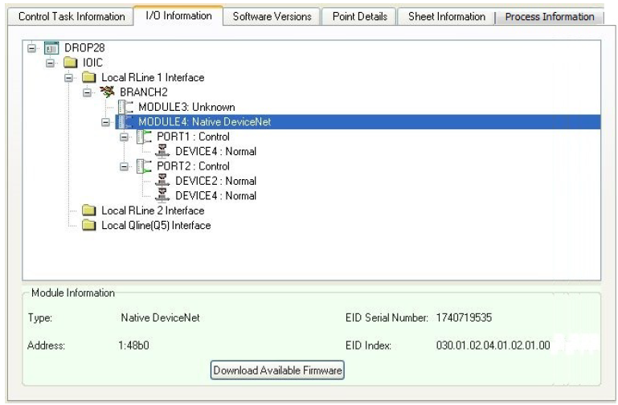

##### Post-processing for ALL Developer Studio components installed on a Database Server

On the Ovation Database Server, Developer Studio component patches automatically execute the OvPtBridge.exe and OvPtNetBridge.exe applications following the reboot phase of the patch installation. Specifically, this occurs when you log in. These applications (OvPtBridge.exe and OvPtNetBridge.exe) may fail to execute correctly if the Oracle database is not available at the time of its execution.

If OvPtBridge.exe does not execute, the installation script does not attempt to execute OvPtNetBridge.exe. Proper patch installation requires that both of these applications be executed successfully and in the proper order (OvPtBridge.exe followed by OvPtNetBridge.exe).

To ensure that the patch installation is complete, perform the following steps:

1. Wait several minutes (**for example, 3-5 minutes**) to log on following the reboot phase of the patch installation.
2. Inspect the patch log file (\Ovation\Log\Patch.log) to verify that the OvPtBridge.exe application has properly executed (use the time/date stamp to determine the proper entry in the file). If these applications do not execute successfully, perform a manual execution of the OvPtBridge.exe application by opening a command window and entering the following commands:

**C:\> OvPtBridge ptadmin@ptdb**

**C:\> OvPtNetBridge ptadmin@ptdb**

# APPENDIX

### Crossroads URL link

<http://pwsintra.emersonprocess.com/sites/crossroads/default.aspx>

### Running Backup / Restore utility

* In Developer Studio, go to *[Systems]* > {Your System} and right-click on this object. Select ‘*Backup / Restore*’.
* The Ovation Backup / Restore utility will show up. ‘*Backup Now*’ can be chosen. The destination directory is usually selected as *C:\Temp*, but a different directory can be specified. Also, make sure the information populated in the ‘Parameters’ tab is populated correctly to avoid errors during backup creation.
* When the backup operation is complete, make sure the backup output file is properly saved. As instructed in the README files from the Oracle patches, it is highly recommended to take the backup of the Oracle Database, the Oracle binaries (found under *%ORA_HOME%*), and

the Oracle inventory under *C:\Program Files\Oracle* before applying these patches.

### Running a System Registration Utility report

**Note:** To prepare for running a System Registration Utility report, the Ovation System ID and the IP address and password from the root switch will be needed.

* In the database server, go to Start > Ovation > Ovation Utilities > SureService Ovation System Registration utility.
* Click Next.
* In the license agreement, select: “I can confirm the existence of a license agreement with Emerson Process Management”
* Click Next.
* Fill out the registration system contact information (red dot indicates a required field) and click Next.
* In the collection screen, select Start Collecting. Before the process begins, the Network Device Login Information dialog box appears; enter the IP address and password for the root switch of the Ovation system. Note that the default password is *wdpf*, default IP address of the root switch is *192.168.x.1*.
* Click on Ok (the collection process begins; it may take several minutes).
* After it finishes click on Next.
* Review all the information and click Save Report and save it in HTML format.

### NIC Driver Deletion Test

If there is a concern before deploying patches, the following test can be run to determine whether the NIC drivers will be deleted following a reboot after patching.

#### Copy Files to Endpoint

Two files need to be copied locally to the endpoint:

* *CheckPCI.ps1*
* *Start-Collection.ps1*

Copy these two files to a local folder such as *c:\temp\PatchTest*

#### Run Test

By default, Windows does not allow all scripts to run. We will temporarily turn this down to test.

* Open a PowerShell prompt.
* Navigate to your temporary location, for example, c:\temp\PatchTest

***cd c:\temp\PatchTest***

* Set the current session’s execution policy to Unrestricted

***Set-ExecutionPolicy -Scope Process -Force Unrestricted***

* Run the test

***.\CheckPCI.ps1 -AutoAssignIP Save -TestOemInf Yes -StartCollect Before***

**NOTE:** Please note these tests will take a few minutes. A few error messages will be seen. This is fine given the version of PowerShell typically present on these endpoints. If you see more errors or the script does not complete, please contact support.

#### Review Output

* In the folder where the scripts are located, for example, c:\temp\PatchTest, locate a file that ends in IP_and_NetAdapter_INF_test.log. If this file does not exist, please contact Support.
* Open this file in Notepad.
* Look near the end of the file.
* If you see lines like those seen in Pass Condition Output Examples, you will not encounter the NIC driver deletion issue. This machine may be patched with high confidence.
* If you see lines like those seen in Fail Condition Output Examples, you will encounter the NIC driver deletion issue. Do not patch this machine. Please verify that it is not a false positive (see the section below). If it is not a false positive, or you are unsure, please contact support.

#### Pass Condition Output Examples

Please note the pass condition reports that an oem*.inf driver was found.

*The oem11.inf driver file was found in C:\windows\INF*. This file is used by:

* NIC(s):
* Driver(s): Ohi Miniport

*The oem6.inf driver file was found in C:\windows\INF*. This file is used by:

* NIC(s):
* Driver(s): vmxnet3 Ethernet Adapter

*The oem11.inf driver file was found in C:\windows\INF*. This file is used by:

* NIC(s):
* Driver(s): Intel(R) Gigabit 4P I350-t rNDC

*The oem12.inf driver file was found in C:\windows\INF*. This file is used by:

* NIC(s):
* Driver(s): Ohi Miniport

*The oem18.inf driver file was found in C:\windows\INF*. This file is used by:

* NIC(s):
* Driver(s): WindRiver WRTAP

*The netb57vx.inf driver file was found in C:\windows\system32\DriverStore\FileRepository*.This file is used by:

* NIC(s):
* Driver(s): Broadcom NetXtreme Gigabit Ethernet

#### Fail Condition Output Examples

Please note these fail condition reports [Warn] and a file was NOT found.

* Examples of bad states would include [Warn] messages for NICs that are in use by your system

*[Warn] The wnetvsc.inf driver file was NOT found in C:\windows\INF*. This file is used by:

* NIC(s):
* Driver(s): Microsoft Virtual Machine Bus Network Adapter
* Examples of false positives would include [Warn] messages for NICs that are not in use by your system

*[Warn] The netbrdgm.inf driver file was NOT found in C:\windows\system32\DriverStore\FileRepository*.

This file is used by:

* NIC(s): MAC Bridge Miniport
* Driver(s): MAC Bridge Miniport

This MAC Bridge Miniport is a known false positive and does not affect Ovation systems. It is safe to ignore. If you have any questions, please contact support.

### Reviewing mini dump files for Windows

As explained before in the document, reviewing mini dump files can be helpful to understand which machines are prone to fail while patching. To review these files, it is recommended to have a miscellaneous tool such as Microsoft Debug Diagnostics Tool. The tool can be downloaded from the following URL link:

<http://www.microsoft.com/download/en/details.aspx?id=26798>

The debug tool can help analyze memory dump files that may have been created by Windows, and generate reports along with recommendations to resolve the identified problems from the Advanced Analysis tab. Further instructions can be found on the Microsoft Support website on <https://support.microsoft.com/en-us/help/2580960/debug-diagnostics-tool-v1-2-is-now-available>

Depending on the Windows OS version, there could be different locations where mini dump or full dump files can be located. However, the standard location is typically *%SystemRoot%memory.dmp*, i.e *C:\Windows\memory.dmp*. If not in this location, search for any *.dmp files in the entire directory. Finally, you may want to check the Startup and Recovery settings on the machine to learn if writing memory dump information is enabled (typically from *Start > Control Panel > Performance and Maintenance > System >Advanced > Settings > Startup and Recovery*).

### Windows Event Logs

 The following instructions are to review/collect these event logs from the Event Viewer at the System, Application, and Security levels

1. Right-click on the Windows Start Icon.
2. Search for *Event Viewer*.

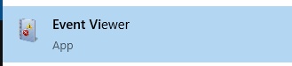

1. Expand the *Windows Logs*

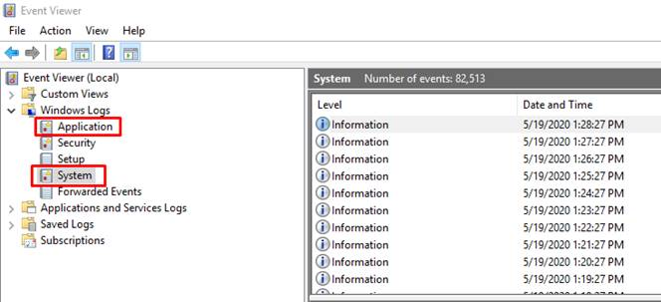

1. Right-click in the *Application tab*, select *Save all Events As...*
2. Choose a location and a name for the Output file.
3. Repeat the process for the *System tab*

### Information for a specific patch, where it is installed, affected components, dependency, Standard Post Processing Instructions, and Additional Instructions

We can use the Ovation User’s Group website <https://www.ovationusers.com/> and go to the tab “Support & Security”, inside there is an option for Ovation patches.

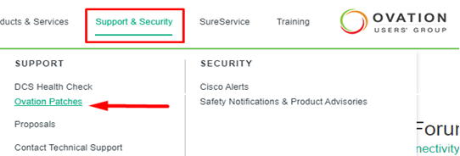

Inside each Ovation patch, we can find these requirements for them. An example of this is below:

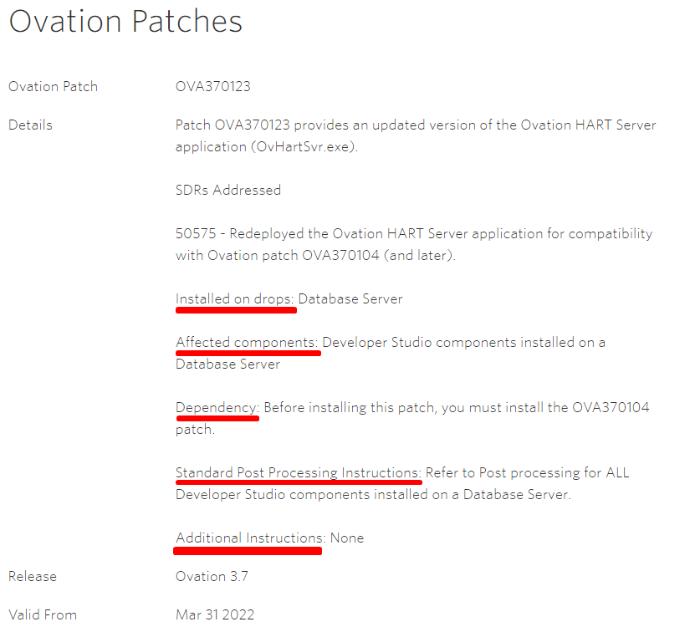

### Guidance on the installation of patches on Windows OS for Windows Server 2008 R2 and Windows 7 to evade issues with the machines

The next problems have been reported when installing update patches on the Windows Server 2008 R2 y Windows 7:

* **Ghost NIC:** after installing all the Windows patches, the computer reboots, but it does not detect any of the network connections that were previously configured, the solution for this many times is by reinstalling the machine completely. (***Internal KBA1325***)
* **RAID Driver issue:** after installing the Windows patches, the computer reboots, but it does not detect any hard drive to initiate Windows. The solution for this is reinstalling the RAID Controller Driver to make the machine able to detect these hard drives again. (***Internal KBA1344***)

To avoid these inconveniences, we must review that the following patches are correctly installed on the machines before attempting to install all the cumulative patches:

* Windows 7 / 32-bit:
  + Review that the patch **KB4490628** is installed correctly, this patch is a pre-requisite for the next step.
  + Review that the patch **KB4489878** is installed correctly, this patch prevents the networks are left without configuration and prevents the driver from being erased on the computer.
  + Review that the patch **KB4474419** is installed correctly.
* Windows 7 / 64-bit:
  + Review that the patch **KB4490628** is installed correctly, this patch is a pre-requisite for the next step.
  + Review that the patch **KB4489878** is installed correctly, this patch prevents the networks are left without configuration and prevents the driver from being erased on the computer.
  + Review that the patch **KB4474419** is installed correctly.
* Windows Server 2008 SP2 / 32-bit:
  + Review that the patch **KB4490628** is installed correctly, this patch is a pre-requisite for the next step.
  + Review that the patch **KB4489878** is installed correctly, this patch prevents the networks are left without configuration and prevents the driver from being erased on the computer.
  + Review that the patch **KB4493730** is installed correctly, on this Windows OS version this is a pre-requisite for the next step.
  + Review that the patch **KB4474419** is installed correctly.
* Windows Server 2008 R2 SP1 / 64-bit:
  + Review that the patch **KB4490628** is installed correctly, this patch is a pre-requisite for the next step.
  + Review that the patch **KB4489878** is installed correctly, this patch prevents the networks are left without configuration and prevents the driver from being erased on the computer.
  + Review that the patch **KB4474419** is installed correctly. For this patch on this OS version, there are 3 different versions with different certificates, when in doubt about which one is installed, we recommend re-installing it.

All the patches can be found inside the last installation disk of Windows patches on the following routes:

* \MS19\MS1903-W7-Ws08R2-SSU\windows6.1-kb4490628-x86_3cdb3df55b9cd7ef7fcb24fc4e237ea287ad0992.msu
* \MS19\MS1903-W7-Ws08R2-SMQR\windows6.1-kb4489878-x86_4850c313f7149cbebe5cd718d4efa0e426aebc81.msu
* \MS19\MS1909-W7-Ws08R2-SHA-2SU\windows6.1-kb4474419-v3-x86_4850c313f7149cbebe5cd718d4efa0e426aebc81.msu

To install these patches, we must access the address where this patch is being stored through the command prompt, and then apply the patch in the following way with the command:

* .\<***name of the patch file***.msu> /quiet /norestart
  + Be sure to replace the section with the actual name of the patch file you want.

Once the command line comes back to display its initial status and more commands can be run, give the system about 5 minutes while the patch finalizes its installation, and then reboot the server [NOTE: every time a Windows patch is installed using this method the server/machine must be restarted before applying the next patch]

Once the required patches have been installed, we must proceed to perform a test through the PowerShell and utilizing two Windows executables that come inside the same set of patches downloaded:

* NIC_Driver_Test/CheckPCI.ps1
* NIC_Driver_Test/Start-Collection.ps1

These two files are going to be copied into a temporal folder that must be created in the Server in the next path:

* C:/tmp/PatchTest

Once the files have been copied, we can proceed to open the program Windows PowerShell and execute the following commands:

* cd c:\temp\PatchTest (these place us on the folder where we have the files)
* Set-ExecutionPolicy -Scope Process -Force Unrestricted (changes the Windows policies to be able to initiate the executables that we copied)
* .\CheckPCI.ps1 -AutoAssignIP Save -TestOemInf Yes -StartCollect Before (this executes the files that were previously copied)

Once the commands are done executing [some expected errors could be observed during the process], search for the finished file in the **IP_and_NetAdapter_INF_test.log**.

* If the file contains similar lines to the following, then it is possible to proceed with the application of the patches:

20180716_094059_0311: **The oem11.inf driver file was found** in C:\windows\INF. This file is used by:

NIC(s):

Driver(s): Ohi Miniport

20180716_094059_1403: **The oem6.inf driver file was found** in C:\windows\INF. This file is used by:

NIC(s):

Driver(s): vmxnet3 Ethernet Adapter

20180710_164313_4021: **The oem11.inf driver file was found** in C:\windows\INF. This file is used by:

NIC(s):

Driver(s): Intel(R) Gigabit 4P I350-t rNDC

**NOTE:** in the message, the number after the **oem** can change and might not be the same as the example above. What is a must is the path after the message, the path **C:\windows\INF**

* If the file contains similar lines to the following, then it is NOT possible to proceed with the application of the patches:

**[Warn] The wnetvsc.inf driver file was NOT found** in C:\windows\INF. This file is used by:

NIC(s): Microsoft Virtual Machine Bus Network Adapter

If the issues for the **Ghost NIC** or the **RAID Driver** present an error after the instructions we described, we must follow with each correspondent internal KBA for each of the issues, these KBA numbers are described at the beginning of this.