Hello NAME,

Thank you for contacting Ovation Product Support today. Below is a recap for your record; please reference the Call Record Number below to request or provide an update on this case.

|  |  |
| --- | --- |
| ***Product Support record number:*** |  |
| ***Customer Name:*** |  |
| ***Customer Support Specialist:*** |  |
| ***Urgency Level:*** | *[Critical, Major, Minor] to be defined by GSC Engineer* |
| ***Call Subject:*** |  |
| ***Affected SW Version:*** |  |

**Problem Details**

General questions to be asked to the customer

* Why the customer is calling Product Support?
* Which is the Affected SW version or versions?
* What is the complexity level of the cybersecurity solution (AV, Standalone, Light, Full PWCS)?
* When did you notice the issue for the 1st time?
* Were any configuration changes being performed?
* Have patches been recently applied?
* What troubleshooting steps have been tried?
* Is the plant running at this moment?
* Is this issue affecting your production?
* Is there a deadline for getting the issue resolved?

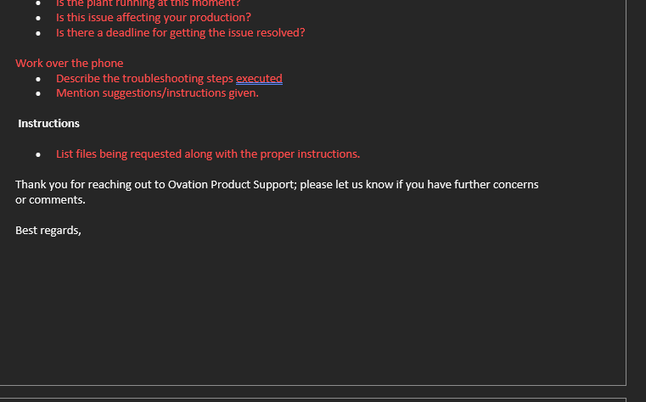

Work over the phone

* Describe the troubleshooting steps executed
* Mention suggestions/instructions given.

**Instructions**

* List files being requested along with the proper instructions.

Thank you for reaching out to Ovation Product Support; please let us know if you have further concerns or comments.

Best regards,

