Teacher.Solar
Hardware Development Write-up

1. Overview:

For the initial phase of the project the goal was to develop a solar powered, bluetooth enabled, audio board that was capable of streaming audio to headphones as well as loudspeakers.

We chose ESP32-A1s modules for this purpose as it incorporates an i2s DAC (digital to analog converter) capable of outputting a stereo headphone audio stream, an unamplified stereo stream for further amplification and has inputs for line level audio signal as well as sufficient infrastructure for hooking up either i2s or capacitive microphones. Furthermore the module is equipped with Bluetooth as well as WiFi, creating multiple ways to get it connected to other devices.

The implementation of the module required several key components to be placed on the custom PCB to allow for desired functionality:

- A. USB to UART converter – to allow the ESP32 module to be interfaced with a PC using a USB cable for programming, debugging and controlling the module
- B. MPPT IC – A Maximum Power Point Tracking IC was used to maximize the power delivered to the PCB when operating from a solar panel
- C. Supercapacitor charger – to allow an on board supercapacitor to be charged and discharged safely, both in USB and Solar modes
- D. Boost converter – since the ESP32 module operates at 3.3v it was necessary to boost the output voltage of the supercapacitors which normally have a maximum voltage rating of ~3v
- E. Card Reader – this allows a micro-SD card to be inserted into the PCB for audio playback, recording as well as other storage intensive operations (data logging, etc.)
- F. Audio Amplifier – this allows us to connect a loudspeaker to the PCB for loud audio output
- G. Connectors & Switches – various connectors and hardware switches allow further control of the module (volume control, download mode, etc.) as well as hooking up of additional peripherals and sensors/actuators
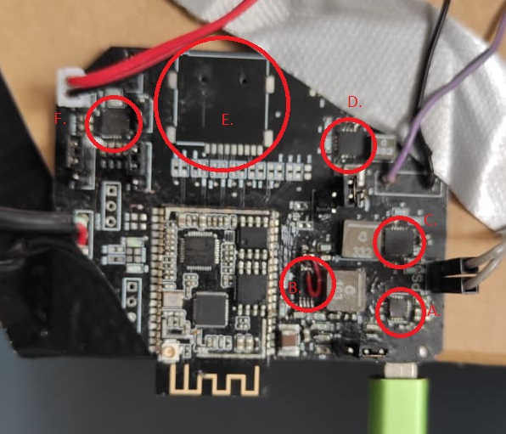
2. Submodule Descriptions:

At the time of writing there exist two hardware iterations. The first iteration had some problems with the power domain that have been fixed in the second revision, however there are still some aspects of the PCB that need further work.

USB to UART converter is fully functional, it's possible to interface with the module over UART both under normal operating conditions as well as download mode (this allows custom code to be programmed to the ESP32 module)

MPPT IC is semi functional however some passive components that are being used for it's configuration don't have optimal values – this leads to longer charging times. Additionally the current sensing part of this subsection is routed wrong so at the moment it needs physical modifications to function correctly. There is a suspected overcurrent condition. This and other issues will be addressed in the next iteration

Supercapacitor charger is fully functional however the center exposed pad on the bottom of the chip doesn't have a sufficiently good connection to the PCB copper fill. This leads to poor thermal dissipation and the IC is at the risk of overheating. This issue needs to be addressed in the next hardware iteration. Currently the IC is configured to draw up to 500mA of current (to make it compliant with USB 2.0 standard) and charges the supercapacitor up to 2.7v. This limitation is imposed to ensure the supercapacitor doesn't get damaged. However, as there are supercapacitor that have various voltage ratings, the charging voltage might have to be amended to make sure we are utilizing the full power storage capabilities of the capacitors

Boost converter is fully functional and configured to output 3.3v to supply the ESP32 module. This IC can boost to 3v when the capacitor charge is as low as 1.7v. This maximizes the operating time of the PCB when relying solely on the charge stored in the capacitor.

Audio amplifier – is fully functional and can operate in both mono and stereo modes. Even without any additional power input, loudspeaker playback can be sustained for up to 3minutes.

Card reader at the moment is not implemented.

3. Proof of Concept:

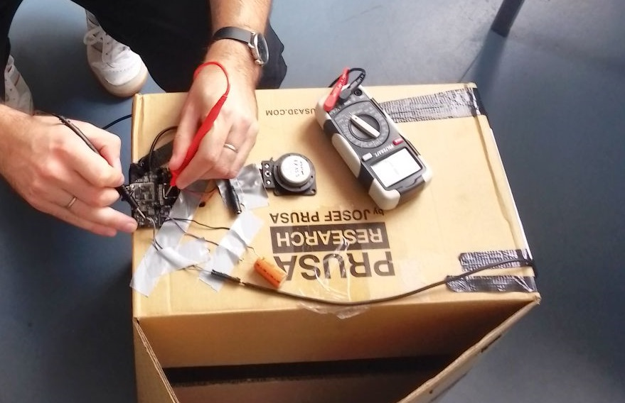
To demonstrate the capabilities of this PCB we've constructed a Solar Boombox. Solar Boombox is a bluetooth speaker that can operate entirely from solar power & batteries. 35F supercapacitor is used to store energy when the lighting conditions are not optimal. At full charge with absolutely no sun coverage the PCB will stay operational for about 3 minutes. This is entirely sufficient to keep operating under intermittent operation. The PCB, a transducer and a solar panel are mounted inside a cardboard box.

General Remarks/Future Plans:

ESP32-A1S module has proven to be relatively more involved to program so the next revision will see a switch towards Arduino Nano Rpi 2040 Connect. Though ESP modules have proven to be a maker's friend, this particular module suffers from a lack of popularity among the developer community, therefore it's relatively undocumented and not supported out of the box on major development platforms such as Arduino IDE making the setup of a development environment for programming it a rather involved process. The firmware for it has to be build on the command line using the EDF (Espressive Development Framework) & ADF (Audio Development Framework). Though this is entirely within the realm of what's possible, being a learning tool and aid primarily it seems more prudent to switch to more newbie friendly platform. An additional benefit of switching to the Arduino RPI 2040 are the PIOs (programmable I/O) that are available on the RPI 2040 chip which allows us to implement various high speed hardware protocols using the designated pins.

There are of course numerous changes that need to be made to switch out the module that's why the second phase of the project (E-Ink display) is delayed until the transition to the new platform happens.

Rev 1.2 Schematics:

