Exercises: Asynchronous Programming
Problems for exercises and homework for the "Web Dev Basics" course from the official "Applied Programmer" curriculum. In these exercises we will create a very simple HTTP Server. We will extend it every time and design it to mimic Microsoft’s IIS.

Chronometer
The Chronometer is one of the easiest examples of an asynchronous processes. Let’s implement a simple Chronometer.
Create an interface IChronometer like this:
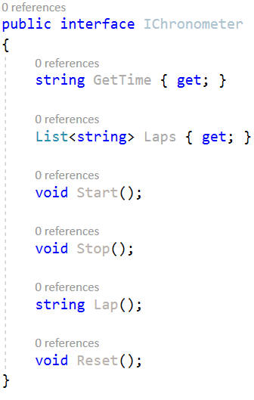
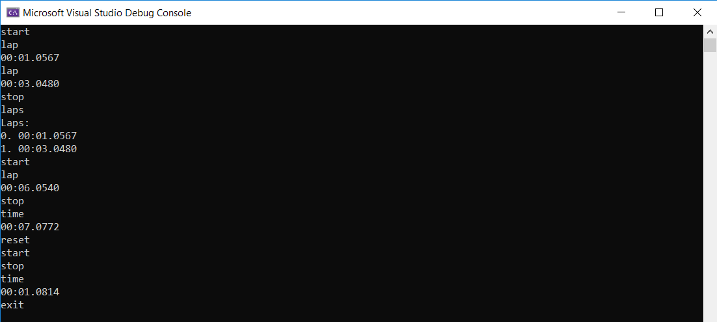
... and implement a class Chronometer, that implements it.
Implement a program which provides a Chronometer functionality, that responds to several commands from the user input:
- start – starts counting time in milliseconds, seconds and minutes
- stop – stops the process of counting time, but the counted time remains
- lap – creates a lap at the current time
- laps – returns all of the currently recorded laps
- time – returns the currently recorded time
- reset – stops the Chronometer, resets the currently recorded time and deletes all of the currently recoded laps
- exit – stops and exits the program
Here is an example screenshot of the functionality:

The time is outputted in the following format: "{minutes}:{seconds}:{milliseconds}", each of them should be padded with zeros.
Upon making a lap you should print the time at which it was made.
Requesting all laps should print them in the following format:
Laps:
0. {lap1}
1. {lap2}
...
In case there are no laps, you should print "Laps: no laps".

Hints
Let's start implementing our asynchronous chronometer. First, we need to create the Chronometer class, which implements the IChronometer interface:
Use the Stopwatch C# class, which provides a set of methods and properties that you can use to accurately measure elapsed time. Create a field for the stopwatch. Also, create a collection for the laps. Initialize the fields in the constructor like this:
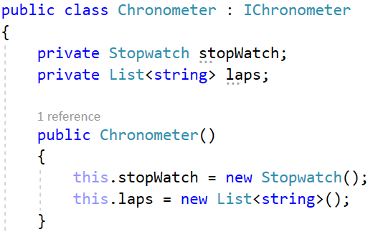
We have the GetTime property, which should return the currently recorded time since the start of the chronometer counter. Use the Elapsed property of the Stopwatch class to get the total elapsed time. This property returns the time as a TimeSpan, so you should convert it to string in the correct format. Do it like this:
The other property we have is the Laps property. It should just return the current laps collection:
Next, we should implement the Start() and Stop() methods of the Chronometer class. The Stopwatch class has its own methods for starting and stopping – use them as shown below:
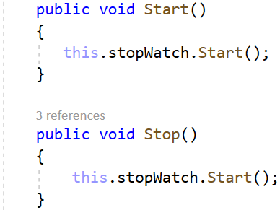

The Lap() method returns the current elapsed time as a string and adds it to a collection of laps. It uses the GetTime property:
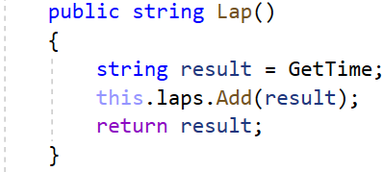
Finally, we have the Reset() method, which should invoke the Reset() method of the Stopwatch class and clear the laps collection. Do it like this:
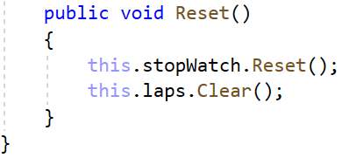
As we already have the Chronometer class let's use it and invoke its methods depending on commands from the console. Instantiate the chronometer in the Main() method of a class called Startup:
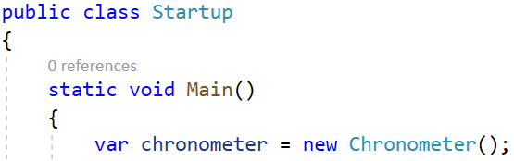
Then, we will read a command from the console, until the "exit" command.
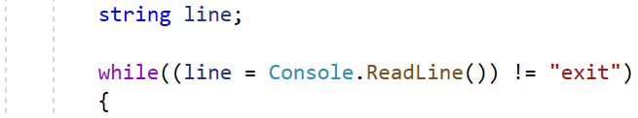
In the while loop, work with the chronometer depending on the read command. Don't forget that the Start() command of the Chronometer class should be run as a task to be asynchronous. After the while loop you should stop the chronometer. Complete the Startup class like this:
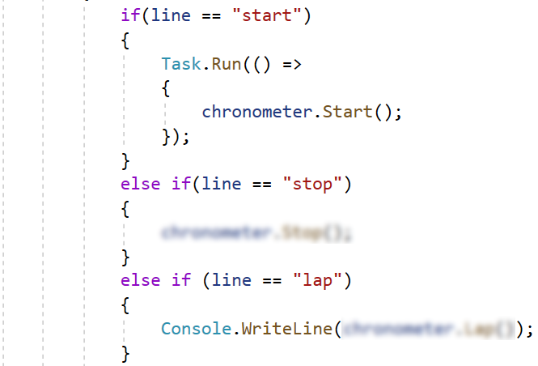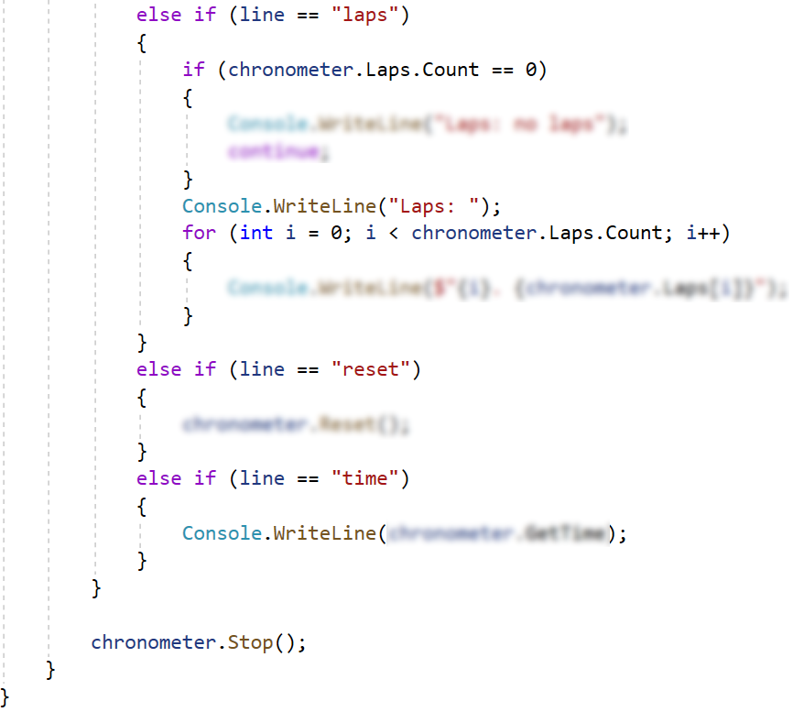

Make the Web Server Run Asynchronously
Now we go back to our server in the "BasicWebServer" project to make it run asynchronously, as this improves overall application performance and responsiveness. To do this, we should replace the synchronous methods with asynchronous, where possible, and await them.

Step 1: Modify the HttpServer Class
Go to the HttpServer class and make it run concurrently. Start with the ReadRequest() method. In it, we read bytes from the network stream, which should be made asynchronously so that bigger requests don't freeze the program. Use the ReadAsync(byte[] buffer, int offset, int count) method and the await keyword:
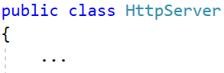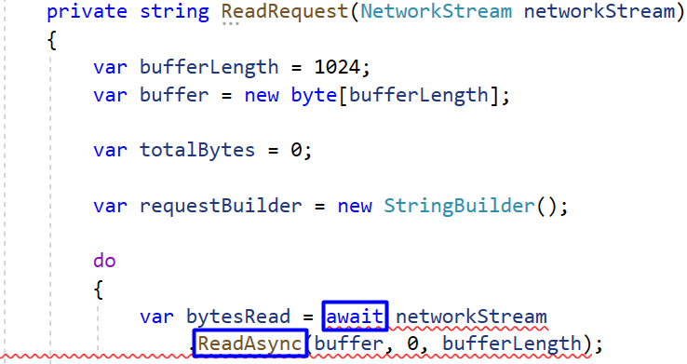
When we add the keyword await to await the task, we also need to make the method async and make it return a Task. Change the ReadRequest(NetworkStream networkStream):

Then, do the same with the WriteResponse(NetworkStream networkStream, Response response) method, which should use an asynchronous method for writing to the network stream. Change the method like this:
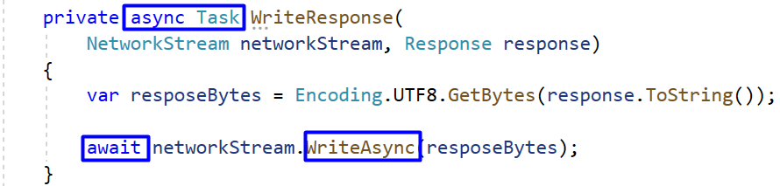
Next, go to the Start() method of the HttpServer class. Here, our aim is to accept and process multiple requests from the browser in parallel, otherwise each request should wait for the others to be completed. To do this, use the AcceptTcpClientAsync() method of the TcpListener class to connect to the network:
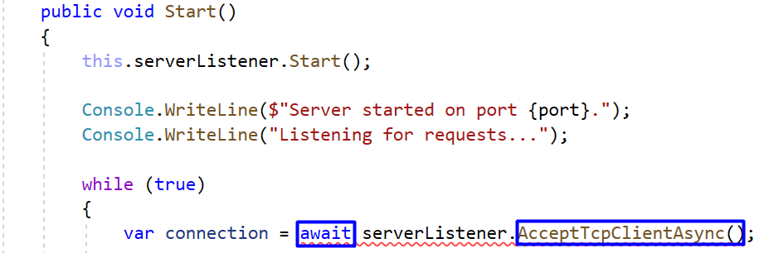
Then, we need to await the methods, which we made asynchronous earlier:
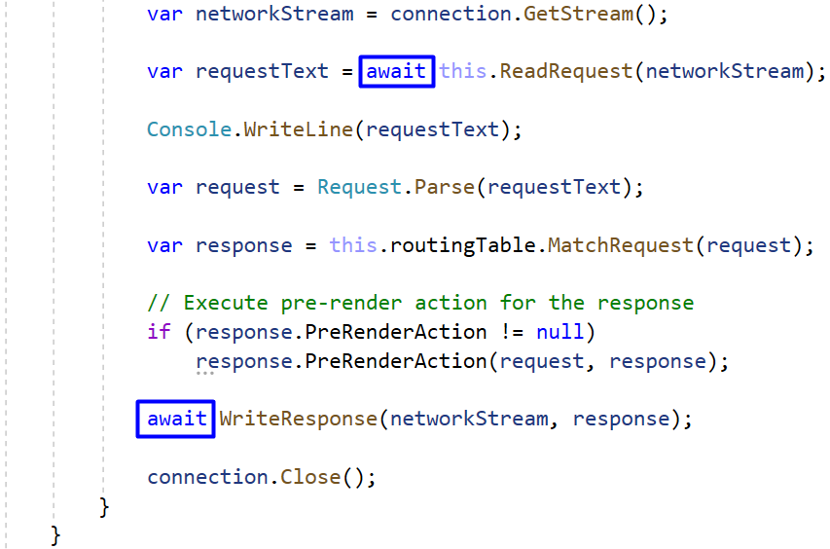
Finally, make the whole Start() method asynchronous like this:
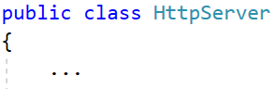
In addition, we can separate the network connection initialization and using in the Startup() method to a separate task to run asynchronously. In order not to await the task, assign it a variable like this:

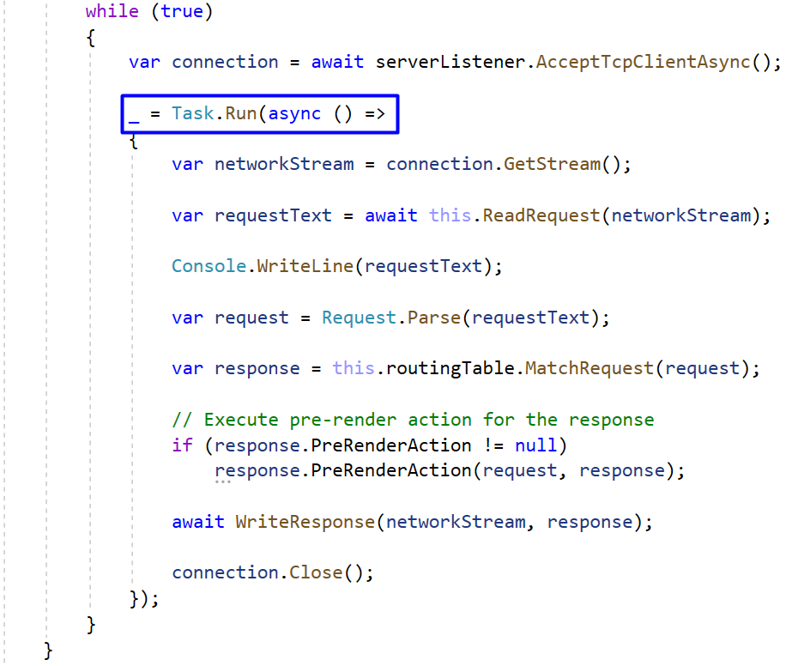

Step 2: Modify the Startup Class
Now let's modify the Main() method of the Startup class in the "BasicWebServer.Demo" project to work asynchronously with the HTTP server. Do it as shown below:
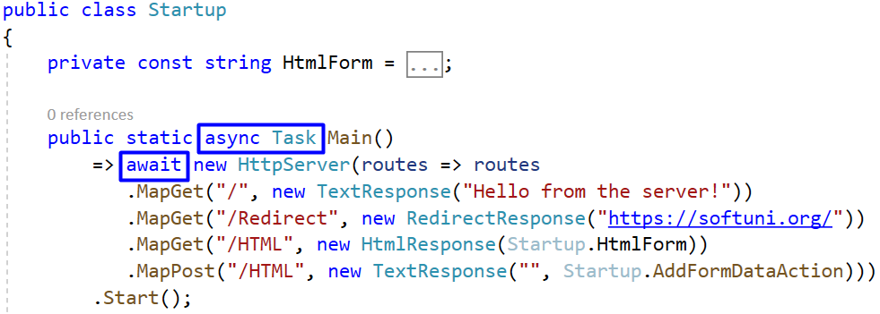

Download Web Content as a File
Our task now is to asynchronously get a part of the HTML content from given sites and add it to a .txt file. In our "BasicWebServer.Demo" app we will click on a button and download the created file. The workflow will be as shown below:
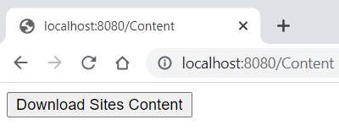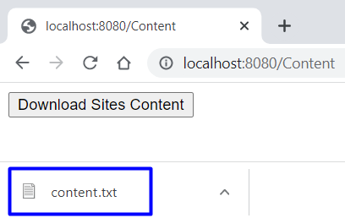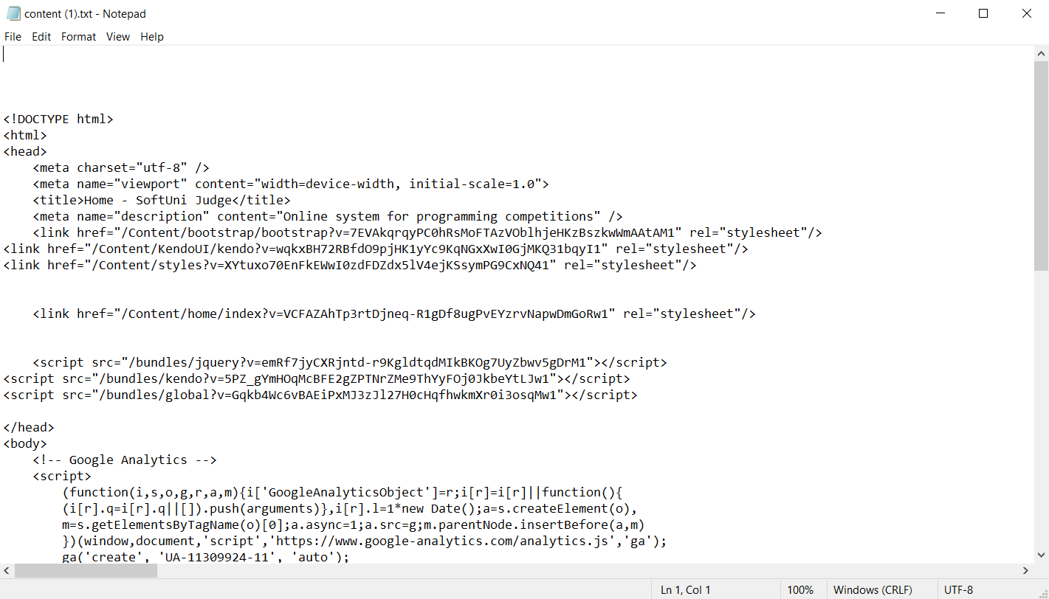

Step 1: Create File Response
To start with, we will need to create an HTTP response, which returns a file, and the file is downloaded. To do this, we will need to add the "Content-Disposition" header to the response headers, which indicates whether the browser should display or download a given file.
Let's first add a constant to the Header class for this header's name:
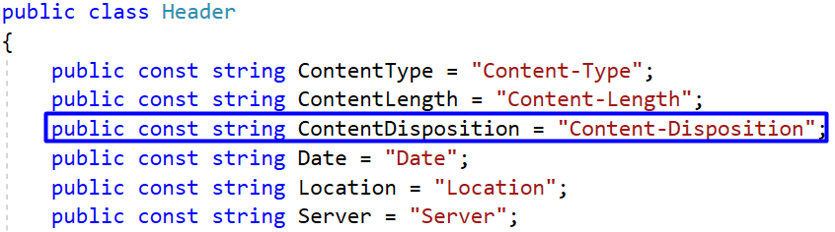
Now we should create a class for the file response. The TextFileResponse will return file content as a plain text and will inherit the Response class:
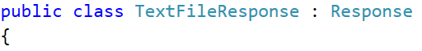
First, we should also have a property for the file name, which should be accepted through the constructor. The constructor should also initialize the FileName property and add the "Content-Type" header. Do it like this:
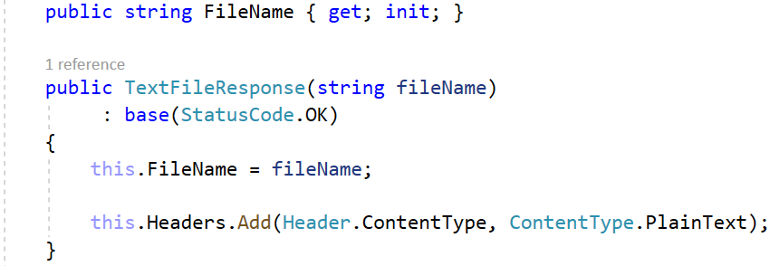
Then, the ToString() method of the class should set the correct headers and the body, if a file with the given name exists. Check this, using the File class and set the file content as a response body asynchronously:
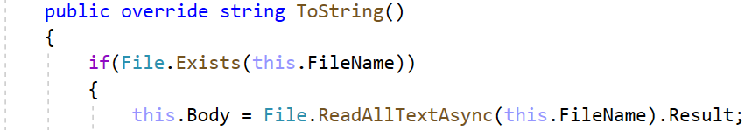
We will need to add the "Content-Length" and "Content-Disposition" headers to the response.
Then, use the FileInfo class to get the length of the file with a given name in bytes and add it as a content length header value:
Add the last header for the content disposition, as well. It should be of type "attachment" and contain the file name:
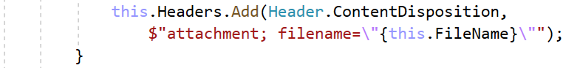
At the end, return the base ToString() method:
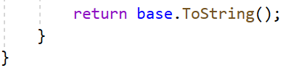

Step 2: Modify the Startup Class
As we have created the TextFileResponse class let's use it. First, go to the Startup class of the "BasicWebServer.Demo" project and create a simple form, which should only have a [Download] button to trigger the action on the "/Content" page with method "POST":
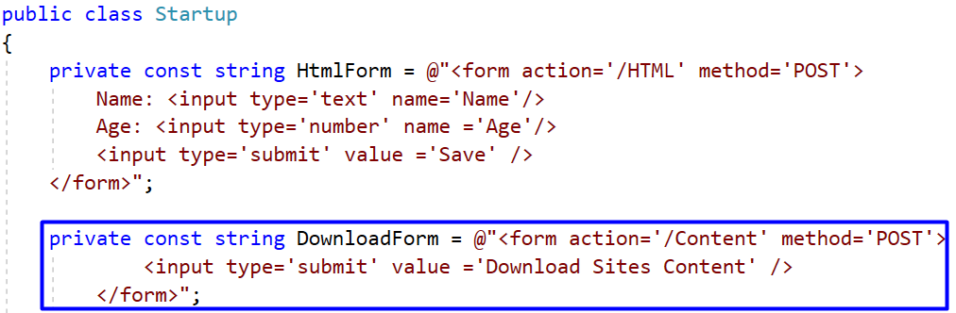
You can copy the form field from here:
private const string DownloadForm = @"<form action='/Content' method='POST'>
<input type='submit' value ='Download Sites Content' />
</form>";
This form should be displayed on the "/Content" page through a "GET" request. Then, when the button is clicked it should send a "POST" request to "/Content" and a TextFileResponse should be returned (and the file should be downloaded). Modify the Main() method as shown below to create the needed mappings:
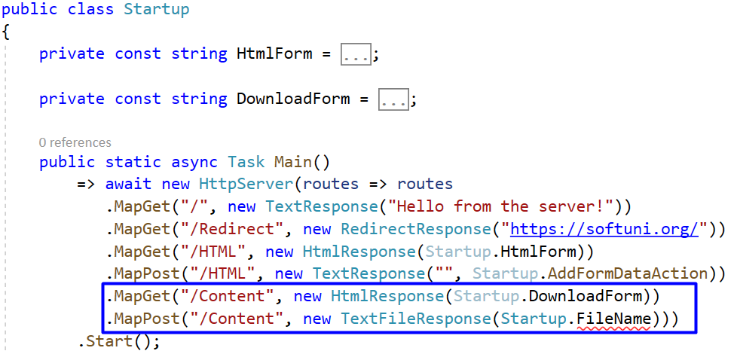
As you can see, we set the file name from a class constant. It is the following:
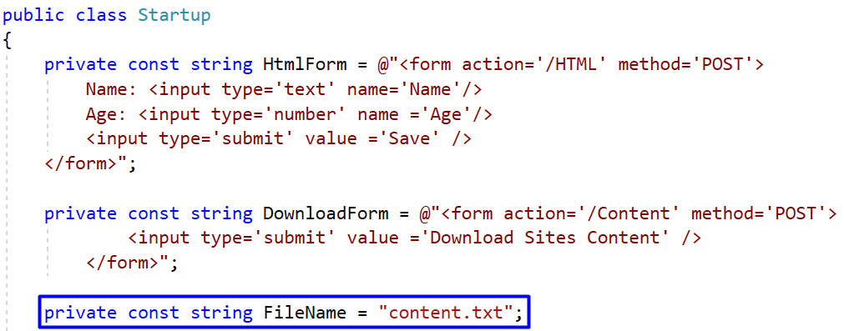
As we have created the "POST" request mapping to return a TextFileResponse with a file name, we should fill in the file with data before the response is returned. To do this, we will create the DownloadSitesAsTextFile(…) method in the Startup class and invoke it before the mappings are created. With this method, we will get the HTML content of several sites and write it to a text file with a given name.
Before we write the above method, let's write another one – the DownloadWebSiteContent(string url) method, which should get the first 2000 symbols of the HTML content of a site on a given URL.
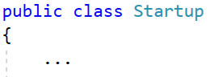
To get the content, we should send a "GET" request to the site and read its content. For this reason, we will use the HttpClient class, which sends HTTP requests and receives HTTP responses from a resource, identified by a URL. The class provides us with the GetAsync(string requestUri) and the ReadAsStringAsync() methods.
Use the HttpClient class with its methods as shown below. At the end, return only part of the HTML content, so that the result file is not too big:
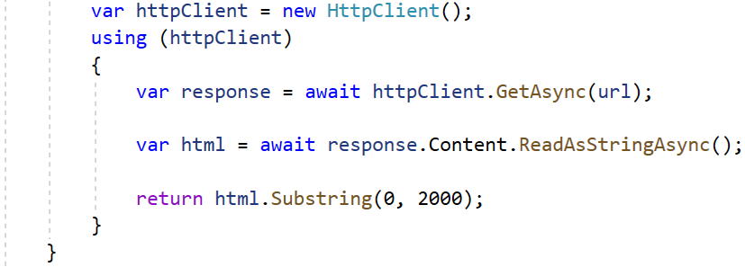
Note that all async methods should be awaited and that's why the DownloadWebSiteContent(string url) should return Task<string>.
The next method we will write is the DownloadSitesAsTextFile() method, which downloads the content of given sites asynchronously. Then, the whole HTML content will be joined and written to a single file.
First, the method should accept a file name and a string array with URLs of sites to be downloaded:
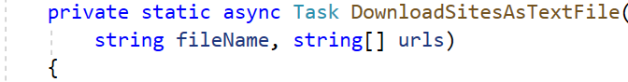
Then, create a collection of type Task<string>, which holds the tasks for getting the HTML content from the sites, and fill in the collection:
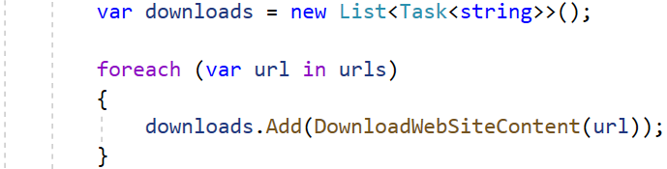
Wait for all tasks to be executed together (in parallel) and get the result like this:
Now join all the content from the responses in a way you want and get the result. You can do it as shown below:
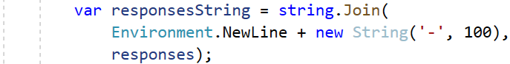
Finally, use the File class to write the HTML content of the sites to a file with a given name asynchronously:
We already have the methods for downloading and saving the HTML content of sites to a file. Use them in the Main() method before the mappings like this:
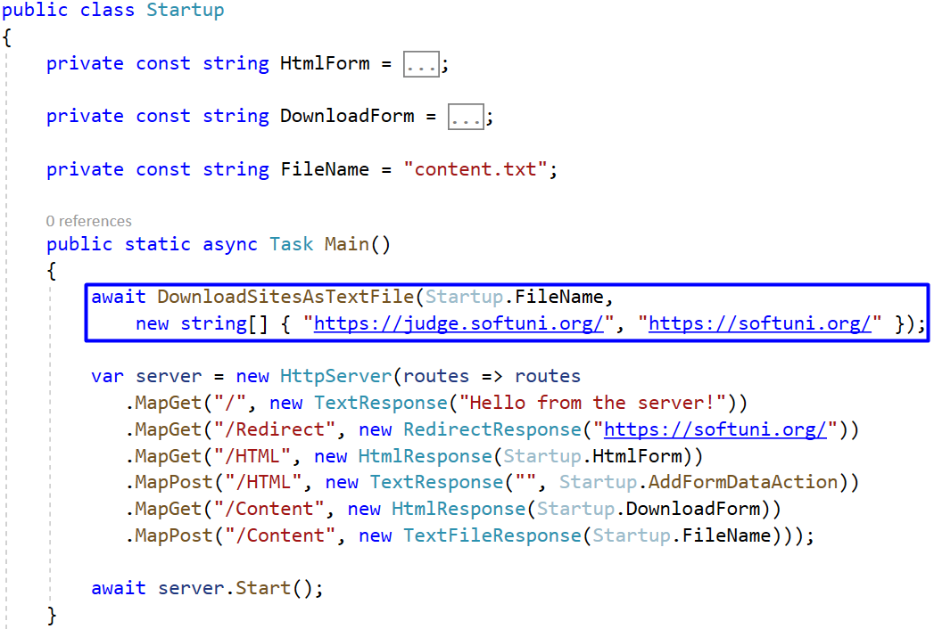
As you can see, we have changed the method structure a little bit, so that we can invoke the method we want. Also, we have added the https://judge.softuni.org/ and https://softuni.org/ sites as URLs and their HTML content will be added to the "content.txt" file.

Step 3: Try File Downloading
Run the application. Note that the Main() method of the Startup class is the first executed method of a program, so the file is created before the server starts. To look at it, open File Explorer "BasicWebServer.Demo" "bin" "Debug" "net5.0" and you should see the HTML content file:
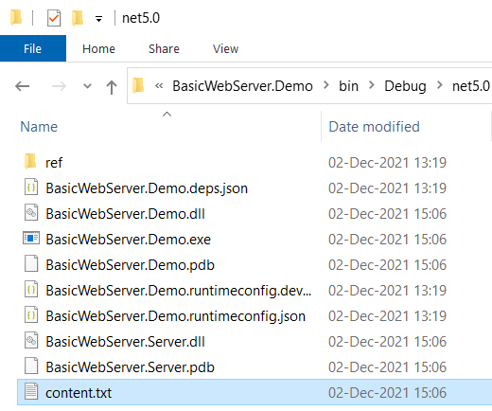
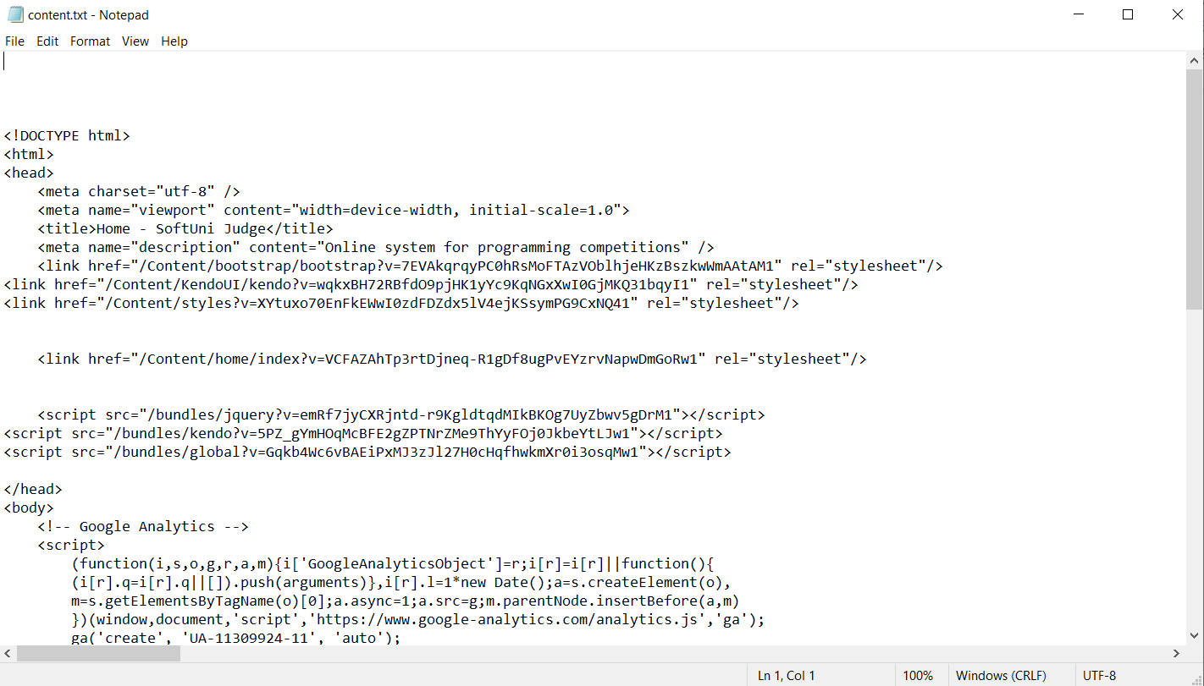
Then, open the browser and go to "/Content". When you click on the [Download] button, the same file should be automatically downloaded:
