Flying Robot
6 states, 2 outputs
(u[k-1] used for training)

Coverage : 432 initial points → traces
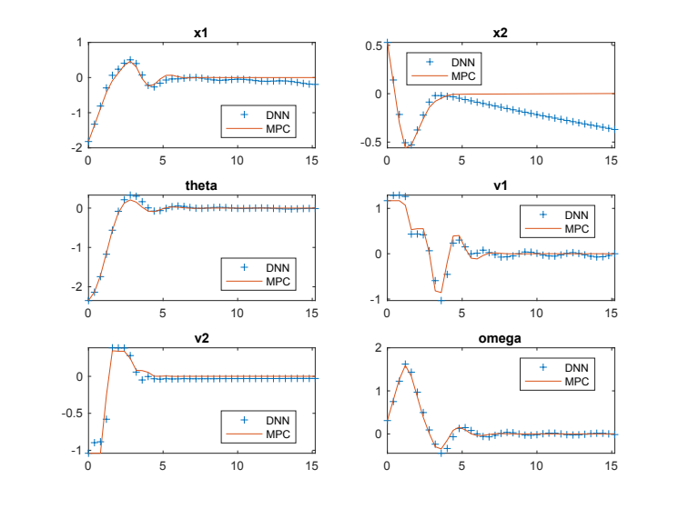
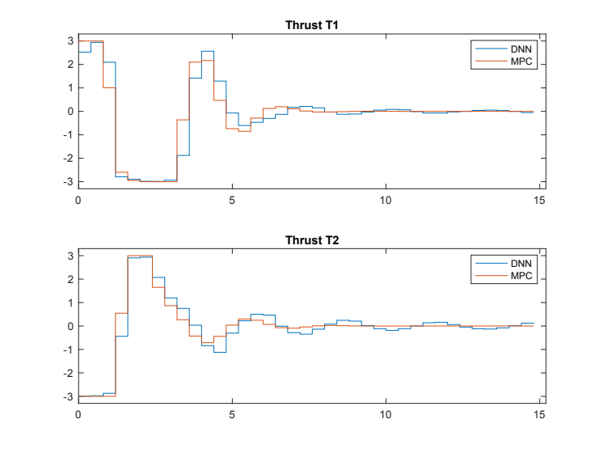

ref_min=[-4;-4;-3.2;-2;-2;-1; -umax; -umax];
ref_max=[4;4;3.2;2;2;1; umax; umax];

umax = 3;

-----Running iteration 1 out of 300.-----
Elapsed time is 19.676857 seconds. With online MPC
Elapsed time is 0.311133 seconds. With DNN

DIFFERENT

-----Running iteration 2 out of 12.-----
Elapsed time is 9.205174 seconds.
Elapsed time is 0.114578 seconds.
The DNN trace 2 is violated. There are 1 violations so far.

The MPC trace 2 is not violated.

-----Running iteration 3 out of 12.-----
Elapsed time is 19.063931 seconds.
Elapsed time is 0.218762 seconds.
The DNN trace 3 is violated. There are 2 violations so far.

The MPC trace 3 is not violated.

-----Running iteration 4 out of 12.-----
Elapsed time is 17.197235 seconds.
Elapsed time is 0.164856 seconds.
The DNN trace 4 is violated. There are 3 violations so far.

The MPC trace 4 is not violated.

-----Running iteration 5 out of 12.-----
Elapsed time is 18.967514 seconds.
Elapsed time is 0.176491 seconds.
The DNN trace 5 is violated. There are 4 violations so far.

The MPC trace 5 is not violated.

-----Running iteration 6 out of 12.-----
Elapsed time is 20.632586 seconds.
Elapsed time is 0.162502 seconds.
The DNN trace 6 is violated. There are 5 violations so far.

The MPC trace 6 is not violated.

11 traces added, 418 points (38 points per trace)

In iteration 1, there are 11 CEX. The nominal controller has 0 CEX.

==========

In iteration 5, there are 12 CEX. The nominal controller has 0 CEX.

Test Data RMSE = 5.086914e-01
Test Data RMSE = 4.937497e-01
===========================
CEX Elimination
Elapsed time is 16.846854 seconds.
Elapsed time is 0.211344 seconds.
Elapsed time is 19.030015 seconds.
Elapsed time is 0.114937 seconds.
Elapsed time is 19.649229 seconds.
Elapsed time is 0.112318 seconds.
Elapsed time is 19.712266 seconds.
Elapsed time is 0.131617 seconds.
Elapsed time is 16.472214 seconds.
Elapsed time is 0.112145 seconds.
Elapsed time is 16.716676 seconds.
Elapsed time is 0.127490 seconds.
Elapsed time is 18.296256 seconds.
Elapsed time is 0.127012 seconds.
Elapsed time is 20.288911 seconds.
Elapsed time is 0.114681 seconds.
Elapsed time is 18.959972 seconds.
Elapsed time is 0.132332 seconds.
Elapsed time is 17.822661 seconds.
Elapsed time is 0.113063 seconds.
Elapsed time is 11.922557 seconds.
Elapsed time is 0.119560 seconds.
Elapsed time is 18.709044 seconds.
Elapsed time is 0.124511 seconds.

After rechecking, there are still 12 CEX out of the original 12.

>>

