Crypto Homework 1
Course: Data Security and Cryptology
Students:
Harel Aronovich - 314860925
Nikolay Savchenko - 323453076
Exercise 1: Encryption and Decryption
Output:
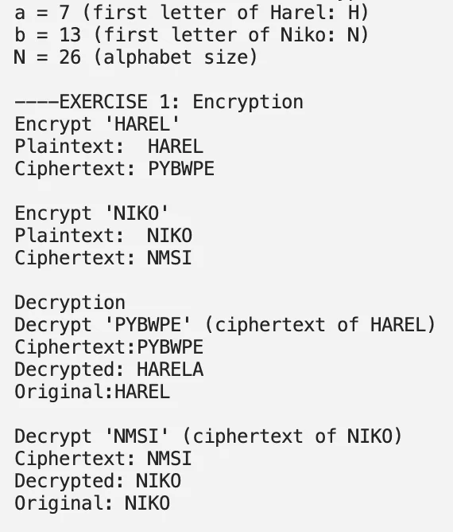

Exercise 2: Iterative Attack
Output:

Exercise 3
Answer: No.
If we apply the encryption twice, the linear part combines nicely
(K3 = K1K2), but the constant term doesn’t stay the same.
After composition the constant becomes (a,b)K2 + (a,b) instead of just (a,b).
Since NameCipher encryption must keep the constant vector equal to (a,b), the composed function usually isn’t of the same form.
An important observation here is the definition of NameCipher, and the use of the constant vector.
So in general there is no single key K3 that makes the double encryption look like one regular encryption.

