Dear customer,

Thank you for placing a price offer with Eurocircuits. While analyzing your data to prepare the offer, our engineers have found some manufacturability issues that require your attention. These are listed below.
Wherever possible we have proposed a solution. This may mean changing the technology parameters of the offer details to the values found in the data.

1. Single traces are found in Bottom circuit layer.
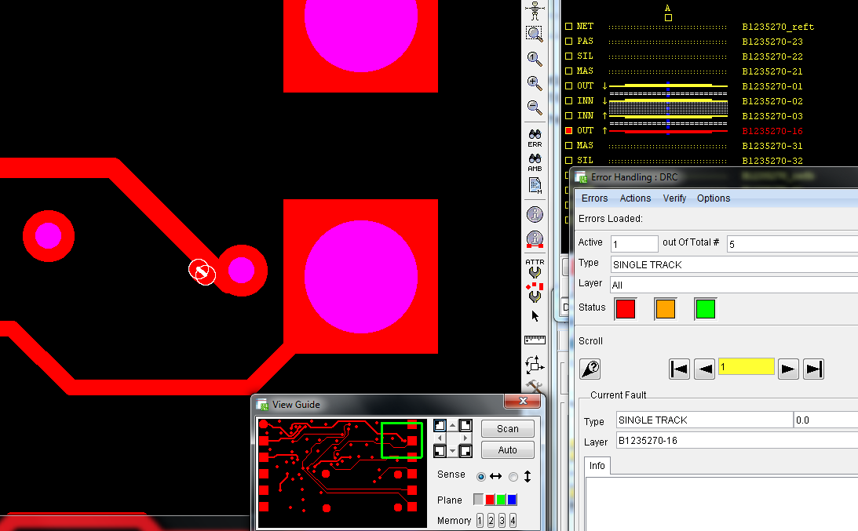
This picture shows one or more locations to demonstrate the problem. Check your whole design as there may be more problem locations.

Proposed Eurocircuits Solution:
We have continue as it is per gerber data including open traces.

Useful information on technical issues:
Detailed information on how to provide the best possible layout data can be found:
- 10 rules for better data
- Eurocircuits PCB design guidelines
EAGLE and Altium users can download specific Eurocircuits DRC rules here:
- Eurocircuits DRC rules for EAGLE V6.x software from CadSoft
- Eurocircuits DRC rules for Altium Designer software from Altium
Detailed specifications of all Eurocircuits services can be found here.
A clarification on TECHNICAL TERMS & ABBREVIATIONS can be found here.

Contact Eurocircuits.
Should you require further technical assistance to help you to continue your order, please do not hesitate to contact us. The fastest solution is to email your question to our head office at euro@eurocircuits.com or by phone on +32 15 28 16 30. We will make sure that your question is answered as soon as possible.

