table of contents

1 The human brain 2

1.2 Neuromorphic Machine learning 3

1.3 Neurons 3

1.3.2 SPIKES 4

1.3.3 Neuron modeling 5

1.4. Dynamical System 6

1.4.1 Pendulum as a dynamical system 6

1.5 Lif Model 9

2. Light emission 10

2.1.2 absorption 11

2.1.3 Material 11

2.2 the laser 12

2.2.2 Optical Resonators 13

2.2.2 Fabry-Perot resonator 13

2.2.3 Phase shift 14

3 The laser model 16

3.2 Absorber (Vabs) 16

3.3 Threshold 16

3.4 Current Injection(I_bias) 16

References 16

Introduction

Artificial intelligence is currently experiencing rapid growth, with the objective of extending its applications beyond domestic environments, as exemplified by drones, augmented reality (AR), and navigation. Among the crucial considerations, power consumption stands out, necessitating the development of novel algorithms and, more significantly, advanced hardware. Taking inspiration from the human brain, scientists are endeavoring to create a spiking neural network[1], which represents one of the most efficient approaches. This entails transmitting minute pulses between neurons and transistors exhibit inefficiency due to the need for charging parasitic capacities while maintaining a tiny continuous current flow when they are in the cut-off area, resulting in a significant energy inefficiency when considering the scale of a neural network. Simultaneously, neurons establish connections with millions, if not billions, of other neurons, thereby intensifying the fanout problem. This paper presents the utilization of lasers as neuron substitutes under specific conditions, effectively mitigating the fanout problem, preventing current leakage, and facilitating faster inter-neuron communication.

# 1 The human brain

The human brain stands as a remarkable example of intricate networks, recognized as one of the most complex entities known to humanity. It encompasses an estimated 100 billion neurons, along with approximately 100 trillion synapses[1], which account for merely 10% of the total cellular composition within the brain [5]. It is noteworthy that the brain's power consumption remains impressively efficient, with a maximum energy utilization of 25W or a typical daily usage of 10W [4]. To provide a tangible perspective, this energy consumption equates to that of an LED light bulb and on the other hand, there is a growing concern regarding the environmental impact associated with the power consumption of current AI models; hence, the imperative to develop novel technologies for machine learning and artificial intelligence arises.

## 1.2 Neuromorphic Machine learning

Neuromorphic machine learning refers to the integration of neuromorphic computing principles and techniques with machine learning algorithms. Neuromorphic computing aims to design and develop computer systems inspired by the architecture and functioning of the human brain's neural networks.

Traditional computing systems, based on the von Neumann architecture[2], have a clear separation between memory and processing units. In contrast, neuromorphic computing systems aim to bring memory and processing closer together, mimicking the parallel and distributed nature of the brain's neural networks. These systems typically employ specialized hardware, such as neuromorphic chips or neuromorphic processors, designed to efficiently perform neural network computations. When applied to machine learning, neuromorphic approaches seek to leverage the unique properties of neuromorphic hardware[3] to enhance the efficiency and performance of learning algorithms. By emulating the brain's neural networks, neuromorphic machine learning models can potentially offer benefits such as improved energy efficiency, faster processing, and the ability to process sensory data in real-time.

Neuromorphic machine learning models often incorporate spiking neural networks (SNNs), which operate based on the concept of spiking neurons that communicate through discrete electrical pulses. SNNs have been shown to be particularly suitable for processing spatiotemporal data and have the potential to achieve high energy efficiency and low latency.

## 

## 1.3 Neurons

In order to advance in the engineering of neuromorphic machine learning chips, it is crucial to gain a comprehensive understanding of the functionality and mechanisms of neurons. They are the building blocks responsible for transmitting electrical and chemical signals, allowing communication within the nervous system and between the nervous system and other parts of the body. Neurons communicate with each other through synapses. When an electrical impulse (action potential) reaches the axon terminals of a neuron, it triggers the release of neurotransmitters into the synapse. These neurotransmitters then bind to receptor sites on the dendrites or cell body of the next neuron in the pathway, generating a new electrical impulse in that neuron. This process allows for the transmission of information and the coordination of various activities in the body. The classification of neurons encompasses several distinct types, notably sensory and motor neurons[6] . Nevertheless, for the present objective of creating a neuron-like model, we prioritize simplicity, thus not focusing in detail on how each neuron behaves.

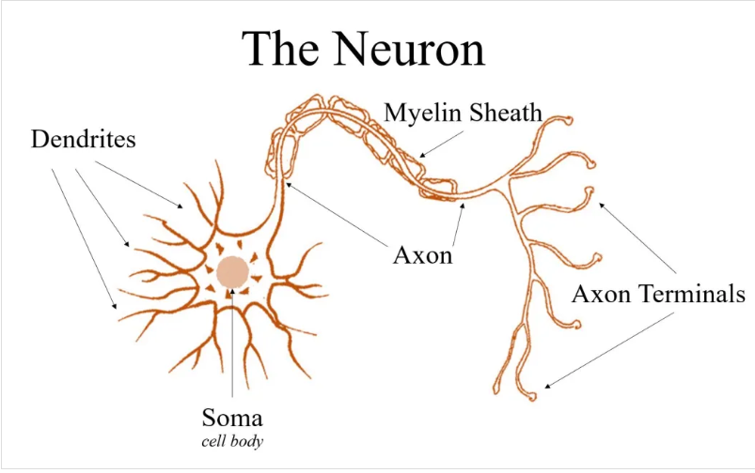

Figure 1: representation of a neuron. Teen Brain Talk "Neuron"

# 

### 

### 1.3.2 SPIKES

The soma, or cell body, of a neuron is responsible for integrating incoming signals from the dendrites and initiating the generation of electrical pulses, also known as action potentials or spikes. The process by which the soma generates pulses is a result of changes in the membrane potential[2]. Each cell has a resting Membrane potential, which is the electrical charge difference across their cell membrane when they are not actively transmitting signals. At rest, the inside of the neuron is more negatively charged compared to the outside, typically around -70 millivolts (mV).

Figure 2: illustrates the concept of membrane potential generating an action potential once it surpasses the threshold level. Image from www.physiologyweb.com

Upon receiving excitatory input from other neurons or sensory receptors, the neuron becomes stimulated. If this stimulation reaches a specific threshold level, a crucial point typically around -55 to -50 millivolts (mV), voltage-gated sodium channels in the cell membrane open. Subsequently, there is a rapid influx of sodium ions into the neuron, leading to a significant depolarization event[7].

As the depolarization progresses, the membrane potential rises towards a positive value. Upon surpassing the threshold, an all-or-nothing response known as an action potential is triggered. During the action potential, the membrane potential experiences a rapid and substantial depolarization, reaching approximately +40 mV. At this stage, voltage-gated potassium channels open, enabling potassium ions to leave the neuron, initiating the repolarization or reset phase.

It is important to note that once the action potential is triggered, it propagates along the neuron's axon, allowing the rapid transmission of signals to communicate with other neurons or effector cells within the nervous system. The mechanism depicted in Figure 2 underlies the fundamental process by which neurons process and transmit information in the nervous system.

### 

### 1.3.3 Neuron modeling

Given the intricate nature of neurons, attempting to employ static equations to address their complexities would be an exceedingly challenging task. Nevertheless, by formulating the neuron as a dynamical system, the intricacy of the problem becomes notably more manageable. Dynamical systems, with their capacity to integrate time-dependent variables and consider the evolving states over time, offer a more suitable and efficient approach to describe the behavior of a neuron. By capturing the dynamic interactions and temporal evolution of various neuron parameters, a dynamical systems framework facilitates a deeper understanding and analysis of neural activities without becoming entangled in the overwhelming complexity posed by static equations.

Over the course of years, numerous models have been developed to describe neurons within the context of spiking neural networks (SNNs). This arises from the profound trade-off between attaining biological plausibility and enabling swift computational processing. While the Hodgkin-Huxley(HH)[7] model meticulously captures the intricacies of neuron biology, implementing it in large-scale SNNs necessitates immense computational resources.

Extensive studies exploring neuron morphology and physiology have yielded insights that the Leaky-Integrate-and-Fire (LIF) model emulates a diverse array of observed biological phenomena while remaining amenable to realistic computational demands for large-scale SNNs. The LIF model provides a more simplified and computationally efficient representation of neuron behavior, making it particularly appealing for simulating vast neural networks.

## 1.4. Dynamical System

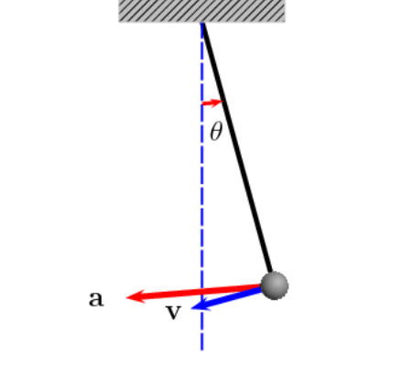The 1.0 equations derive from the analysis of the neuron as a dynamical system, they constitute a fundamental mathematical framework for describing the behavior and evolution of various systems over time. A dynamical system is characterized by three key components: state variables, time and dynamics. Each state represents a system’s condition. Time serves as the independent variable, capturing the system's evolution over a continuous or discrete temporal domain. Dynamics, or the evolution rule, specifies the mathematical relationships governing the interplay of state variables and their changes over time. Dynamical systems theory is a powerful tool used in various fields such as physics, engineering, biology, economics, and chaos theory. It helps in understanding and predicting the behavior of complex systems and plays a significant role in modeling and simulating real-world phenomena. Before analyzing neurons and lasers, a simple example of a dynamical analysis is presented.

Figure 2: pendulum in motion with arrows denoting position and velocity. Image taken from Wikipedia

### 1.4.1 Pendulum as a dynamical system

The pendulum's oscillatory motion is among the most iconic and instructive demonstrations of employing differential equations and phase portraits to characterize its dynamics over time. Its ubiquity in daily life and the simplicity of its underlying mechanics makes it an ideal exemplary for illustrating the principles of dynamical systems analysis. The oscillation can be described using a second-order linear differential equation[3], which relates the angular displacement and velocity of the pendulum with respect to time. This equation derives from the fundamental principles of classical mechanics and assumes small-amplitude oscillations.

At any given time, the system possesses a variable *θ* denoting the angular displacement of the pendulum from its equilibrium position. Thus, *θ* serves as one of the state variables characterizing the system's configuration.

In addition to *θ*, the system exhibits another state variable, *V*, representing the velocity of the weight (or pendulum bob). The velocity of the weight, denoted as *V*, can be expressed as the angular velocity of *θ*, denoted as *θ*′, which arises from the correlation between the angular displacement and the sine of *θ* as well as the length of the string.

Mathematically, the relationship can be represented as follows:

To predict the forthcoming state of the system, it necessitates the angular acceleration, denoted as ,[4] in addition to the angular displacement . Hence, the state of the system at any specific time is contingent on two variables, and , which will be the state variables. To come up with the equations that govern the system, finally an equation that describes the angular acceleration based on the displacement is needed. Which can simply be found by using the first derivative of the equation 1.1:

At this point, we have the system variables and the system’s equations, thus we can procced at creating a phase portrait

A phase portrait is a graphical representation of the state space of a dynamical system, illustrating the evolution of the system over time. In the context of a simple pendulum, the phase portrait typically displays the relationship between the angular position (θ) and the angular velocity (ω) of the pendulum.

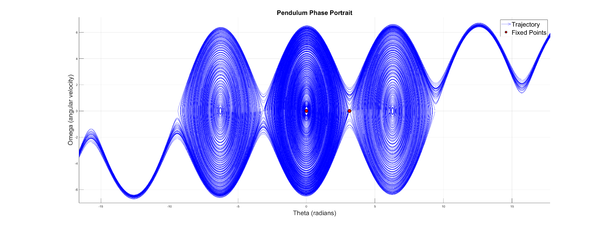

Figure 3: illustrates the phase portrait of a pendulum, a graphical representation showcasing the evolution of the system in its dynamical state space. Fixed points situated at θ=0 and θ=π, also known as the hanging and upright positions. The upright position is characterized as a repeller, as minuscule perturbations will set the pendulum in motion, whereas the point at θ=0 is classified as an attractor, signifying the pendulum's inexorable return to this position over an infinite amount of time.

In the context of a dynamical system, fixed points, also known as equilibrium points or steady states, are positions in the phase space where the system's state remains constant over time. Mathematically, a fixed point occurs when the derivatives of the system's state variables with respect to time are equal to zero. In other words, the system is in a state where there is no change. Fixed point can be divided into 3 categories.

***Stable Fixed Point* (Attractor):** In the vicinity of a stable fixed point, trajectories tend to converge towards the fixed point over time. Small perturbations or disturbances lead the system back to the fixed point, indicating stability. In a phase portrait, a stable fixed point is often represented by a point attractor.

**Unstable Fixed Point (Repeller):** Near an unstable fixed point, trajectories diverge away from the fixed point over time. Small perturbations or disturbances result in trajectories moving away from the fixed point, indicating instability. In a phase portrait, an unstable fixed point is often associated with a repeller.

**Saddle Point:** A saddle point is a fixed point with both stable and unstable directions. Trajectories approaching the saddle point along one direction are attracted (stable), while trajectories moving away along another direction are repelled (unstable). Saddle points are characterized by a combination of stability and instability.

## 1.5 Lif Model

In the realm of computational neuroscience, the Leaky Integrate-and-Fire (LIF) neuron model serves as a foundational concept, providing a simplified yet insightful representation of neuronal behavior. This introductory chapter aims to present an overview of the LIF neuron model, outlining its mathematical framework, dynamic characteristics, and its significance in simulating neural processes.

Understanding the complexity of neural circuits and their information processing capabilities is a formidable challenge. The LIF model, introduced as a computational simplification, allows researchers to dissect and explore the fundamental principles governing neural dynamics. Its efficiency and tractability make it a key player in studying both individual neurons and large-scale neural networks.

The core of the LIF neuron model lies in its mathematical formulation. The model is characterized by ordinary differential equations governing the evolution of the membrane potential over time. Key parameters, such as the membrane time constant (), threshold potential ( ) and reset potential ( ), collectively define the model's behavior. A more mathematical representation of the model is as follows[10]:

Where is the rate of change of the membrane potential is the active pumping, describes the leakage and adds the external spikes.

The manifestation of spike events in the context of the Leaky Integrate-and-Fire (LIF) neuron model is succinctly captured through the imposition of a Dirac delta function, denoted as where signifies the temporal delay associated with the spike occurrence.

The temporal dynamics of the LIF neuron's membrane potential reveal a distinctive spiking behavior. As the membrane potential integrates synaptic inputs, it undergoes a gradual increase until reaching a predefined threshold. The ensuing spike event involves a rapid reset of the membrane potential to a resting state, capturing the essence of action potential generation.

Chapter 2: Photonics

As previously elucidated, the resolution to the fanout problem and the optimization of energy efficiency are achieved through the utilization of light. However, a comprehensive understanding of the fundamental principles of light is imperative to facilitate the implementation of the laser in simulating neuronal behavior. Delving into the intricacies of the laser, this section will elucidate its key attributes and operational characteristics. While the physics of light is a broad domain, we will concentrate solely on aspects directly pertinent to our specific implementation, streamlining the discourse for a more focused examination of the laser's role in the experiment.

# 2. Light emission

Electrons within atoms exhibit quantized energy levels which are distinct and defined, corresponding to specific orbits or shells within the atom. The electron transitions between these energy levels are governed by the principles of quantum mechanics.

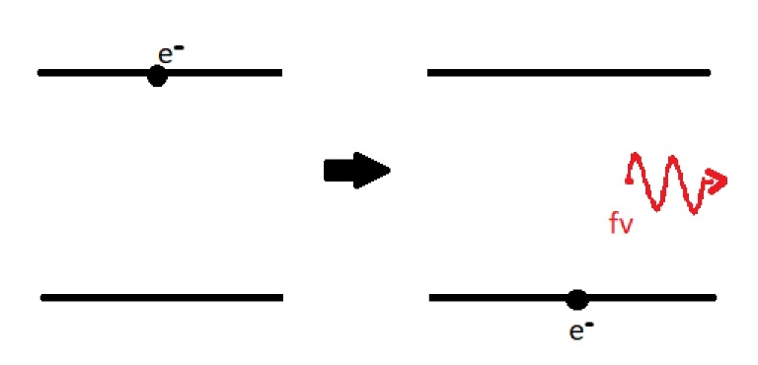An electron typically occupies the lowest energy level, referred to as the ground state (band A), but can absorb energy and transition to a higher energy level, known as the excited state (band B). This absorption of energy can occur through various mechanisms, such as exposure to external light or electrical stimulation. Once in the excited state, the electron is in an unstable configuration and tends to return to its lower energy state.

Figure 4 : placeholder

When the electron transitions back to the lower energy level, it releases the excess energy in the form of a photon. The energy of the photon is directly proportional to the energy difference between the excited and ground states. Consequently, photons emitted during this process exhibit specific wavelengths, corresponding to different regions of the electromagnetic spectrum. Moreover, the material composition plays a crucial role in determining the energy levels and, consequently, the emitted photons' characteristics. For instance, different elements and compounds have unique energy level structures, resulting in the emission of photons with distinct colors and wavelengths.

An alternative method for light generation resides in stimulated emission, a process characterized by the induction of electrons to higher energy levels through current injection. In this paradigm, electrons are elevated to higher energy states, and upon descent to lower levels, photons are emitted within a resonant cavity. Significantly, stimulated emission embodies a distinctive feature: photons discharged during this process possess identical characteristics to their precursors. This phenomenon is a consequence of the coerced energy transfer from electrons to photons, resulting in a cascade of emissions featuring photons with precise attributes. Stimulated emission serves as a cornerstone in the development of lasers, amplifying coherent light by harnessing the principles of quantum optics and electron-photon interactions. This intricate process underscores the sophisticated interplay between electron dynamics and photon generation, contributing to advancements in optical technologies.

### 2.1.2 absorption

Conversely, in a reciprocal manifestation of optical processes, electrons possess the ability to absorb energy from photons traversing through the cavity. This phenomenon, aptly termed absorption, involves the transfer of energy to electrons, propelling them to higher energy states. The crux of absorption lies in the intricate interaction between photons and electrons, where the latter harness energy from the incident photons, facilitating an elevation to higher energy levels within the atomic structure. Notably, absorption serves as the cornerstone mechanism harnessed in solar panels, wherein incident photons from sunlight are absorbed within the photovoltaic material. This absorption-induced energy transfer initiates a cascade of events that culminate in the generation of an electric current, underscoring the pivotal role of absorption in the conversion of solar energy into electrical power.

### 2.1.3 Material

But why doesn’t your phone, TV remote or even cables emit light? The answer is material. Modern electronic systems predominantly employ silicon semiconductors, a material acknowledged for its suboptimal light-emitting characteristics. This inadequacy can be attributed to the positioning of energy levels within silicon, specifically delineated by the concept of bandgaps.

Within the realm of bandgap classifications, two fundamental categories emerge: direct and indirect. In a direct bandgap semiconductor, the minimal energy requisite for an electron to traverse from the valence band to the conduction band, denoted as the bandgap, aligns precisely with a specific momentum. This alignment facilitates a highly efficient transition, wherein both energy and momentum are conserved. Consequently, semiconductors characterized by a direct bandgap, such as gallium, demonstrate enhanced efficacy in the emission of photons. Conversely, within the domain of indirect bandgap semiconductors exemplified by silicon, a discordance arises in the momentum of electrons transitioning between the conduction and valence bands. This misalignment renders the transition less efficient in terms of momentum conservation. Consequently, silicon exhibits a diminished effectiveness in directly emitting photons from band-to-band transitions. The surplus energy incurred during these transitions tends to dissipate predominantly in the form of heat, rather than the desired emission of light.

Figure 5 place holder

In a broader context, materials falling within the IV-VI and III-V groups are distinguished by their manifestation of direct bandgaps, endowing them with the capacity for light emission. Conversely, materials beyond this classification generally lack this intrinsic ability.

## 2.2 the laser

Light Amplification by Stimulated Emission of Radiation (aka L.A.S.E.R), distinguish themselves through a comprehensive set of characteristics that set them apart from conventional light sources. Notably, the concept of a lasing threshold is fundamental to lasers (will be further explained in chapter 3), representing the minimum level of pump power or optical intensity required to initiate and sustain laser action. Laser light's remarkable coherence extends beyond being merely spatial and temporal; it is characterized by exceptionally high coherence lengths, enabling the propagation of well-defined wavefronts over considerable distances. This coherence is further manifested in the monochromatic nature of laser light, where the emission spectrum is exceedingly narrow, resulting in a singular, well-defined wavelength—a property particularly advantageous in applications demanding precision and spectral purity. Moreover, lasers exhibit extraordinary directionality, allowing for the generation of tightly focused beams, a feature harnessed in diverse applications ranging from medical procedures to cutting-edge technologies. The intense concentration of laser beams, often several orders of magnitude higher than that of conventional light sources, underpins their effectiveness in tasks such as materials processing and telecommunications. Furthermore, the stability of laser output, characterized by minimal fluctuations in power and wavelength, reinforces their utility in scientific research and industrial applications where consistency is paramount. Together, these multifaceted characteristics collectively underscore the versatility and significance of lasers across a broad spectrum of scientific, technological, and industrial domains.

### 2.2.2 Optical Resonators

Optical resonators, also known as optical cavities, are fundamental components in laser systems and optical devices. They play a crucial role in enhancing the coherence and intensity of light by confining it within a specific spatial region. This confinement allows for the amplification of specific wavelengths through the process of stimulated emission. A typical optical resonator consists of two mirrors facing each other. One mirror is highly reflective, while the other may be partially transmissive, allowing a portion of the light to exit the cavity. The mirrors create an optical feedback loop, leading to the constructive interference of light. There are mainly three types or resonators, *Fabry-Perot, RingResonator and Microresonators*[9]. In this section the focus will be on Fabry-Perot, since they are mainly the ones used in lasers.

### 2.2.2 Fabry-Perot resonator

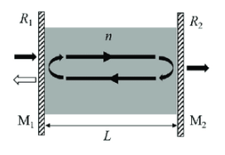

The Fabry-Perot resonator constitutes a crucial optical cavity formed by two parallel mirrors, prominently reflective and partially transmissive. Named after Charles Fabry and Alfred Perot, this resonator serves as a foundational element in various optical systems, including lasers, filters, and spectrometers. Its core architecture involves two mirrors, one possessing nearly complete reflectivity and the other designed for partial transmission, thereby establishing an optical cavity.

Figure 6: Schematic of a Fabry-Perot resonator consisting of parallel mirrors M 1 and M 2 with reflectances of R 1 and R 2 , respectively, surrounding a cavity medium of refractive index n and thickness L. Light introduced from one side undergoes multiple reflections, leading to partial transmission from the other side. Image taken from Bitarafan, Mohammad & DeCorby, Ray. (2017). On-Chip High-Finesse Fabry-Perot Microcavities for Optical Sensing and Quantum Information. Sensors (Basel, Switzerland). 17. 10.3390/s17081748.

Within this cavity, light undergoes multiple reflections, resulting in constructive interference under specific resonance conditions. The performance of the Fabry-Perot resonator is intricately linked to the reflective coatings on its mirrors. One mirror is engineered for nearly 100% reflectivity, while the other is selectively transmissive. These coatings, meticulously tailored for optimal reflectivity at specific wavelengths, significantly influence the resonator's transmission and reflection characteristics. The partially transmissive mirror facilitates the transmission of a specific fraction of incident light, constituting the resonator's output or transmission. This dual capability, reflecting light between mirrors and permitting transmission, renders the Fabry-Perot resonator versatile across various optical applications within scientific and industrial domains.

In the dynamic interplay within the laser cavity, the traversing photons engage in collisions, manifesting as pivotal events shaping the optical characteristics of the laser system. In instances where photons exhibit congruent phases, constructive interference ensues, resulting in a pronounced doubling of their amplitude. Conversely, encounters with photons characterized by a phase difference of π lead to destructive interference, attenuating the overall amplitude. These interference phenomena critically influence the emergent optical output of the laser. Upon plotting the laser output in a two-dimensional graph, juxtaposing amplitude against frequency, a discernible pattern emerges. Remarkably, the graph unveils a selective frequency transmission profile, underscoring the laser's propensity to selectively amplify and emit specific frequencies. This intricate interplay of phase coherence and interference underscores the nuanced behavior of the laser system, elucidating the intricate dynamics governing its spectral output. Further exploration and understanding of these phenomena contribute to the refinement of laser technologies and their diverse applications in fields ranging from telecommunications to materials processing.

### 2.2.3 Phase shift

In our earlier discussion, we briefly overlooked the intricate mechanisms underlying the occurrence of phase shifts in photons within a laser cavity, emphasizing the role of stimulated emission in maintaining identical characteristics between incident and generated photons. However, an intriguing question persists: why do they not invariably exhibit identical phases? The unequivocal response to this query is that, indeed, they do. Yet, as photons traverse the laser cavity, their trajectory becomes punctuated by a myriad of interactions, chief among them being collisions with other particles and reflections from mirrors. These encounters introduce nuanced phase shifts to the photons, shaping their ultimate behavior. Furthermore, the intrinsic properties of the gain medium, such as its refractive index, play a contributory role in dictating phase alterations. An additional pivotal determinant of phase shifts is the length of the cavity itself. The progression of a wave within the cavity can coincide with the completion of an entire oscillation period upon striking a mirror. However, envisioning the mirror positioned at a minutely altered distance introduces a dynamic wherein photon reflection may transpire before the completion of one oscillation, or conversely, post-oscillation. This intricate interplay between inherent properties and cavity dynamics elucidates the multifaceted nature of phase shifts in the laser system.

Mathematically, to ascertain the conditions for lasing within a Fabry-Perot (FP) laser, the phase of a photon must adhere to the following equation:

Where L is the distance between the two mirrors, λ is the vacuum wavelength, η the refraction index

## 2.3 relaxation oscillations

The occurrence of relaxation oscillations during the initiation of lasing in a laser system can be attributed to the intricate interplay between gain, losses, and the cavity dynamics. In the initial phases, the gain medium of the laser, driven by an external pump or excitation source, begins amplifying photons. However, during this startup process, the gain and loss mechanisms within the laser cavity are not instantaneously balanced. The transient imbalance leads to periodic variations in the net gain and loss, resulting in oscillatory behavior in the output power. These oscillations signify the laser system's dynamic attempt to establish equilibrium, as it navigates through phases of amplification and relaxation. The interplay of parameters such as the gain medium characteristics, cavity design, and the interplay of photons with mirrors contributes to the nuanced oscillatory response. As the laser system progresses, these transient oscillations gradually subside, giving way to a stabilized, continuous lasing state as the gain, losses, and cavity properties reach an equilibrium. Understanding and characterizing these relaxation oscillations are pivotal for optimizing laser performance and ensuring a reliable and predictable output.

Figure 6: a temporal representation, or timetrace, of the power output of a laser, revealing the characteristic period of relaxation oscillations.

In the subsequent chapter, the utilization, and criticality, of the observed phenomenon are demonstrated in the simulation of a neuron using a laser.

Simulation

In this section, a detailed investigation unfolds into the intricacies of the MATLAB-based laser model, focusing on systematically manipulated parameters that emulate laser-like behaviors. Specifically adjusting the absorber parameter, which governs the rate of electron transition from higher to lower energy bands, reveals nuanced dynamics within the laser system. Additionally, fine-tuning encompasses the characteristics of the input pulse, laser threshold calculations, and the optimal current injection. The latter parameter critically ensures a positive population without exceeding the defined threshold. As these refined adjustments are navigated, the analysis sheds light on the tailored control of the laser model for optimal performance. This focused exploration not only mimics real-world laser phenomena but also contributes valuable insights into the precision engineering of laser systems for diverse applications.

# 3 The laser model

## In the employed research model, a quantum well (QW) laser is employed, adhering to the foundational principles of population dynamics, stimulated emission, and absorption akin to traditional laser models. Nonetheless, the utilization of the quantum well model imparts distinct advantages over the Fabry-Perot (FP) laser model, offering attributes that are not attainable through the implementation of the FP configuration.

Initially, the incorporation of quantum wells, which are thin semiconductor layers confining charge carriers vertically, is observed to augment the likelihood of carrier recombination, thereby yielding heightened emission efficiency. Furthermore, they often manifest lower threshold current densities, and narrower linewidths, attributes attributable to the quantum confinement effect. In the pursuit of establishing an interconnected network of these lasers, considerations encompass the imperative of achieving high communication speeds between neurons. Such a requisition is notably addressed by quantum well lasers, simultaneously offering lower energy consumption, due to their lower lasing thresholds. Lastly, it is noteworthy that semiconductor (SW) lasers, by virtue of their reduced sensitivity to temperature fluctuations, emerge as an advantageous choice for deployment within extensive network configurations.

## 3.2 Population Inversion

Population inversion is a crucial phenomenon in lasers, occurring when more atoms or molecules exist in higher energy states than in lower ones. In the context of lasers, this inversion of the typical population distribution sets the stage for stimulated emission, a key process in laser operation. Stimulated emission involves the release of photons from atoms or molecules that are already in an excited state, triggered by the presence of incident photons with the same energy. This creates a cascade effect, leading to the emission of coherent and collimated light – the laser beam. Population inversion is essential for laser action because it establishes the conditions for amplification and sustained emission of light, forming the basis for the coherence and directionality characteristic of laser beams.

## 3.3 Threshold

The concept of population inversion is intimately connected to the threshold in laser operation. The threshold in a laser refers to the minimum level of population inversion required to achieve and sustain laser action. Below this threshold, the spontaneous emission of photons predominates, leading to a non-coherent output. However, once the population inversion surpasses the threshold, stimulated emission begins to dominate, resulting in coherent and amplified light output in the form of a laser beam. Achieving and maintaining a population inversion above the threshold is essential for the sustained and efficient operation of a laser, ensuring that the amplification of light through stimulated emission consistently outweighs losses and spontaneous emission. Therefore, population inversion serves as a critical condition for surpassing the threshold and enabling the coherent and directional emission characteristic of lasers.

## 3.4 Current Injection(I_bias)

Utilizing injection current in a laser system enables precise control over the population inversion, allowing the laser to operate in proximity to the threshold. Analogous to the membrane potential in a neuron, the injection current serves as a modulating factor influencing the energy states of the active medium in the laser. By adjusting the injection current, the population inversion can be finely tuned, ensuring that the laser hovers near the threshold level. This control mechanism is akin to regulating the membrane potential in a neuron to modulate its excitability. In both cases, maintaining a specific condition—whether it's proximity to the threshold in lasers or a specific potential in neurons—facilitates optimal performance. This parallel underscores the utility of injection current as a means of controlling and stabilizing the laser's operation, much like the regulation of membrane potential in neuronal systems.

# 4 Laser as neurons

The utilization of a laser to emulate a leaky integrate-and-fire (LIF) neuron arises from its inherent resemblance to neuronal mechanisms. This fundamental connection will be elucidated through mathematical analysis in subsequent sections. However, for the current discussion, a more logical approach will be employed to establish the rationale for this simulation.

The threshold, a fundamental attribute of a neuron, plays a pivotal role in determining whether the neuron fires or not. This critical parameter significantly impacts the selection of an appropriate element for simulation. As previously mentioned, the inherent lasing threshold of a laser renders it an ideal candidate for emulating neuronal dynamics. This resemblance between neuronal and laser thresholds stems from their shared ability to transition between distinct states in response to external stimuli.

The excitation of electrons via current injection mirrors the functionality of membrane potential in neurons. This analogy highlights the fundamental mechanisms shared by neurons and lasers. The injection of current serves to maintain the laser in a state of heightened excitability, priming it to respond to external stimuli. Upon receiving sufficient external input, the laser's current surpasses the lasing threshold, triggering a sharp increase in its output intensity, analogous to a neuronal action potential.

To accurately simulate neuronal dynamics, a reset mechanism is indispensable. Upon cessation of external stimuli, electrons in the higher energy band gradually relinquish their energy to photons, causing the laser's current to recede to the level of the injection current. This natural decay effectively resets the laser's state, mimicking the refractory period observed in neurons. The natural decay of the laser's excited state serves as a *passive reset mechanism*, returning the laser to its ground state after emitting a light pulse

The passive reset has the drawback of creating pulses with big width, however an active reset mechanism can be engineered by the use of an external signal to quickly quench the laser's population inversion. This can be done by applying a negative voltage to a saturable absorber, which is a material that changes its optical properties when it is illuminated with light[11].

## 4.1 the math ☹

Based on the Yamada equations, which describe a predicting self-pulsation model, we have the following…

.

.

.

.

.

## 5 Measurements

The commencement of measurements is deemed necessary, with the initial step involving the determination of the threshold for each laser. To achieve this objective, various values of injection current are systematically scanned, and the region at which the laser attains a value greater than 0 is approximately identified. Following the attainment of this preliminary approximation, focused investigation within that specific region is subsequently conducted to ascertain the precise value of the threshold.

The subsequent phase involves the measurement of the input current (derived from the preceding lasers) to discern the laser's behavior in response to varied pulses. This process is subdivided into two sequential steps. In the initial step would be to measure the pulse width and height, followed by the observing the influence of pulse durations on the output.

The investigation into the single neuron chapter is concluded by measuring the laser's capacity to return to its initial state after the cessation of the input pulse, commonly known as the refractory period. This assessment involves the systematic injection of small pulses at progressively shorter intervals. The results demonstrate that the duration of the pulse significantly influences the laser's ability to exhibit multiple spikes. Subsequently, an analysis of the laser's firing rate is carried out to quantify the speed at which successive spikes are generated. This parameter, akin to neuronal firing rates, offers valuable insights into the temporal dynamics of the laser system. The parallel drawn between the behavior of the laser and the firing patterns observed in biological neurons enhances our understanding of the intricate similarities between these two disparate systems.

# References

1. H. Amin and R. Fujii, "Spike train decoding scheme for a spiking neural network," 2004 IEEE International Joint Conference on Neural Networks (IEEE Cat. No.04CH37541), Budapest, Hungary, 2004, pp. 477-482, doi: 10.1109/IJCNN.2004.1379956.
2. von Neumann, J. (1982). First Draft of a Report on the EDVAC. In: Randell, B. (eds) The Origins of Digital Computers. Texts and Monographs in Computer Science. Springer, Berlin, Heidelberg
3. Heemskerk, Jan NH. "Overview of neural hardware." Neurocomputers for brain-style processing. Design, implementation and application (1995).
4. R.C. Merkle, “Energy limits to the computational power of the human brain” Foresight Update No. 6 August 1989
5. Herculano-Houzel S. The human brain in numbers: a linearly scaled-up primate brain. Front Hum Neurosci. 2009 Nov
6. J.B Furness Types of neurons in the enteric nervous system Journal of the Autonomic Nervous System Volume 81, Issues 1–3 2000 Pages 87-96 ISSN 0165-1838
7. Rodolfo R. Llinás, ”I of the Vortex: From Neurons to Self”, The MIT Press ISBN electronic: 9780262278454
8. HODGKIN AL, HUXLEY AF, KATZ B. Measurement of current-voltage relations in the membrane of the giant axon of Loligo. J Physiol. 1952 Apr;116(4):424-48. doi: 10.1113/jphysiol.1952.sp004716. PMID: 14946712; PMCID: PMC1392219.
9. Hodgson, Norman, and Horst Weber. Optical resonators: fundamentals, advanced concepts and applications. Springer Science & Business Media, 2013.
10. Prucnal, P.R., & Shastri, B.J. (Eds.). (2017). Neuromorphic Photonics (1st ed.). CRC Press. <https://doi.org/10.1201/9781315370590>
11. Dubbeldam, J. L. A., & Krauskopf, B. (1999). Self-pulsations of lasers with saturable absorber: dynamics and bifurcations. Optics Communications, 159, 325-338. https://doi.org/10.1016/S0030-4018(98)00568-9

1. Synapses: the connections between neurons. The point where the dendrites meet the axon terminals.
2. Membrane potential: refers to the difference in electrical charge that exists across the cell membrane of a neuron.
3. Second-order DE: an equation that involves the second derivative of a dependent variable
4. In the context of dynamical systems and differential equations, the dot notation on top of variables indicates the derivative of the variable with respect to time.