<latex editor Project>

Design Recovery and Quality Assessment Report

Version <1.0>

**<IOANNA PAPAGIANNI 2790, NIKOS PANTELIDIS 2787>**

Table of Contents

Introduction 4

Design Recovery 4

Architecture 4

Detailed Design 4

Implementation 4

Quality Assessment 5

# Introduction

The goal of this phase, is to deeply understand the design and logic of the existing project, detect the collaborations among classes and eventually, spot functional and non-functional issues.

# Design Recovery

## Architecture

Packages UML

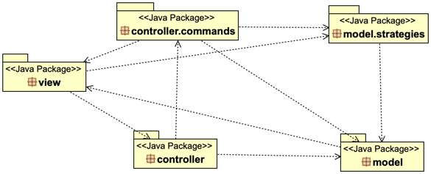

## Detailed Design

* view package UML

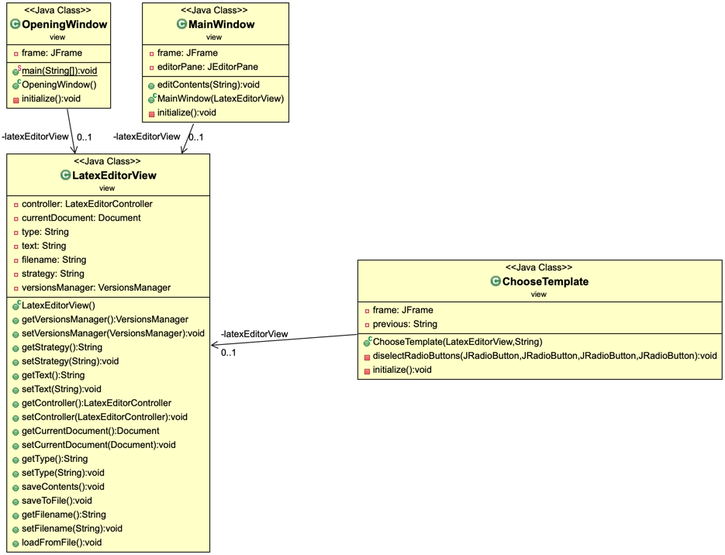

* controller package UML

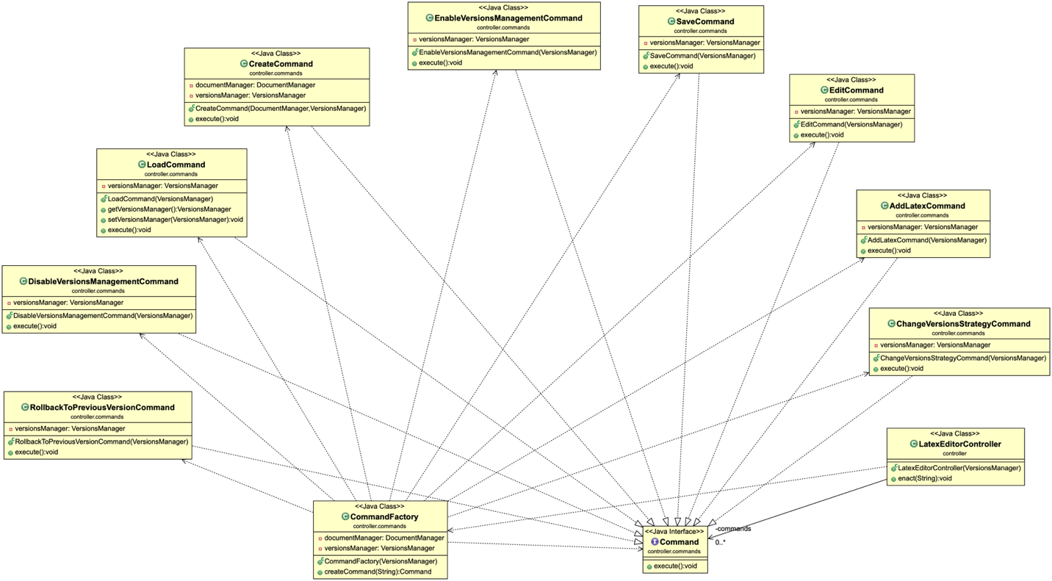

* model package UML

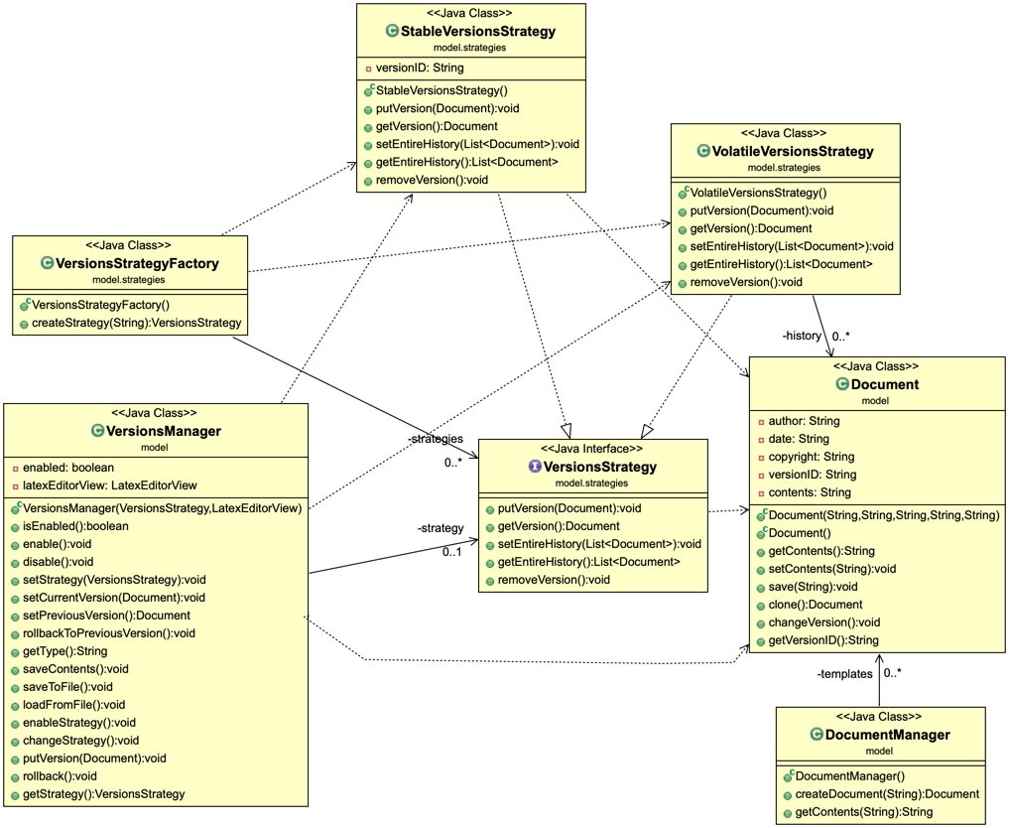

## Implementation

* For each class give a brief description in terms of a CRC card (see the format below)

|  |  |
| --- | --- |
| **Class Name:** | |
| **Responsibilities** | **Collaborations** |
| * List the responsibilities of the class in simple precise statements - don't use passive voice.   + E.g., This class is responsible for this task.   + This class performs this activity... | * List the dependencies and associations of this class with the other classes of the project |

# Quality Assessment

Prepare here a report for the quality problems that you found in this phase.

Report here more general problems and justify them:

1. Possibilities of problematic classes with many responsibilities,
2. Detect possibilities of similar classes with duplicated code
3. Detect possibilities of similar methods with duplicated code
4. Possibilities of problematic classes with very few responsibilities