<latex editor Project>

Design Recovery and Quality Assessment Report

Version <1.0>

<IOANNA PAPAGIANNI 2790, NIKOS PANTELIDIS 2787>

Table of Contents
Introduction 4
Design Recovery 4
Architecture 4
Detailed Design 4
Implementation 4
Quality Assessment 5

Introduction
The goal of this phase, is to deeply understand the design and logic of the existing project, detect the collaborations among classes and eventually, spot functional and non-functional issues.

Design Recovery

Architecture
Packages UML

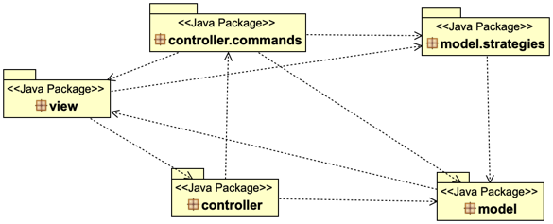

Detailed Design
- view package UML
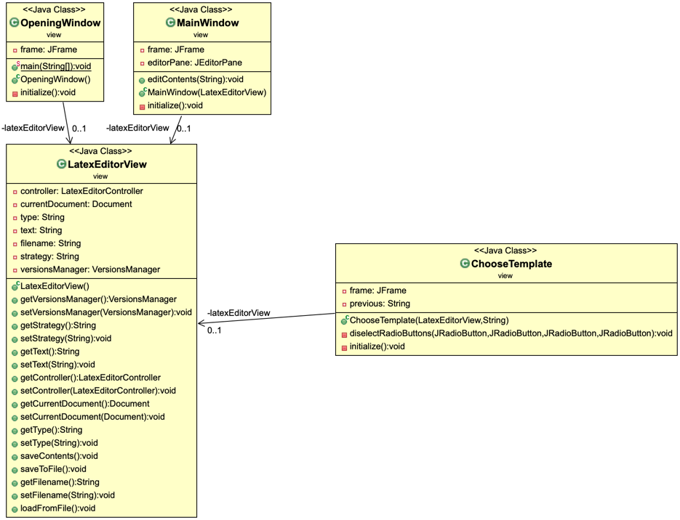

- controller package UML
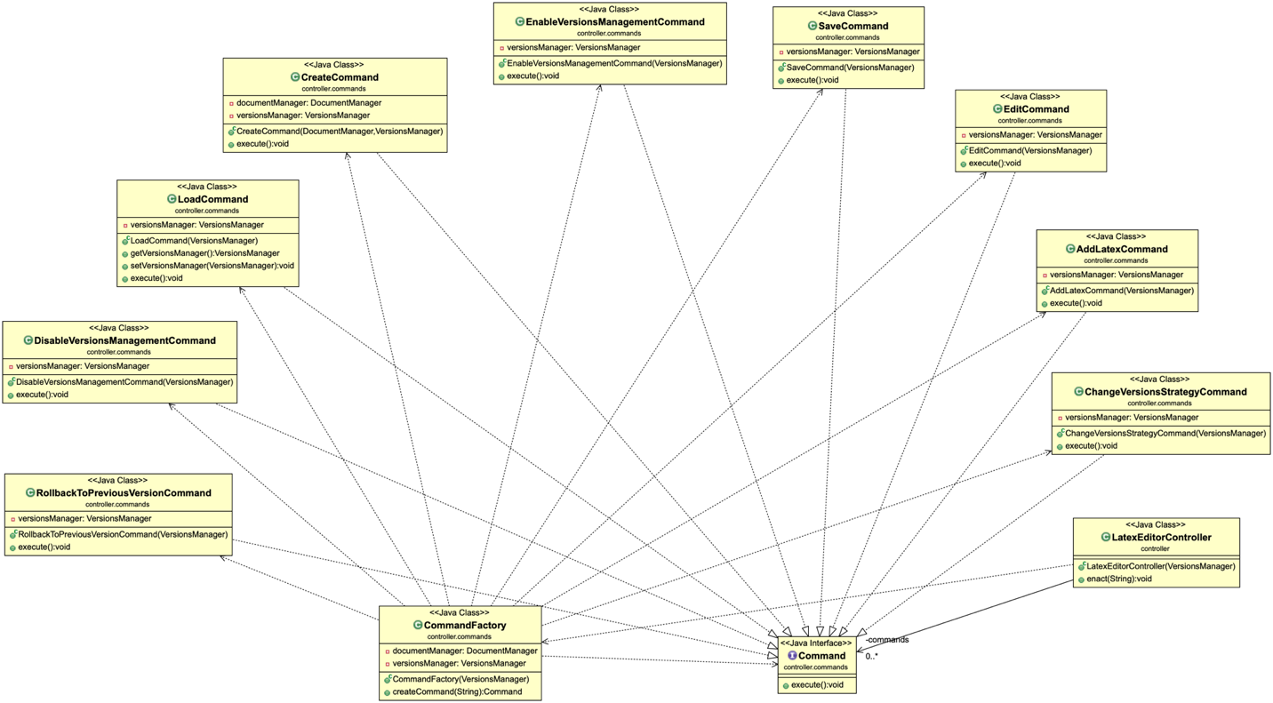

- model package UML
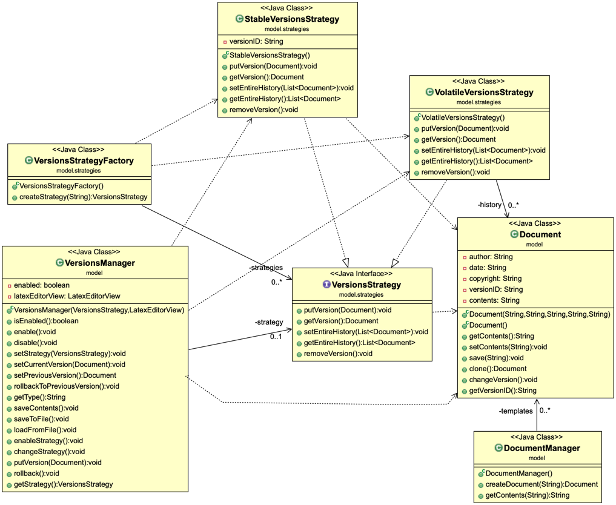

Implementation
- For each class give a brief description in terms of a CRC card (see the format below)
Class Name: Document
Responsibilities | Collaborations
- This class gives us the basic properties of the Documnents, allows us to configure them properly and save it to a specific file. | - List the dependencies and associations of this class with the other classes of the project

Class Name:
Responsibilities | Collaborations
- List the responsibilities of the class in simple precise statements - don't use passive voice.  - E.g., This class is responsible for this task.  - This class performs this activity... | - List the dependencies and associations of this class with the other classes of the project

Class Name:
Responsibilities | Collaborations
- List the responsibilities of the class in simple precise statements - don't use passive voice.  - E.g., This class is responsible for this task.  - This class performs this activity... | - List the dependencies and associations of this class with the other classes of the project

Class Name:
Responsibilities | Collaborations
- List the responsibilities of the class in simple precise statements - don't use passive voice.  - E.g., This class is responsible for this task.  - This class performs this activity... | - List the dependencies and associations of this class with the other classes of the project

Class Name:
Responsibilities | Collaborations
- List the responsibilities of the class in simple precise statements - don't use passive voice.  - E.g., This class is responsible for this task.  - This class performs this activity... | - List the dependencies and associations of this class with the other classes of the project

Class Name:
Responsibilities | Collaborations
- List the responsibilities of the class in simple precise statements - don't use passive voice.  - E.g., This class is responsible for this task.  - This class performs this activity... | - List the dependencies and associations of this class with the other classes of the project

Class Name:
Responsibilities | Collaborations
- List the responsibilities of the class in simple precise statements - don't use passive voice.  - E.g., This class is responsible for this task.  - This class performs this activity... | - List the dependencies and associations of this class with the other classes of the project

Class Name:
Responsibilities | Collaborations
- List the responsibilities of the class in simple precise statements - don't use passive voice.  - E.g., This class is responsible for this task.  - This class performs this activity... | - List the dependencies and associations of this class with the other classes of the project

Class Name:
Responsibilities | Collaborations
- List the responsibilities of the class in simple precise statements - don't use passive voice.  - E.g., This class is responsible for this task.  - This class performs this activity... | - List the dependencies and associations of this class with the other classes of the project

Class Name:
Responsibilities | Collaborations
- List the responsibilities of the class in simple precise statements - don't use passive voice.  - E.g., This class is responsible for this task.  - This class performs this activity... | - List the dependencies and associations of this class with the other classes of the project

Class Name:
Responsibilities | Collaborations
- List the responsibilities of the class in simple precise statements - don't use passive voice.  - E.g., This class is responsible for this task.  - This class performs this activity... | - List the dependencies and associations of this class with the other classes of the project

Class Name:
Responsibilities | Collaborations
- List the responsibilities of the class in simple precise statements - don't use passive voice.  - E.g., This class is responsible for this task.  - This class performs this activity... | - List the dependencies and associations of this class with the other classes of the project

Class Name:
Responsibilities | Collaborations
- List the responsibilities of the class in simple precise statements - don't use passive voice.  - E.g., This class is responsible for this task.  - This class performs this activity... | - List the dependencies and associations of this class with the other classes of the project

Class Name:
Responsibilities | Collaborations
- List the responsibilities of the class in simple precise statements - don't use passive voice.  - E.g., This class is responsible for this task.  - This class performs this activity... | - List the dependencies and associations of this class with the other classes of the project

Quality Assessment
Prepare here a report for the quality problems that you found in this phase.
Report here more general problems and justify them:
- Possibilities of problematic classes with many responsibilities,
- Detect possibilities of similar classes with duplicated code
- Detect possibilities of similar methods with duplicated code
- Possibilities of problematic classes with very few responsibilities

