

COMP 6721

Project Phase II



TEAM FL_07

|  |  |  |
| --- | --- | --- |
| Name | Student Id | Specialization |
| Amritpreet Singh | 40150231 | Data Specialist |
| Nikhil Nikhil | 40151391 | Training Specialist |
| Pushpa Gautam Ojha | 40151892 | Evaluation Specialist |

Table of Contents

Dataset 2

Data Preprocessing 2

CNN Architecture 2

Evaluation: 5

BIAS 6

K-Fold Cross Validation 8

K-Fold Cross validation on Original Dataset 9

K-Fold Cross validation on Bias Eliminated Dataset 10

Result Comparison (K-fold vs Fixed Datasets) 12

GIT Link 16

References: 16

# Dataset

For the dataset creation Images were collected from various open-source datasets available online and those images were manually classified into the classes for the training and testing of the model. For detailed information of the image sources please check the ***datasourceInfo.pdf*** file.

Since images were gathered from the various open sources available online because of which image sizes were inconsistent to resolve. Hence, before loading the dataset we fixed the image dimensions to 100X100. So once image size was fixed, we were able to process images and create our training and test datasets.

We have a total of 3544 images which are divided into training and test data sets. For training we have kept 2898 images across all classes and for testing total comprises 646 images across all classes. Further details are as follows:

|  |  |  |
| --- | --- | --- |
| Class | Training Dataset (Image Count) | Test Dataset (Image Count) |
| Class 0 (Unmasked) | 1092 | 220 |
| Class 1 (Masked) | 1177 | 252 |
| Class 2 (Not a person) | 629 | 164 |
| Total | 2898 | 646 |

# Data Preprocessing

The system pre-processes the raw images before feeding them to the CNN model. At first, we resized all the input images to 100 X 100 resolution. In addition to this, in phase II we are converting the images to grayscale to achieve a better performance of the system. Once, all the raw images are converted to the specified size and into grayscale we are storing them to a new location marking them ready to be feed to the CNN model. We are reusing existing python library OpenCV for resizing and converting the input images to grayscale.

# CNN Architecture

We have created CNN model which has total 9 major layers considering convolution layer, pooling layer and classification layer along with the activation function. We use ReLU as an activation function because of its faster computability and fewer vanishing gradients. Below is the brief description of each of these layer and function used in our CNN architecture.

* **Conv2d**: This is the convolution layer we convolute the input the weight matrix to create activation maps.
* **ReLU (Rectified Linear Unit):** This is an activation function which use the activation maps to give the outputs to the next layer. The activation function defined as f(x) =max (0, x).
* **Pooling**: We use max pooling to reduce the number of activation maps.
* **Linear**: This layer basically maps the input to output linearly (n inputs to m output). it can be described as Ax = b function.

The structure of the model:

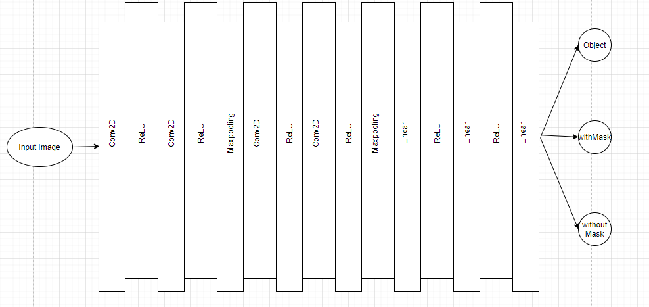

Below is the detail information about the image shape transformation, when these pass into each of these layers:

|  |  |  |  |  |  |  |  |  |
| --- | --- | --- | --- | --- | --- | --- | --- | --- |
| Layers | | Input channel | Filter matrix size | Stride | Padding | Pool size | Output channel | Output Image shape |
| Layer 1 | Convolution Layer | 3 | 3*3 | 1 | 1 | - | 100 | 100*100 |
| Layer 2 | Convolution Layer | 100 | 3*3 | 1 | 1 | - | 128 | 100*100 |
| Layer 3 | Max Pooling Layer | - | - | - | - | 2*2 | 128 | 50*50 |
| Layer 4 | Convolution Layer | 128 | 3*3 | 1 | 1 | - | 256 | 50*50 |
| Layer 5 | Convolution Layer | 256 | 3*3 | 1 | 1 | - | 256 | 50*50 |
| Layer 6 | Max Pooling Layer | - | - | - | - | 2*2 | 256 | 25*25 |

Once these layers are trained with the data, then the image has to be converted to 1D form for mapping them into the specified class labels. Hence, the output from layer 6 is feed to the classification layer, i.e., Layer 7 to flatten the data into 1D array. In our project we have 3 classes and the output of last layer of size 3.



We also use cross Entropy loss or log loss that mesures the difference between the actual and predicted values. This loss is then back propagated through the network to update the weights.

We use SGD (Stochastic gradient descent) to calculate gradients to update the weights with a learning rate of 0.005 and a momentum of .9.

We train the model for 30 epochs to make it more robust. At the 28th epoch, the model shows the training accuracy as 100%. Below is the image how the accuracy for the training data increases in each epoch.

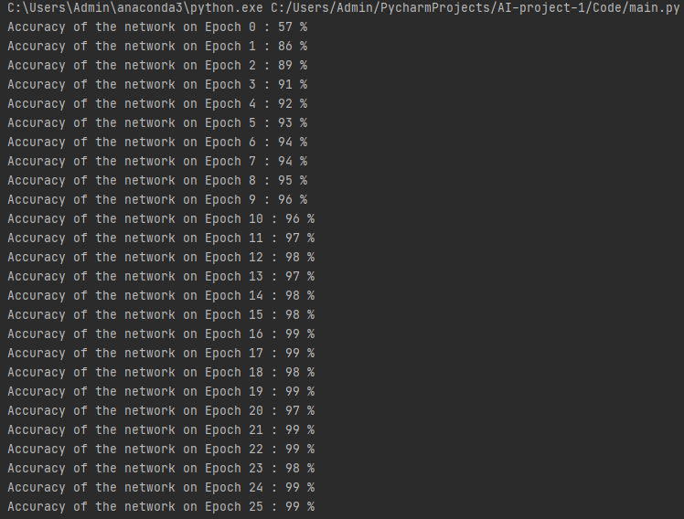

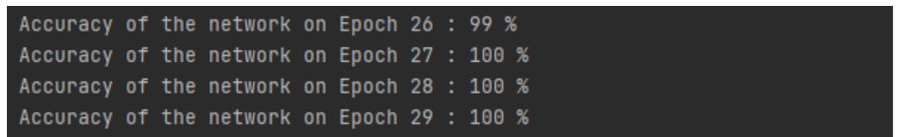

# Evaluation:

The model designed for this project has been evaluated using mainly 5 metrics, which are described below:

1. **Accuracy:** For computing accuracy, we are comparing the output labels, class 0,1 or 2, representing classes *Person With Mask*, *Person Without Mask* and *Not a Person* respectively, from CNN model with the actual test data labels. We then compute the sum of the test data that has been evaluated correctly by the model and divide it with the total test data size to get accuracy rate.
2. **Recall:** This is the ratio of true positive results and sum of true positive and false negatives result from CNN model. For our model it is computed by using *sklearn.metrics.recall_score*
3. **Precision**: This is the ratio of true positive results and sum of true and false positives result from CNN model. For our model it is computed by using *sklearn.metrics.precision_score*.3.4 F1 Measure: This is the ratio of twice the product of recall and precision over sum of recall and precision. For our model it is computed by using *sklearn.metrics.f1_score*.3.5
4. **Confusion Matrix**: This provides the accuracy of classification of each of the results by the CNN model. For our model it is computed by *sklearn.metrics.confusion_matri*x

For Computing above four metrics, i.e., *precision, recall, f1 measure* and *computation metrics*, we are first preparing the list of the *test data*, that have the labels represented by 0,1 or 2 (*0 for People Without Mask* class*, 1* for *People With Mask* class *and 2* for *Not a person* class). Then we prepare the list of predicted results by the CNN model against these test data, which also have elements representing class by 0,1 or 2. We are then using *sklearn.metrics* library to compute these metrics for each of the classes, by sending labels as input i.e. *labels=[0,1,2].*

Accuracy for 630 tested images as predicted by model was 86%. We are planning to work on the various aspects of the model in Project phase II for improving model’s performance. Below is the CNN model output for 3 classes of the test data for each evaluation metrics as specified above.

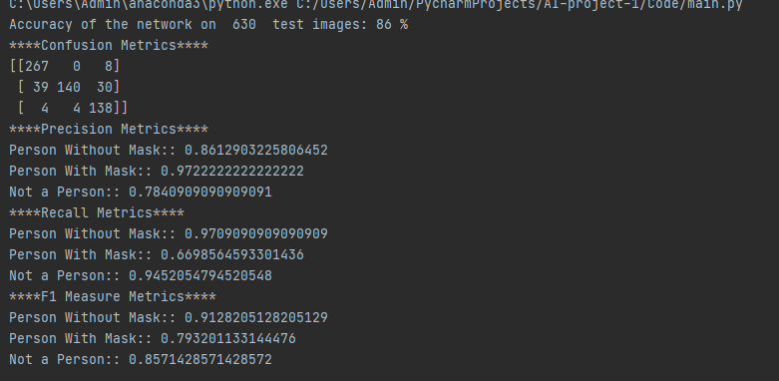Figure 1: Accuracy, Precision, Recall, F1-Measures, Confusion Matrix and Graph for Precision and Recall for Test results of Original Model

# BIAS

For Bias Testing, we considered the category of gender. Initially we separated the test dataset into two type.

1. Male Test Dataset – Contains only Male images in masked and unmasked category.
2. Female Test Dataset – Contains only Female images in masked and unmasked category.

We completely removed the “Not a Person” folder to get accurate bias results for just male and female images. When we tested our model on these datasets, the results are given below.

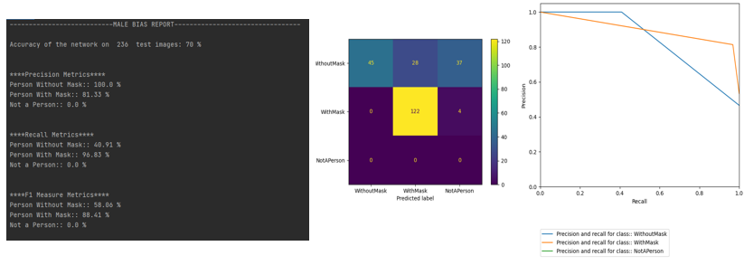

Above figure depicts the metrics for male data set run by old model.

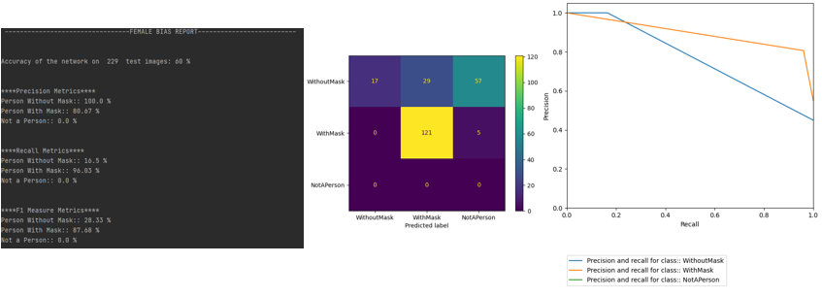

Above figure depicts the metrics for Female data set run by old model.

We rebalanced our data to equal number of images for both the categories in the training set and trained the model again. This new model showed better performance. The results are displayed below.

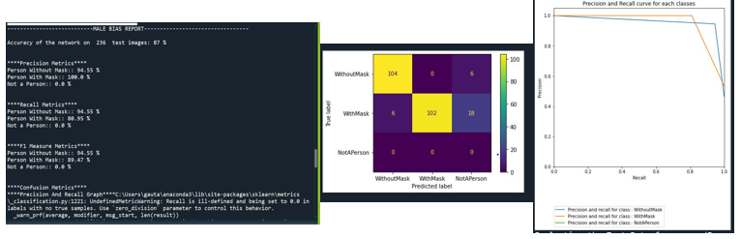

Above figure depicts the metrics for Male data set run by New model.

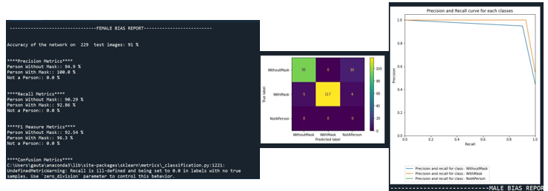

Above figure depicts the metrics for Female data set run by New model

We had an accuracy of 70% for male and 60% for female for old model. After the rebalancing of training datasets, we have an accuracy of 88% for male and 91% for female. Below is the detail statistical metrics evaluation for separate Male and Female test dataset with original biased dataset and Bias eliminated New datasets.

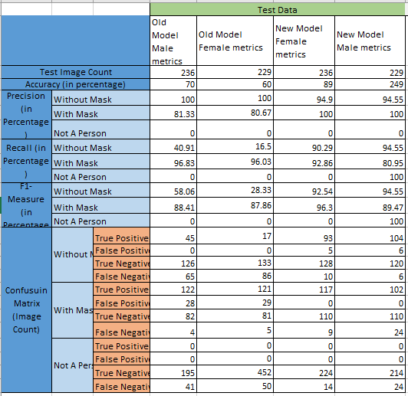

Summary of the bias results.

# K-Fold Cross Validation

Instead of the fixed set of train and test dataset as in Phase I, we implemented the K-fold cross validation with 10 folds for the train dataset, during the model training. To achieve this, We utilized the existing python library ***sklearn.model_selection.StratifiedKFold.*** First, we maintain two separate datasets i.e., the original dataset from Phase I and a new dataset maintained after the elimination of Bias. Then, we trained the model with these two different datasets and stored their trained model separately for performing further testing.

We captured the test data splitted by K-Fold cross-validation(10-folds) in each fold. Then for the test /validation data in each of the fold, we evaluated the accuracy, precision, recall, f1-measure and confusion matrix. Below are the detail results obtained by training the model with original datasets and new dataset with 10-fold cross validation:

## K-Fold Cross validation on Original Dataset

We applied the K-Fold cross validation on Original Dataset with Train Images Count -> 2898 and Test Images Count ->646. For original dataset, we used the same old CNN model, that use to process 100*100 resolution of image as RGB (3-input/output channels). The statistical evaluation results for test data splitted by K-Fold cross-validation in each fold is provided below in the tabular format:

|  |  |  |  |  |  |  |  |  |  |  |  |  |  |
| --- | --- | --- | --- | --- | --- | --- | --- | --- | --- | --- | --- | --- | --- |
|  | | | Test Images splitted in each fold from Train Dataset | | | | | | | | | | Average Statistics for 10 Folds |
|  | | | Fold0 | Fold1 | Fold2 | Fold3 | Fold4 | Fold5 | Fold6 | Fold7 | Fold8 | Fold9 |
| Test Image Count | | | 290 | 580 | 870 | 1160 | 1450 | 1740 | 2030 | 2320 | 2609 | 2898 | - |
| Accuracy (in percentage) | | | 86 | 85 | 70 | 97 | 93 | 89 | 95 | 93 | 68 | 66 | 84.2 |
| Precision (in Percentage) | Without Mask | | 96.7 | 95 | 95.85 | 96.04 | 95.92 | 92.99 | 93.84 | 93.9 | 89.04 | 86.33 | 93.56 |
| With Mask | | 80.14 | 82.11 | 75.21 | 80.07 | 81.87 | 83.77 | 85.04 | 86.4 | 87.02 | 87.36 | 82.9 |
| Not A Person | | 86.79 | 82.61 | 77.84 | 82.45 | 84.93 | 85.76 | 87.24 | 86.9 | 82.21 | 77.18 | 83.39 |
| Recall (in Percentage) | Without Mask | | 80 | 77.73 | 63.22 | 71.92 | 77.33 | 80.95 | 83.66 | 85.1 | 86.78 | 87.19 | 79.39 |
| With Mask | | 100 | 100 | 100 | 100 | 99.83 | 98.73 | 98.67 | 98.1 | 91.7 | 85.73 | 97.27 |
| Not A Person | | 73.02 | 75.4 | 76.19 | 80.16 | 78.73 | 76.46 | 77.55 | 79.2 | 77.56 | 77.42 | 77.16 |
| F1-Measure (in Percentage) | Without Mask | | 87.56 | 85.5 | 76.19 | 82.25 | 85.63 | 86.55 | 88.46 | 89.3 | 87.89 | 87.11 | 85.64 |
| With Mask | | 88.97 | 90.17 | 85.5 | 88.93 | 89.96 | 90.64 | 91.35 | 91.9 | 89.3 | 86.54 | 89.32 |
| Not A Person | | 79.31 | 78.84 | 77.01 | 81.29 | 81.71 | 80.84 | 82.11 | 82.9 | 79.82 | 77.3 | 80.11 |
| Confusion Matrix (Image Count) | Without Mask | True Positive | 88 | 171 | 208 | 315 | 423 | 531 | 640 | 744 | 853 | 960 | - |
| False Positive | 3 | 9 | 9 | 13 | 18 | 40 | 42 | 48 | 105 | 152 | - |
| True Negative | 177 | 351 | 532 | 709 | 885 | 1044 | 1223 | 1398 | 1521 | 1654 | - |
| False Negative | 22 | 49 | 121 | 123 | 124 | 125 | 125 | 130 | 130 | 132 | - |
| With Mask | True Positive | 117 | 234 | 352 | 470 | 587 | 697 | 813 | 924 | 972 | 1009 | - |
| False Positive | 29 | 51 | 116 | 117 | 130 | 135 | 143 | 145 | 145 | 146 | - |
| True Negative | 144 | 295 | 402 | 573 | 732 | 899 | 1063 | 1233 | 1404 | 1575 | - |
| False Negative | 0 | 0 | 0 | 0 | 1 | 9 | 11 | 18 | 88 | 168 | - |
| Not A Person | True Positive | 46 | 95 | 144 | 202 | 248 | 289 | 342 | 399 | 439 | 487 | - |
| False Positive | 7 | 20 | 41 | 43 | 44 | 48 | 50 | 60 | 95 | 144 | - |
| True Negative | 220 | 434 | 640 | 865 | 1091 | 1314 | 1539 | 1756 | 1948 | 2125 | - |
| False Negative | 17 | 31 | 45 | 50 | 67 | 89 | 99 | 105 | 127 | 142 | - |

Table 1: K-fold Cross-validation on Original Dataset

We have attached screenshots for the first and last Fold of the K-fold cross-validation on training data from the python console:

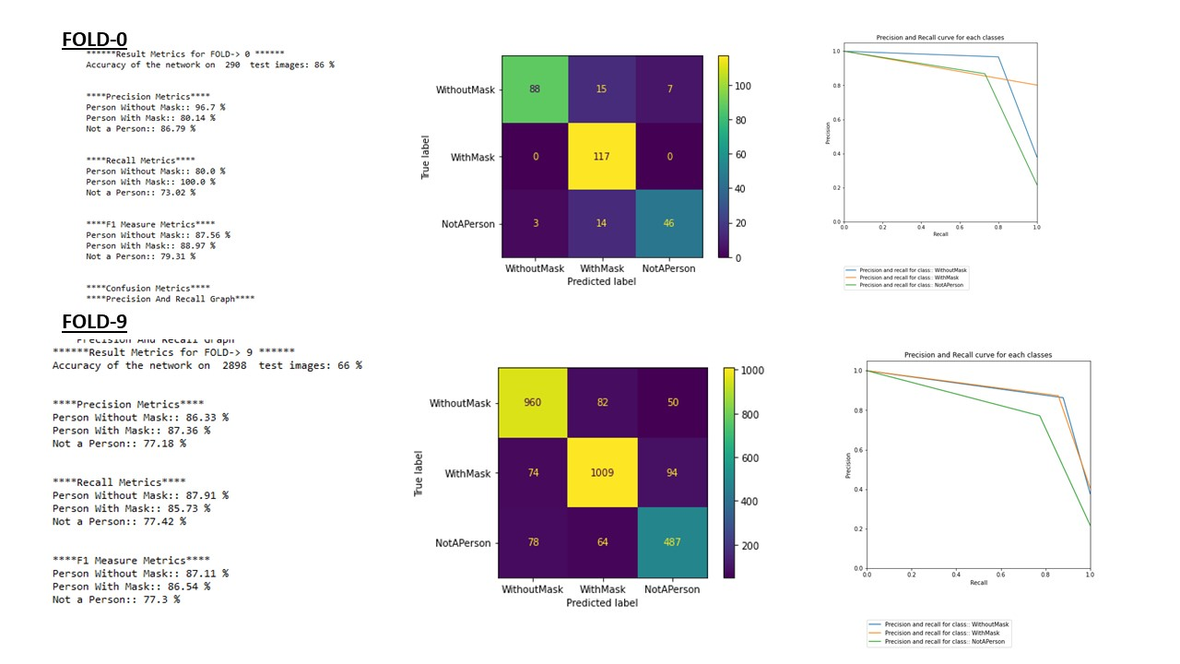

Fig: Fold 0 and Fold1 Result metrics in python console

## K-Fold Cross validation on Bias Eliminated Dataset

The count of train images in the new dataset after the bias elimination was kept same as the original dataset to maintain the consistency in the obtained result i.e., Train Images Count -> 2898. However, the count of new test image dataset count was 639.

For this new dataset, we used the new CNN model, that process 100*100 resolution of grayscale image as 1-input/output channel. The statistical evaluation results for test data splitted by K-Fold cross-validation in each fold is provided below in the tabular format.

|  |  |  |  |  |  |  |  |  |  |  |  |  |  |
| --- | --- | --- | --- | --- | --- | --- | --- | --- | --- | --- | --- | --- | --- |
|  | | | Test Images splitted ineach fold from Train Dataset | | | | | | | | | | Average Statistics for 10 Folds |
|  | | | Fold0 | Fold1 | Fold2 | Fold3 | Fold4 | Fold5 | Fold6 | Fold7 | Fold8 | Fold9 |
| Test Image Count | | | 290 | 580 | 870 | 1160 | 1450 | 1740 | 2030 | 2320 | 2609 | 2898 | - |
| Accuracy (in percentage) | | | 67 | 72 | 69 | 88 | 92 | 88 | 91 | 85 | 71 | 62 | 78.5 |
| Precision (in Percentage) | Without Mask | | 86.21 | 92.31 | 93.14 | 92.45 | 92.64 | 91.87 | 90.53 | 89 | 85.5 | 83.15 | 89.67 |
| With Mask | | 67.84 | 73.19 | 71.87 | 74.64 | 77.45 | 79.24 | 81.4 | 82 | 81.95 | 82.28 | 77.16 |
| Not A Person | | 60 | 57.07 | 57.3 | 61.68 | 66.22 | 68.24 | 70.8 | 72.4 | 71.4 | 67.16 | 65.222 |
| Recall (in Percentage) | Without Mask | | 22.73 | 27.7 | 28.88 | 44.75 | 55.21 | 62.04 | 67.45 | 71.2 | 73.75 | 75.92 | 52.96 |
| With Mask | | 99.15 | 99.15 | 99.43 | 99.57 | 99.32 | 97.88 | 97.21 | 96.7 | 92.08 | 85.22 | 96.52 |
| Not A Person | | 85.71 | 89.68 | 85.19 | 78.57 | 77.78 | 76.72 | 76.42 | 73.2 | 71.91 | 72.81 | 78.8 |
| F1-Measure (in Percentage) | Without Mask | | 35.97 | 42.11 | 44.08 | 60.31 | 69.19 | 74.07 | 77.3 | 79.1 | 79.19 | 79.37 | 64.06 |
| With Mask | | 80.56 | 84.21 | 83.43 | 85.32 | 87.03 | 87.58 | 88.61 | 88.8 | 86.72 | 83.72 | 85.59 |
| Not A Person | | 70.59 | 69.75 | 68.51 | 69.11 | 71.53 | 72.23 | 73.5 | 72.8 | 71.65 | 69.87 | 70.95 |
| Confusion Matrix (Image Count) | Without Mask | True Positive | 25 | 60 | 95 | 196 | 302 | 407 | 516 | 622 | 725 | 829 | - |
| False Positive | 4 | 5 | 7 | 16 | 24 | 36 | 54 | 77 | 123 | 168 | - |
| True Negative | 176 | 355 | 534 | 706 | 879 | 1048 | 1211 | 1369 | 1503 | 1638 | - |
| False Negative | 85 | 160 | 234 | 242 | 245 | 249 | 249 | 252 | 258 | 263 | - |
| With Mask | True Positive | 116 | 232 | 350 | 468 | 584 | 691 | 801 | 911 | 976 | 1003 | - |
| False Positive | 55 | 85 | 2 | 159 | 170 | 181 | 183 | 200 | 215 | 216 | - |
| True Negative | 118 | 261 | 381 | 531 | 692 | 853 | 1023 | 1178 | 1334 | 1505 | - |
| False Negative | 1 | 2 | 137 | 2 | 4 | 15 | 23 | 31 | 84 | 174 | - |
| Not A Person | True Positive | 54 | 113 | 161 | 198 | 245 | 290 | 337 | 369 | 407 | 458 | - |
| False Positive | 36 | 85 | 120 | 123 | 125 | 135 | 139 | 141 | 163 | 224 | - |
| True Negative | 191 | 369 | 561 | 785 | 1010 | 1227 | 1450 | 1675 | 1880 | 2045 | - |
| False Negative | 9 | 13 | 28 | 54 | 70 | 88 | 104 | 135 | 159 | 171 | - |

Table 2: K-fold Cross-validation Bias Eliminated Dataset

We have attached screenshots for only first and last folds results of k-fold cross-validation on training data from the python console.

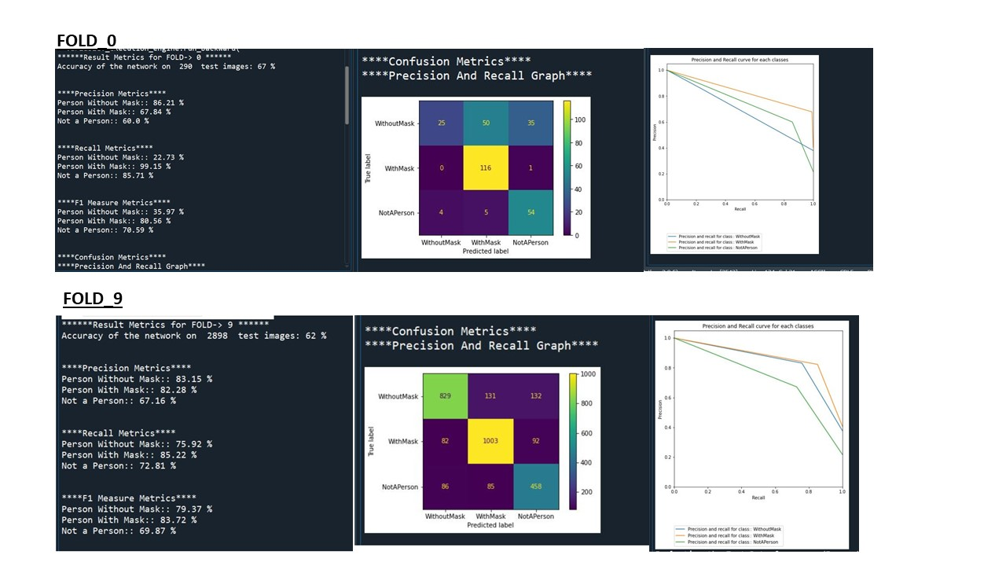

Fig: Fold 0 and Fold1 Result metrics in python console

## Result Comparison (K-fold vs Fixed Datasets)

We observed slight increase in the performance of system after we added k-fold cross validation with 10 folds during the model training. The accuracy of the system with fixed dataset train/test split was 86%. However, when we trained the model of the same original dataset along with k-fold cross validation, the accuracy was improved by 1%. We also observed a higher accuracy of 10-fold implementation in the new dataset after the Bias elimination. In addition to this, the new CNN model, that converts image to grayscale instead of RGB seems to have improvement in the computation time and slightly with the performance too.

Below is the statistical comparison of testing on the original model, K-fold cross validation model trained with original dataset and K-fold cross validation model trained with new dataset (bias elimination).

|  |  |  |  |  |  |
| --- | --- | --- | --- | --- | --- |
|  |  |  | Test Data | | |
|  | | | Original Train/Test Split Model | K-Fold Cross validation in Original Trained Model | K-Fold Cross validation in New Trained Model |
| Test Image Count | | | 630 | 646 | 639 |
| Accuracy (in percentage) | | | 86 | 87 | 89 |
| Precision (in Percentage) | Without Mask | | 86.12 | 84.71 | 87.82 |
| With Mask | | 97.22 | 90.69 | 97.35 |
| Not A Person | | 78.4 | 86.11 | 82.94 |
| Recall (in Percentage) | Without Mask | | 97 | 98.18 | 95.87 |
| With Mask | | 66 | 88.89 | 87.3 |
| Not A Person | | 94 | 71.26 | 85.98 |
| F1-Measure (in Percentage) | Without Mask | | 91 | 90.95 | 91.67 |
| With Mask | | 79 | 89.78 | 92.05 |
| Not A Person | | 85 | 77.99 | 84.43 |
| Confusion Matrix (Image Count) | Without Mask | True Positive | 267 | 216 | 209 |
| False Positive | 43 | 39 | 29 |
| True Negative | 312 | 387 | 392 |
| False Negative | 8 | 4 | 9 |
| With Mask | True Positive | 140 | 224 | 220 |
| False Positive | 4 | 23 | 6 |
| True Negative | 417 | 371 | 381 |
| False Negative | 69 | 28 | 32 |
| Not A Person | True Positive | 138 | 124 | 141 |
| False Positive | 38 | 20 | 29 |
| True Negative | 446 | 452 | 446 |
| False Negative | 8 | 50 | 23 |

Table 3: Evaluation Metrics for original model, K-fold cross validation on Original Trained model and K-fold cross validation on New Trained Model

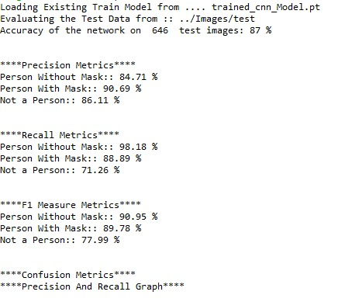

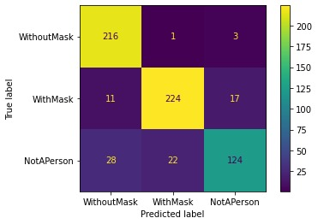 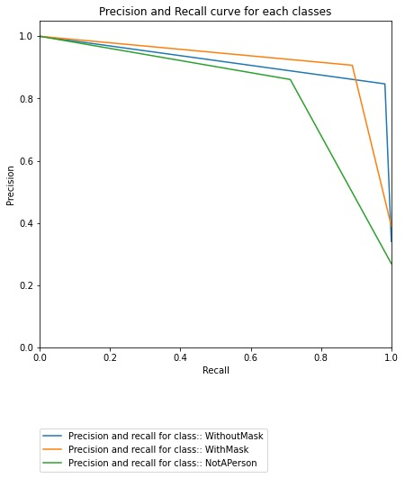

Figure 1: Accuracy, Precision, Recall, F1-Measures, Confusion Matrix and Graph for Precision and Recall for Test results of K-fold cross-validation on Original Model

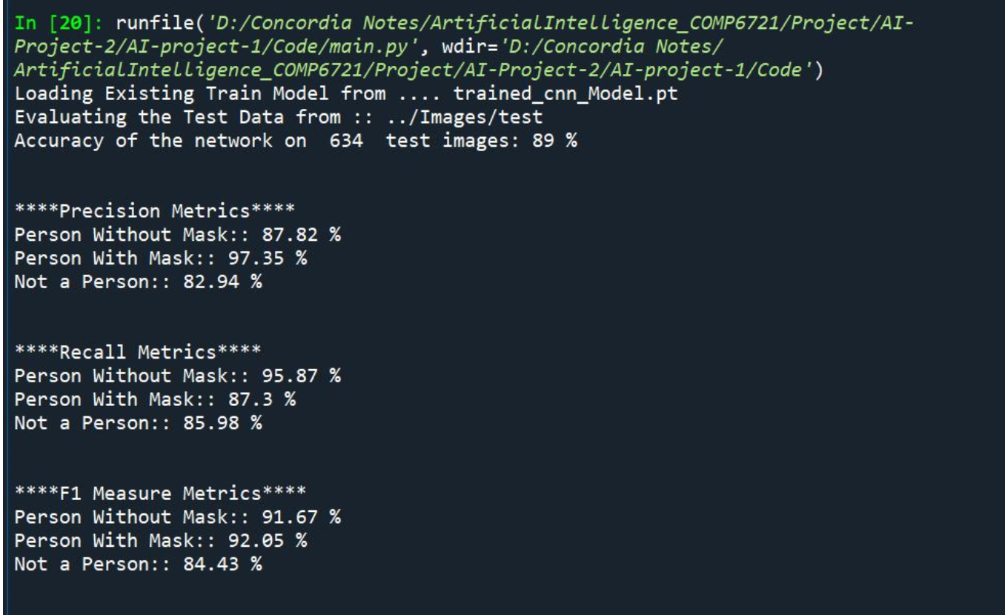

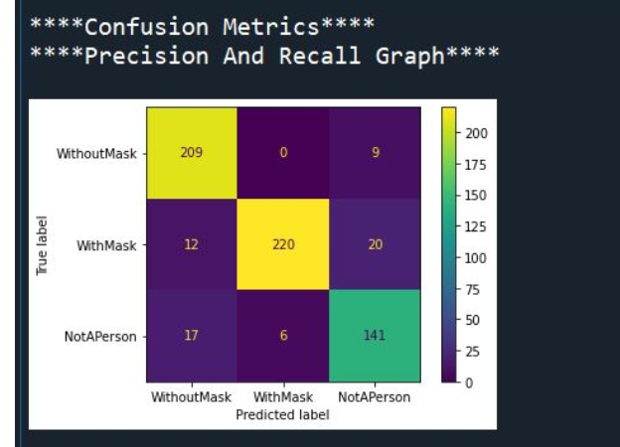 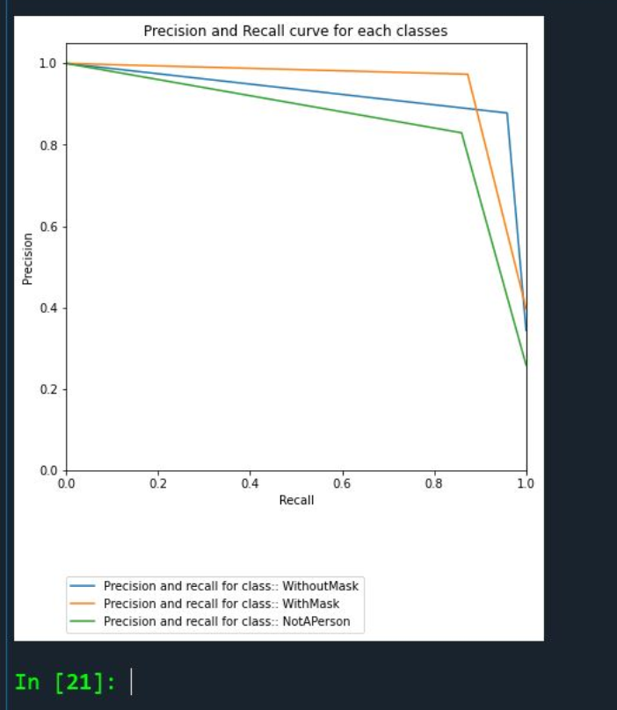

Figure 2: Accuracy, Precision, Recall, F1-Measures, Confusion Matrix and Graph for Precision and Recall for Test results of K-fold cross-validation model (After Bias)

# GIT Link

https://github.com/nikpat9/AI-project-1

# References:

* <https://pytorch.org/tutorials/beginner/blitz/cifar10_tutorial.html>

* <https://stats.stackexchange.com/questions/360157/epoch-vs-iteration-in-cnn-training>
* https://www.analyticsvidhya.com/blog/2020/07/how-to-train-an-image-classification-model-in-pytorch-and-tensorflow/

* <https://medium.com/jovianml/how-i-created-a-simple-mask-detector-using-gpu-in-pytorch-bd13f3542f46>

* <https://medium.com/@i2i-blog/facial-mask-detection-using-deep-learning-and-computer-vision-c0966e14dd94>
* https://towardsdatascience.com/understanding-pytorch-with-an-example-a-step-by-step-tutorial-81fc5f8c4e8e
* <https://www.researchgate.net/publication/267269542_SWU-OFDB_A_database_for_occluded_face_detection_research>
* <https://deeplizard.com/learn/video/MasG7tZj-hw>
* <https://www.tutorialspoint.com/pytorch/pytorch_convolutional_neural_network.htm>
* <https://scikit-learn.org/0.15/modules/generated/sklearn.cross_validation.StratifiedKFold.html>
* <https://www.reuters.com/article/us-amazon-com-jobs-automation-insight-idUSKCN1MK08G>
* <https://machinelearningmastery.com/k-fold-cross-validation/>
* https://scikit-learn.org/stable/modules/cross_validation.html