**Azure functions** are used for serverless computing.

If we use a Virtual Machine, we need to take care of multiple things like the Operating System or its versions. The size allocated, or what the capacity has to be.

To avoid these, we use azure functions to construct an event driven data pipeline

Serverless deployment pipelines usually come with the following advantages:

>It is an abstraction of servers.

>It is based on the philosophy of event driven computing or a “push model “ method of deployment as opposed to conventional pull model methods

>Micro billing. Only pay for what is used.

Benefits:

>Reduced DevOps burden. Maintaining a VM, manual security updates, load balancing tasks will not be the users responsibility.

>Focus on business login, because infrastructure is mostly taken care here.

>Faster time to market, as the job gets done earlier.

We can create an azure function from portal.azure.com or we can write commands on the PowerShell using azure command line interface(CLI) to create it. Provisioning functions locally and publishing them is a very effective method with very low latency.

Step 1: Login to azure from PowerShell.

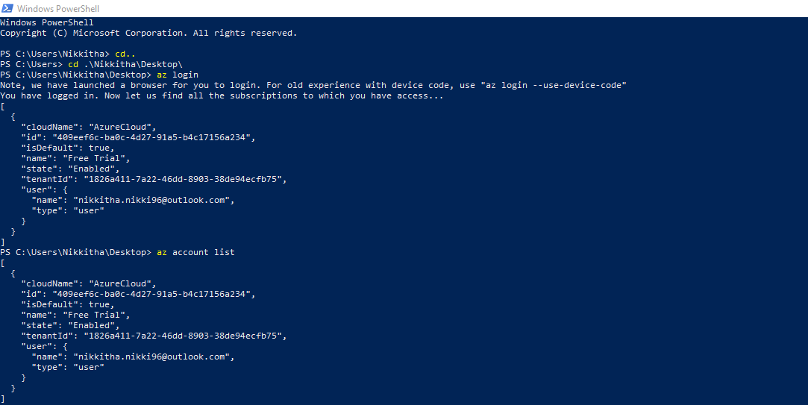

Step 2: Create a resource group.

We create a resource group to configure all the necessary azure resources in a common location.

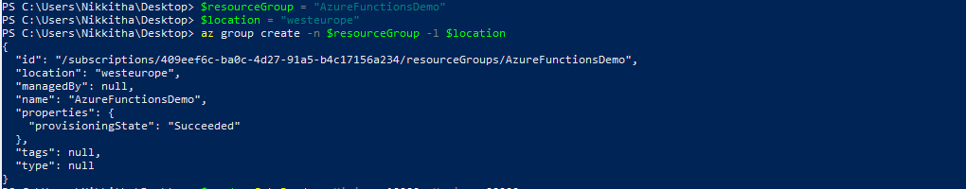

Step 3: Create a storage account.

Storage Accounts should have unique names as it will form part of their domain name, so we use a random number to help pick a suitable name.

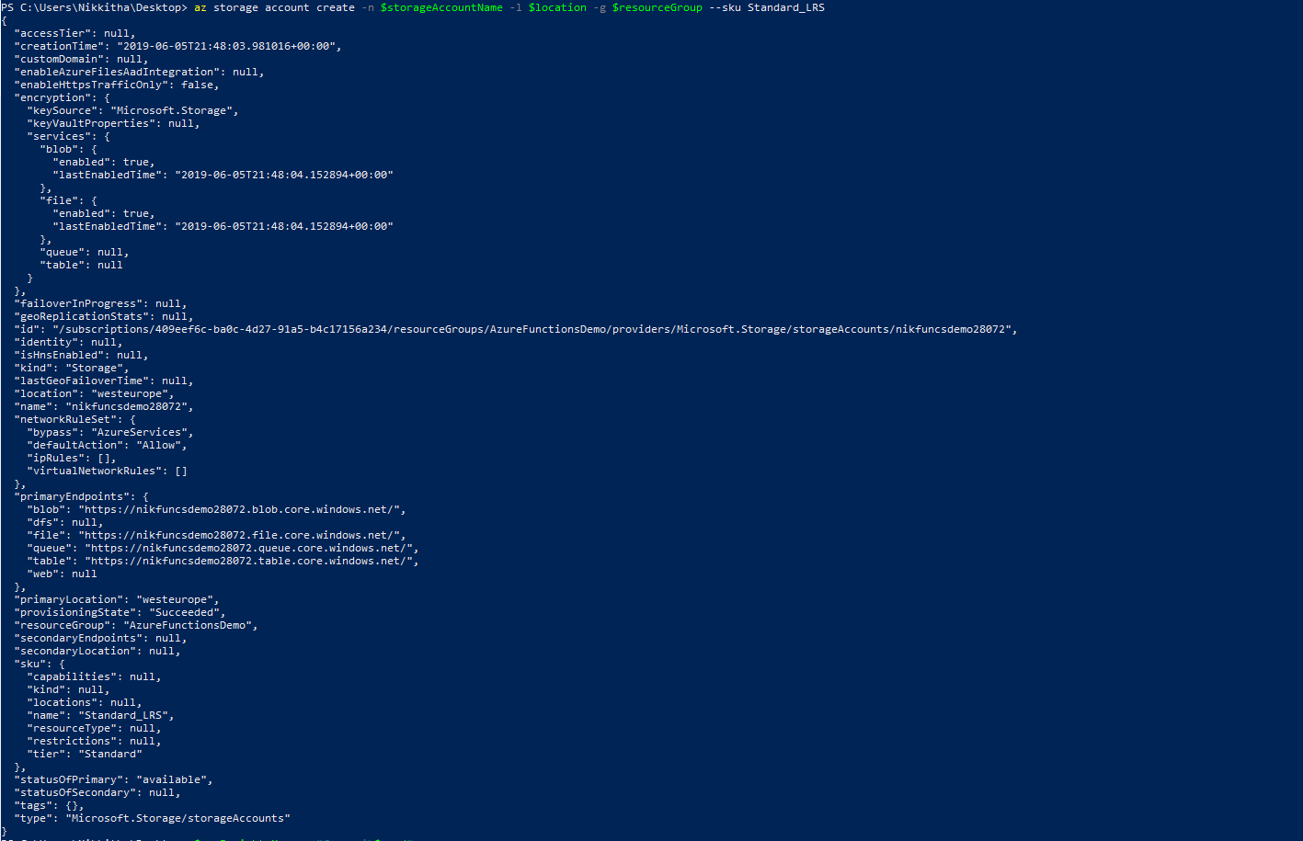

Step 4: Create a resource.

Using .net as azure functions runtime. Mention the Language Choice. You can write azure functions in any of your languages using C#, F#,Node.js, Python, PHP.

