AI Chat Assist - Complete Technical Documentation
This document provides a complete technical overview of the AI Chat Assist application developed using Next.js, React, TypeScript, and AI integrations with Groq and Google Gemini.

1. Project Overview
AI Chat Assist is a modern AI-powered conversational web application that enables users to interact with AI models using streaming responses similar to mainstream Generative AI platforms.
The application was designed with a focus on scalable architecture, reusable components, secure API communication, responsive UI design, maintainability, and production-style frontend engineering practices.

2. Architecture Diagram
The architecture diagram below illustrates the end-to-end application flow including frontend rendering, state management, secure API communication, AI provider selection, SSE streaming, JSON fallback handling, and response rendering.
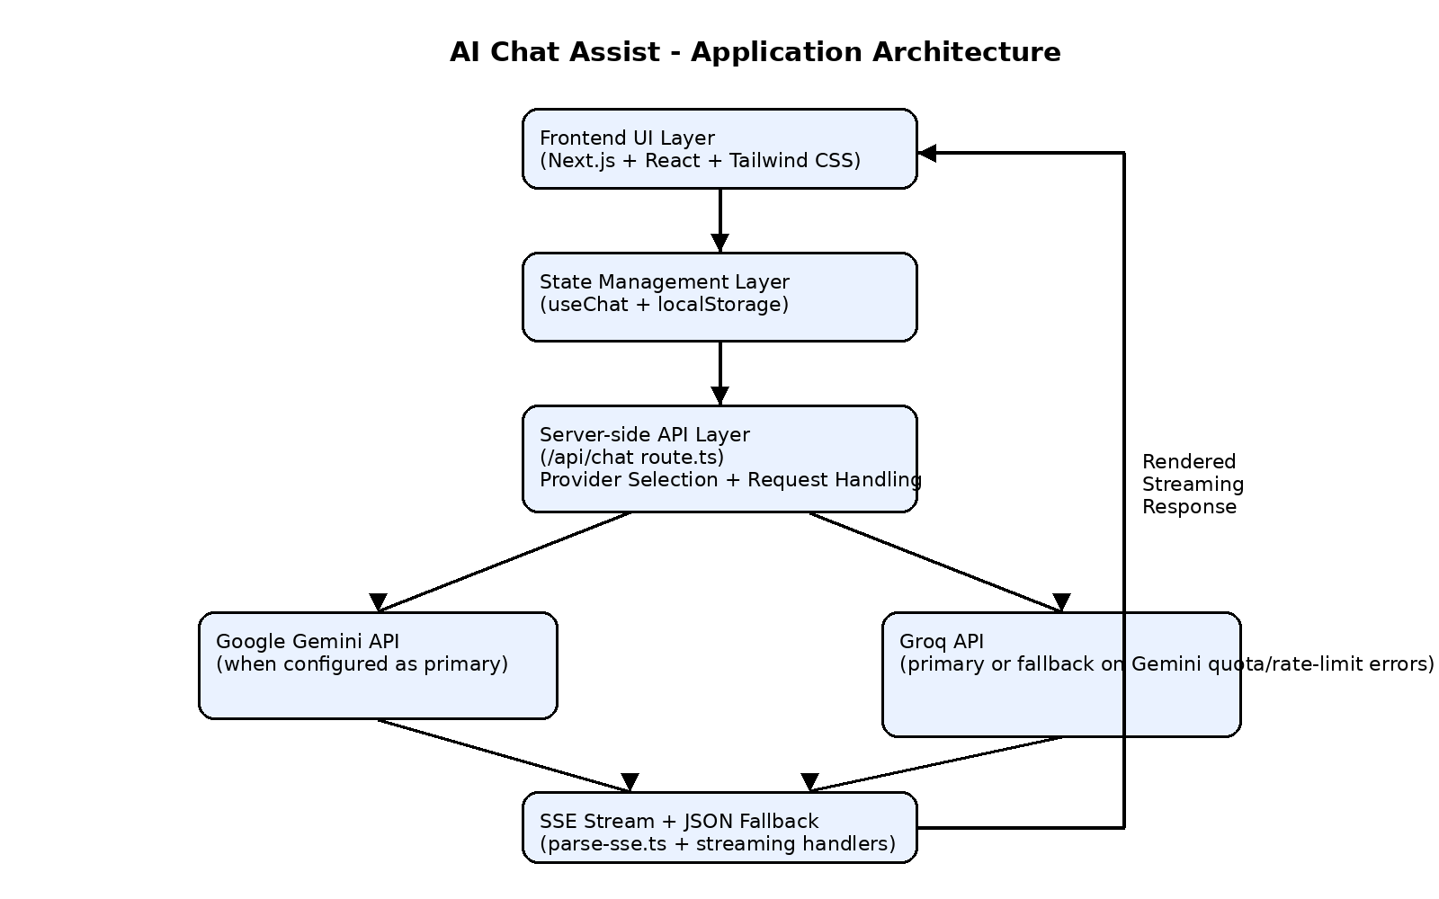
All AI calls go through Next.js API routes so API keys remain secure on the server. The active provider is determined using AI_PROVIDER and the configured environment variables. When Gemini is configured as the primary provider and quota or rate-limit errors occur, the application retries requests using Groq if a Groq API key is available. Responses stream over SSE and are rendered in the frontend using sanitized Markdown rendering.

3. Key Features
- Real-time AI chat with streaming responses
- Multi-conversation sidebar support
- Persistent conversation history using localStorage
- Dynamic message rendering without page refresh
- Loading states and user-friendly error handling
- Groq and Google Gemini AI integrations
- Automatic Groq fallback when Gemini rate limits occur
- Secure API communication through Next.js API routes
- Markdown rendering with sanitization support
- Copy message and copy code block functionality
- Edit and resend user prompts
- Delete and clear conversation actions
- Input validation for empty messages and character limits
- Responsive mobile and desktop layouts
- Unit testing with Vitest and React Testing Library

4. Technology Stack
Technology | Purpose
Next.js 16 | Full-stack framework (UI + API routes)
React 19 | UI component rendering
TypeScript | Static type safety
Tailwind CSS 4 | Responsive application styling
Groq API | AI provider integration
Google Gemini API | AI provider integration
react-markdown | Markdown rendering
remark-gfm + rehype-sanitize | Markdown sanitization
localStorage | Conversation persistence
Vitest + React Testing Library | Unit testing

5. Design Decisions
- Server-side API Integration: AI provider communication is handled through server-side API routes to ensure API keys are never exposed to the browser.
- Streaming Response Implementation: Streaming responses were implemented using SSE to provide a real-time conversational experience similar to modern Generative AI products.
- Groq Fallback Mechanism: Fallback handling was implemented so the application can continue responding when Gemini quota or rate limits are reached.
- Component-Based Architecture: Reusable React components and custom hooks were used to improve maintainability, scalability, and code organization.
- Local Storage Persistence: localStorage was selected for lightweight client-side conversation persistence without introducing additional database complexity.
- Markdown Sanitization: Markdown responses are sanitized before rendering to improve content safety and reduce security risks.
- Tailwind CSS: Tailwind CSS was used to rapidly build a responsive and consistent user interface.

6. Application Architecture
- Reusable UI component architecture
- Dedicated useChat hook for chat state management
- Server-side AI provider integration
- Streaming response handling using SSE
- JSON fallback support for reliability
- Persistent localStorage conversation management
- Type-safe application development using TypeScript
- Responsive mobile and desktop user interface

7. Project Structure
AI-Chat-Assist/
│
├── src/
│ ├── app/
│ │ ├── api/chat/route.ts
│ │ ├── globals.css
│ │ ├── layout.tsx
│ │ └── page.tsx
│ │
│ ├── components/
│ ├── hooks/
│ ├── lib/
│ │ ├── ai/ (groq, gemini, provider, stream-events)
│ │ ├── stream/ (parse-sse)
│ │ ├── types.ts
│ │ ├── conversations.ts
│ │ ├── storage.ts
│ │ └── ...
│ │
│ └── test/setup.ts
│
├── public/
├── vitest.config.ts
├── next.config.ts
├── .env.example
├── package.json
└── README.md
The project structure separates frontend UI logic, AI provider integrations, stream handling, utility functions, and testing configuration to improve maintainability and scalability.

8. Environment Configuration
AI_PROVIDER=groq
GROQ_API_KEY=your_groq_api_key
GROQ_MODEL=llama-3.3-70b-versatile
GEMINI_API_KEY=your_gemini_api_key
GEMINI_MODEL=gemini-2.5-flash
The application supports both Groq and Google Gemini AI providers. The active provider is controlled using the AI_PROVIDER environment variable.
Configuration | Primary Provider
AI_PROVIDER=groq | Groq
AI_PROVIDER=gemini | Gemini
Both API keys configured without AI_PROVIDER | Gemini (default)
Only GROQ_API_KEY configured | Groq
All API credentials are securely managed through server-side environment variables and are never exposed in browser-side code.

9. Installation and Running the Application
Repository URL: https://github.com/nikshithareddyaella/AI-Chat-Assist
Prerequisites:
- Node.js 18+
- npm 9+
- Clone the repository from GitHub
- Navigate to the project directory
- Install dependencies using npm install
- Copy .env.example to .env.local
- Configure environment variables in .env.local
- Start the development server using npm run dev
Command | Description
npm run dev | Start development server
npm run build | Create production build
npm run start | Run production build
npm run lint | Run ESLint
npm run test | Run unit tests
npm run test:watch | Run tests in watch mode

10. Deployment
The application is configured for deployment on Vercel. Environment variables configured locally should also be configured within the Vercel deployment environment.
Live Demo: https://ai-chat-assist-mu.vercel.app

11. Coding Standards and Best Practices
- Component-based architecture
- TypeScript-based type safety
- Reusable and maintainable code structure
- Semantic HTML implementation
- Responsive Tailwind CSS layout
- Secure server-side API handling
- Environment variable protection
- Input validation and user-facing error handling
- Streaming response implementation with fallback support
- Sanitized markdown rendering
- Unit testing implementation

12. Future Enhancements
- User authentication support
- Conversation export functionality
- Request cancellation while streaming
- Enhanced accessibility support
- Cloud database synchronization
- Dark/light theme toggle

13. Conclusion
AI Chat Assist demonstrates modern frontend engineering practices through scalable architecture, streaming AI integrations, reusable components, secure API handling, responsive UI design, and robust state management. The project emphasizes maintainability, reliability, and production-oriented development standards.

