AI Chat Assist - Technical Documentation
This document provides a technical overview of the AI Chat Assist application developed using Next.js, React, TypeScript, and AI integrations with Groq and Google Gemini.

1. Project Overview
AI Chat Assist is a modern AI-powered chat application designed to provide users with real-time conversational AI interactions using streaming responses similar to mainstream Generative AI products.
The application was designed with a focus on scalable architecture, reusable components, secure API communication, responsive design, and production-style frontend engineering practices.

2. Architecture Diagram
The architecture diagram below illustrates the end-to-end application flow, including frontend rendering, state management, secure API communication, AI provider integration, fallback handling, and streaming response processing.
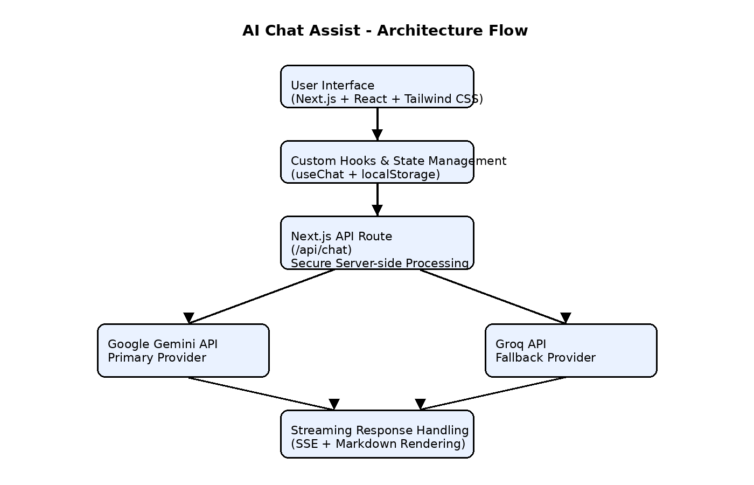
The application uses a secure server-side architecture where all AI provider communication is handled through Next.js API routes. Gemini acts as the primary AI provider, while Groq serves as a fallback provider during quota or rate-limit failures. Streaming responses are processed using Server-Sent Events (SSE) and dynamically rendered in the frontend.

3. Key Features
- Real-time AI chat with streaming responses
- Multi-conversation sidebar support
- Persistent conversation history using localStorage
- Dynamic message rendering without page refresh
- Loading states and user-friendly error handling
- Groq and Google Gemini AI integrations
- Automatic Groq fallback when Gemini rate limits occur
- Secure API communication through Next.js API routes
- Markdown rendering with sanitization support
- Copy message and copy code block functionality
- Edit and resend user prompts
- Delete and clear conversation actions
- Input validation for empty messages and character limits
- Responsive mobile and desktop layouts
- Unit testing with Vitest and React Testing Library

4. Technology Stack
Technology | Purpose
Next.js 16 | Full-stack framework (UI + API routes)
React 19 | UI component rendering
TypeScript | Static type safety
Tailwind CSS 4 | Responsive application styling
Groq API | AI provider integration
Google Gemini API | AI provider integration
react-markdown | Markdown rendering
remark-gfm + rehype-sanitize | Markdown sanitization
localStorage | Conversation persistence
Vitest + React Testing Library | Unit testing

5. Design Decisions
- Server-side API Integration: AI provider communication is handled through server-side API routes to ensure API keys are never exposed to the browser.
- Streaming Response Implementation: Streaming responses were implemented using SSE to provide a real-time conversational experience similar to modern Generative AI products.
- Groq Fallback Mechanism: Automatic fallback handling was implemented so the application can continue responding even when Gemini quota or rate limits are reached.
- Component-Based Architecture: Reusable React components and custom hooks were used to improve maintainability, scalability, and code organization.
- Local Storage Persistence: localStorage was selected for lightweight client-side conversation persistence without introducing additional database complexity.
- Markdown Sanitization: Markdown responses are sanitized before rendering to reduce security risks and improve content safety.
- Tailwind CSS: Tailwind CSS was used to build a responsive UI quickly while maintaining consistent styling across the application.

6. Application Architecture
- Reusable UI component architecture
- Dedicated useChat hook for chat state management
- Server-side AI provider integration
- Streaming response handling using SSE
- JSON fallback support for reliability
- Persistent localStorage conversation management
- Type-safe application development using TypeScript
- Responsive mobile and desktop user interface

7. Project Structure
AI-Chat-Assist/
│
├── src/
│ ├── app/
│ │ ├── api/chat/route.ts
│ │ ├── globals.css
│ │ ├── layout.tsx
│ │ └── page.tsx
│ │
│ ├── components/
│ ├── hooks/
│ ├── lib/
│ │ ├── ai/ (groq, gemini, provider, stream-events)
│ │ ├── stream/ (parse-sse)
│ │ ├── types.ts
│ │ ├── conversations.ts
│ │ ├── storage.ts
│ │ └── ...
│ │
│ └── test/setup.ts
│
├── public/
├── vitest.config.ts
├── next.config.ts
├── .env.example
├── package.json
└── README.md

8. Environment Configuration
AI_PROVIDER=groq
GROQ_API_KEY=your_groq_api_key
GROQ_MODEL=llama-3.3-70b-versatile
GEMINI_API_KEY=your_gemini_api_key
GEMINI_MODEL=gemini-2.5-flash
The application supports both Groq and Google Gemini AI providers. The active provider is controlled using the AI_PROVIDER environment variable.

9. Installation and Running the Application
Repository URL: https://github.com/nikshithareddyaella/AI-Chat-Assist
Prerequisites:
- Node.js 18+
- npm 9+
- Clone the repository from GitHub
- Navigate to the project directory
- Install dependencies using npm install
- Copy .env.example to .env.local
- Configure environment variables in .env.local
- Start the development server using npm run dev
Command | Description
npm run dev | Start development server
npm run build | Create production build
npm run start | Run production build
npm run lint | Run ESLint
npm run test | Run unit tests
npm run test:watch | Run tests in watch mode

10. Deployment
The application is configured for deployment on Vercel. Environment variables configured locally should also be configured within the Vercel deployment environment.
Live Demo: https://ai-chat-assist-mu.vercel.app

11. Coding Standards and Best Practices
- Component-based architecture
- TypeScript-based type safety
- Reusable and maintainable code structure
- Semantic HTML implementation
- Responsive Tailwind CSS layout
- Secure server-side API handling
- Environment variable protection
- Input validation and user-facing error handling
- Streaming response implementation with fallback support
- Sanitized markdown rendering
- Unit testing implementation

12. Future Enhancements
- User authentication support
- Conversation export functionality
- Request cancellation while streaming
- Enhanced accessibility support
- Cloud database synchronization
- Dark/light theme toggle

13. Conclusion
AI Chat Assist demonstrates modern frontend engineering practices through scalable architecture, streaming AI integrations, reusable components, secure API handling, responsive UI design, and robust state management. The project emphasizes maintainability, reliability, and production-oriented development standards.

