#include "pch.h"

#include <iostream>

#include <iomanip>

#include <cstdlib>

#include <ctime>

using namespace std;

int main() {

srand((int)time(0));

const int n = 10;

int a[n][n], sum = 0;

for (int i = 0; i < n; i++)

{

for (int j = 0; j < n; j++)

{

a[i][j] = rand() % 21 - 10;

if (a[i][j] > 0) sum += a[i][j];

cout << " " << a[i][j];

}

}

return(0);

}

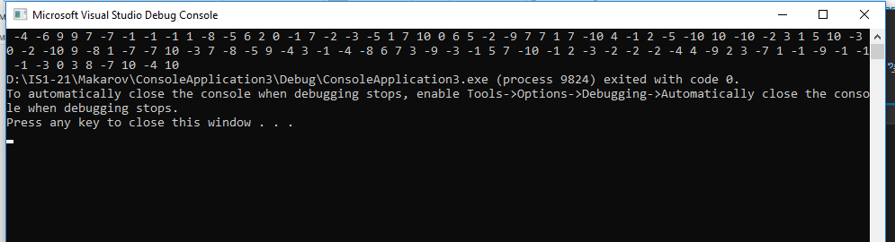

#include "pch.h"

#include <iostream>

#include <iomanip>

#include <cstdlib>

#include <ctime>

using namespace std;

int main()

{

int arr[10];

for (int i = 0; i < 10; i++)

{

cin >> arr[i];

}

for (int i = 0; i < 10; i++)

{

cout << endl;

cout << arr[i] << endl;

}

}

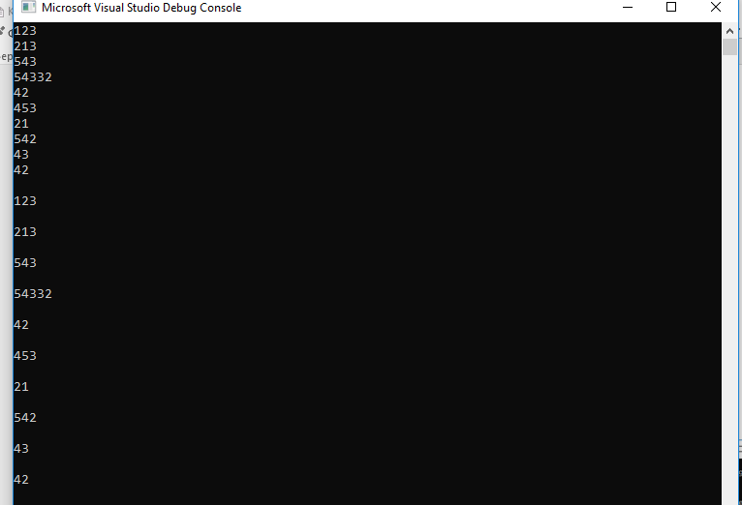

int ex3()

{

srand(time(0));

int arr[5], sum = 0;

for (int i = 0; i < 5; i++)

{

arr[i] = rand() % 201 - 100;

}

for (int i = 0; i < 5; i++)

{

sum += arr[i];

}

cout << sum;

return(0);

}

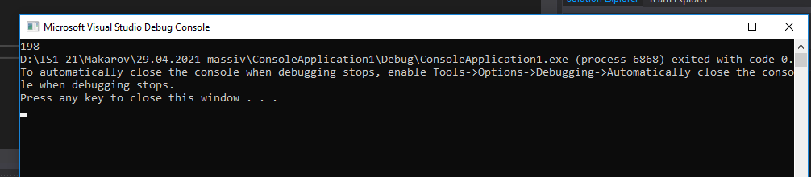

int ex4()

{

srand(time(0));

int arr[10], pr = 1;

for (int i = 0; i < 10; i++)

{

arr[i] = rand() % 201 - 100;

}

for (int i = 0; i < 10; i++)

{

pr \*= arr[i];

}

cout << pr;

return(0);

}

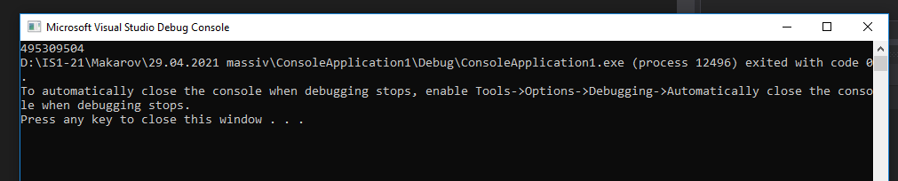

int ex5()

{

srand(time(0));

int arr[10], count = 0;

for (int i = 0; i < 10; i++)

{

arr[i] = rand() % 201 - 100;

}

for (int i = 0; i < 10; i++)

{

if (arr[i] > 0)

count++;

}

cout << count;

return(0);

}

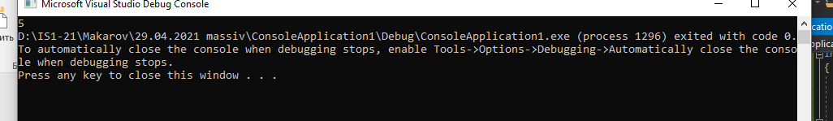

int ex6()

{

srand(time(0));

int arr[10], count = 0;

for (int i = 0; i < 10; i++)

{

arr[i] = rand() % 201 - 100;

}

for (int i = 0; i < 10; i++) {

for (int j = 0; j < 10 - 1; j++) {

if (arr[j] > arr[j + 1]) {

int temp = arr[j];

arr[j] = arr[j + 1];

arr[j + 1] = temp;

}

}

}

for (int i = 0; i < 10; i++) {

cout << arr[i] << " ";

}

cout << endl;

for (int i = 0; i < 10; i++) {

for (int j = 0; j < 10 - 1; j++) {

if (arr[j] < arr[j + 1]) {

int temp = arr[j];

arr[j] = arr[j + 1];

arr[j + 1] = temp;

}

}

}

for (int i = 0; i < 10; i++) {

cout << arr[i] << " ";

}

return(0);

}

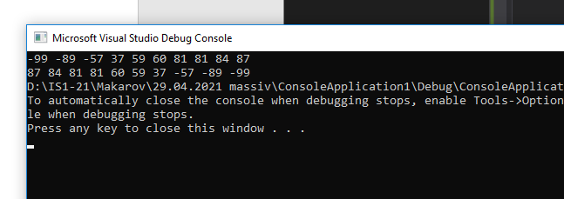

int ex7()

{

srand(time(0));

int arr[10], sum = 0;

for (int i = 0; i < 10; i++)

{

arr[i] = rand() % 201 - 100;

}

for (int i = 0; i < 10; i++)

{

sum += arr[i];

}

cout << sum / 10;

return(0);

}

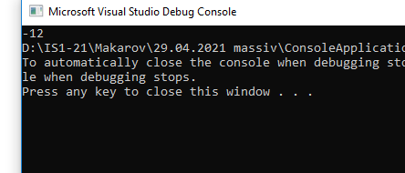

int ex8()

{

srand(time(0));

int arr[10], max = 0;

for (int i = 0; i < 10; i++)

{

arr[i] = rand() % 201 - 100;

}

for (int i = 0; i < 10; i++)

{

if (arr[i] > max)

max = arr[i];

}

cout << max;

return(0);

}

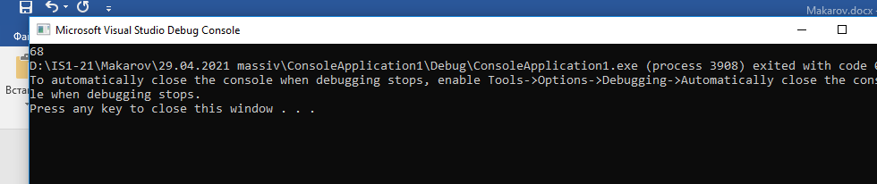

int ex9()

{

srand(time(0));

int arr[10];

for (int i = 0; i < 10; i++)

{

arr[i] = rand() % 201 - 100;

}

int min = arr[0];

for (int i = 0; i < 10; i++)

{

if (arr[i] < min)

min = arr[i];

}

cout << min;

return(0);

}

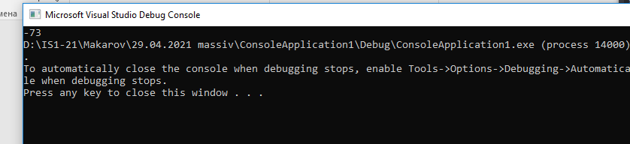

int ex10()

{

srand(time(0));

int arr[10];

for (int i = 0; i < 10; i++)

{

arr[i] = rand() % 21 - 10;

}

for (int i = 0; i < 10; i++)

{

cout << arr[i] << " ";

}

return(0);

}

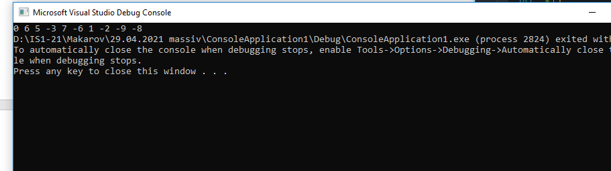

int ex11()

{

srand(time(0));

int arr[10];

for (int i = 0; i < 10; i++)

{

arr[i] = rand() % 21 - 10;

}

for (int i = 0; i < 10; i++)

{

cout << arr[i] << endl;

}

return(0);

}

