1. **Add a gradle dependency and its related repository url.**

**Ans -**

**Url :** [**https://mvnrepository.com/artifact/com.google.code.gson/gson**](https://mvnrepository.com/artifact/com.google.code.gson/gson)

dependencies **{**

testCompile **group**: **'junit'**, **name**: **'junit'**, **version**: **'4.12'**

compileOnly **group**: **'com.google.code.gson'**, **name**: **'gson'**, **version**: **'2.8.6'**

**}**

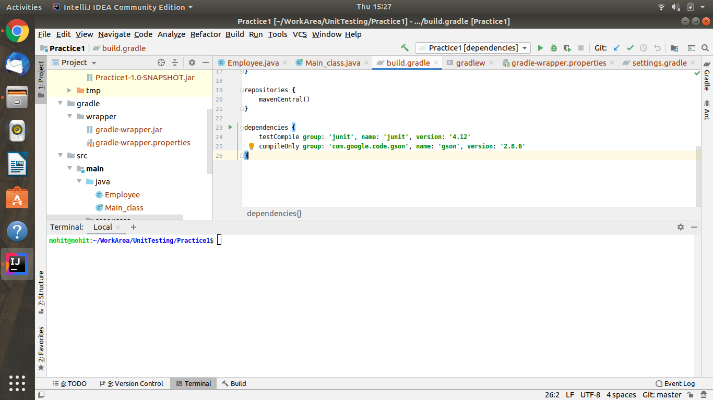

1. **Using java plugin, make changes in the manifest to make the jar executable. Using java -jar JAR_NAME, the output should be printed as "Hello World"**

**Ans -**

**apply plugin: 'java'**

**sourceSets{**

**main{**

**java {**

**srcDirs = ["src/main/java"]**

**}**

**}**

**}**

**jar{**

**manifest{**

**attributes(**

**"Main-Class": 'Main_class',**

**"Class-Path": configurations.compile.collect { it.getName() }.join(' '),**

**)**

**}**

**}**

**Main_Class :-**

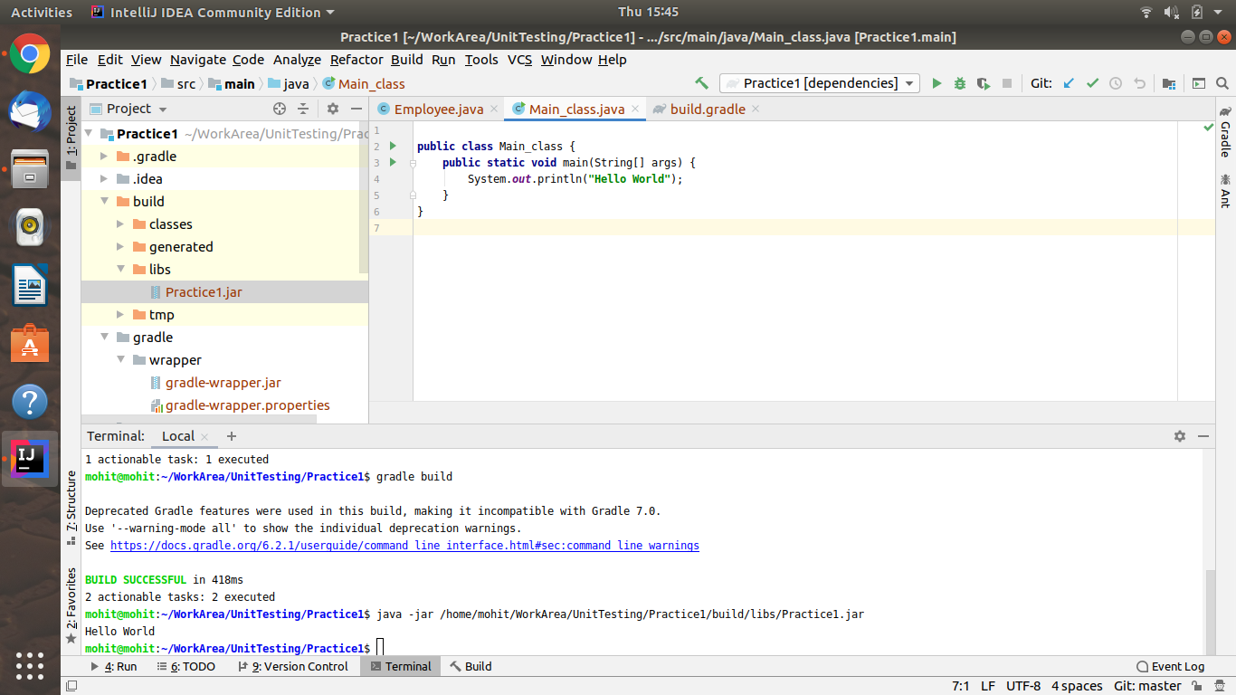

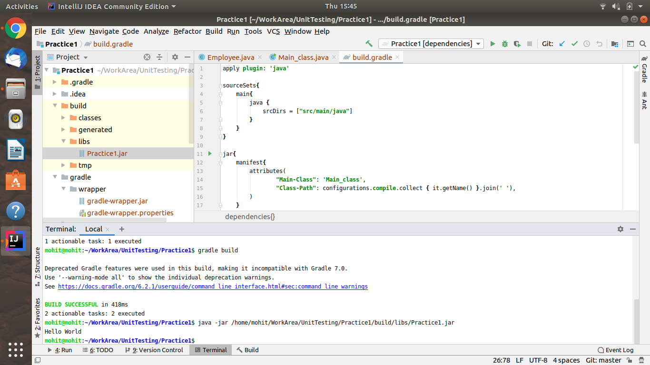

1. **Differentiate between the different dependency scopes: compile, runtime, testCompile, testRuntime using different dependencies being defined in your build.gradle.**

**Ans -**

**Compile:** The compile scope is the default scope. We can use it when we have no special requirements for declaring a certain dependency.

**Runtime**: We use the runtime scope for dependencies that are not needed at compile time, like when we’re compiling against an API and only need the implementation of that API at runtime.

**testCompile**: We can use the testCompile scope for dependencies that are only needed in tests compile time and that should not be available in production code.

**testRuntime**: We use the runRuntime scope for dependencies that are not needed at compile time, like when we’re compiling against an API and only need the implementation of that API at runtime.

1. **Create a custom plugin which contains a custom task which prints the current date-time. Using that plugin in your project, execute that task after the jar task executes.**

**Ans -**

**task showDate{**

**dependsOn(build)**

**doLast {**

**println 'Current Date :' + new Date();**

**}**

**}**

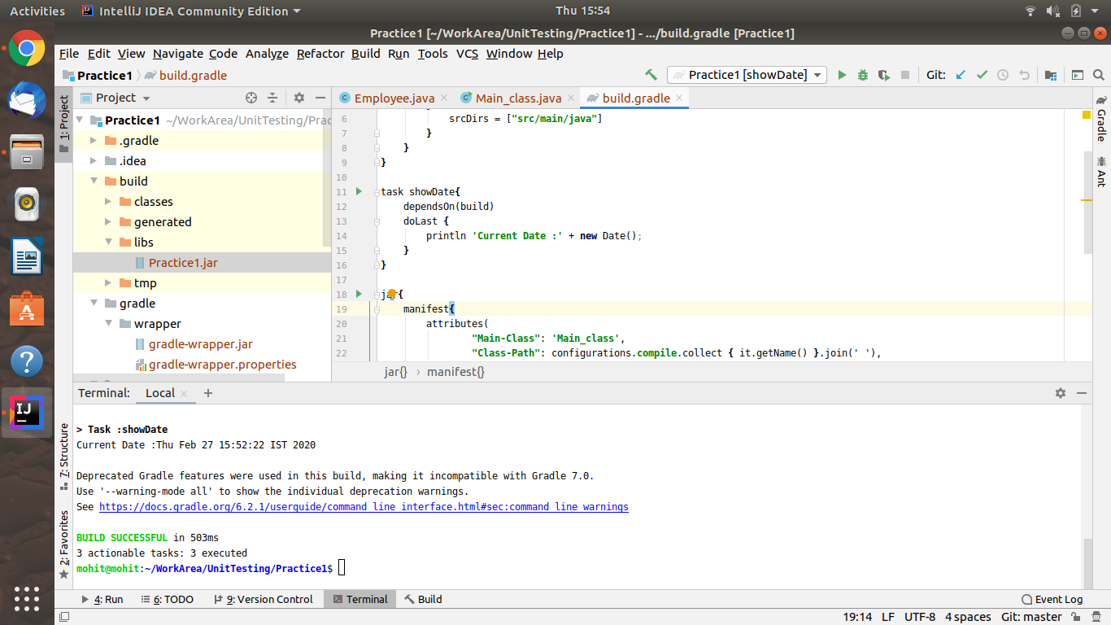

1. **Instead of using default source set, use src/main/javaCode1, src/main/javaCode2 to be taken as code source. Make sure that the JAR created contains files from both the directories and not from src/main/java.**

**Ans -**

**sourceSets{**

***main*{**

**java {**

**srcDirs = ["src/main/javaCode1", "src/main/javaCode2"]**

**}**

**}**

**}**

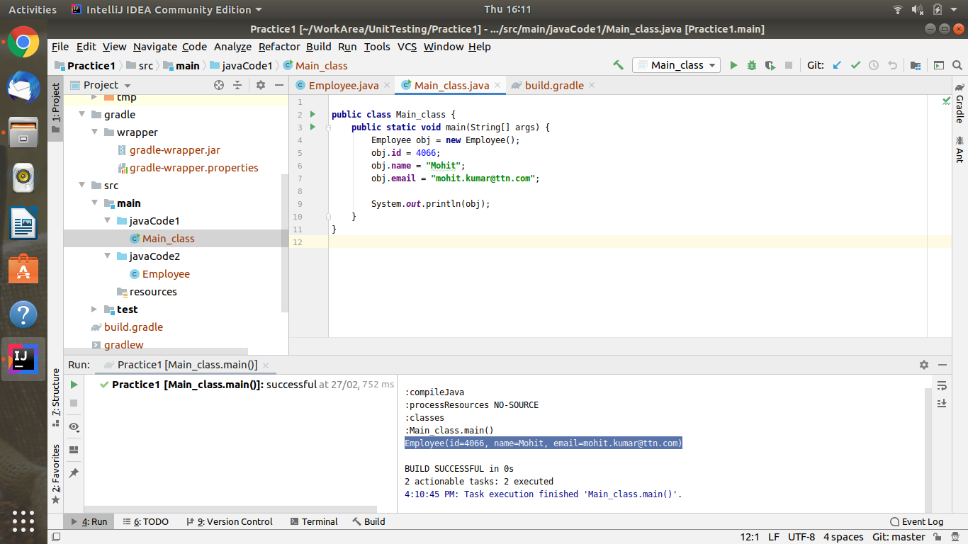

1. **Override the Gradle Wrapper task to install a different version of gradle. Make sure that the task written in Q4 also executes with it.**

**Ans -**

**Previous version - 4.4.1**

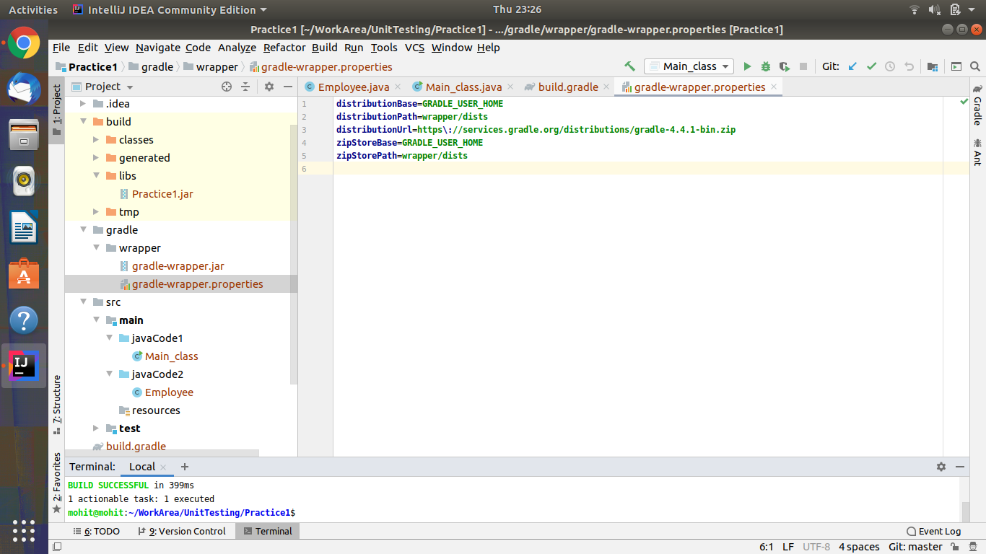

**Changing version :-**

gradle wrapper --gradle-version 6.2.1

**//New version - 6.6.2**

**Printing current date-time :-**

gradle showDate

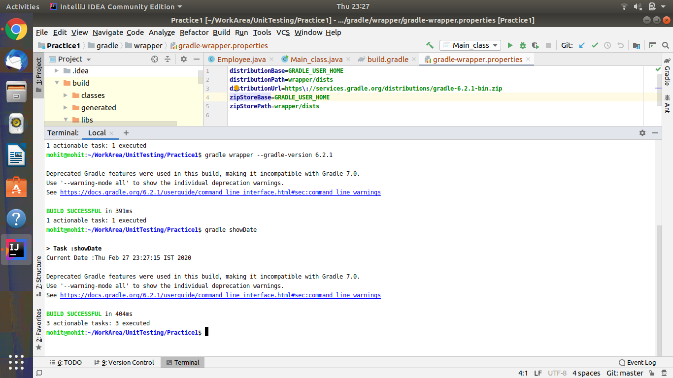

1. **Run the gradle profile command and attach the resulting files.**

**Ans -**

gradle --profile

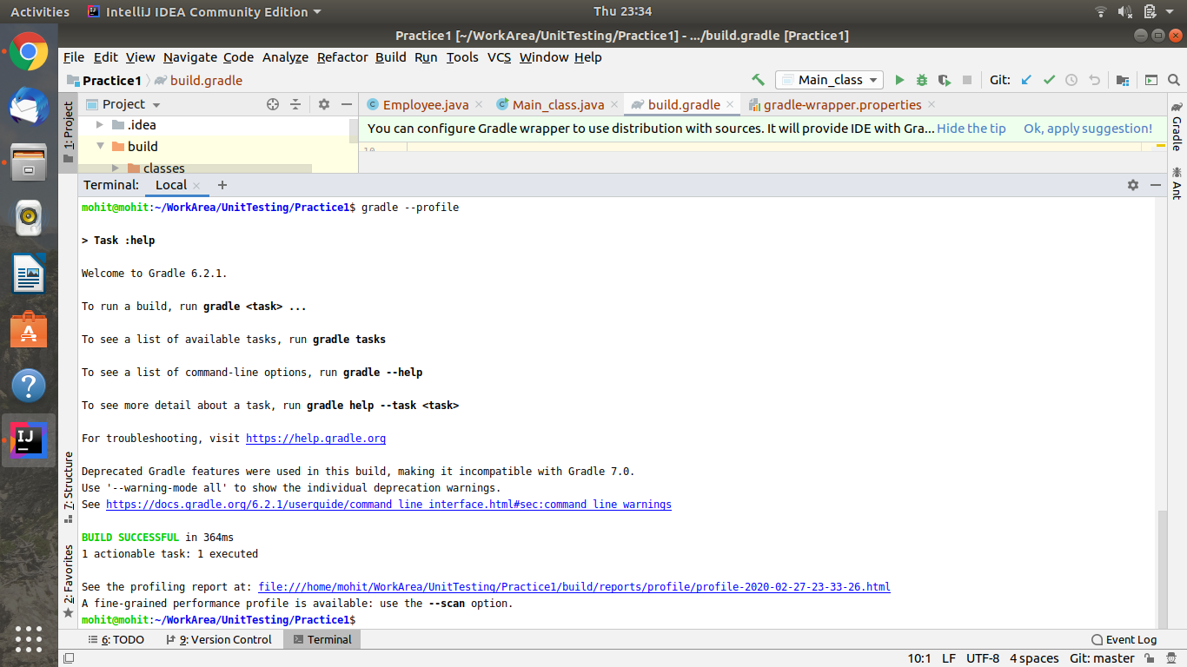

**<!DOCTYPE html>**

**<html>**

**<head>**

**<meta http-equiv="Content-Type" content="text/html; charset=utf-8"/>**

**<meta http-equiv="x-ua-compatible" content="IE=edge"/>**

**<title>Profile report</title>**

**<link href="css/base-style.css" rel="stylesheet" type="text/css"/>**

**<link href="css/style.css" rel="stylesheet" type="text/css"/>**

**<script src="js/report.js" type="text/javascript"></script>**

**</head>**

**<body>**

**<div id="content">**

**<h1>Profile report</h1>**

**<div id="header">**

**<p>Profiled build: help </p>**

**<p>Started on: 2020/02/28 - 10:08:45</p>**

**</div>**

**<div id="tabs">**

**<ul class="tabLinks">**

**<li>**

**<a href="#tab0">Summary</a>**

**</li>**

**<li>**

**<a href="#tab1">Configuration</a>**

**</li>**

**<li>**

**<a href="#tab2">Dependency Resolution</a>**

**</li>**

**<li>**

**<a href="#tab3">Artifact Transforms</a>**

**</li>**

**<li>**

**<a href="#tab4">Task Execution</a>**

**</li>**

**</ul>**

**<div class="tab" id="tab0">**

**<h2>Summary</h2>**

**<table>**

**<thead>**

**<tr>**

**<th>Description</th>**

**<th class="numeric">Duration</th>**

**</tr>**

**</thead>**

**<tr>**

**<td>Total Build Time</td>**

**<td class="numeric">0.362s</td>**

**</tr>**

**<tr>**

**<td>Startup</td>**

**<td class="numeric">0.345s</td>**

**</tr>**

**<tr>**

**<td>Settings and buildSrc</td>**

**<td class="numeric">0.002s</td>**

**</tr>**

**<tr>**

**<td>Loading Projects</td>**

**<td class="numeric">0.001s</td>**

**</tr>**

**<tr>**

**<td>Configuring Projects</td>**

**<td class="numeric">0.009s</td>**

**</tr>**

**<tr>**

**<td>Artifact Transforms</td>**

**<td class="numeric">0s</td>**

**</tr>**

**<tr>**

**<td>Task Execution</td>**

**<td class="numeric">0.002s</td>**

**</tr>**

**</table>**

**</div>**

**<div class="tab" id="tab1">**

**<h2>Configuration</h2>**

**<table>**

**<thead>**

**<tr>**

**<th>Project</th>**

**<th class="numeric">Duration</th>**

**</tr>**

**</thead>**

**<tr>**

**<td>All projects</td>**

**<td class="numeric">0.009s</td>**

**</tr>**

**<tr>**

**<td>:</td>**

**<td class="numeric">0.009s</td>**

**</tr>**

**</table>**

**</div>**

**<div class="tab" id="tab2">**

**<h2>Dependency Resolution</h2>**

**<table>**

**<thead>**

**<tr>**

**<th>Dependencies</th>**

**<th class="numeric">Duration</th>**

**</tr>**

**</thead>**

**<tr>**

**<td>All dependencies</td>**

**<td class="numeric">0s</td>**

**</tr>**

**<tr>**

**<td>:compile</td>**

**<td class="numeric">0s</td>**

**</tr>**

**</table>**

**</div>**

**<div class="tab" id="tab3">**

**<h2>Artifact Transforms</h2>**

**<table>**

**<thead>**

**<tr>**

**<th>Transform</th>**

**<th class="numeric">Duration</th>**

**</tr>**

**</thead>**

**<tr>**

**<td>All transforms</td>**

**<td class="numeric">0s</td>**

**</tr>**

**</table>**

**</div>**

**<div class="tab" id="tab4">**

**<h2>Task Execution</h2>**

**<table>**

**<thead>**

**<tr>**

**<th>Task</th>**

**<th class="numeric">Duration</th>**

**<th>Result</th>**

**</tr>**

**</thead>**

**<tr>**

**<td>:</td>**

**<td class="numeric">0.002s</td>**

**<td>(total)</td>**

**</tr>**

**<tr>**

**<td class="indentPath">:help</td>**

**<td class="numeric">0.002s</td>**

**<td></td>**

**</tr>**

**</table>**

**</div>**

**</div>**

**<div id="footer">**

**<p>**

**<div>**

**<label class="hidden" id="label-for-line-wrapping-toggle" for="line-wrapping-toggle">Wrap lines**

**<input id="line-wrapping-toggle" type="checkbox" autocomplete="off"/>**

**</label>**

**</div>Generated by**

**<a href="http://www.gradle.org">Gradle 6.2.1</a> at 28 Feb, 2020 10:08:45 AM</p>**

**</div>**

**</div>**

**</body>**

**</html>**

