TASK 1 :

Power BI Desktop

- THIS IS A BLANK DASKTOP OF POWER BI DESKTOP.
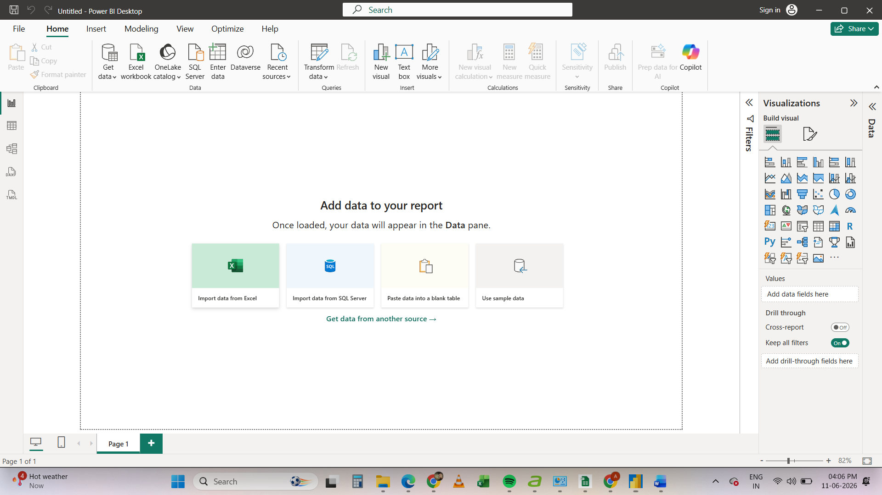

TASK 2 :

- INFORMATION ABOUT COMPONENTS IN POWER BI.
• Report View:
The primary canvas workspace where you design, build, and arrange interactive data visualizations and charts.

• Data View (Table View):
A spreadsheet-like grid interface that allows you to inspect, filter, and format the underlying data tables after they are loaded.
• Model View:
A structural workspace used to view and manage relationships, schemas, and connections between different data tables.
• Fields Pane (Data Pane):
A collapsible panel on the right that lists all the tables and specific columns/fields available to use in your report.
• Visualizations Pane:
A control panel containing built-in chart types and formatting options used to build and customize your report visuals.
• Filters Pane:
A dedicated panel used to apply narrow criteria and filter data across a specific visual, a single page, or all report pages.

TASK 3 :

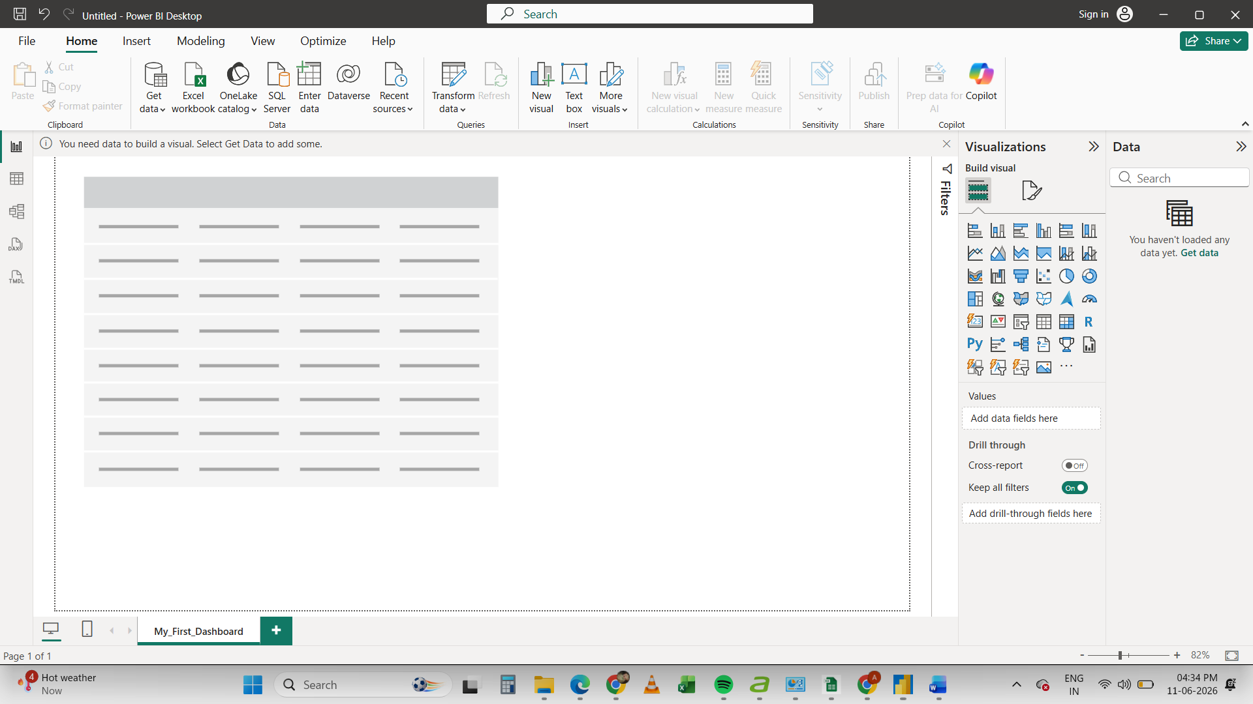

TASK 4 :
- Differences between Excel Dashboards and Power BI Dashboards.

- Power BI can manage larger and more complex datasets than Excel.
- Power BI dashboards are more interactive, offering advanced filtering and drill-down features.
- Power BI provides built-in data modelling and transformation tools, reducing manual work compared to Excel.

