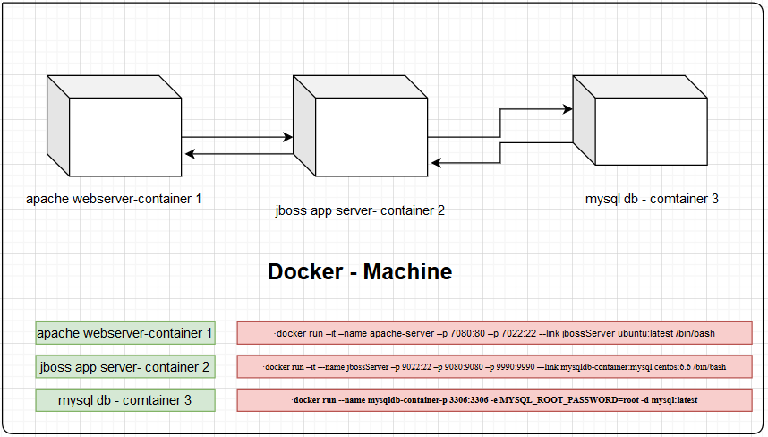

**##1## For configuring websever (Apache2) container**

* docker pull ubuntu:latest
* docker run –it –name apache-server –p 7080:80 –p 7022:22 --link jbossServer ubuntu:latest /bin/bash

(NOTE: jbossServer is another appserver container [basically, centos:6.6 images over which jdk 8 and redhat jboss eap 6.4 is installed ]

* apt-get install ssh
* service enable ssh
* service ssh restart or /etc/init.d/ssh restart
* /etc/init.d/ssh status -> to check the status of ssh
* apt-get intall apache2 (installing the apache2 server on linux server)
* service apache2 start ( to start the web server)

# There are some cmd for enabling http modules , proxy modules, load balanceing modules

* apt-get update
* apt-get install apache2 –y
* a2enmod proxy
* a2enmod proxy_http

## added on custom site for my jboss.conf inside

* /etc/apache2/sites-available

File: apacheProxy.conf => content is given below

<VirtualHost *:80>

ServerName example.com

ServerAdmin webmaster@localhost

DocumentRoot /var/www/html

ErrorLog ${APACHE_LOG_DIR}/error.log

CustomLog ${APACHE_LOG_DIR}/access.log combined

ProxyRequests Off

<Proxy *>

Order deny,allow

Allow from all

</Proxy>

ProxyPass /MyAppWeb-0.0.1-SNAPSHOT http://172.31.40.209:9080/MyAppWeb-0.0.1-SNAPSHOT/

ProxyPassReverse /MyAppWeb-0.0.1-SNAPSHOT <http://172.31.40.209:9080/MyAppWeb-0.0.1-SNAPSHOT/>

Or using container name jbossServer (jboss container name which is linked with this webserver)

ProxyPass /MyAppWeb-0.0.1-SNAPSHOT http://jbossServer:9080/MyAppWeb-0.0.1-SNAPSHOT/

ProxyPassReverse /MyAppWeb-0.0.1-SNAPSHOT http://jbossServer:9080/MyAppWeb-0.0.1-SNAPSHOT/

Or using container ip 172.17.0.3 (jboss container ip)

ProxyPass /MyAppWeb-0.0.1-SNAPSHOT http://172.17.0.3:9080/MyAppWeb-0.0.1-SNAPSHOT/

ProxyPassReverse /MyAppWeb-0.0.1-SNAPSHOT http://172.17.0.3:9080/MyAppWeb-0.0.1-SNAPSHOT/

<Location />

Order allow,deny

Allow from all

</Location>

</VirtualHost>

* a2dissite 000-default.conf
* a2ensite apacheProxy.conf
* service apache2 restart or /ete/init.d/apache2 restart

#Miscellaneous cmds

* getout of running container without stopping it

CTRL P + CTRL Q

* sudo usermod -a -G docker ec2-user - ( avoid to use sudo for docker cmds where ec2-user is currentuser)
* apachectl configtest
* systemctl reload apache2
* docker run -it --memory 512mb ……… [resource limiting]
* docker run -it -e HELLO=HELLO [setting environment variables]
* docker run -it -v /home/docker_clod:/home/container_huehue -----[to set a shared directory between the host and container:]
* **passwd** -> to change the password of current user
* **adduser** -> add new user
* **alternatives –config java ->** update the alternative java version

**##2## Configuring app [jboss] server container**

* **docker pull centos:6.6**
* **docker run –it –-name jbossServer –p 9022:22 –p 9080:9080 –p 9990:9990 –-link mysqldb-container:mysql centos:6.6 /bin/bash**
* **yum update**
* **yum install update**
* **yum install openssh.x86_64 -y**
* **yum install openssh-server openssh-clients**
* **chkconfig sshd on**
* **service sshd start**
* **netstat -tutpn |grep 22**
* **yum install java-1.8.0-openjdk-1.8.0.252.b09-2.el6_10.x86_64 –y**
* **yum search zip/unzip 🡪** search for zip and unzip for extracting jboss eap server
* **yum install zip –y**
* **yum install unzip –y**
* **now create /webapp folder on / directory download jbosseap server zip file and place inside /webapp directory  
  URL: https://drive.google.com/drive/folders/1j1_fkIruOJZVc2AqZA-yOouTGYOS5pxj**
* **run this cmd on dir where jboss.zip is present**

1. **unzip jboss-eap-6.4.zip**
2. **go to /webapp/jboss-eap-6.4/standalone/configuration : file-> standalone-full.xml**

**change http port from 8080: 9080 to match with docker exposing port**

1. **create startJboss.sh file inside and place inside /script folder [create /script folder]**

**startJboss.sh file content:**

**ps aux | grep jboss | awk '{print $2}'| xargs kill -9**

**export JAVA_HOME="/usr/lib/jvm/java-1.8.0-openjdk-1.8.0.252.b09-2.el6_10.x86_64"**

**export PATH="$JAVA_HOME/bin:$PATH"**

**export JAVA_OPTS="-Duser.timezone=Asia/Calcutta"**

**nohup /webapp/jboss-eap-6.4/bin/standalone.sh -c standalone-full.xml -b "0.0.0.0" -bmanagement "0.0.0.0" > /webapp/jboss-eap-6.4/bin/Server.log**

1. **finally run the startJboss.sh and check process is running or not**

* **ps aux|grep java**

1. **now access the jboss app serverusing <hostmachine public ip>**

**localhost:9990 -> for jboss console**

**localhost:9080/MyTestApp -> for web application http port accessing**

**or**

**13.126.54.189:9990**

**13.126.54.189:9080/MyTestApp**

**##3## Configuring mysql db container**

* **docker pull mysql:latest** -> download the mysql image in localrepo
* **docker run --name mysqldb-container -p 3306:3306 -e MYSQL_ROOT_PASSWORD=root -d mysql:latest**

**or**

**docker run –it –-name mysqldb-container –p 3306:3306 -e MYSQL_ROOT_PASSWORD=root mysql:latest /bin/bash**

* **to do database activity with container**

docker exec -it mysqldb-container mysql --protocol=tcp -hlocalhost -P3306 -uroot -proot