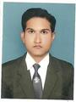
CURRICULUM VITAE

Mridul Verma
Address: Shankar Nagar Colony, Hiramanpur, Ashapur (Gazipur Road)
Sarnath, Varanasi 221007 (UP)
Mobile: 09044415215
E-mail: mridulverma6@gmail.com

Professional Qualification

S.No. | Course | College/University | Passing Year | Division | Percentage
1 | MCA | RSMT Varanasi  (GBTU Lucknow) | 2011 | First | 70.46%
2 | CCC | NIELIT | MAY-2016 | Gr-B | --

Academic Qualification

S.No. | Course | College/University | Passing Year | Division | Percentage
1 | B.Sc.(Math) | Mahadev College Varanasi  (VBSPU Jaunpur) | 2008 | Second | 58.44%
2 | Intermediate | UP Board | 2005 | First | 72.20%
3 | High School | UP Board | 2003 | Second | 46.33%

Project/Training Details

- I have done Six month project training from SCHENCK ROTEC INDIA LIMITED, Noida. The project ‘s title was “Material Management System” . The project platform was Oracle forms & reports(6i) and Oracle database(9i).
- I have done mini project on “Blood Bank Management System”.

Extra Achievements
- Certificate of Excellence conducted by NIC.
- Certificate Course in Dotnet (c#,ASP.Net) from future tech, Varanasi
- Attend seminar on ”Human Value and Professional Ethics”.
Skill Set

- MS Office
- Internet Knowledge
- Networking Knowledge
- Windows XP,Vista,7,8 etc.
- Hardware Knowledge
- ERP

Working Experience
- As a Computer faculty from July 2011 to March 2013 in Ambition Academy, Sarnath Varanasi.
- As a IT Executive from April 2013 to till date in Jhunjhunwala Oil Mills Ltd, Ashapur Varanasi

Personal Profile
Father’s Name : Shri Surendra Kumar Verma
Date of Birth : 22 December 1987
Marital Status : Unmarried
Language Known : English, Hindi
Mailing Address : Shankar Nagar Colony, Hiramanpur, Ashapur
Sarnath Varanasi - 221007(UP)
Mobile No. : 09044415215
E-mail : mridulverma6@gmail.com

Declaration

All the information given in these resume are true to the best of my knowledge. If any information is found incorrect at any stage. I shall no objection to cancellation of my appointment.
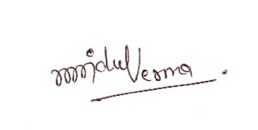
Date: Signature of Candidate
Place: (Mridul Verma)

