HTML CSS

# ABOUT:

This Document is write for beginner, who is new to Web Designs. In This Documents We Touch Almost all the components and Concepts in HTML and CSS. So Let Start Hope u enjoy it.

# Introduction:

So What Is HTML?

Html Stands for Hyper Text Markup Language. **Hypertext** is text which contains links to other texts, web page, websites and on the same pages. **Markup** languages are designed for the processing, Defining and presentations of text. Basically its Structure, formatting and Style of web

Pages.

HTML is not Case Sensitive.

So, Let’s Start with simple Html code to print HELLO WORLD :-

<! DOCTYPE html>

<html>

<head>

<title> </title>

</head>

<body>

Hello World.

</body>

</html>

1.<! DOCTYPE html> declaration defines this document to be HTML5 and tell the Brower that what version of html we using.

2.<html> </html> Any html code Come under these tags. This is the root element of any web pages.

3.<head></head> Any information about this web page came under this tags. This is not show on web Browser Body.

4.<body></body> In these tags we write the data (text, image, vedieo) what were shown on web browser.

5.<meta charset=””UTF-8> define the charset and encoding .

6.Viewport : Viewport is the user's visible area of a web page. Viewport varies with the device, and will be smaller on a mobile phone than on a computer screen. It’s Define the User’s visible area for the Web Page. HTML Define a method to help Web Designer to take control over viewport by the method <meta>. Example <meta name=”viewport”>

7.(width=device-width ) part sets the width of the page to follow the screen-width of the device (which will vary depending on the device).

8.Initial Scale equal to 1 set initial Zoom level when page first load to browswer.

Example of page with viewport and without viewport :

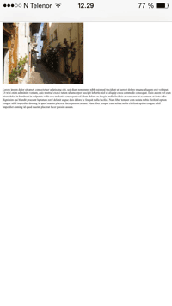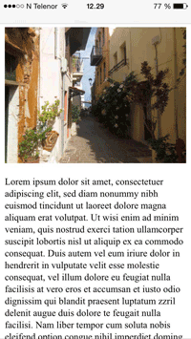

# Without Viewport With Viewport

# HTML Tags:

What is tags?

It defines every structure of HTML page. Example placements of text ,images and links on the web pages. Example head, body, HTML etc.

These are many type of HTML tags:

1. <h1> to <h6> tags (explore What it does) heading tags used by Search engines use the headings to index the structure and content of your web pages.
2. <p></p> tag (explore it) It is a block type tag. Display the content with line breaks.
3. <pre></pre> tag(explore it ) It display the content as u write on your Editor.
4. <HR> tag (explore it ) Horizontal line
5. <br> tag(explore it ) break line tag
6. <backquote></backquote> tag(explore it ) Used for write quotes.
7. <abbr> (explore it) Used to add abbrebation to he content.
8. <a></a>(explore it ) Anchor tag used to link to other web pages or on same pages ..
9. <img src=” ”>(explore it ) Image tag used to get image src attribute tell the path of the image.
10. <table> tag (explore it ) it define the table . Each table row is defined with the **<tr>** tag. A table header is defined with the **<th>** tag. By default, table headings are bold and centered. A table data/cell is defined with the **<td>** tag.
11. <ul> tag(explore it ) it define the unordered list.
12. <li> tag (explore it) It a child tag of <ul> tag. It Define the content came in list.
13. <div> tag(explore it ) It a Block Level Element. Used to define a section or act like a wrapper elements.

# HTML Element:

An HTML element usually consists of a start and end tags, with the content inserted in between them. Example <h1> Hello World </h1>. Some html elements have no content. Example <br>.

# Type of Elements in HTML:

There are two types of Elements :

* Block Elements
* Inline Elements

Block Element : These elements take all the width of the window .If we Implicity give the width to it .It property of block is not lost ,It still Cover The whole Window Width(MARGIN-explore it). These Block Elements are come next to each other like stack.

Inline Elements : These elements take the width of the content in that. If we want to print multiple inline elements, They come next to each other like in line.

# HTML SEMANTICS ELEMENTS:

HTML define eight new semantics elements. All these elements are block level elements. Semantic elements mean elements with meaning, it descried its meaning. Non-semantics elements we used are <div> and <span>. Semantics elements we used are <form><table> and <article> Clearly define its meaning.

New semantics element in html5 are <header> <nav> <section> <aside> <footer>

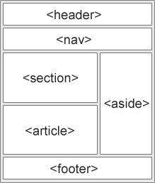

CSS

# What is CSS?

CSS stands for Cascading Style Sheets. CSS describes how HTML elements are to be displayed on screen, paper, or in other media CSS saves a lot of work. It can control the layout of multiple web pages all at once External stylesheets are stored in CSS files.

# Why Use CSS?

CSS is used to define styles for your web pages, including the design, layout and variations in display for different devices. HTML define the Skeleton of the Web Page and CSS Help In Look Good. Think like CSS make u Wear good cloths And html is your body.

# CSS selector:

* Element Selectors (Explore it)
* ID Selectors (Explore it)
* Class Selectors (Explore it)
* Group Selectors (Explore it)

# Three Ways to Insert CSS:

* External style sheet (Explore it)
* Internal style sheet (Explore it)
* Inline style (Explore it)

# Order Of Style Sheets (used multiple style):

One has the highest priority:

1. Inline style (inside an HTML element)
2. External and internal style sheets (in the head section)
3. Browser default

So, an inline style (inside a specific HTML element) has the highest priority, which means that it will override a style defined inside the <head> tag, or in an external style sheet, or a browser default value.

# Type of Style in CSS:

1. COLOR (EXPLORE IT)
2. Background (EXPLORE IT)
3. Borders (EXPLORE IT)
4. Margin (EXPLORE IT)
5. Padding (EXPLORE IT)
6. Height/width (EXPLORE IT)
7. Fonts (EXPLORE IT)

# BOX MODEL:

All HTML elements can be considered as boxes. In CSS, the term box model is used when talking about design and layout. The CSS box model is essentially a box that wraps around every HTML element. It consists of: margins, borders, padding, and the actual content.

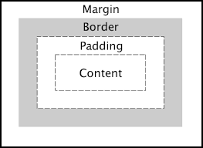

Explanation of the different parts:

* **Content** - The content of the box, where text and images appear.
* **Padding** - Clears an area around the content. The padding is transparent.
* **Border** - A border that goes around the padding and content.
* **Margin** - Clears an area outside the border. The margin is transparent.

# FLOAT (HELP IN LAYOUT OF WEB PAGES):

The float property is used for positioning and layout on web pages.

There are 4 type of float:

* Float-left: The element floats to the left of its container.
* Float-right: The element floats to the right of its container.
* Float-none: The element does not float (will be displayed just where it occurs in the text). This is default.
* Float-inherit: The element inherits the float value of its parent.

When we use Float property to tag .It came out from their normal flow of the page. Example if we have 4 div elements and we apply the float property to first div element, The first elements makes this own flow (Stack).while other div elements are push up and get override.

If we want Other div elements are not override use float to every elements.

Display Property(MAIN):

There are three type of Display:

1. Display-inline
2. Display-block
3. Display-inline-block

Display-inline: For inline elements these Display-inline is default. If we want to make ant block elements inline, Used Display-inline property in there style Sheet. But We cannot Set user Define width for that.It takes the width of the content.

Display-Block : For block elements these Display-Block is by default. I we want to make inline element Block use Display-Block Property in his Style Sheet. We can set user define width to it,but its act like block element.

Display-Inline-block: If we want to give User Define Width to block element then this property is used to display like inline elements.

# Form:

<Form></Form> element define a form that is used to collect used define inputs.

<form>

………OTHER ELEMENTS

</Form>

Form elements are different types of input elements, like text fields, checkboxes, radio buttons, submit buttons etc.

<input > Element: It can Displayed many way depend on his type we use.

Example:

<input type=”text”> used for one-line input field(stream).

<input type=”number”> used for one-line input for numbers.

<input type=”radio”> used for selecting between option.

<input type=”Submit”> used for submitting the form.

Attributes in Form tag:

Action: The action attribute defines the action to be performed when the form is submitted. Normally, the form data is sent to a web page on the server when the user clicks on the submit button.

Target: The target attribute specifies if the submitted result will open in a new browser tab, a frame, or in the current window. The default value is "_self" which means the form will be submitted in the current window. To make the form result open in a new browser tab, use the value "_blank".

Method: The **method** attribute specifies the HTTP method **GET**or **POST**)to be used when submitting the form data.

Get is the default Method used, In Get Method its appends the form data to URL. Never used Get method with important data as its shown on the URL.

POST if the form data contains sensitive or personal information. The POST method does not display the submitted form data in the page address field.

Name: Each input field must have a name attribute to be submitted. If the name attribute is omitted, the data of that input field will not be sent at all.

<select> tag it define the Drop-Down List. <option> tag is child of select, its Define option for that. Default first element is selected.

<text area> used for multiple text area, Mostlly used for Feedbacks in the form.

<button> element define the clickable button

New Elements in HTML5 is <data list> and <output> (EXPORE IT) Media Elements (Explore it as u can).

**960 Grid System**

960 grid system is nothing but are some CSS file to style web pages. Download these CSS file from 960 grid website. Its contain CSS file name as 960.CSS , Explore this file to understand what is that.

The CSS Grid Layout Module offers a grid-based layout system, with rows and columns, making it easier to design web pages without having to use floats and positioning.

First we have to make a div element and add class Container_12 Example (<div class=”container_12”>) Its define a section of width of 960 px, It’s align to Center of the page, have margin auto.

We have grid class, these are grid_1 to grid_12. Each grid class have corresponding width like grid_1 represent one column, grid_2 represent the span of two column like that grid_12 represent the span of 12 column. These grid classes use property like display: inline and float: left. Which makes then align along the same row if the width remain is more or same to that block that come to align on same row. Let’s see example

Case 1: If we want to span three block along the same row, then use three grid class who’s grid class sum add up to 12 (grid_3+grid_6+grid_3=12).

Case 2:If the grid class sum exceed 12 then the block not align along same row , its go down and align in new row.

These grids class are form using the style property like display: inline and float: left.

Example :

<! DOCTYPE html>

IN

IN

9+

9+

IN

9+

<html>

<head>

<title></title>

<link rel="stylesheet" type="text/ css" href ="960.css">

<link rel="stylesheet" type="text/css" href="reset.css">

<link rel="stylesheet" type="text/css" href="text.css">

<style type="text/css">

</style>

</head>

<body>

<div class=container_12 style="background-color: silver">

<div class="grid_12">

<h1 style="background-color: green">Block1</h1>

</div>

<div class="grid_6" style="background-color: red">

<h1>Block2</h1>

</div>

<div class="grid_6" style="background-color: gray">

<h1>Block3</h1>

IN

9+

</div>

</div>

</body>

</html>

Output:

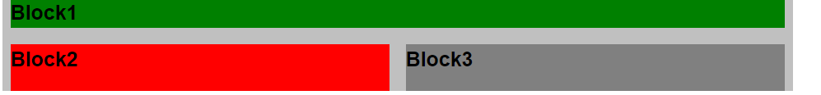

So, let’s review the code,

First link the 960 grid system CSS file to code, by using link tag in the head section. The file you have required to link is 960.css, reset.css and text.css.

In the body section, We first make <div class =”container_12”> its define a section in the browser window with width of 960px and align-Center with margin: auto.

Then we make a <div class=”grid_12”> its parent is container_12 class. Grid_12 define that this block want 12 column in the container, as u see Block1 spanning all over the row as it cover all 12 column . As it have default margin-left : 10 px and margin-right : 10px.

Then we make another <div class=”grid_6”> as the above grid_12 takes all the space , so this div element can’t fit in that, so it make a new row below it and span to 6 column.

Then we make another <div class=”grid_6”> as the current row have space of 6 column and this div have grid_6 , it required only 6 column to span on this row, as grid class have style property as float: left and Display: inline , it align to the block2 div elements.

I think that help u lot.(Explore yourself too, if u try and practice u Learn more).

Nested Grid :

Let’s suppose we want a grid layout like this :

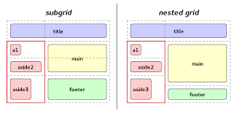

In the above picture , the box with red border is one grid of 4 column. We make 4 section in that. In the grid_4 class we make 3 section with grid length less that or equal to 4. So, It’s like we make 3 section in one grid to get that kind of layout. Let’s I show u code of it.

<html>

<head></head>

<body>

<div class=”container_12”>

<div class=”grid_4”>

<div class=”grid_4”>Any Content……..</div> <! – Nested grid>

<div class=”grid_3”>Any Content……….</div> <! – Nested grid>

<div class=”grid_2”>Any Content……..</div> <! – Nested grid>

</div>

<div class=”grid_6”> </div>

</div>

</body>

</html>

So Explore yourself to ...Thank you!