Boostrap 4

This guide is meant as a first look into Bootstrap for beginners, so won’t be going into LESS and Sass integration, which are more advanced concepts. Hey guys... today we are here to discuss about bootstrap. So what is bootstrap? According to the official website of bootstrap which is https://getbootstrap.com, Bootstrap is the most popular HTML, CSS, and JS framework for developing responsive, mobile first projects on the web. Now how do I use it? Just now I said that it is html and CSS framework, so yes obviously you need to know that and for that you may read my previous post on html and css. So here we start !

Bootstrap is a free and open-source front-end web framework for designing websites and web

applications. It contains HTML- and CSS-based design templates for typography, forms, buttons,

navigation and other interface components, as well as optional JavaScript extensions. Unlike

many web frameworks, it concerns itself with front-end development only.

To make sure that the application you are developing works on all the devices i.e from large

sized desktops to the tiny mobile screens, and we don’t have to code differently for them,

bootstrap is used. This is one of the reasons. Below is the list of all the advantages of bootstrap.

Why We Use Bootstrap?

* Mobile First Approach: Mobile-first style are core framework for Bootstap 4.
* Responsive Feature’s : CSS used in Boostrap can adjust to Tablets, mobile and Desktop.
* Easy to use : Its’ Easy to understand, They give very beautifull and simple Documentation about the Bootstrap 4.

Installation :

There are two ways to get bootstrap 4 :

* Download Bootstrap 4 from getbootstrap.com(Download file , link to their program)
* Include files from BootstrapC CDN(If you not know how to add files EXPLORE YOURSELF )

# Responsive Website:

Responsive web design is about creating web sites which automatically adjust themselves to look good on all devices, from small phones to large desktops. Bootstrap have inbuild css style sheets to adjust acordingto devies. Now i show u some css style to make website responsive.

# Responsive Style Sheet :

As i tell u above, Responsive web design help to make website adjust according to the deviece screen. Its just a CSS nothing more than that.

As u know Grid system , if u not know read my article on 960 Grid Sytem. So how to make them responsive ?? Before Going to Bootstrap class, First we see what we do and Chande to css to make them responsive , So let’s Start !

Viewport : viewport is user Define Area. Viewport varies with the devies, smaller for mobile han for computer screen. Width= device-width part sets the width of the page to follow the screen-width of the device.

Now start with the Grid view ??

Many web pages are based on a grid-view, which means that the page is divided into columns . Using a grid-view is very helpful when designing web pages. It makes it easier to place elements on the page. Responsive grid-view often has 12 columns, and has a total width of 100%, and will shrink and expand as you resize the browser window.

Now Let’s build a Responsive grid view :

First ensure that all HTML elements have the box-sizing property set to border-box. This makes sure that the padding and border are included in the total width and height of the elements.If u not know about Box-Sizing property u must go through HTML/CSS Article. Example Border-sizing: border-box. However, we want to use a responsive grid-view with 12 columns, to have more control over the web page. First we must calculate the percentage for one column: 100% / 12 columns = 8.33%. Then we make one class for each of the 12 columns, class="col-" and a number defining how many columns the section should span.

Example :

.col-1 {width: 8.33%;}

.col-2 {width: 16.66%;}

.col-3 {width: 25%;}

.col-4 {width: 33.33%;}

.col-5 {width: 41.66%;}

.col-6 {width: 50%;}

.col-7 {width: 58.33%;}

.col-8 {width: 66.66%;}

.col-9 {width: 75%;}

.col-10 {width: 83.33%;}

.col-11 {width: 91.66%;}

.col-12 {width: 100%;}

So, we just devide each column with their width . Now we add float property to each [ col ] class to stack each them on stack. Example :

{

float : left;

}

We we wrap each column in each div element . Add a class row in each div element. The columns inside a row are all floating to the left, and are therefore taken out of the flow of the page, and other elements will be placed as if the columns do not exist. To prevent this, we will add a style that clears the flow . Example

.row ::after{

clear: both;

}

Now the question, how to make responsive , we still not do anything about that. So, we want this grid system behave according to device width. Now how web page know about the device width, that is been tell my MEDIA QUERIES.

What is MEDIA QUERIES?

It uses the @media to add to the css Style sheet , i explain u with an Example

@media only screen and (max-width: 500px) {

body {

background-color: lightblue;

}

it tell the brower that if the device width is less or wqual to the 500px, Change the backgrounf color to lightblue. Hope u get the Idea of that.

So, In above Grid view If we want when the device width is less that 720px we want the column take all width ,This we do with Media Query Example .

@media only screen and (max-width: 768px) {

/* For mobile phones: */

[class*="col-"] {

width: 100%;

}

So that is how we add our CSS to make Website Responsive . So, Lets See Bootstrap Inbuild CSS to Make Grid Responsive.

Bootstarp Grid Responsive :

Lets First Start to know what is Container is .

Container class is Responsively add margins, center, and wrap your content. It’s of two type Container and Container-fluid. Conainer dont not take all device width and have margin auto , look to have center on the web page. Container-fluid take full width of the device. Try to code simple hello world program with container and with container class add, u see the difference.

Grid Sytem in Bootstrap:

Bootstrap divides a page into a grid of 12 columns and multiple rows for easier positioning of elements.Grid system is responsive and columns will rearrange automatically depending on the screen size. Bootstrap's grid system is responsive, and the columns will re-arrange depending on the screen size: On a big screen it might look better with the content organized in three columns, but on a small screen it would be better if the content items were stacked on top of each other.

Bootstrap used the flexbox Concept to display the column one after to the other, that why they stack to each oher. So what is Flexbox , Lets understand first this , So let’s start

Flexbox :

Before we start with Flexbox, Let’s we what we have done to make layouts :

* Block for any section in web page.
* Inline for text on web page.
* Positioned

The Flexible Box Layout Module, makes it easier to design flexible responsive layout structure without having to use floats or positioning.

Flexbox Element : A flexbox layout consists of a parent element, with one or more child elements. Parent Element have css style DISPLAY: FLEX. All child of this parent inherit Flex property.

Flexbox have different property :

* Flex-direction
* flex-wrap
* flex- flow
* flex – justify content

Flex direction Property : defines in which direction the container wants to stack the items. Example

Use the column value to stack the items in a column from top to bottom: Example

{

display:flex;

fllex-direction : column;

}

Use the column-reverse value to stack the items in a column from bottom to top: Example :

{

display : flex;

flex-direction : column-reverse;

}

Flex Wrap Property : Defines if, and how, the container wants its children to wrap. It wrap all the childeren in one block. Example Add in CSS parent style Sheet :

{

display:flex;

fllex-wrap : wrap;

}

Flex Flow Property : Define is a shorthand property for setting both the flex-direction and flex-wrap properties.

Justify-content property : Define aligns the items as much way u want. Example -

{

display : flex;

justify-content : center;

}

So that is enough for understanding Bootstrap grid system column.

Grid Classes:

The Bootstrap grid system has four classes:

* xs for device with width less or equal to 768px.
* Sm for device with width greater or equal to 768px.
* Md for deviece with width greater or equal to 992px.
* Lg for deviece with width greater or equal to 1200px.

Grid System Rule :

* Rows must be placed within a .container (fixed-width) or .container-fluid (full-width) for proper alignment and padding
* Use rows to create horizontal groups of columns
* Content should be placed within columns, and only columns may be immediate children of rows
* Predefined classes like .row and .col-sm-4 are available for quickly making grid layouts
* Columns create gutters (gaps between column content) via padding. That padding is offset in rows for the first and last column via negative margin on .rows
* Grid columns are created by specifying the number of 12 available columns you wish to span. For example, three equal columns would use three .col-sm-4
* Column widths are in percentage, so they are always fluid and sized relative to their parent element.

Grid options :

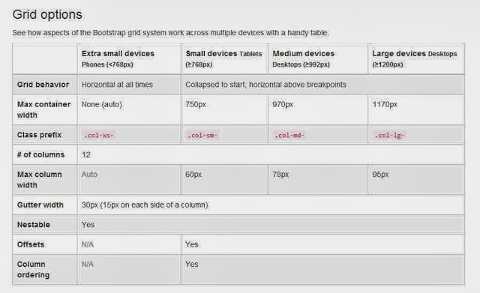

Grid System -Multi-Device :

Sometimes columns are stacked vertically on smaller screens. Use col-sm-* , col-sm-* , col-md-* togher to get different column widths for different screen sizes.

Example :

Allow 2 columns in a row for mobile, 3 for desktop

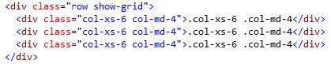

On Desktop Its look like:



On Mobile it’s look like :

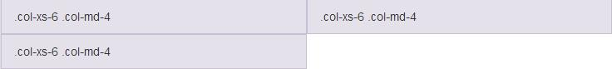Allow 2 columns in a row for mobile, 3 for desktop

Grid System – Column offseting :

There are four type of column offseting :

* col-xs-offset-*
* col-sm-offset-*
* col-md-offset-*
* col-lg-offset-*

Example :

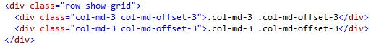

Output :



As we see in above example the both column are shifting 3 column. And it inpact to see in above column class like col-lg-* but not for lower classes.

Grid System Nested Column :

We can nested the column from Parent column element. Nested column add upto its parent or less. Example.

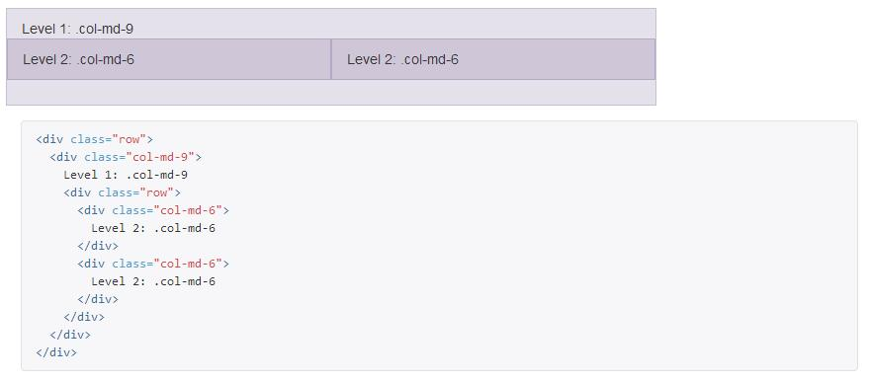In above Code :

Add we see Nested Column column ad upto less or equal to parent.

Bootstrap Text/Typography :

<h1> to <h6>

By default, Bootstrap will style the HTML headings (<h1> to <h6>) in the following way:

### Example

# h1 Bootstrap heading (36px)

## h2 Bootstrap heading (30px)

### h3 Bootstrap heading (24px)

#### h4 Bootstrap heading (18px)

##### **h5 Bootstrap heading (14px)**

###### **h6 Bootstrap heading (12px)**

## <small>

In Bootstrap the HTML <small> element is used to create a lighter, secondary text in any heading:

### Example

# h1 heading secondary text

## h2 heading secondary text

### h3 heading secondary text

#### h4 heading secondary text

##### **h5 heading secondary text**

###### **h6 heading secondary text**

## <abbr>

Bootstrap will style the HTML <abbr> element in the following way:

### Example

**The WHO was founded in 1948.**

## <pre>

Bootstrap will style the HTML <pre> element in the following way:

### Example

Text in a pre element

is displayed in a fixed-width

font, and it preserves

both spaces and

line breaks.

# Bootstrap Jumbotron:

A Bootstrap jumbotron specifies a big box for getting extra attention to some special content or information. It is displayed as a grey box with rounded corners. It can also enlarge the font sizes of the text inside it.

You can put any valid HTML or other Bootstrap elements/ classes inside a jumbotron.

The **class .jumbotron** within the <div> element is used to create a jumbotron.

## Responsive Images

Images come in all sizes. So do screens. Responsive images automatically adjust to fit the size of the screen.

Create responsive images by adding an class<img-fluid>. The image will then scale nicely to the parent element.

Navigation Bars:

A navigation bar is a navigation header that is placed at the top of the page. Bootstrap provide its class called navbar.If u not want to uise this class , u can make your own css by using display: inline or float property. Bootstrap also provide many css to style our navbar like (nav-default. Nav-inverse) and may class to design style aligned add button add serch buttan and many more to make web page responsive.

Thanks Hope u like it .