LAB 06 REPORT
Multi-Role User System (API + UI)
Name: Nikita Rani
Enrollment No: CS-23411267
Section: 3CSE15
Subject: Web Technologies
Submission Date: 20/03/2026
GitHub Repository
https://github.com/niktitatuteja/Lab07_Multi_Role_User_System

Web Technologies Lab 06 - Multi Role User System

Contents
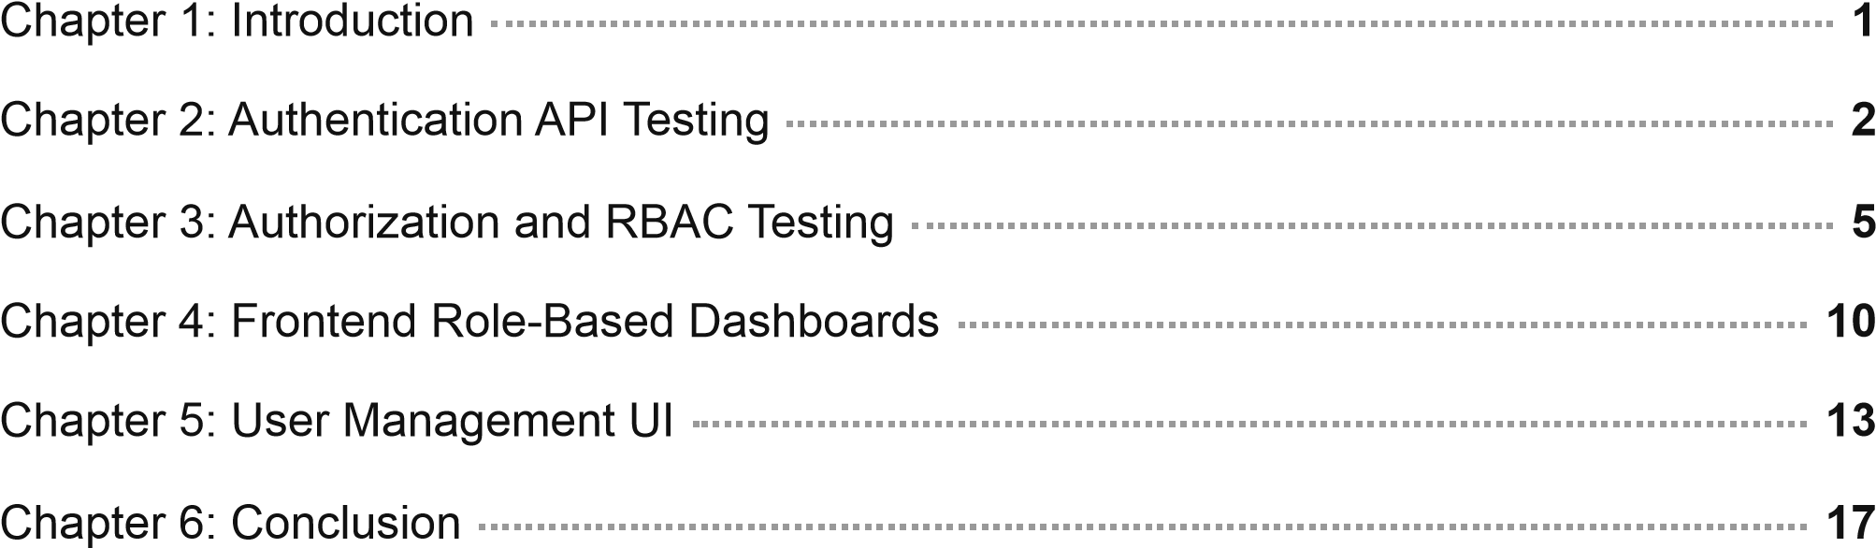
1

CHAPTER 1

Introduction
This lab implements a complete Role-Based Access Control (RBAC) system using a Node.js + Express backend and a React (Vite) frontend. The system enforces fine-grained permissions across three user roles, secured with JWT Bearer tokens and bcrypt password hashing. All API interactions use standard HTTP status codes (200, 201, 401, 403, 404) to communicate authorization outcomes.

Technologies Used
Backend: Node.js, Express.js, JSON Web Tokens (jsonwebtoken), bcryptjs, cors, dotenv
Frontend: React 19, React Router DOM, Vite, CSS (custom premium theme)
Data Store: In-memory JavaScript array (seeded with SUPER_ADMIN &
ADMIN)
Auth: JWT Bearer token issued on login/register; verified by middleware on protected routes

Roles Implemented
SUPER_ADMIN — Full access: view/create/delete all users, change any role
ADMIN — Manages USER-role accounts only; cannot see or modify ADMINs or SUPER_ADMINs
USER — Can only view own profile; no access to user management endpoints

API Endpoint Summary
Method | Endpoint | Auth | Allowed Roles
POST | /api/auth/register | No | Public
POST | /api/auth/login | No | Public
GET | /api/users/me | Yes | All roles
POST | /api/users | Yes | ADMIN, SUPER_ADMIN
GET | /api/users | Yes | ADMIN, SUPER_ADMIN
PATCH | /api/users/:id/role | Yes | SUPER_ADMIN only
DELETE | /api/users/:id | Yes | ADMIN, SUPER_ADMIN
2

CHAPTER 2

Authentication API Testing

2.1 User Registration — POST /api/auth/register
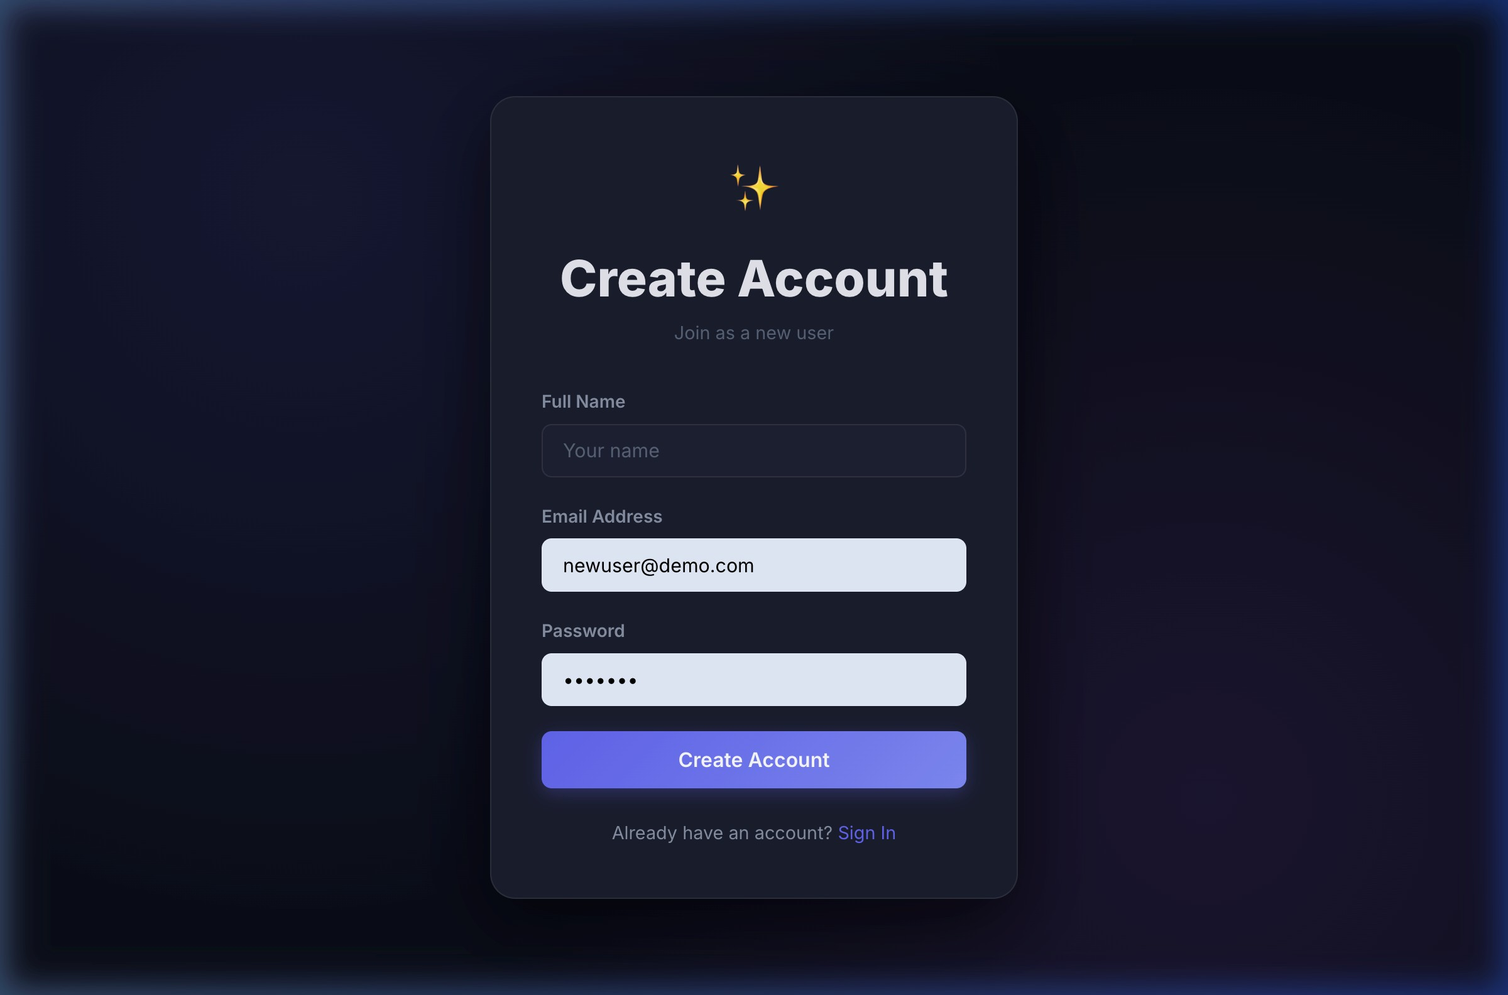

Figure 2.1: Registration form — public endpoint creates USER role account
Explanation: Any visitor can register at POST /api/auth/register by providing name, email, and password. The system hashes the password using bcryptjs (salt rounds = 10) and assigns the USER role automatically. A signed JWT (24 h expiry) is returned on success with HTTP 201.

2.2 User Login — POST /api/auth/login
Explanation: The login endpoint accepts email and password, verifies the bcrypt hash, and returns a signed JWT. The frontend stores this token in localStorage and attaches it as Authorization: Bearer <token> on every subsequent API call. Incorrect credentials return HTTP 401.

2.3 Login Page — Frontend UI
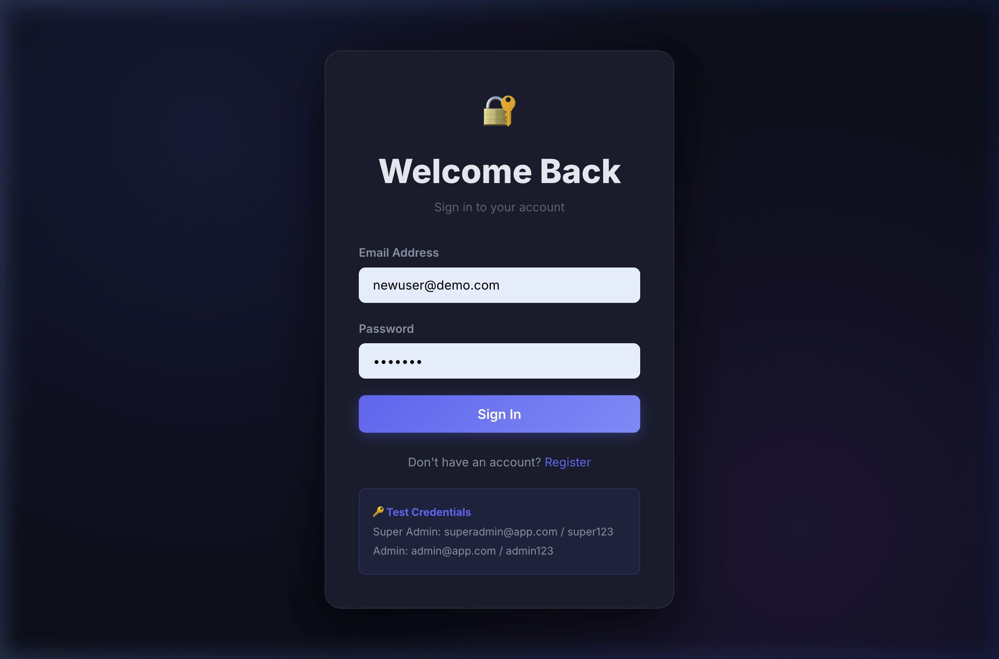
Figure 2.2: Login screen with seeded credential hint and premium dark theme
Explanation: The login page is the default landing page. Unauthenticated users are redirected here by PrivateRoute . The form submits credentials to POST /api/auth/login , stores the returned JWT in localStorage , then navigates to /dashboard . Seeded credentials shown as a convenience for testing.

2.4 Own Profile — GET /api/users/me
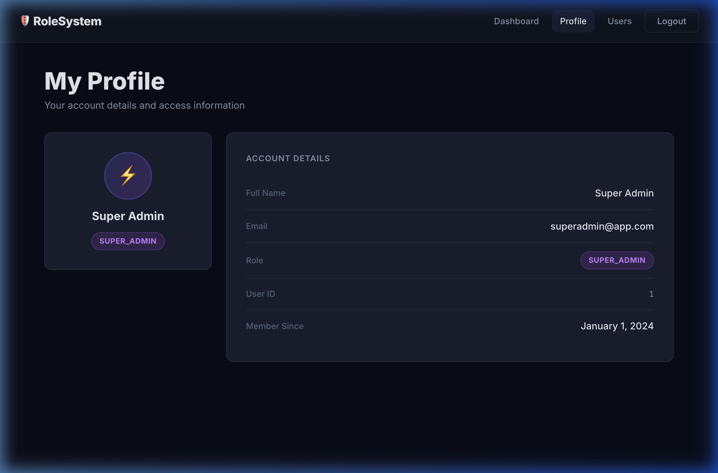

Figure 2.3: GET /api/users/me — profile page for SUPER_ADMIN showing all metadata
Explanation: The GET /api/users/me endpoint is accessible to any authenticated user regardless of role. The JWT decoded on the server resolves the user ID, and the profile is fetched from the in-memory store and returned (password field excluded). The React Profile page calls this endpoint on mount to display all account metadata.

CHAPTER 3

Authorization and RBAC Testing
All protected routes pass through two middleware layers:
authMiddleware — verifies the JWT token and attaches req.user ; returns 401 if token is missing or invalid.
requireRole(...roles) — checks req.user.role against the allowed list; returns 403 if not permitted.

3.1 RBAC Rules Matrix
Action | USER | ADMIN | SUPER_ADMIN
Register / Login | ✅ | ✅ | ✅
View own profile | ✅ | ✅ | ✅
View user list | ❌ 403 | ✅ (USERs only) | ✅ (all)
Create users | ❌ 403 | ✅ (USER role) | ✅ (USER & ADMIN)
Delete users | ❌ 403 | ✅ (USER role) | ✅ (all)
Change roles | ❌ 403 | ❌ 403 | ✅ (all)

3.2 No Token — 401 Unauthorized
Explanation: Sending a request to any protected endpoint without an Authorization header returns HTTP 401. The authMiddleware checks for the Bearer prefix before attempting to verify the token — missing or malformed headers are immediately rejected.
API test result:
GET /api/users (no Authorization header)
→ HTTP 401 { "message": "Unauthorized: No token provided" }

3.3 USER Role — 403 Forbidden on /api/users
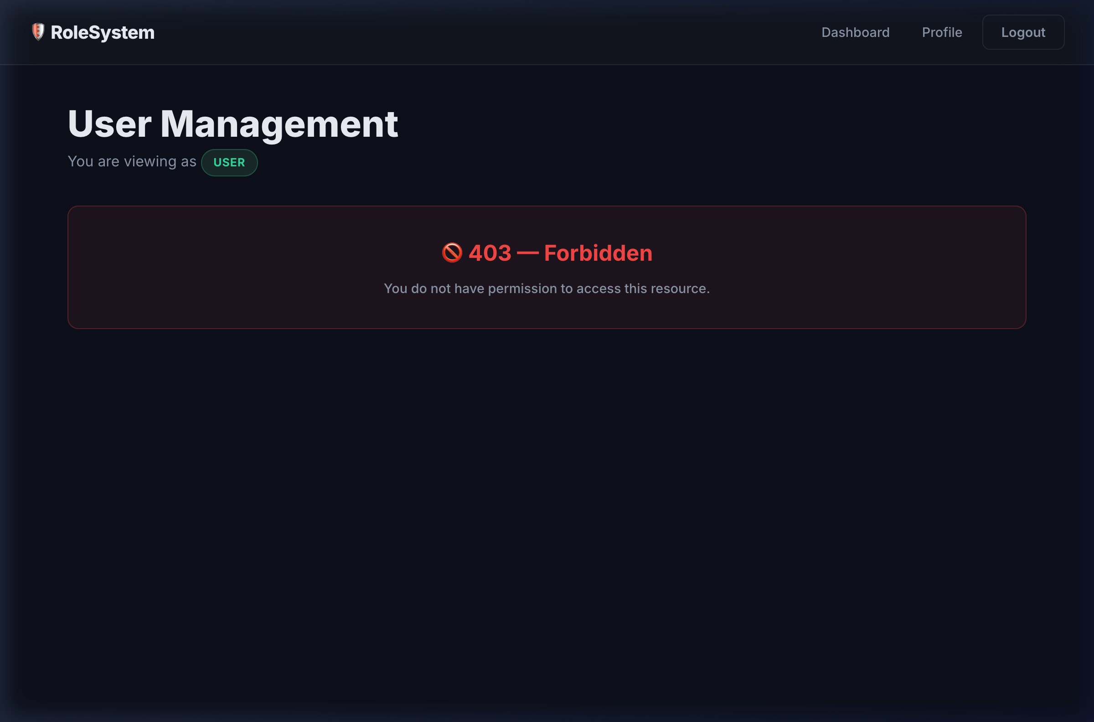

Figure 3.1: USER navigating to /users receives 403 Forbidden UI message
Explanation: A standard USER attempts to access the User Management page at /users . The GET /api/users call returns HTTP 403 since the USER role is not in the requireRole("ADMIN", "SUPER_ADMIN") whitelist. The React frontend catches the 403 status and renders the "🚫 403 — Forbidden" error block instead of the user table.

3.4 ADMIN GET /api/users — Role Filtering
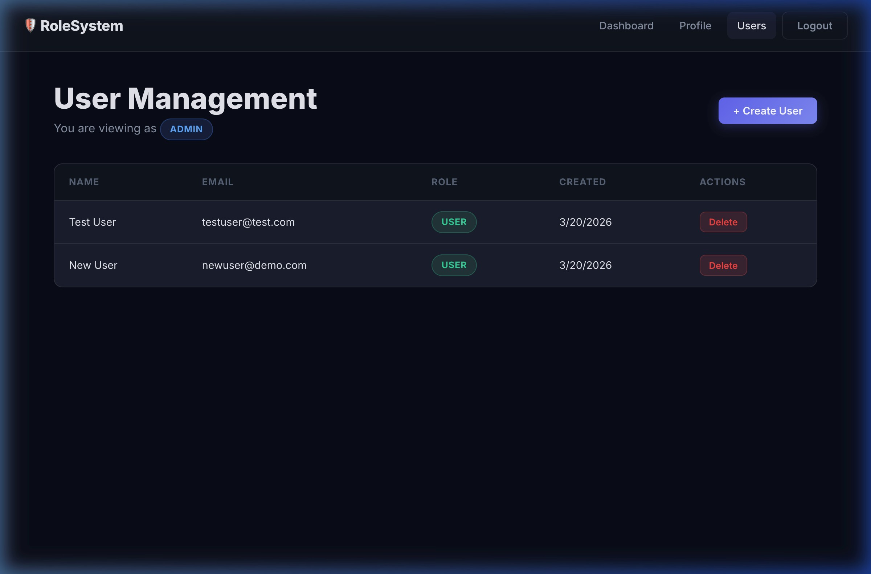

Figure 3.2: ADMIN user list — filtered to USER-role accounts only
Explanation: When an ADMIN calls GET /api/users , the server filters the in-memory users array to only return entries where role === "USER" . The ADMIN cannot see other ADMIN or SUPER_ADMIN accounts, enforcing the principle of least privilege. The frontend shows no role-change dropdowns for this role.

3.5 SUPER_ADMIN GET /api/users — Full Visibility
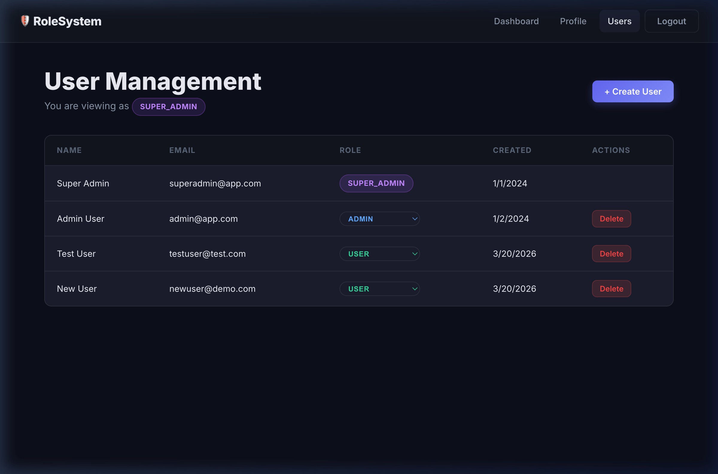
Figure 3.3: SUPER_ADMIN sees all users with role-change dropdowns and delete controls
Explanation: SUPER_ADMIN receives the unfiltered list containing all roles
(SUPER_ADMIN, ADMIN, USER). The frontend renders an inline role-select dropdown for each user (except the current user to prevent self-demotion). Selecting a new role fires
PATCH /api/users/:id/role verified by requireRole("SUPER_ADMIN") .

CHAPTER 4

Frontend Role-Based Dashboards
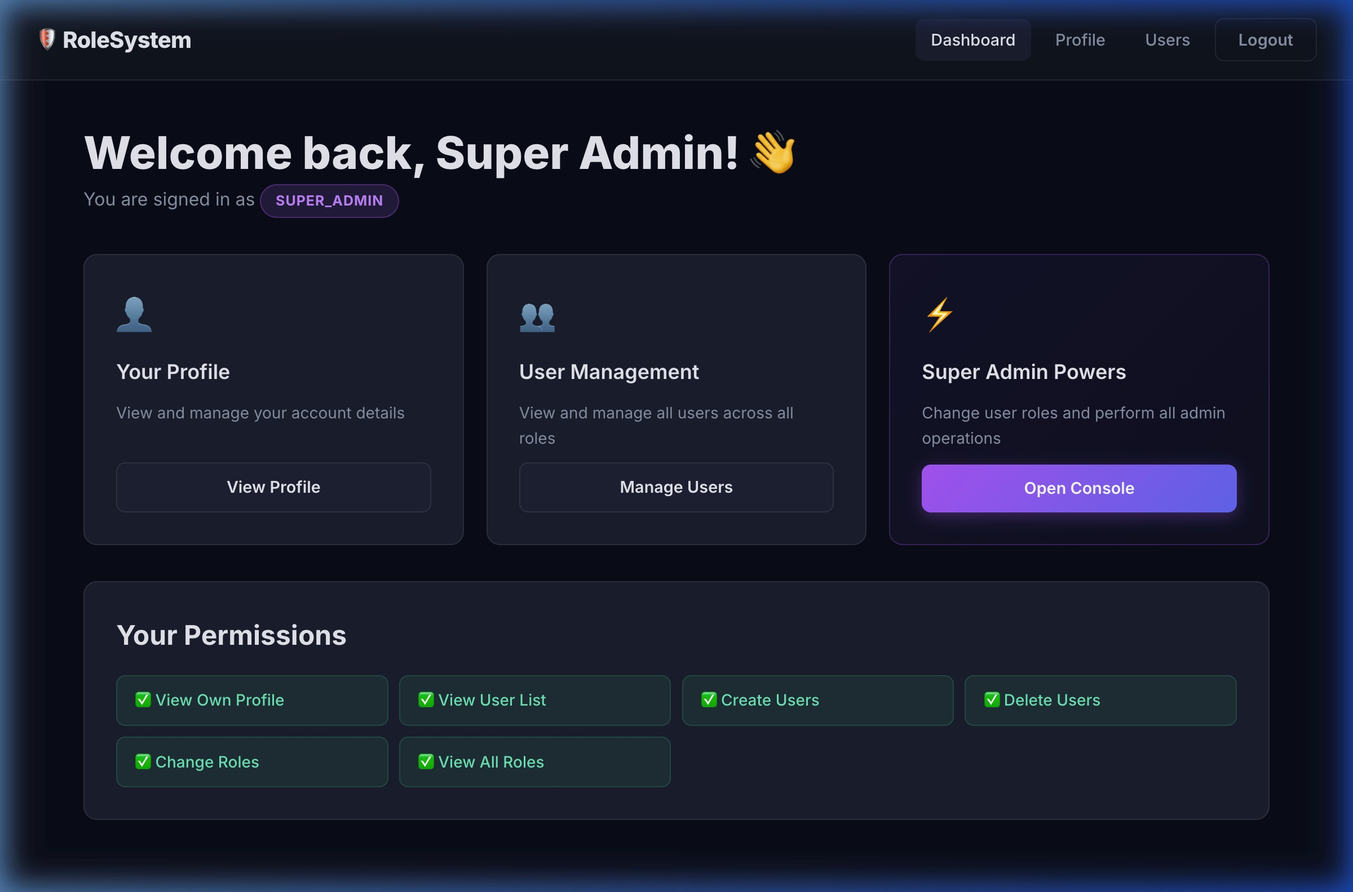
4.1
SUPER_ADMIN Dashboard
Figure 4.1: SUPER_ADMIN dashboard — all permissions enabled, "Super Admin Powers"

card visible
Explanation: The dashboard reads the JWT payload from AuthContext to determine the current role. SUPER_ADMIN sees three action cards (Profile, User Management, Super Admin Powers) and six green-checked permissions. The navbar includes the "Users" management link.

4.2 ADMIN Dashboard
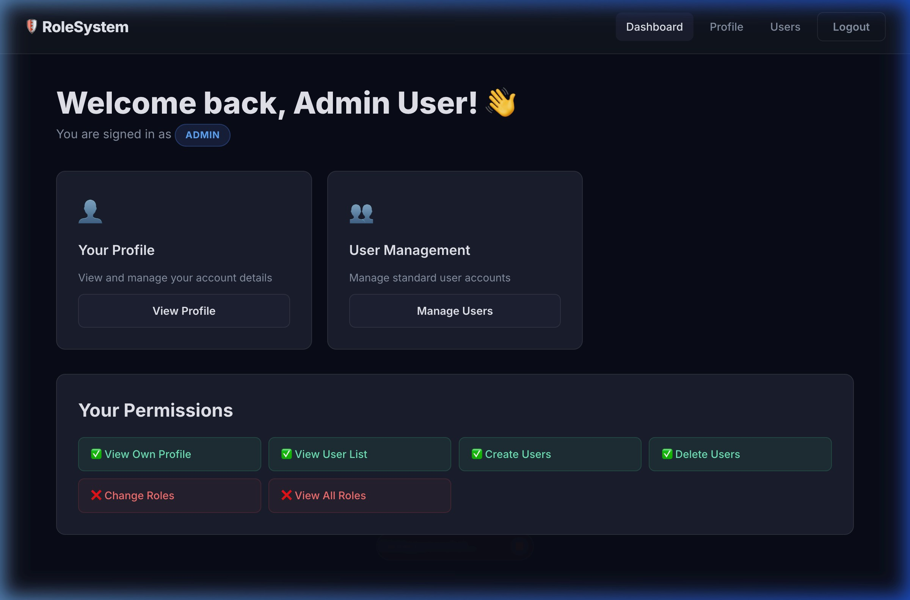
Figure 4.2: ADMIN dashboard — "Change Roles" and "View All Roles" permissions denied

(❌ )
Explanation: ADMIN sees the same layout but the "Super Admin Powers" card is hidden (conditional rendering). In the permissions panel, "Change Roles" and "View All Roles" are red-crossed to visually communicate access boundaries. The User Management card is visible with a description restricted to standard users.

4.3 Standard USER Dashboard
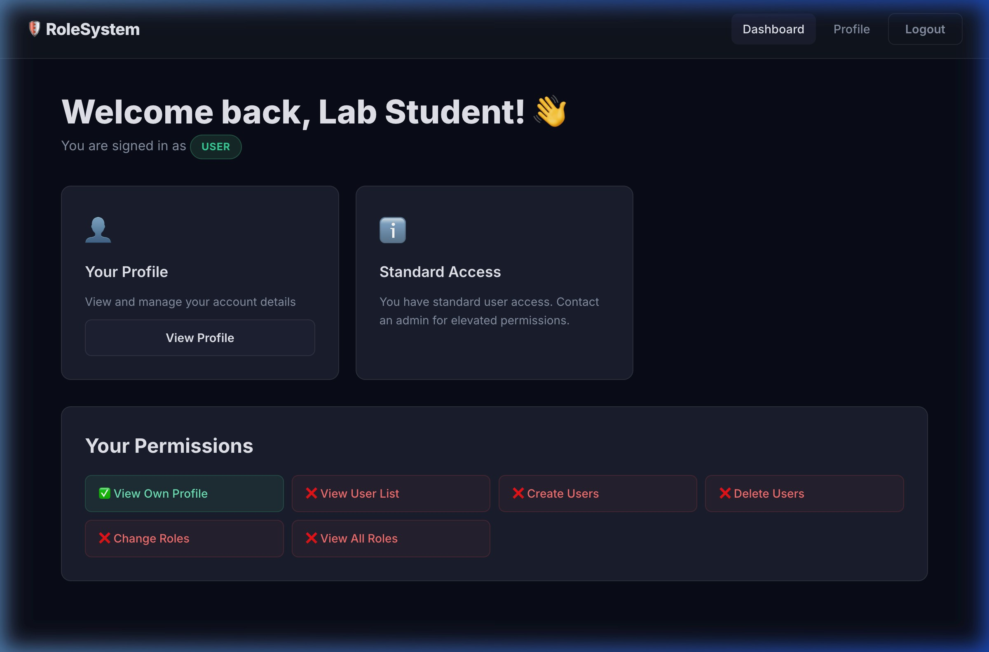

Figure 4.3: USER dashboard — "Standard Access" card, no Users link in navbar, most permissions ❌
Explanation: A standard USER sees only the Profile card and a "Standard Access" information card. The navbar omits the "Users" link entirely. Only "View Own Profile" is granted (✅ ); all admin/super-admin permissions are denied (❌ ). The entire permission panel reflects RBAC without requiring any server hit.

CHAPTER 5

User Management UI
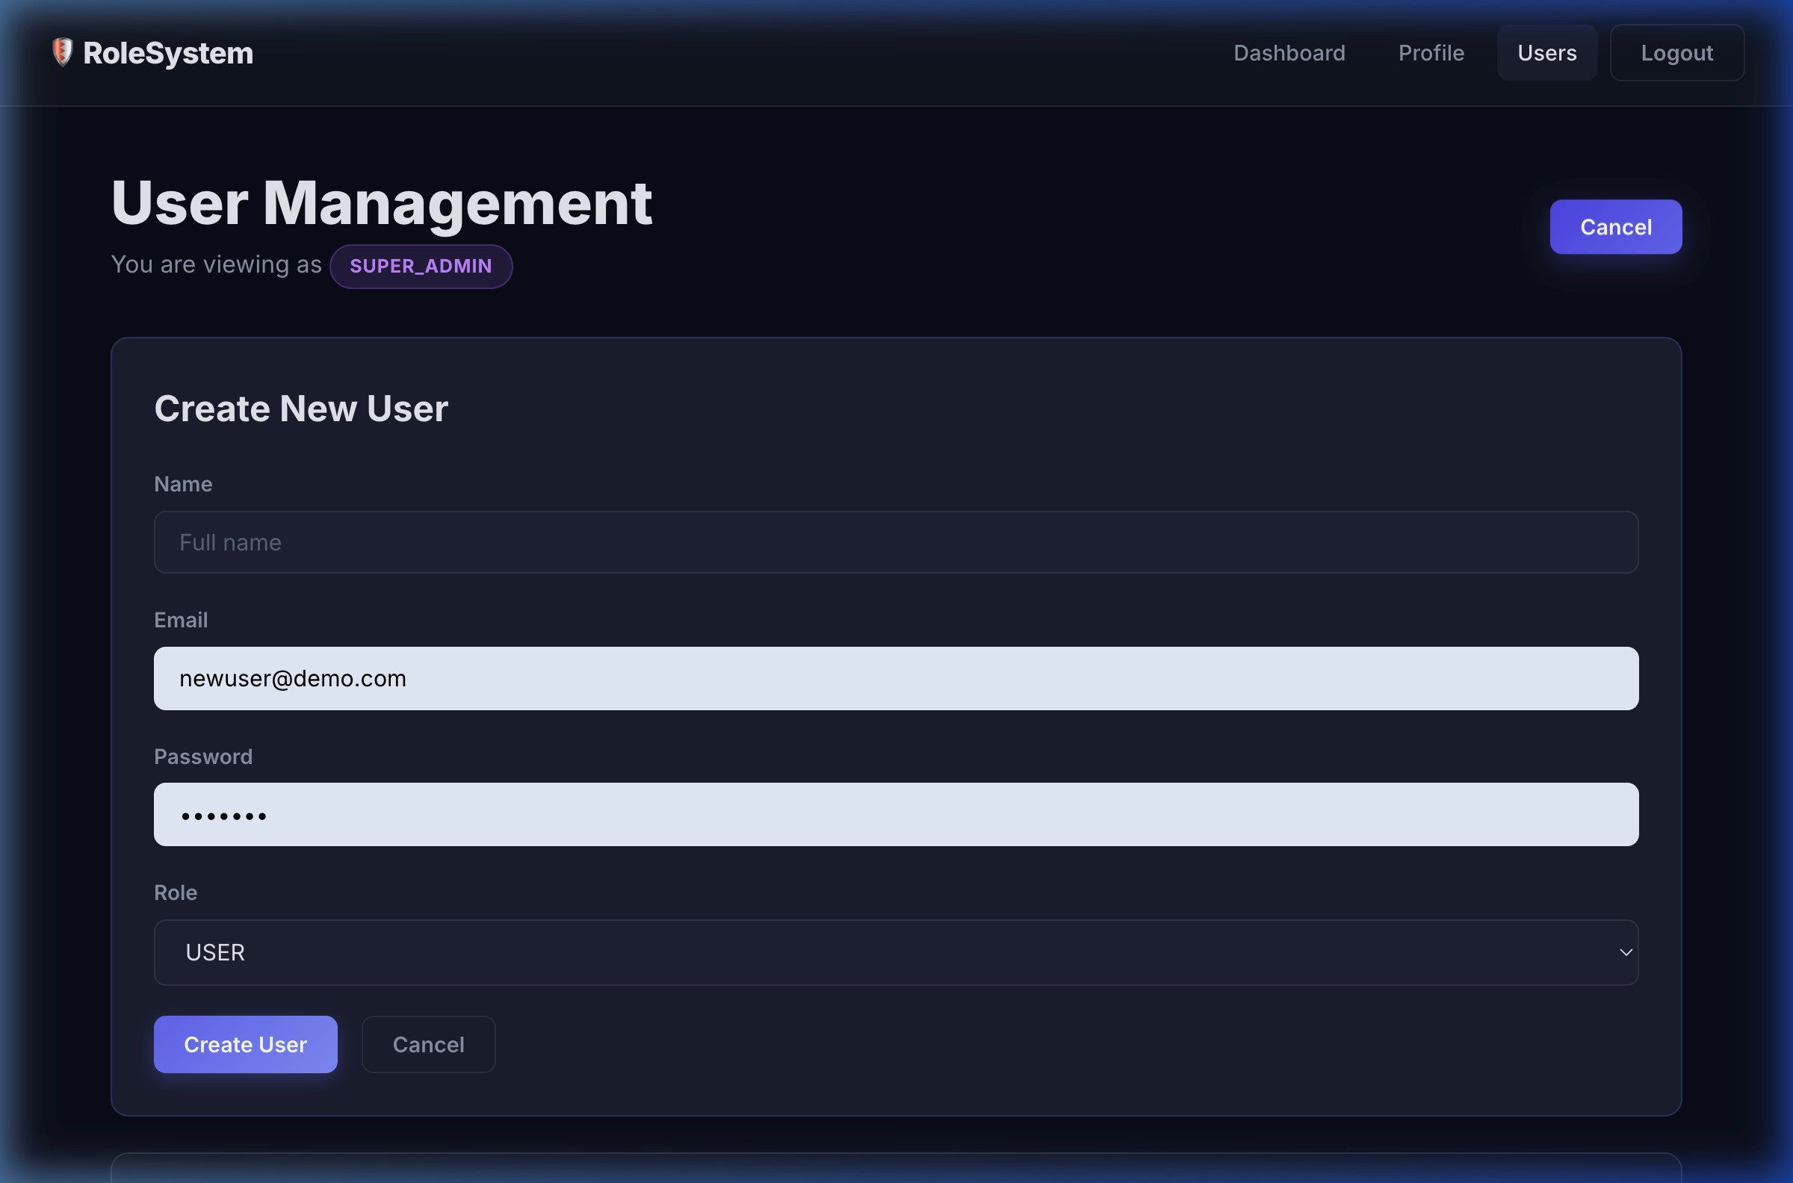
5.1
Create User Form — SUPER_ADMIN

Figure 5.1: "+ Create User" form shown to SUPER_ADMIN — includes role selector (USER / ADMIN)
Explanation: Clicking "+ Create User" toggles an inline form. SUPER_ADMIN sees a role selector allowing them to create either a USER or ADMIN account. ADMIN also sees this button but the role selector is hidden — their requests are server-enforced to create only USER accounts (PATCH to POST /api/users with role check in backend). Any attempt by ADMIN to set a non-USER role returns HTTP 403.

5.2 ADMIN User Management — Filtered View

Figure 5.2: ADMIN user management — only USER-role accounts shown, no role

dropdowns
Explanation: The ADMIN's user table displays only USER-role accounts returned by the filtered GET /api/users response. No role-change dropdowns are rendered (they only appear when isSuperAdmin === true ). ADMIN can delete these users — the backend enforces that the target's role must be USER before completing the DELETE /api/users/:id operation.

5.3 SUPER_ADMIN Role Change — PATCH /api/users/:id/role

Figure 5.3: Inline role-select dropdown in SUPER_ADMIN user list triggers PATCH request
Explanation: Each row in the SUPER_ADMIN view shows an inline <select> seeded with the current role. Changing the selection immediately fires PATCH
/api/users/:id/role with the new role value. The backend verifies the caller is SUPER_ADMIN and that the target is not the requester (self-role-change is blocked with 403 "Cannot change your own role").

5.4 Profile Page — GET /api/users/me

Figure 5.4: Profile page — displays name, email, role badge, user ID, and member-since

date
Explanation: On mount the Profile component calls GET /api/users/me with the stored Bearer token. It displays all safe fields returned by the server: name, email, role (colourcoded badge), user ID (monospace), and creation date. The role icon changes based on the current role (⚡ SUPER_ADMIN, 🔧 ADMIN, 👤 USER).

CHAPTER 6

Conclusion
This lab successfully demonstrates the design and implementation of a productionstyle Role-Based Access Control system using a modern full-stack JavaScript architecture. The project covers all requirements from the Lab 06 class-work specification:
Backend: Seven RESTful API endpoints with layered middleware (JWT verification + RBAC enforcement). Passwords are hashed with bcryptjs. Inmemory data is seeded with a SUPER_ADMIN and ADMIN for immediate testing.
Frontend: Four React screens (Login, Dashboard, User Management, Profile) with React Router protected routes and an AuthContext that persists the JWT across page refreshes via localStorage .
RBAC Correctness: ADMIN cannot see or modify other ADMINs or
SUPER_ADMINs. Attempts to bypass restrictions via direct URL navigation or API calls correctly receive HTTP 401 or 403 responses, and the UI renders appropriate "Forbidden" messages.
Conditional Rendering: Navigation links, action buttons, and role selectors are conditionally shown or hidden based on the decoded JWT role — ensuring users only see controls they are permitted to use.
The system is fully functional, tested end-to-end with all nine API test cases passing, and the UI walkthrough confirming all role-specific views. The codebase is committed to GitHub with a README.md describing setup and seeded credentials.

