# DSim HW 6

Bader, Dölle, Pöhlmann

### Ex. 1c)

First best configuration: L = 10 and X = 50

This configuration performs comparably well, since most of customers only need to wait for a short period of time (< 2). Scaling the server up by X = 50 seems to therefore work fine, although the laziness threshold is relatively high.

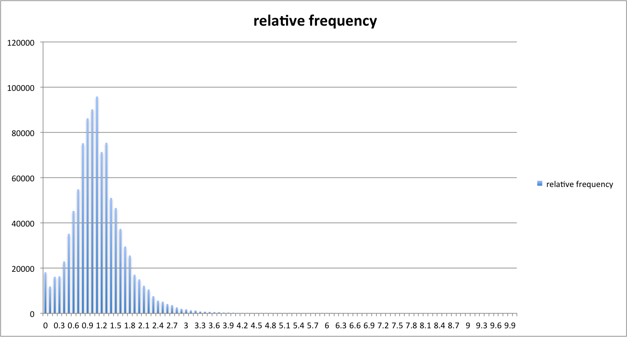

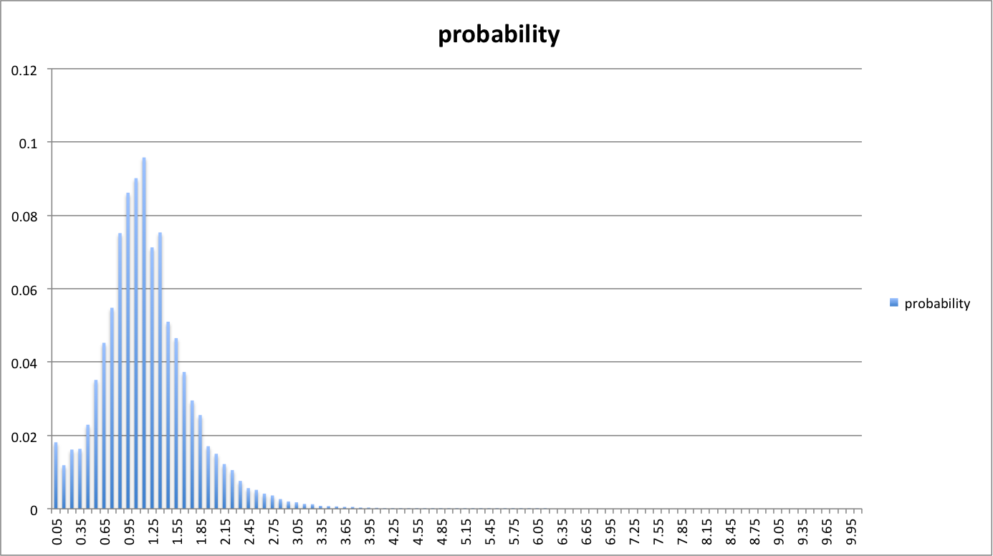

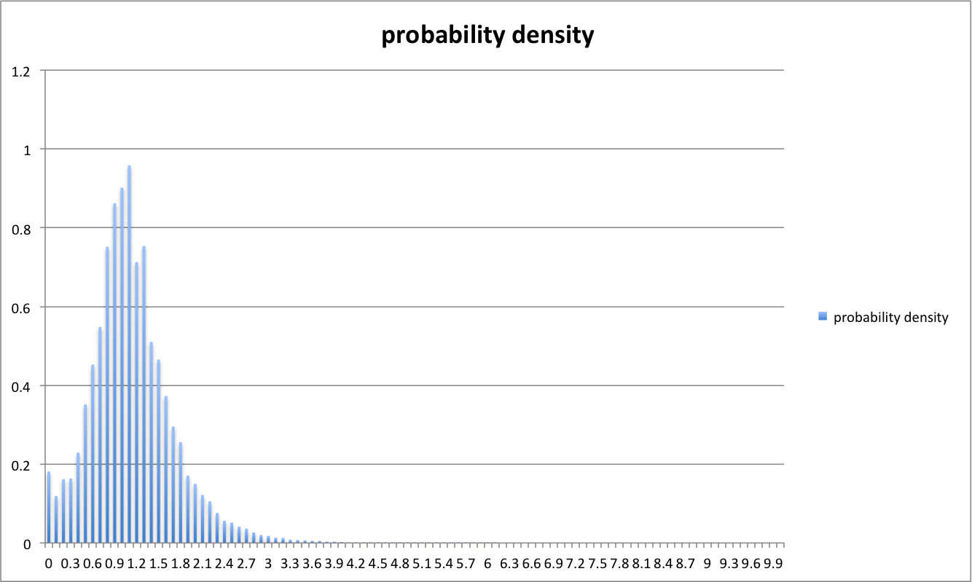

Second best configuration: L = 5 and X = 25

This configuration performs comparably well, since most of customers need to wait for a relatively short period of time (about 5.5, +-2.5). However, compared to the [L=10, X=50] configuration, scaling the server’s performance by .25 seems not to be so effective (although having a smaller laziness threshold).

