Faculty CV

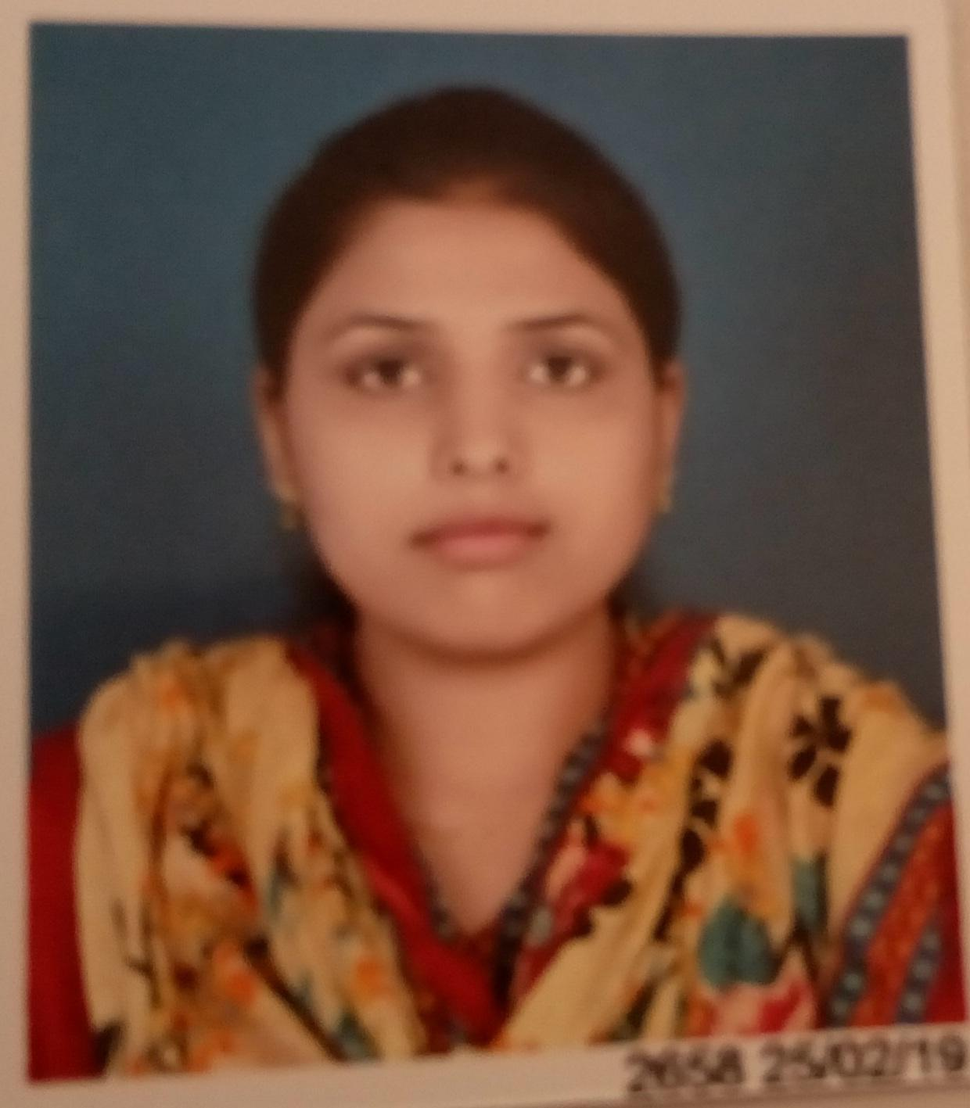
- Name of Faculty: Mrs. LAXMI MOHAN RAUT
- Present Position : Lecturer in Electrical Engineering
- Address : Government Polytechnic, Samangaon Road,
Nashik Road, Nashik (M.S.),
Pincode: 422 101.
- Mobile No. : +917875315740
- E-Mail Id : rautlaxmi1994@gmail.com
- Date of Birth : 20th October 1994
5. Memberships of professional organizations/Bodies :

QUALIFICATIONS:

Sr.  No. | Examination | Institute | Board/  University | % of  Marks | Class Award | Remark
1 | Diploma in Electrical Engineering | Government Polytechnic, Nashik | Autonomous | 72.00 | First class with distinction
2 | Bachelor in Electrical Engineering | K. K. Wagh Institute of Engineering Education & Research , Nashik | Savitribai Phule Pune university | 66.86 | First class with distinction

ADDITIONAL SKILLS
1) Third party audit
1 | Third party technical audit of the Street Light | Sinner,Nagar Palika | 2021-2022

CAREER DETAILS:

Sr. No. | Organization | Designation | Duration | Period | Work Done in Brief
1 | Government Polytechnic Gondia, Fulchur, Gondia | Lecturer in Electrical Engineering | 10/01/ 2019 to  22/10/2021 | 2-Years  9- Month | Teaching,  Examination Work, FC Committee member, Member Of SC/ST committee,
2. | Government Polytechnic, Nashik | Lecturer in Electrical Engineering | 23/10/2021 to Till date |  | Teaching,  Examination Work,

SPECIALIZED TRAINING COURSES ATTENDED:

Sr. No. | Course Name | Duration | Place | Training Agency | Remarks
1 | NBA e-SAR Preparation for Diploma Institutes | 15/06/2020 to 19/06/2020 | Govt. Polytechnic, Gondia | DTE Mumbai
2 | Internet Of Things | 28/07/2020 to 29/07/2020 | Government polytechnic Nanded | DTE Mumbai
3 | Induction Programme Phase – I | 10/8/2020 to  21/8/2020 | NITTTR, Bhopal | NITTTR ,Bhopal
4 | Foundation training Programme for class- I Officers | 16/06/2021 to  27/06/2021 | Yashwantrao chavan academy Development Administration | Yashada Pune
5 | Industry 5.0 : Next wave of technology | 10/01/2022 to  14/01/2022 | Government polytechnic , nashik | ISTE

WORK DONE AT ORGANIZATIONAL LEVEL
Sr. No | Position held | Period
1 | Coordinator, Staff Club Committee | 2020-2021
2 | Co -Coordinator, Sessional Exam at institute Level. | 2019-2020
3 | Arrange school connect program in Schools. | 2021-2022
4 | Scrutiny officer for Admission process | 2021-2022
5 | Scrutiny officer for MAHABDT | 2021-2022

WORK DONE FOR SOCIETY
1 | Third party technical audit of the Street Light | Sinner,Nagar Palika | 2021-2022

SIGNATURE
Ms. Laxmi Mohan Raut

