Faculty CV 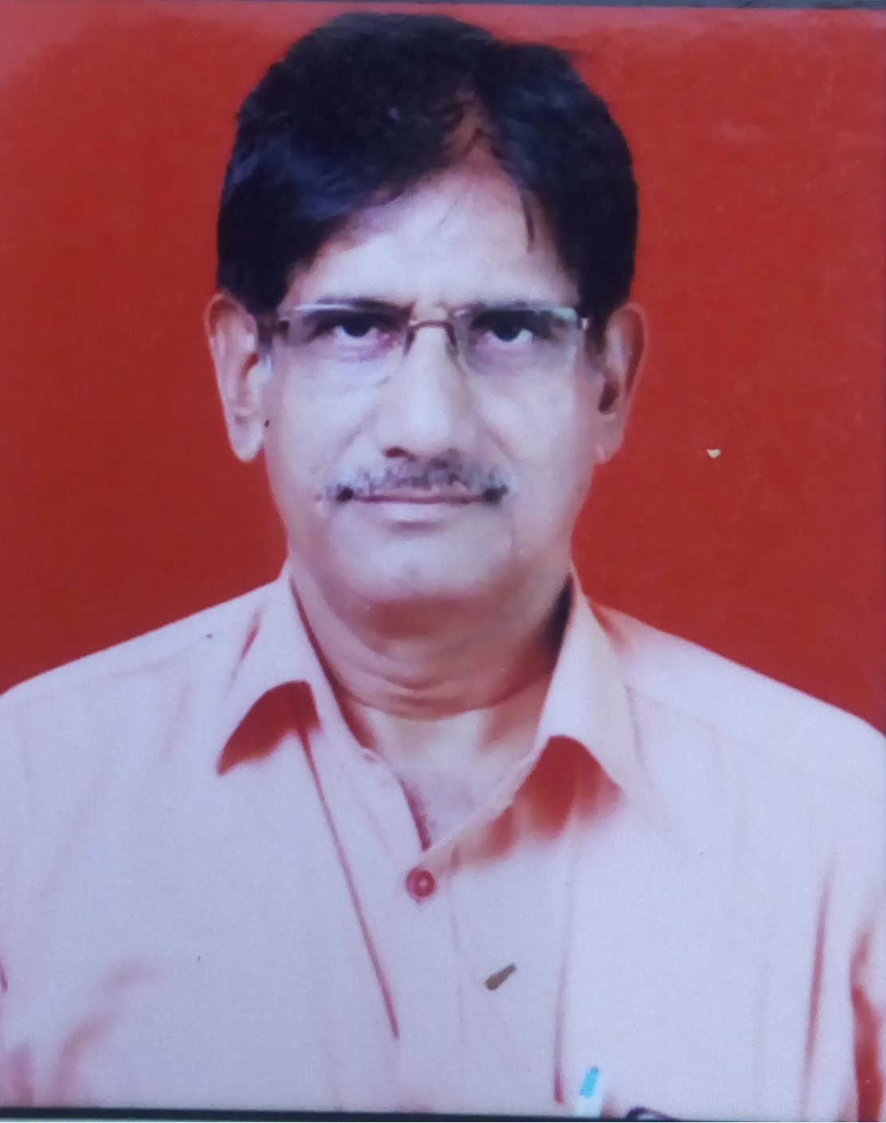

- Name of Faculty: RAKESHKUMAR SHIVADEO SHUKLA
- Present Position : Lecturer in Electrical Engineering

- Address :GOVT. POLYTECHNIC SAMANGAON ROAD NASHIK
- Mobile No. : 7972395162
- E-Mail Id :rakeshkumarsshukla@gmail.com
- Date of Birth : 15/10/1966
5. Memberships of professional organizations/Bodies : NIL

QUALIFICATIONS:

Sr.  No. | Examination | Institute | Board/  University | % of  Marks | Class Award | Remark
1 | BE | Govt College Of Engg ,Amravati | Sant Gadge Baba University Amravati | 64 | FIRST

ADDITIONAL SKILLS
Good Communication Skills, hardworking, Experienced in Electrical Maintenance

Sr. No. | Organization | Designation | Duratio | Period | Work Done in Brief
1 | Shriram Polytechnic.Airoli,Navi Mumbai | LEE | August 1989 To Jan 1996 | Near About 6 Years | Teaching ,Coordination  Of Student Activities
2 | Govt Poly Ratnagiri | LEE | Feb 1996 To May 1997 | 15 Months | Teaching ,Exam Work,  Short Term Training
3 | Govt Poly Yavatmal | LEE | May 1997 To Aug 200 | 03 Years | Teaching,Exam  Work,Sports ,Visit  ,Maitenance
4 | Govt Resi Women’s Poly Yavatmal | LEE | Aug 2000 Tojuly 2010 | 10 Years | Teaching,Exams,Sports,Visit  ,Maitenance,Gathering,  Rector,Security Officer  Monitoring,Inspection  Of Non Aicte Institute  External Squad,Curriculum  Work Of Msbte,  State Level Admission  Committee Member Etc
5 | Govt Poly Washim | LEE/HOD incharge | July 2010 To July 2017 | 7 Years | Teaching,Exams,Sports,Visit  ,Maitenance,Gathering,  Rector,Security Officer  Monitoring,Inspection  Of Non Aicte Institute  External Squad,Curriculum  Work Of Msbte,  State Level Admission  Committee Member ,  External Squad,  I/C Principal,Campus  Incharge,Distribution  Oic,

SPECIALIZED TRAINING COURSES ATTENDED:

Sr. No. | Course Name | Duration | Place | Training Agency | Remarks
1 | Electrical Welding | 1 Week | Govt Poly Pune | Staff Development Cell | DTE
2 | Induction Phase 1 | 4 Weeks | Govt Poly Mumbai | TTTI, Bhopal | DTE
3 | Induction Phase 2 | 4 Weeks | Govt Poly Mumbai | TTTI, Bhopal | DTE
4 | Computer Hardware | 3 Weeks | Govt Poly Yavatmal | Staff Development Cell | DTE

RESEARCH ACTIVITIES

NIL

Papers published in Refereed Journal Articles (Total –Nil )

Presentations and Publications in Refereed International Conference Proceedings (Total –Nil )

Presentations & Publications in Refereed National Conference Proceedings (Total-Nil )

WORK DONE IN THE AREA OF TECHNICAL EDUCATION
- Electrical Maintenance of campus of Polytechnic,
- Teaching and Administrative Works in technical education
- Rector of Boys Hostels
- Curriculum Development in Autonomous Polytechnics

WORKSHOP/ COMPETITION ARRANGED
- Industrial visits organized for polytechnic students
- Three days Induction Programme for teachers in Govt. Polytechnic, Washim for Polytechnic Teachers

EXPERT TALK
- PCRA Expert Lecture was arranged of Mr. Daspute recently for Polytechnic students in year 2021-22
WORK DONE AT ORGANIZATIONAL LEVEL
- Gathering Incharge at Govt. Polytechnic at Yeotmal and Washim

WORK DONE FOR SOCIETY
- Done duties of election commission
- Oxygen Audit during corona Pandemic

RESEARCH /OTHER GRANTS
Nil

SIGNATURE

