Faculty CV

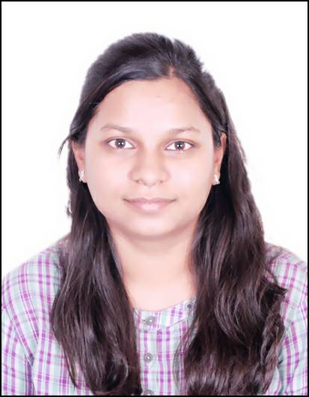

1. Name of Faculty : Manisha Pratik Wakchaure
2. Present Position : Lecturer in Information Technology
3. Address : Government Polytechnic, Samangaon Road,

Nashik Road, Nashik (M.S.),

Pincode: 422 101.

4. Mobile No. : 9665402344

1. E-Mail Id : manishawakchauregpn@gmail.com

**QUALIFICATIONS:**

|  |  |  |  |  |  |  |
| --- | --- | --- | --- | --- | --- | --- |
| **Sr.**  **No.** | **Examination** | **Institute** | **Board/ University** | **% of**  **Marks/ CGPA** | **Class Award** | **Remark** |
| 03 | B.E. (CSE) | Government College of Engineering,  Aurangabad | BAMU, Aurangabad | 7.1 | Distinction |  |

**CAREER DETAILS:**

|  |  |  |  |  |  |
| --- | --- | --- | --- | --- | --- |
| **Sr.**  **No.** | **Organization** | **Designation** | **Duration** | **Period** | **Work Done in Brief** |
| 01 | Government Polytechnic Nashik | Lecturer in Information Technology | 0.9 | 12/08/2021  to till date | Lecturer |
| 02 | Puranmal Lahoti Government Polytechnic, Latur | Lecturer in Information Technology | 4 | 03/10/2011  To  11/08/2021 | Lecturer |
| 03 | Datametica Pvt. Ltd., Pune | Software Engineer | 3 | 15/09/2014  to 29/09/2017 | BigData Engineer |

**SPECIALIZED TRAINING COURSES ATTENDED:**

|  |  |  |  |  |
| --- | --- | --- | --- | --- |
| **Sr No** | **COURSE/TRAINING TITLE** | **TRAINING PERIOD** | **TRAINING PLACE** | **TRAINING**  **SPONSORED AGENCY** |
| 1 | Induction Phase-I | 20/05/2019 to  31/05/2019  2 Weeks(12 days) | PLGP Latur | NITTTR, Bhopal |
| 2 | Induction Phase-I | 02/04/2018 to  13/04/2018  2 Weeks(12 days) | NITTTR, Bhopal | NITTTR, Bhopal |

**WORK DONE AT ORGANIZATIONAL LEVEL**

|  |  |  |
| --- | --- | --- |
| **Sr. No** | **Position held** | **Period** |
| 1 | **Coordinator,** Curricular and co-curricular activities, Information Technology, Government Polytechnic, Nashik. | 2021 - till date |
| 2 | **Academic Coordinator,** Information Technology, Government Polytechnic, Nashik. | 2021 - till date |
| 3 | **Member,** Admission committee for centralized first year diploma engineering admission in Nashik District at Government Polytechnic, Nashik. | 2021-22 |

**SIGNATURE**

**Smt. M. P. Wakchaure**