Curriculum Vitae

1. Name of Faculty: Sanjay Girdhar Chaudhari

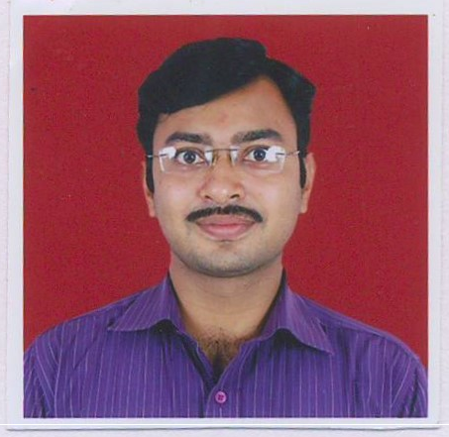

1. Present Position : Lecturer in Automobile Engineering
2. Address : Dept. of Automobile Engineering,

Government Polytechnic Nashik

Samangaon Road, Nashik Road, Nashik

1. Mobile No. : +91- 9309561163
2. E-Mail Id :sgchaudhari@rediffmail.com
3. Date of Birth: 20-03-1979
4. Memberships of professional organizations: Nil

**QUALIFICATIONS:**

|  |  |  |  |  |  |  |
| --- | --- | --- | --- | --- | --- | --- |
| **Sr.**  **No.** | **Examination** | **Institute** | **Board/**  **University** | **% of**  **Marks** | **Class Award** | **Remark** |
| 1 | M.E. (Design Engineering) | R.H. Sapat College of Engineering. Research and management centre Nashik | SPPU, Pune | 7.66 CGPI | 1st class |  |
| 2 | B.E. Mechanical | Government College of Engineering Pune | University of Pune | 60.00 | 1st class |  |
| 3 | Diploma in Automobile Engineering | Government Polytechnic Washim | MSBTE, Mumbai | 81.80 | 1st class |  |
| 4 | SSC | Mahatma Gandhi Vidyalaya, Varangaon Jalgaon | Pune (Divisional Board Nashik) | 78.00 | 1st class with Distinction |  |

**CAREER DETAILS:**

|  |  |  |  |  |  |
| --- | --- | --- | --- | --- | --- |
| **Sr. No.** | **Organization** | **Designation** | **Duration** | **Period** | **Work Done in Brief** |
| 1 | Ordnance Factory Varangaon, Jalgaon | Chargeman Technical | 19/11/2002 to 30/06/2006 | 03 years 6 months | Maintenance Supervisor. |
| 2 | Ordnance Factory Institute Of Learning, Deharadun, Uttarakhand | Junior Works Manager | 03/07/2006 to 22/03/2007 | 10 months | On job Training |
| 3 | Ammunition Factory Khadki, Pune | Junior Works Manager | 23/03/2007 to 13/10/2016 | 9 years 6 months. | Management of Production, Purchasing, Marketing Sections. |
| 4 | Government Polytechnic Nashik | Lecturer in Automobile Engineering | 14/10/2016 till date | 5 year | Teaching Automobile Engineering Subjects |

**ADDITIONAL SKILLS:**

**SPECIALIZED TRAINING COURSES ATTENDED:**

|  |  |  |  |  |
| --- | --- | --- | --- | --- |
| **Sr. No** | **Course Name** | **Place/Training Agency** | **Duration** | **Remarks** |
| 1 | Guidance Counseling and Mentoring Skills | NITTTR Bhopal | 04/06/2018 to 08/06/2018 |  |
| 2 | Core Teaching Skills and Assessment Methods | NITTTR, Pune | 18/06/2018 to 22/06/2018 |  |
| 3 | MSBTE sponsored Industrial Training Program | KEC International, Nagpur | 24/02/2020 to 28/02/2020 |  |
| 4 | Induction Phase I | NITTTR Bhopal (Online Mode) | 6/07/2020 to  17/07/2020 |  |
| 5 | Induction Phase II | NITTTR Bhopal (Online Mode) | 03/08/2020 to  14/08/ 2020 |  |
| 6 | Applications of FEA and CFD using ANSYS | TEQIP program GCE Karad (Online mode) | 13/06/2020 to 17/06/2020 |  |
| 7 | Industrial Training on Creo Software | NSIC, Hyderabad (Online mode) | 21/01/2021 to 04/02/2021 |  |

**RESEARCH ACTIVITIES: Nil**

**WORK DONE IN THE AREA OF TECHNICAL EDUCATION:**

1. Co-ordinator for development of curriculum for short term (1 year) course “Diploma in Automobile Servicing”. It is developed for MSBTE during Nov-19 to Feb-2020.
2. Co-ordinator for Automotive Service Technician (Two and Three Wheeler) Course under PMKVY Scheme. A skill development course by designed by ASDC and implemented by Government polytechnic Nashik and completed 2 batches successfully. (Jan-2017 to July 2017 and Jan-2018 to July-2018).

**WORKSHOP/ COMPETITION ARRANGED:**

1. State level Online Quiz Organised on Automobile Engineering

**PROJECT GUIDANCE**

|  |  |  |  |
| --- | --- | --- | --- |
| **Sr. No** | **Project Title** | **Year** | **Remark** |
| **1** | **Engine colling system Working Model** | **2021-22** |  |
| **2** | **Design and Manufacturing of solar operated Multipurpose Agriculture machine** | **2021-22** |  |
| **3** | **Automatic hand brake release system** | **2021-22** |  |
| **4** | **Air purifying machine** | **2020-21** |  |
| **5** | **Design the cycle with shaft and bevel gear transmission** | **2020-21** |  |
| **6** | **Manufacturing printer ink from vehicle exhaust carbon** | **2020-21** |  |
| **7** | **Obstacle Braking system** | **2019-20** |  |
| **8** | **Motorised screw jack** | **2018-19** |  |
| **9** | **Electronic emission testing machine** | **2018-19** |  |
| **10** | **Wheel operated spray pump** | **2018-19** |  |
|  |  |  |  |
|  |  |  |  |
|  |  |  |  |

**WORK DONE AT ORGANIZATIONAL LEVEL**

1. Verification Officer, for Local Assessment Center (LAC) for Exam 2017-18 and 2018-2019.
2. Member, Application Receiving Center (ARC) for Direct Second Year Diploma Engineering Admission for Academic Year 2020-21, 2021-22.

**WORK DONE FOR SOCIETY**

1. Presiding Officer, for Vidhansabha Election of Nashik Constituency, held in OCT-2019.
2. Presiding Officer, for Loksabha Election of Nashik Constituency, held in Apr 2019.
3. Venue Officer, MBA CET Exam 2020-21 and 2021-22.
4. During Covid-19, carried inspection of medical oxygen supply lines to ensure no leakage of oxygen in various covid-19 hospitals in month of May, 2021.