Faculty CV

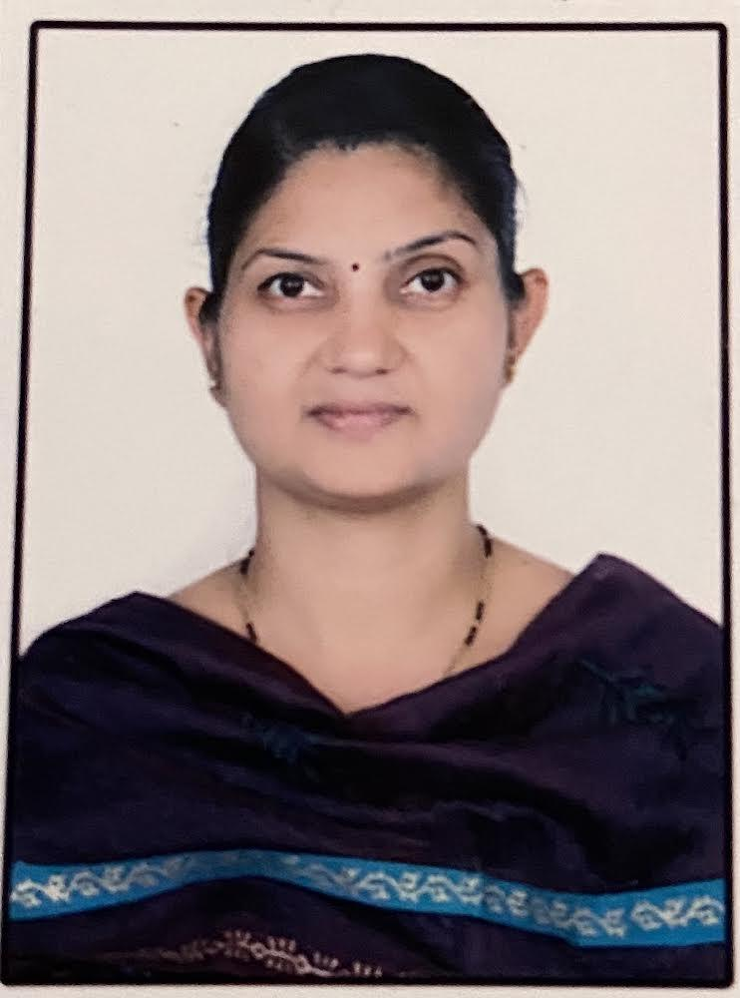

1. Name of Faculty: YOGITA SUNIL PATIL
2. Present Position: Lecturer in Physics
3. Address : Dream nest Society, B/204, Tagore Nagar, Nasik,
4. Mobile No. : 8805162358
5. E-Mail Id : yswagh111@gmail.com
6. Date of Birth : 20/05/1974

**QUALIFICATIONS:**

|  |  |  |  |  |  |  |
| --- | --- | --- | --- | --- | --- | --- |
| **Sr.**  **No.** | **Examination** | **Institute** | **Board/**  **University** | **% of**  **Marks** | **Class Award** | **Remark** |
| 01 | SSC | JaiHind high school,Dhule | Pune | 76.14 | Distinction | - |
| 02 | HSC | JaiHind Junior college dhule | Pune | 67.17 | First Class | - |
| 03 | B.SC | . JaiHind Junior college Dhule | North Maharashtra University,Jalgaon | 71.3 | Distinction | **-** |
| 04 | M. SC | North Maharashtra University,Jalgaon | North Maharashtra University,Jalgaon | 63 | First Class | **-** |
| 05 | B.Ed | Mulji Jetha College,Jalgaon | North Maharashtra University,Jalgaon | 78.12 | Distinction |  |

**CAREER DETAILS:**

|  |  |  |  |  |  |
| --- | --- | --- | --- | --- | --- |
| **Sr. No.** | **Organization** | **Designation** | **Duration** | **Period** | **Work Done in Brief** |
| 01 | S.M.I.T. Polytechnic, Jalgaon | Lecturer  in Physics | 05/08/2005to 07/08/2008 | 03 years | Teaching  Examination |
| 02 | Govt. Polytechnic, Nashik | Lecturer  in Physics | 08/04/2008  To till date | 14 years | Teaching  Evaluation  Examination  Extracurricular activities |

**SPECIALIZED TRAINING COURSES ATTENDED:**

|  |  |  |  |  |  |
| --- | --- | --- | --- | --- | --- |
| **Sr. No.** | **Course Name** | **Duration** | | **Place /Training Agency** | **Remarks** |
| 01 | Induction Phase I | 6/6/2016 | 17/06/2016 | NITTTR,Bhopal | 2 weeks |
| 02 | Environmental Pollution : Green and Alternative Fuels | 12/12/2016 | 23/12/2016 | NITTTR,Bhopal | 1 week |
| 03 | Induction Phase II | 20/2/2017 | 03/03/2017 | NITTTR,Bhopal | 2 weeks |
| 04 | Research Methodology and Optimization Techniques | 30/1/2018 | 03/02/2018 | Government Polytechnic, Nashik | 1 week |
| 05 | Empowering Teaching Skills Using Modern Pedagogy Tools. | 14/01/2019 | 18/01/2019 | Government Polytechnic, Nashik | 1 week |
| 06 | Emotional Inellingence | 27/01/2020 | 27/03/2020 | NPTEL | 8 week |
| 07 | Simulation Techniques in Applied Science | 31/1/2022 | 4/02/2022 | Online NITTTR,Bhopal | 1 week |

**WORK DONE IN THE AREA OF TECHNICAL EDUCATION --**

* G.P. Nashik of Curriculum Development
* G.P .Nashik Laboratory Manual Development
* G P Nashik Question Bank Development

**Competition Arranged**

* IEDSSA Girls Carrom and Chess competition
* **Other Work**

Cultural Activities **SIGNATURE**