Steps for generating reports by providing Tags in Cucumber Framework

- Go to feature file and add tag.
e.g.: Tag @regression is given in below screenshot.

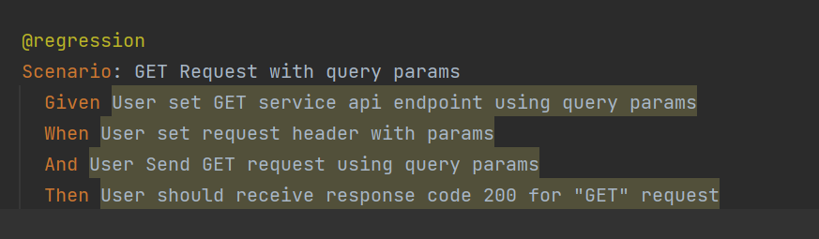

2.Create Runner class and add tags in CucumberOptions.
e.g.: RegressionTestsRunner.java is created with tag=”@regression”

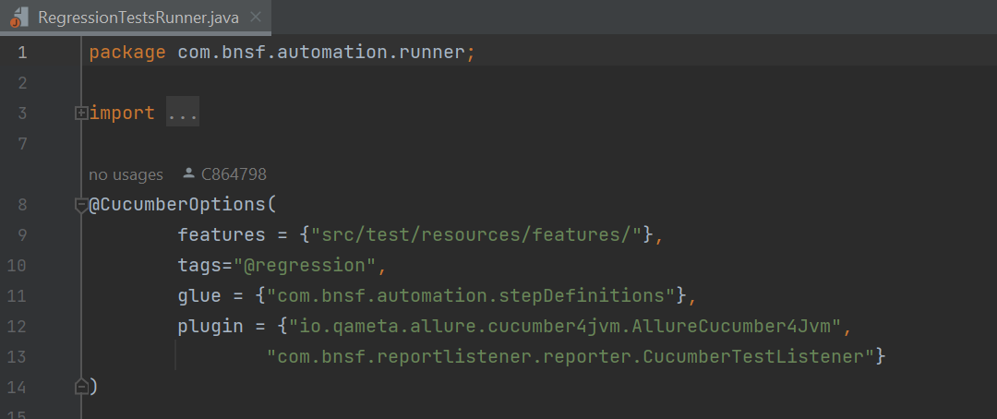

3. Open build.graddle from release-test folder and set runner path as per profile.
e.g.: for regression profile (profile.regression), RegressionTestRunner path is provided.

bnsfTest {
profile.acceptance {
includeTestsMatching "com.bnsf.automation.runner.AcceptanceTestsRunner"
}
profile.smoke {
includeTestsMatching "com.bnsf.automation.runner.SmokeTestsRunner"
}
profile.regression {
includeTestsMatching "com.bnsf.automation.runner.RegressionTestsRunner"
}

- Go to Jenkins.file and add testProfiles
e.g.: For regression execution, testProfiles is provided as regression in ci environment.

environments : [
ci : [deployType : 'auto' , testProfiles : 'regression'],
dev : [deployType : 'auto' , testProfiles : 'regression']

- After Commit and Push code, Regression report is generated :

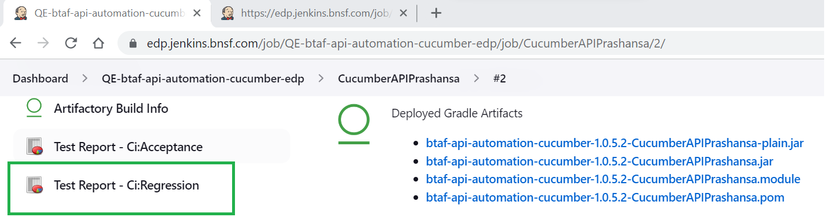

Steps for generating multiple reports same time:

- Go to feature file and add required tags
e.g: @regression and @smoke tags are added

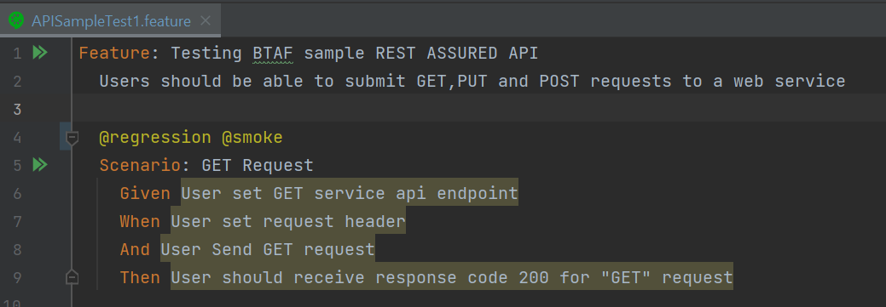

- Configure multiple tags in Jenkinsfile like below to generate smoke and regression reports.
testProfiles : 'smoke,regression']

- environments : [
ci : [deployType : 'auto' , testProfiles : 'smoke,regression']
- ]

- After Commit and Push code, Regression and smoke reports are generated:

