Boxcode IDE
Installation Manual
This guide walks you through downloading, installing, signing in to, and getting started with the Boxcode IDE on Windows.
Step 1 Open the Boxcode Website
- Open a web browser.
- Go to the Boxcode website:
https://boxcode.sh/
- On the Boxcode homepage, click Download IDE.
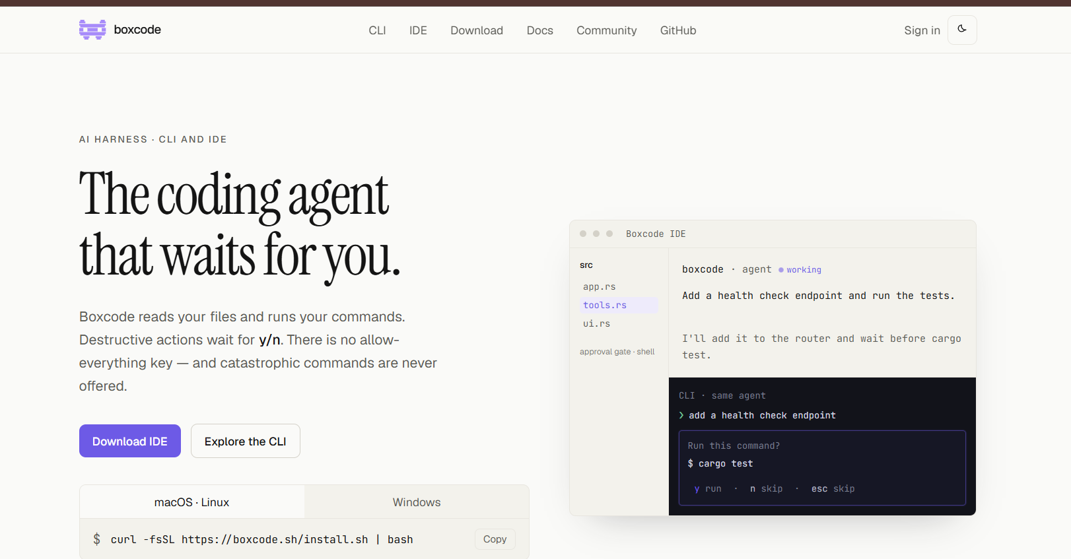
Figure 1: Boxcode homepage — click Download IDE
Tip You can also get the installer from the latest GitHub release page: https://github.com/HolboxAI/boxcode-ide/releases/latest. The recommended route is the Boxcode website above.
Step 2 Download the Windows IDE
Clicking Download IDE takes you to the IDE download section of the website.
- Scroll down to the IDE download options.
- Locate the Windows option.
- Click Download Windows.
- The Windows .exe installer begins downloading.
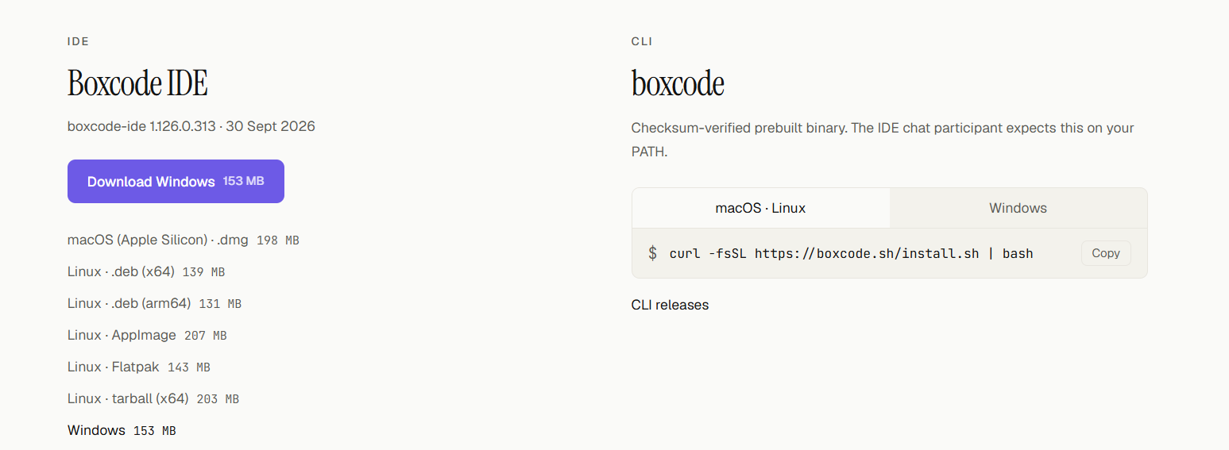
Figure 2: Boxcode IDE download options
The installer in this guide is named:
BoxcodeSetup-x64-1.126.0.313.exe
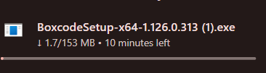
Figure 3: Windows installer downloading
Important The version number changes with each release. Always download the latest Windows installer shown on the official Boxcode download page.
Step 3 Run the Installer and Accept the Agreement
- Locate the downloaded .exe file, usually in your Downloads folder.
- Double-click the installer. The Boxcode Setup window opens.
- Read the License Agreement.
- Select I accept the agreement.
- Click Next.
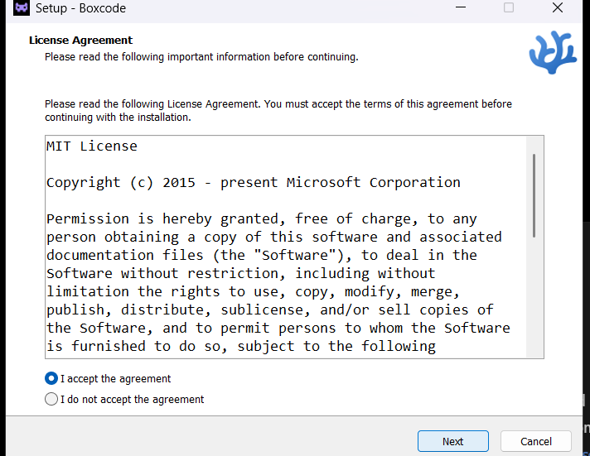
Figure 4: Boxcode IDE License Agreement
Step 4 Choose Installation Location and Install
The Ready to Install screen summarizes where Boxcode IDE will be installed and which additional options are selected.
Setting | As shown in the installer
Destination location | C:\Program Files\Boxcode
Start Menu folder | Boxcode IDE
Additional tasks | Create a desktop icon
 | Register Boxcode as an editor for supported file types
 | Add to PATH (requires shell restart)

- Review the installation directory. Change it only if necessary.
- Review the additional installation options.
- Click Install.
- Wait for the installation to complete.
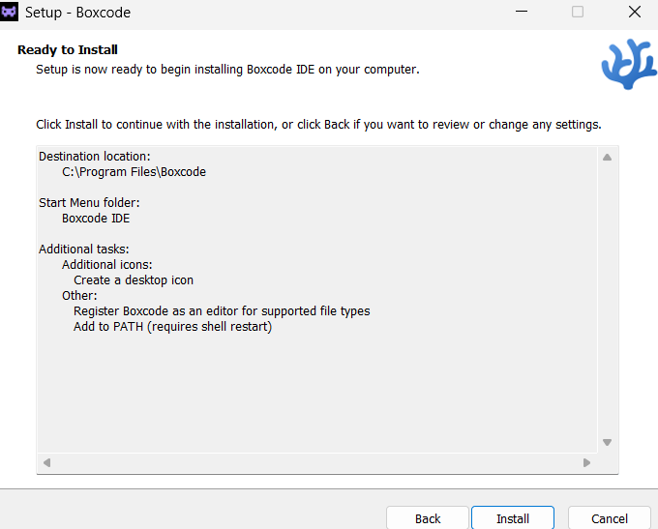
Figure 5: Ready to Install — review the settings and click Install
Step 5 Launch Boxcode IDE
- After the installation completes, launch Boxcode IDE (from the Start Menu, or from the desktop icon if you kept that option selected).
- The Boxcode IDE welcome screen appears, with options to Open Folder..., create a New file..., or Clone Git Repository....
Boxcode IDE is now installed and ready for account authorization.
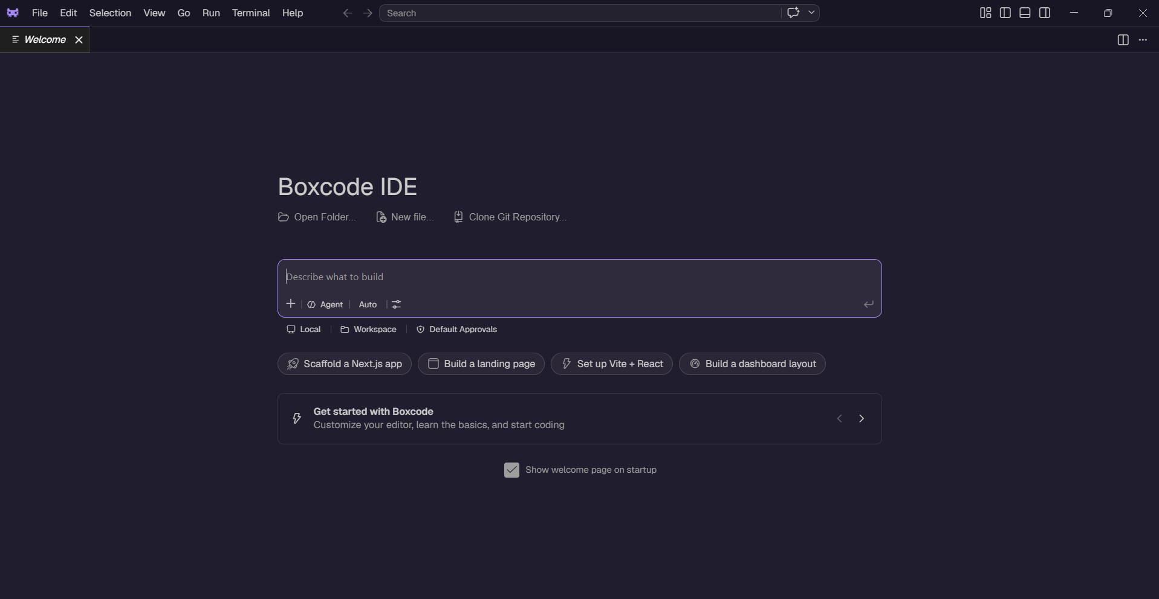
Figure 6: Boxcode IDE welcome screen after installation
Step 6 Sign In and Authorize Boxcode
- In the top-right corner of Boxcode IDE, click Sign in.
- Your default browser opens.
- Sign in to your Boxcode account. If you do not have an account, create one.
- Authorize Boxcode when prompted.
- After authorization, return to Boxcode IDE.

Note After authorization, you will receive $5 in free credits and can start working with Boxcode.
Step 7 Start Working with Boxcode IDE
- Open a project folder using Open Folder... on the welcome screen, or File › Open Folder.
- Describe what you want to build or change in the Describe what to build prompt box.
- Boxcode then works with your project.
Example prompt:
Create a responsive landing page for a pizza shop.
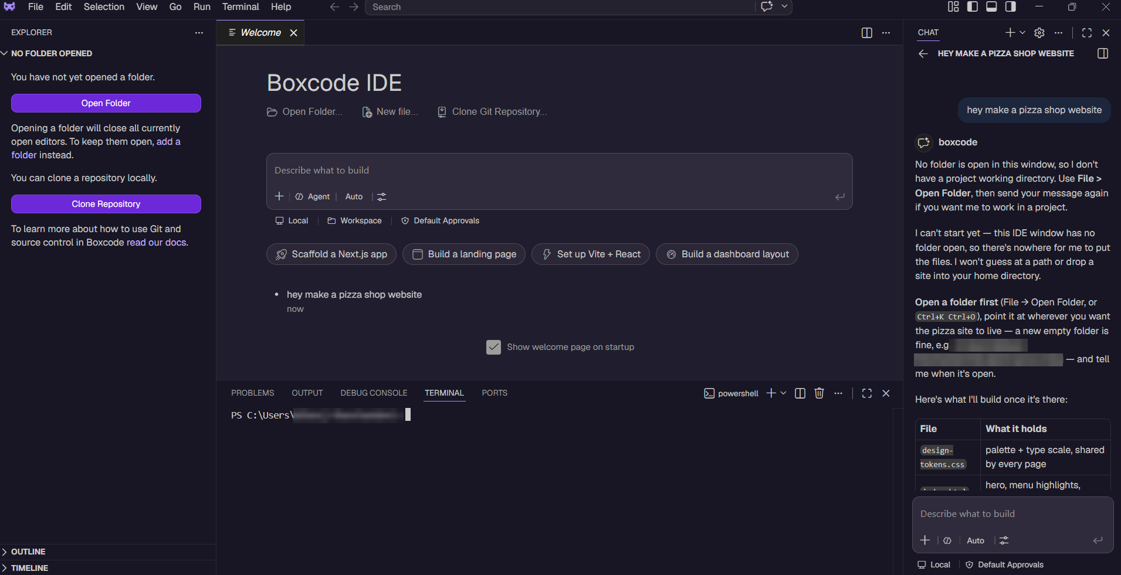
Figure 7: Boxcode IDE chat — open a folder first so Boxcode can work with your project
Quick Reference
Item | Details
Website | https://boxcode.sh/
Latest IDE Releases | https://github.com/HolboxAI/boxcode-ide/releases/latest
Platform | Windows
Installer | BoxcodeSetup-x64-<latest-version>.exe
Sign In | Click Sign in in the top-right corner
Free Credits | $5 after authorization

