Boxcode CLI
Installation Manual
This guide walks you through installing and setting up the Boxcode CLI, a terminal coding agent that reads your files and runs commands, and asks for your approval (y/n) before anything destructive. It works on Windows, macOS and Linux.

Step 1: Open the Boxcode website
Go to https://boxcode.sh/ in your browser. This is the Boxcode home page.
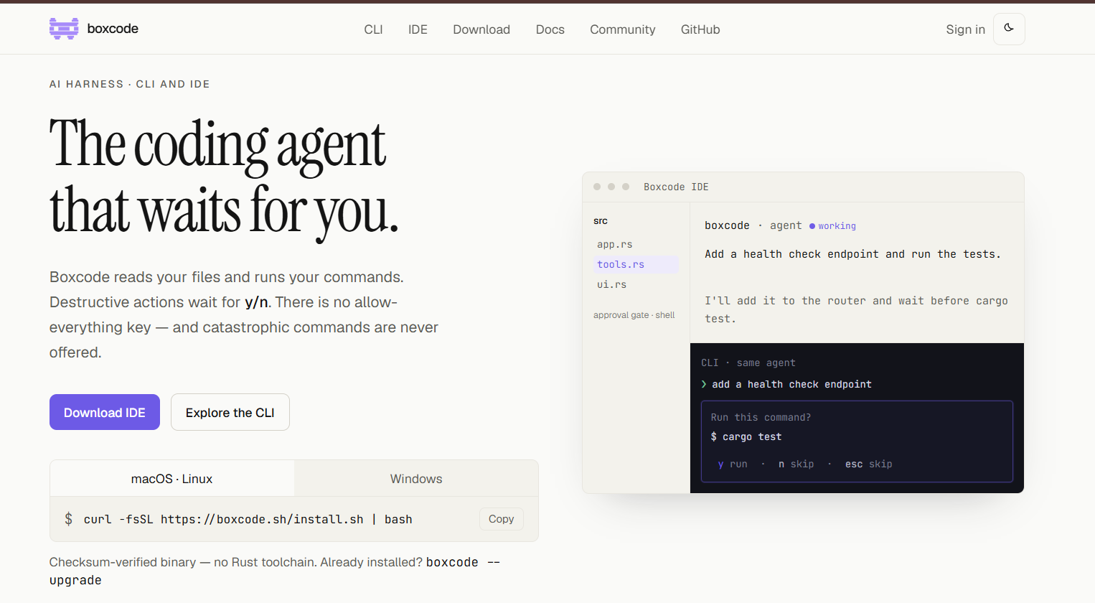
Figure 1: The Boxcode home page

Step 2: Open the CLI install commands
On the home page, click Explore the CLI. You will see an install box with two tabs:
- macOS · Linux for Mac and Linux computers
- Windows for Windows computers
Pick the tab that matches your operating system, then use the Copy button to copy the command.
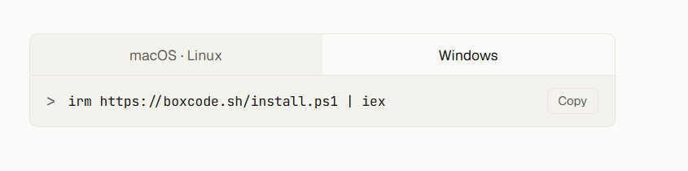
Figure 2: Install command box with the macOS · Linux and Windows tabs (Windows tab selected)

Step 3: Paste the command and install

Windows users
- Open PowerShell.
- Paste the Windows install command:
irm https://boxcode.sh/install.ps1 | iex
- Press Enter.
The installer downloads a prebuilt binary, installs Boxcode and adds it to your PATH. When it finishes you will see "Installation complete!".
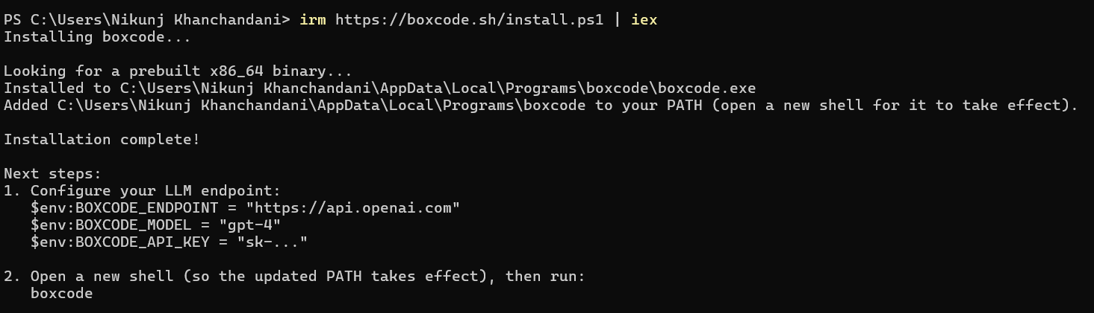
Figure 3: The install command pasted in PowerShell and the installation completing

macOS and Linux users
- Open the Terminal.
- Paste the install command:
curl -fsSL https://boxcode.sh/install.sh | bash
- Press Enter and wait for the installation to finish.
Important: After the installation is done, close this window and open a NEW PowerShell (or Terminal) tab. The updated PATH only takes effect in a new window.

Step 4: Start Boxcode
In the new PowerShell / Terminal tab, type the following and press Enter:
boxcode
The Boxcode welcome screen appears. The CLI setup is almost done. You only need to sign in so the agent has a model to work with.
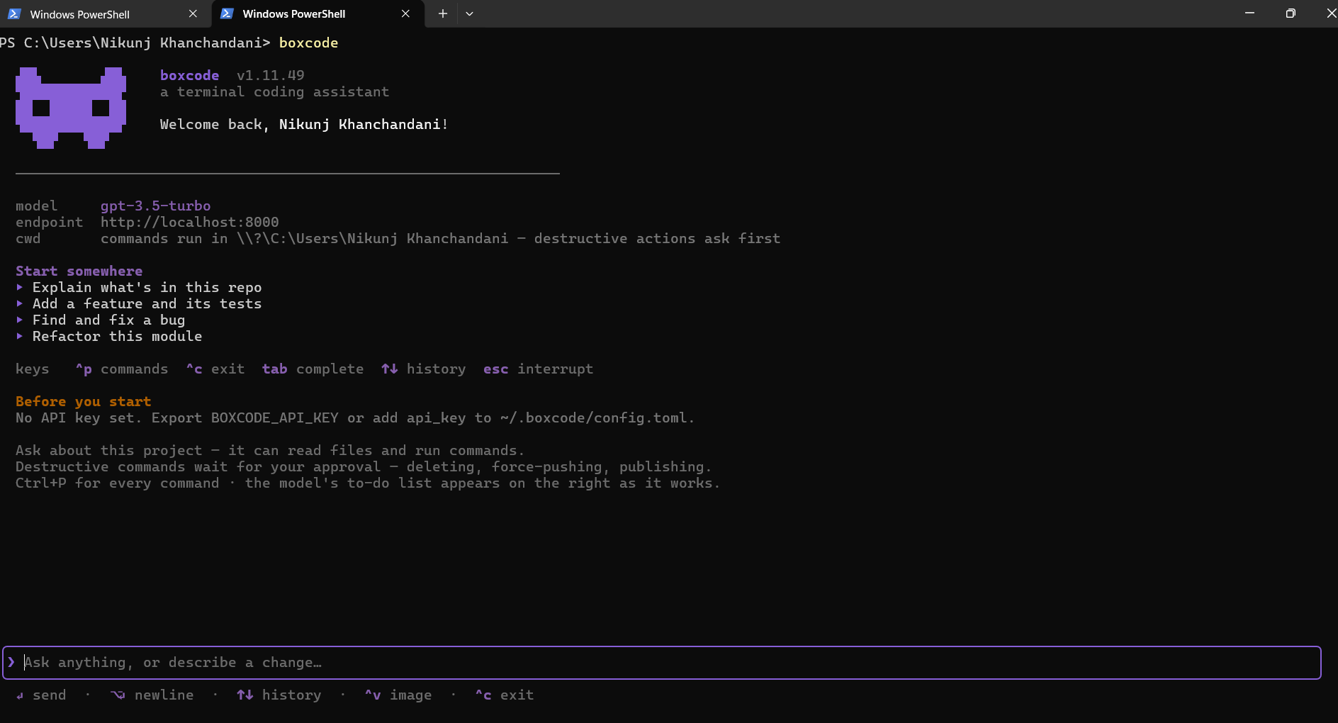
Figure 4: Typing boxcode in a new PowerShell tab opens the Boxcode CLI

Step 5: Sign in or sign up with /login
- Inside the Boxcode CLI, type /login and press Enter.
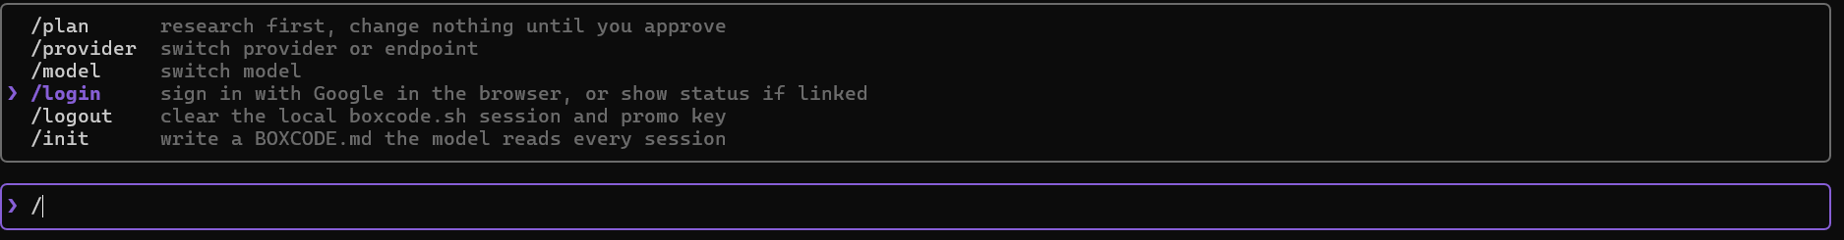
Figure 5: The /login command in the Boxcode command list
- Your default browser opens automatically with the Boxcode login page. Choose Sign in if you already have an account, or Sign up to create a new one. Then authorize Boxcode.
- After you sign in or sign up you will see your dashboard. You can get your $5 free credits here.
- Go back to the CLI. You can now start working.
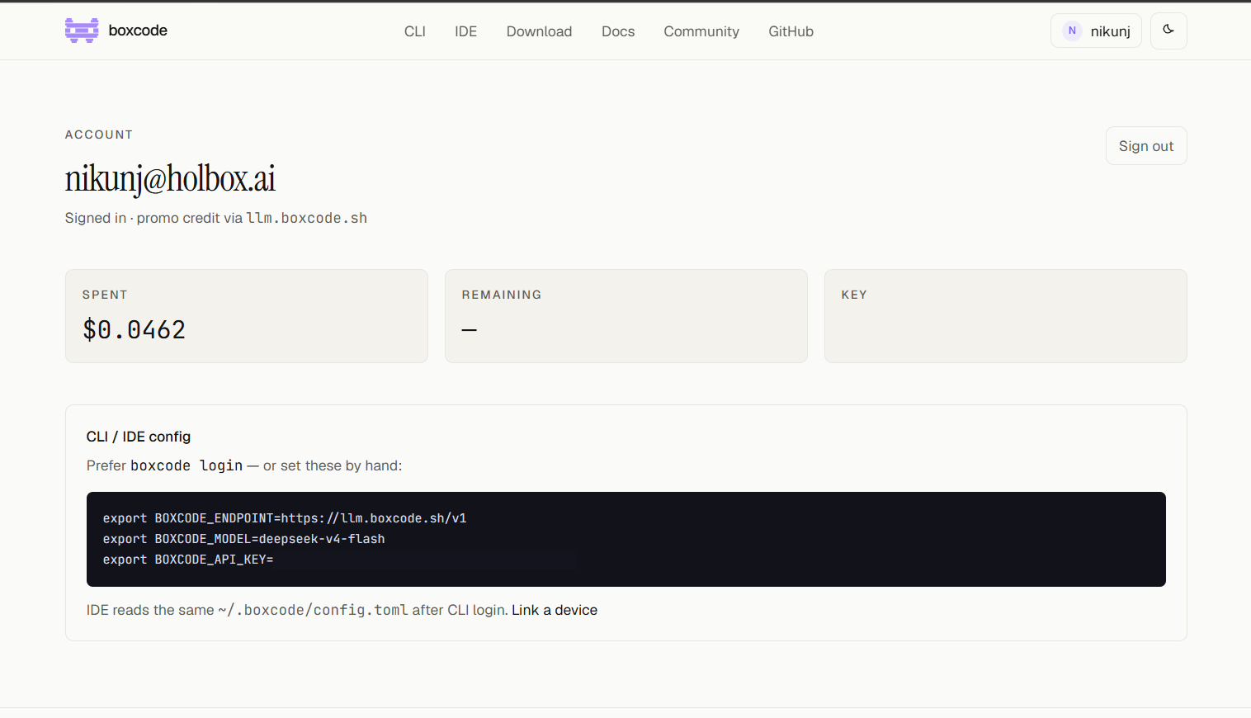
Figure 6: The Boxcode dashboard after signing in

Step 6 (if /login does not work): Set up a custom endpoint
If /login does not work, you can connect manually using the commands shown on your dashboard profile.
- On your dashboard, find the CLI / IDE config box. It lists three settings: the endpoint, the model and your API key.
- Return to your CLI, type /provider and press Enter.
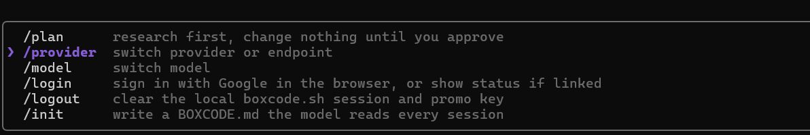
Figure 7: The /provider command in the Boxcode command list
- Choose Custom endpoint and press Enter.
- Copy the values from your profile one by one. Start with the endpoint: select the URL after BOXCODE_ENDPOINT= and copy it.
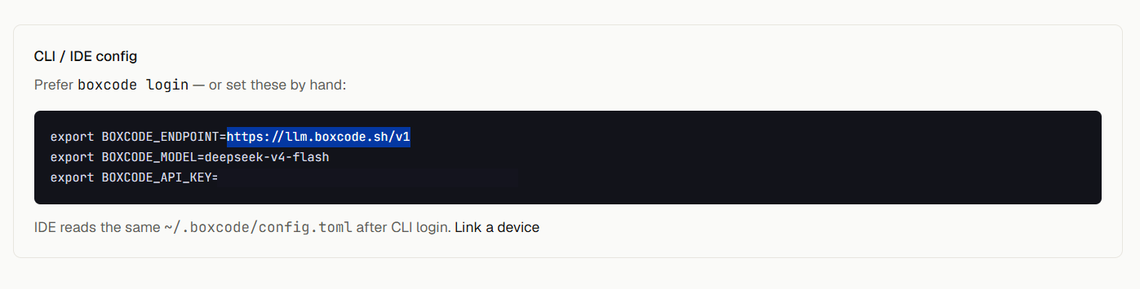
Figure 8: Select the value from your dashboard config (your API key stays private)
- Paste it into the Custom endpoint box and press Enter to confirm.
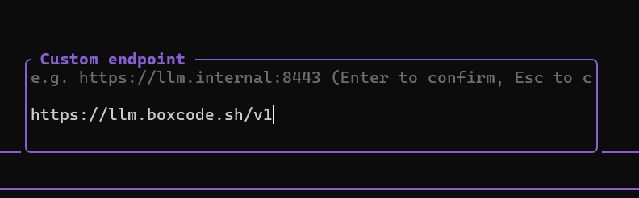
Figure 9: Pasting the endpoint into the Custom endpoint box
- Repeat the same for the other two values, the model and the API key, copying each from your profile.
- When done, you will see a confirmation that Boxcode switched to the new endpoint and model.
Keep your API key private. Never share your API key or post screenshots that show it. Anyone with the key can use your credits.

Step 7: Start working
Type your request in the input box at the bottom and press Enter. For example:
hey make a landing page for the pizza shop
Boxcode will plan and build it. Whenever it wants to run a destructive command, it asks for your approval first: y runs it, n or esc skips it.
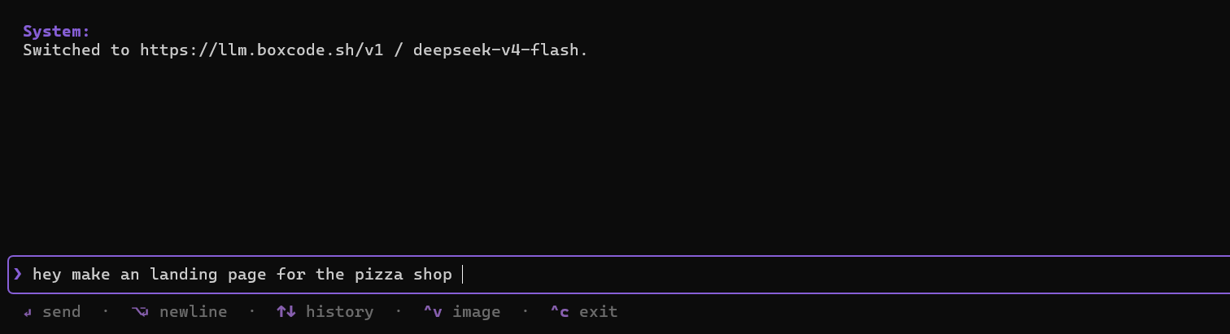
Figure 10: Entering a prompt in the Boxcode CLI. The CLI setup is complete.

Quick reference
Command | What it does
/login | Sign in with Google in the browser, or show status if linked
/logout | Clear the local boxcode.sh session and promo key
/provider | Switch provider or endpoint
/model | Switch model
/plan | Research first, change nothing until you approve
/init | Write a BOXCODE.md that the model reads every session
Ctrl + P | Show every command
Ctrl + C | Exit
To update an existing install, run: boxcode --upgrade

