Assignments

Software Engineering Assignment

MODULE: 1

1. **What is software? What is software engineering?**

Ans :

**Software**

A collection of programs/set of instruction

Software refers to a collection of instructions, data, programs, and documentation that tells computer system how to perform specific tasks or functions. It is the opposite of hardware which describes the physical aspects of a computer

**Software engineering**

A process to build this software

Software engineeringis theprocess of designing, developing, testing and maintaining software.it is a systematic and disciplined approach to software development that aims to create high-quality, reliable and maintainable software.

**(2) Explain types of software**

Ans :

**There are two types of software system**

**(1) System software (2) Application software**

1. **System software**

**System software** is software that directly operates the ***computer hardware*** and provides the basic functionality to the users as well as to the other software to operate smoothly. It is like an interface between hardware and user application .In other words, system software basically controls a computer’s internal functioning and also controls hardware devices such as monitors, printers and storage devices, etc. System software is fast in speed. System software is difficult to design and understand

**(2)Application software**

**Software** that performs special function or provides functions are much more than the basic operation of the computer is known as **application software. application software** is designed only to fulfill end-users requirements. It includes word processors, **spreadsheets**, database management, inventory, etc. The application software is easy to design and understand Mostly, the size of the software is big, so it requires more storage space. Application software is written in a high-level language in general**.**

**(3)what is SDLC? Explain each phase of SDLC**

**Ans**

**SDLC stands for software development life**

**Cycle .software development life cycle** is a structured process that is used to design, develop , and test good-quality software. **software development life cycle** is a methodology that defines the entire procedure of software development step-by-step.

**Step by step approach to provide the software with quality, within the cost, within time, quality + cost + time .**

**SDLC Phases**

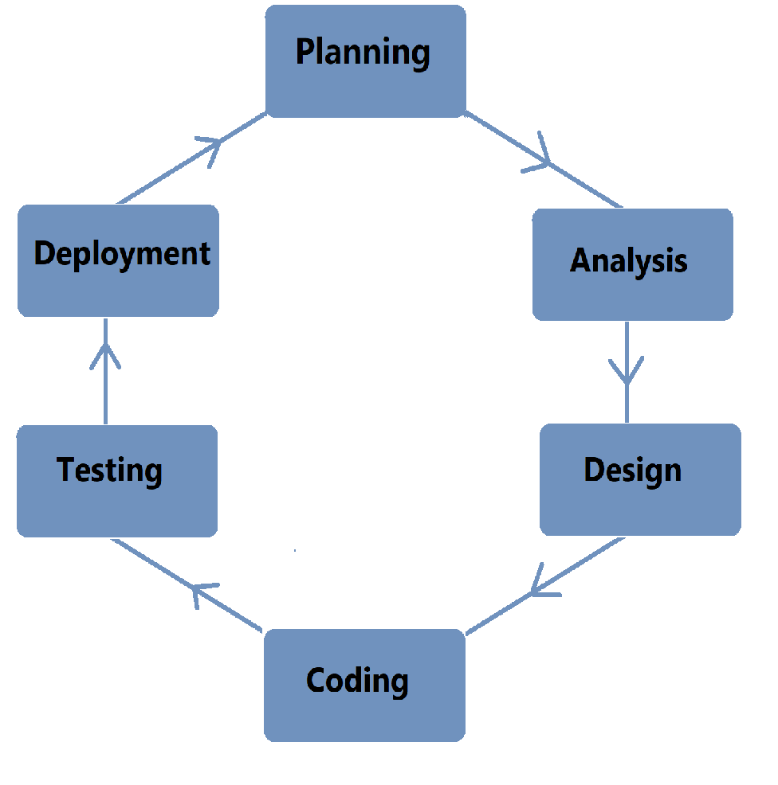**.**

**Software development life cycle**

**Are Given below the various phases**

**(1) Planning (2) analysis (3) Coding**

**(4) Testing (5) Deployment**

**(1) Planning**

Planning for coding involves outlining the steps and strategies you'll use to approach a coding task or project before you start writing actual code. It's like creating a roadmap or blueprint for your development process.

**(2) Analysis**

During this phase, all the relevant information is collected from the customer to develop a product as per their expectation. Any ambiguities must be resolved in this phase only.

Business analyst and project manager set up a meeting with the customer to gather all the information like what the customer wants to build, who will be the end-user, what is the purpose of the product.

Before building a product a core understanding or knowledge of the product is very important.

**(3) Coding**

Coding starts once the developer gets the design document. The software design is translates into source code .All the component of the software are implemented in this phase.

**(4) Testing**

Testing starts once the coding is complete and the modules are released for testing .In this phase, the developed software is tested thoroughly and defects found are assigned to developers to get them fixed**.**

**(5) Deployment**

Once the product is tested, it is deployed in the production environment first UAT(user acceptance testing) is done depending on the customer expectation . In the case of UAT, a replica of the production environment is created and the customer along with the developers does the testing . If the customer finds the application as expected, then sign off is provided by the customer to go live.

**(4)What is DFD? Create a DFD diagram on Flipkart**

**Ans**

**DFD**

A data flow diagram offers a visual representation that maps the flow of information within a system, emphasizing processes, data stores, and external entities. It helps security teams identify and analyze data pathways, ensuring secure data handling and optimized processes.

**DFD diagram on Flipkart**

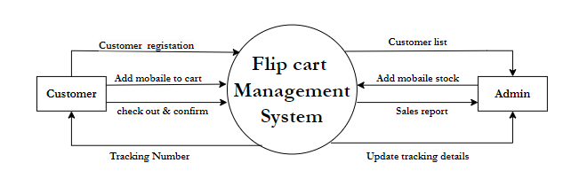

**(5)What is Flow chart? Create a flowchart to make addition of two numbers**

**Ans**

A flowchart is a graphical representations of steps. It was originated from computer science as a tool for representing algorithms and programming logic but had extended to use in all other kinds of processes. Nowadays, flowcharts play an extremely important role in displaying information and assisting reasoning. They help us visualize complex processes, or make explicit the structure of problems and tasks. A flowchart can also be used to define a process or project to be implemented.

**Flowchart**

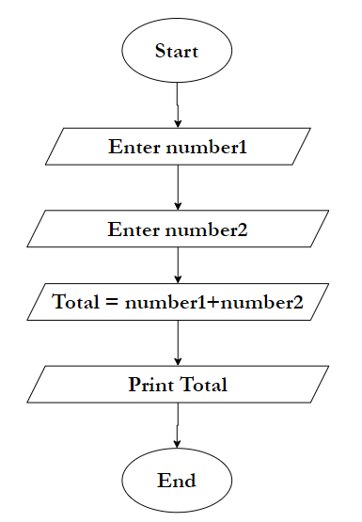

**(6) What is Use case Diagram? Create a use-case on bill payment on paytm**.

**Ans**

A use case diagram is a dynamic or behavior diagram in [UML](https://www.smartdraw.com/uml-diagram/). Use case diagrams model the functionality of a system using actors and use cases. Use cases are a set of actions, services, and functions that the system needs to perform. In this context, a "system" is something being developed or operated, such as a web site. The "actors" are people or entities operating under defined roles within the system.

