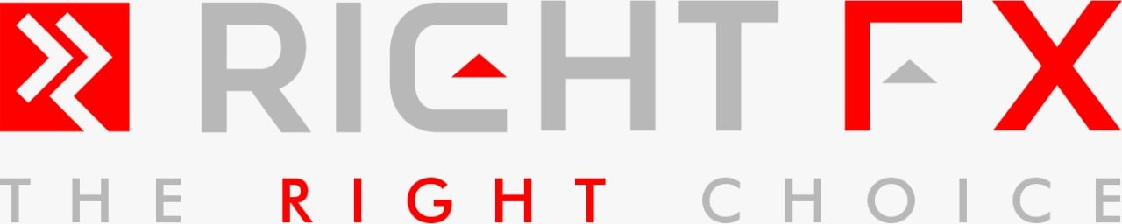

Risk Warning

Investing in a CFD carries a high degree of risk because the ‘gearing’ or ‘leverage’ often obtainable means that a relatively small movement in the market can lead to a proportionately much larger movement in the value of your investment and this can work against you, as well as for you. You may need to provide further funds with little or no notice. It is possible to lose more money than you have deposited into the Account. This notice provides you with information about the risks associated with investment products, which you may invest in through services provided to you the Company. The Company provides CFDs, the purpose of this type of transaction is to secure a profit or avoid a loss by reference to fluctuations in the value or price of an underlying instrument.

CFDs are high risk financial products, which are not appropriate for many members of the public, it is important that you fully understand that it is your responsibility to remain aware of the risks involved; that you have adequate financial resources to deal with them, you have taken a proper advice from a third party and that you monitor your positions closely.

This notice provides you with information about the risks but, cannot explain them all nor how they relate to your personal circumstances. If you are in any doubt you should seek professional or legal advice before signing this document. If you are not sure that you understand a particular product, instrument, service or transaction, you should also first seek appropriate professional advice before entering into the product, instrument, service or transaction.

This Risk Warning forms part of the Client Agreement. Any capitalized term not defined in this Risk Warning shall have the meaning ascribed to it in the Client Agreement.

The Company may amend this Risk Warning and it shall apply to you once it is published on our Website. Please ensure to check our Website regularly.

Version 1 Right Group Financial Limited Risk Disclosure Notice - Page **1** of **1**