🛰️
Observatory Dome & Safety Monitor
Installation & Setup Guide
A Raspberry Pi-native ASCOM Alpaca service for a DIY roll-off-roof observatory — Dome, SafetyMonitor, ObservingConditions and dew/frost Heater control, with a built-in web dashboard and event log.
Covers: what you need before you start, installing the service on the Pi, running it as a systemd service, configuring every Settings section, connecting an ASCOM client, and publishing the project to GitHub.

1. Overview
This service runs directly on the Raspberry Pi that is wired to your observatory's sensors and actuators — no separate microcontroller or bridge computer is needed. It exposes three standard ASCOM Alpaca devices that any Alpaca-compatible client (N.I.N.A., SGPro, and others) can connect to over the network, plus a web dashboard for humans.
- SafetyMonitor — fuses four independent, individually-toggleable checks with fail-safe logic (any one can veto SAFE, and an unreachable/stale sensor counts as UNSAFE): Day/Night (from solar elevation), Rain, an MLX90614 ambient-vs-sky clear/cloud delta, and Simple Cloud Detect's ML sky classification from an all-sky camera feed. Two optional AI checks (off by default; see Section 10) add your own trained sky-condition models to the decision once you trust them: the AI Model check, trained on your sensor readings (its live prediction shows on the dashboard as “AI Sky Prediction”), and the Cloud Image Model check, a real image-classification model trained by the companion cloud training server (shown on the dashboard as “AI Cloud Detect”) — and each fails open — never blocking SAFE — if it's turned on before its model exists or with no fresh reading/frame to predict from. Either check also holds its last real prediction instead of reacting when the model predicts your configured “Ignore” label. A manual Force-SAFE / Force-UNSAFE override can bypass all six at once.
- Dome — drives a roof relay and reed switch as an OPEN/CLOSED/MOVING state machine, with optional safety-auto-close/open and rain-auto-close.
- Dew/frost Heater — not part of the SafetyMonitor decision, since equipment protection and observing safety are separate concerns — runs AUTO ramped power from freeze/dew-point math, or a manual power slider.
- ObservingConditions — exposes the raw BME280 / MLX90614 / DHT11 / Simple Cloud Detect readings to any ASCOM client.
- Web dashboard & Settings — live status at all times, plus a Settings page covering location/timezone, safety checks, schedule, hardware pins/addresses, sensor and ASCOM device names, the All Sky camera, AI Learning, and log retention.
- AI Learning — captures raw All Sky frames and sensor readings on a timer, lets you manually classify them, trains a from-scratch sky-condition model from those classifications, and can feed that model into the SafetyMonitor's fifth check above once you trust it (Section 10).
- Event log — records every safety-relevant change (sensor connect/disconnect, check flips, overall SAFE/UNSAFE, dome/heater actions, manual overrides), optionally attaching an All Sky snapshot per event type.

2. Before You Start
Gather the following before installing anything — the service will still run with pieces missing (each sensor is individually toggleable), but it's easiest to confirm everything is wired and enabled once, up front.

2.1 Hardware
- A Raspberry Pi (Pi 4 or Pi 5) running Raspberry Pi OS, with GPIO header access and an I2C bus.
- A roof relay and motor/actuator that opens and closes your roll-off roof, wired so the Pi's relay output can drive it.
- A reed switch (or equivalent) that reports whether the roof is physically open or closed.
- A BME280 sensor (temperature / humidity / pressure) on I2C — the "Environment" reading.
- An MLX90614 non-contact IR thermometer on I2C — the ambient-vs-sky clear/cloud check.
- A DHT11 sensor on a GPIO pin — the inside-the-box temperature/humidity reading.
- A MOSFET (e.g. an IRF520 module) on a GPIO pin, driving a dew/frost heater strip or pad.
- Optional: an RG-9 (or similar) rain sensor on a GPIO pin.
- Optional: a small SSD1306 OLED display on I2C, for a local status readout.
- Optional: an all-sky camera running Allsky (or similar capture software), and Simple Cloud Detect (an ML sky classifier) — the docker-compose.clouddetect.yml file in this project sets that up as a container.
None of the optional items are required to get the service running — every sensor and every subsystem (Dome, Heater) has its own on/off toggle in Settings, and an item left disabled is simply skipped instead of crashing the service.

Default GPIO / I2C assignments
These are the defaults the service ships with — all of them can be changed later from Settings → Hardware Pins & Addresses without editing code.
Device | Connection | Default | Purpose
DHT11 | GPIO | GPIO4 (pin 7) | Box (inside enclosure) temp/humidity
Reed switch | GPIO | GPIO16 (pin 36) | Roof open/closed feedback
Roof relay | GPIO | GPIO23 (pin 16) | Roof open/close actuator
Heater MOSFET | GPIO | GPIO18 (pin 12) | Dew/frost heater driver
RG-9 rain sensor | GPIO | GPIO17 (pin 11) | Rain detection (optional)
BME280 | I2C | Bus 1, address 0x76 | Environment temp/humidity/pressure
MLX90614 | I2C | Bus 1, address 0x5A | Sky/ambient IR temperature
OLED display | I2C | Bus 2, address 0x3C | Local status readout (optional)

2.2 Software
- Raspberry Pi OS (Bullseye or newer) with Python 3 and pip.
- I2C enabled on the Pi (via raspi-config — see Step 1 below).
- The Python packages: flask requests adafruit-circuitpython-bme280 adafruit-circuitpython-mlx90614 adafruit-circuitpython-dht adafruit-extended-bus rpi-lgpio.
- git, if you're pulling the project from GitHub rather than copying the file over another way.
- An ASCOM/Alpaca-aware client on whatever computer runs your imaging session (N.I.N.A., SGPro, or similar), if you intend to connect to this service remotely.
- Docker, only if you're running Simple Cloud Detect's container from docker-compose.clouddetect.yml.

2.3 Network
- The Pi and your imaging PC should be on the same network (or otherwise able to reach each other).
- Know the Pi's IP address or hostname ahead of time — you'll use it for the web dashboard and for ASCOM discovery.

3. Step-by-Step Installation
The fastest path is the included installer script — clone the repo (Step 2 below), then from inside it run:
sudo bash install.sh
It automates Steps 1, 3, and 5 below, plus the systemd half of Step 6 — enabling I2C, installing the system and Python dependencies, and generating a dome-safety.service unit for wherever the repo actually ended up and whichever user ran sudo — then prints the exact visudo line Step 6 needs for its passwordless-sudo half. Safe to re-run any time, including after a later git pull (see Section 8). The rest of this section walks through the same steps by hand, useful if you’d rather understand or customize any part of it, or if install.sh doesn’t fit your setup.

Step 1 — Enable I2C on the Pi
From a terminal on the Pi:
sudo raspi-config
Navigate to Interface Options → I2C → Enable, then reboot if prompted.

Step 2 — Get the code onto the Pi
Choose whichever is easiest for you:
Option A — Clone from GitHub: if the project is on GitHub (see Section 9), run:
git clone https://github.com/<your-username>/<your-repo>.git
cd <your-repo>
Option B — Copy the file directly from your computer to the Pi, e.g. with scp:
scp dome_safety_service.py pi@<pi-ip-address>:/home/pi/

Step 3 — Install the Python dependencies
pip install flask requests adafruit-circuitpython-bme280 \
adafruit-circuitpython-mlx90614 adafruit-circuitpython-dht \
adafruit-extended-bus rpi-lgpio

Step 4 — Test-run it manually first
Before wiring it into systemd, run it directly so you can see any startup errors right away:
python3 dome_safety_service.py
Watch the startup messages — a sensor that fails to initialize (e.g. nothing wired to that I2C address yet) is caught and logged, not fatal: the service continues without it and that reading simply shows N/A until it's connected. Then, from another device on the same network, open a browser to:
http://<pi-ip-address>:11112/
You should see the dashboard (Section 4 below shows what to expect). Press Ctrl+C in the terminal to stop the test run once you've confirmed it loads.

Step 5 — Install it as a systemd service
Running it as a service means it starts automatically on boot and restarts itself if it ever crashes. Create a unit file:
sudo nano /etc/systemd/system/dome-safety.service
with contents along these lines (adjust the paths and User= for your setup):
[Unit]
Description=Observatory Dome + Safety Monitor
After=network.target
[Service]
ExecStart=/usr/bin/python3 /home/pi/dome_safety_service.py
WorkingDirectory=/home/pi
User=pi
Restart=on-failure
[Install]
WantedBy=multi-user.target
Then enable and start it:
sudo systemctl enable --now dome-safety.service
sudo systemctl status dome-safety.service
The status command should show "active (running)". The dashboard at http://<pi-ip-address>:11112/ should now be reachable any time the Pi is powered on.

Step 6 — Allow the page's Restart / Reboot buttons to work (optional)
The Settings → Service Control section (Section 5.8 below) has buttons to restart the service or reboot the Pi without opening a terminal. They shell out to systemctl, which needs passwordless sudo for exactly those two commands. One-time setup:
sudo visudo
Add a line like this (swap "pi" for whichever User= your service file above uses):
pi ALL=(ALL) NOPASSWD: /usr/bin/systemctl restart dome-safety.service, /usr/bin/systemctl reboot
Confirm the systemctl path on your Pi with "which systemctl" first, in case it differs from /usr/bin/systemctl.

4. First Look at the Dashboard
Once the service is running, http://<pi-ip-address>:11112/ shows four live cards at the top: Safety Monitor, All Sky (once configured), Dome, and Dew/Frost Heater. Everything below that is the Settings area covered in Section 5. The browser tab itself also shows a green shield when overall SAFE and a red shield (with an X) when UNSAFE, so the state is visible even from another tab or a minimized window.
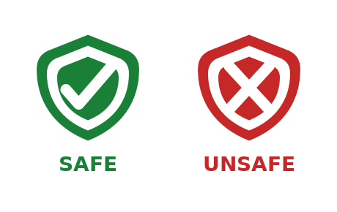
The browser-tab favicon: green for SAFE, red for UNSAFE.
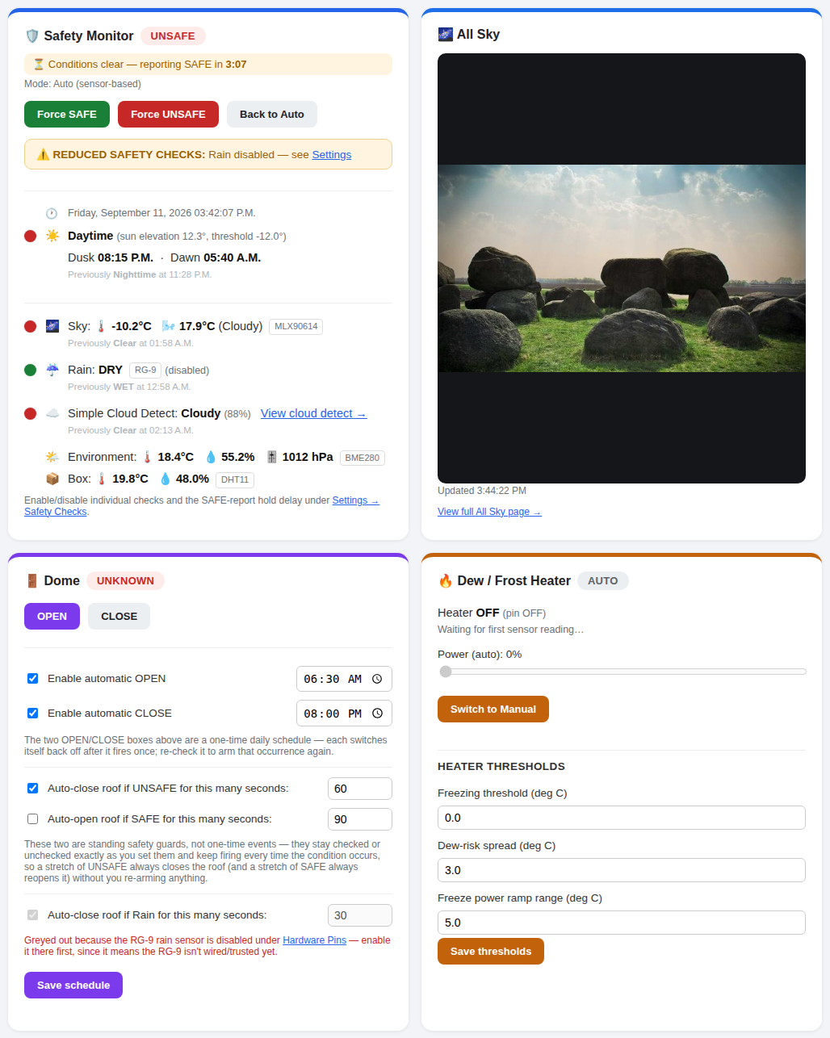
Figure 1 — The four main dashboard cards.

Safety Monitor
Shows the overall SAFE/UNSAFE badge, the manual override buttons, and every individual check with a colored status dot (green = passing, red = actively failing, grey = disabled). Readings are grouped into four sections: Day/Night; every sky/cloud reading together (MLX90614, AI Sky Prediction, AI Cloud Detect, Simple Cloud Detect); Rain; and Environment/Box (the two ambient readings that don’t feed the SAFE/UNSAFE decision at all). Simple Cloud Detect disappears from the card entirely while its own check is off, rather than sitting there greyed out. A "Previously X at 2026-09-23 03:42 P.M."-style line under each reading — including the two AI rows — shows both when and on what day it last changed, so a value from yesterday at the same clock time as right now isn’t mistaken for a value from a few minutes ago. This is tracked in status_history.json next to the service file, so it reflects the true last-change time even across a service restart, not just since the service happened to last start up.
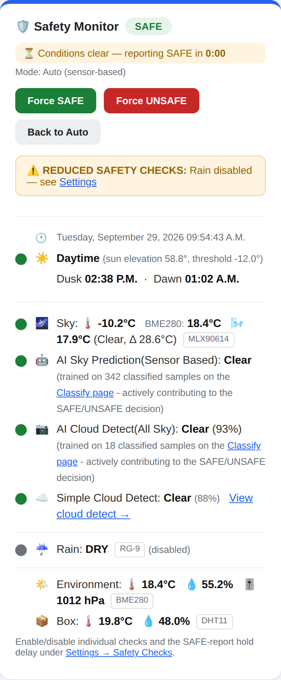
Figure 2 — Safety Monitor card.

Dome
Manual OPEN/CLOSE buttons, the daily schedule, and the standing safety-triggered auto-close/auto-open guards.
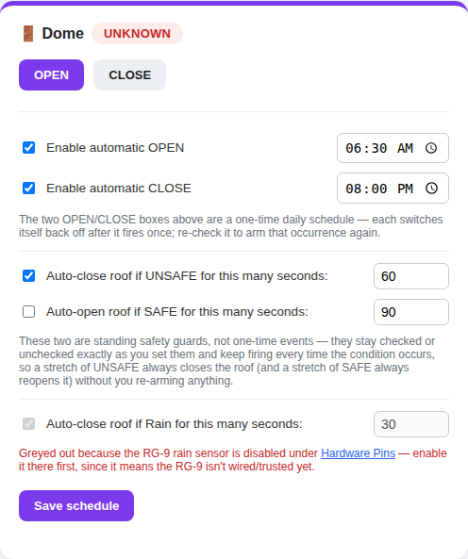
Figure 3 — Dome card.

Dew / Frost Heater
Shows AUTO/MANUAL mode, current power, and (further down) the Heater Thresholds that drive the AUTO calculation.
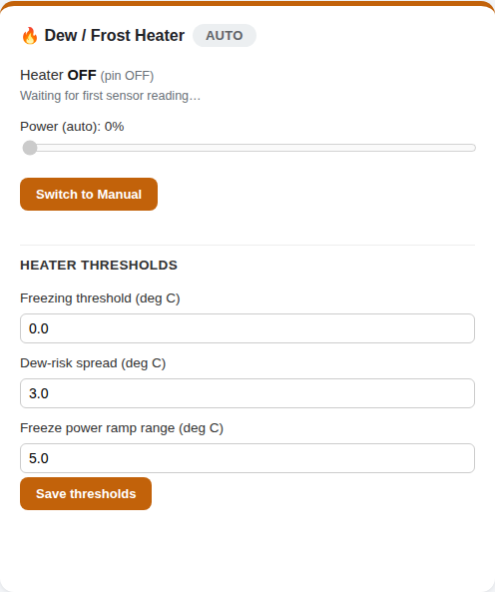
Figure 4 — Dew/Frost Heater card, including its Heater Thresholds section.

All Sky
Shows the latest frame from your all-sky camera once enabled under Settings → All Sky Camera (Section 5.3). Optionally overlays the current sensor readings — outside/box temperature and humidity, Sky state, Rain, ML Cloud class, and overall SAFE/UNSAFE — directly on the image, either drawn by this service itself or fed to Allsky's own overlay via a shared text file (see Section 5.3).
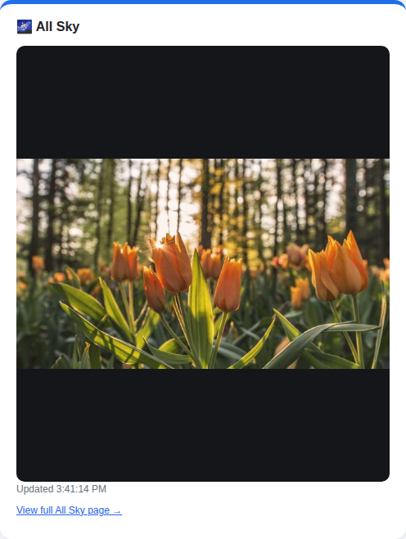
Figure 5 — All Sky card.

5. Configuring Settings
Every Settings section below is safe to leave at its defaults and come back to later — nothing here is required just to get the dashboard running.

5.1 Location & Timezone
Sets the latitude/longitude/timezone the Day/Night check uses to compute solar elevation. Left at the 0°,0° placeholder, the dashboard shows a reminder banner until you set your real coordinates.

5.2 Safety Checks
Turns the Day/Night check, Simple Cloud Detect ML check, Sky Sensor (MLX90614) clear-sky check, AI Model check, and Cloud Image Model check on or off individually (the dashboard shows these last two’s live predictions as “AI Sky Prediction” and “AI Cloud Detect” respectively), sets the night-elevation and clear-sky thresholds, and controls the "hold before reporting SAFE" delay (a UNSAFE reading is always reported immediately; this delay only smooths the transition back to SAFE). The Rain check toggle lives under Hardware Pins instead, next to that sensor's own wiring settings. A sensor's Hardware Pins toggle only controls whether it's installed/polled at all — whether its reading counts toward the SAFE/UNSAFE decision is set here instead, so (for example) the MLX90614 can keep feeding an AI check even while its own threshold check is turned off, or the reverse. If either AI check’s model predicts your configured "Ignore" label, that check holds its last real prediction instead of reacting to the frame — shown everywhere as Ignore(last prediction) — rather than silently voting SAFE/UNSAFE off a frame you’ve told it not to trust.
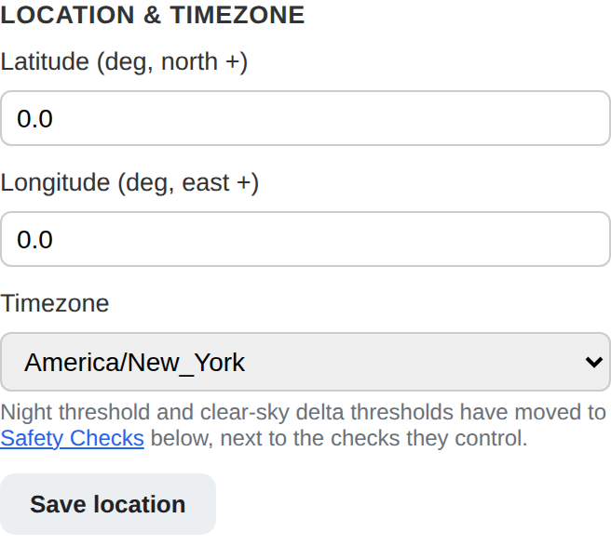
Figure 6a — Location & Timezone.
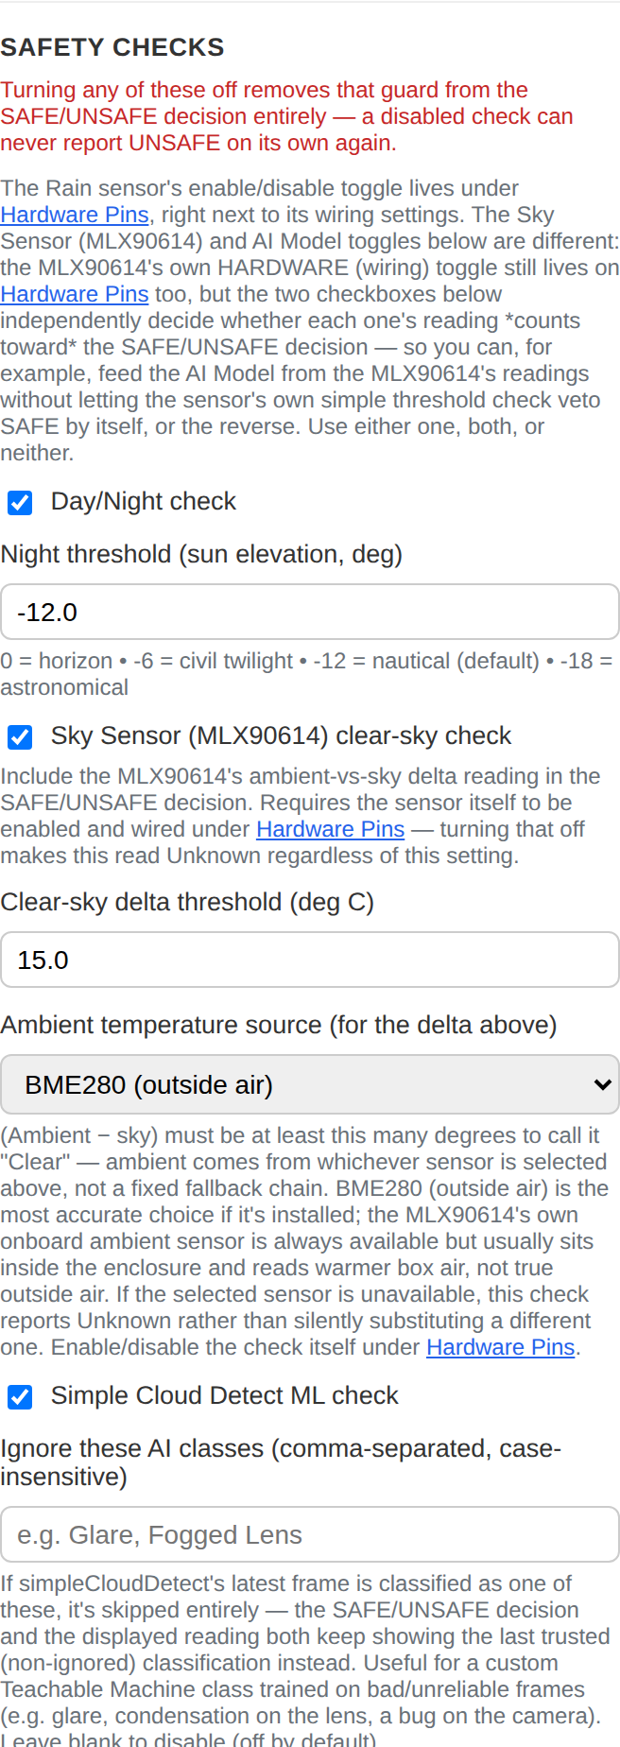
Figure 6b — Safety Checks (the original four).
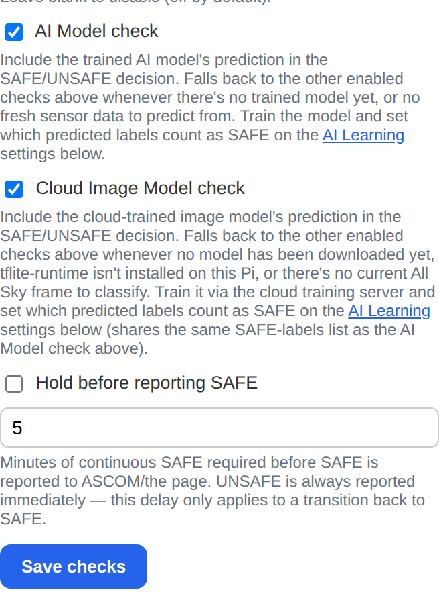
Figure 6c — The two new AI checks under Safety Checks.

5.3 Dome & Heater / All Sky Camera
Dome & Heater are master on/off switches for each whole subsystem — turn one off if you don't have that hardware at all (e.g. no motorized roof). All Sky Camera points the dashboard at your camera's latest frame, either a local file path on the Pi or an http(s):// URL from another device's own all-sky web server. Two more All Sky fields feed a sensor-info overlay onto the image: the Extra Text File path, where this service writes the current readings (one per line) every poll cycle — paste the exact same path into Allsky's own Settings → Overlay → "Extra Text File" field so Allsky bakes them into every frame it captures — and a checkbox to skip this service's own drawn overlay once Allsky's is doing that job, so you don't end up with two overlapping info boxes.
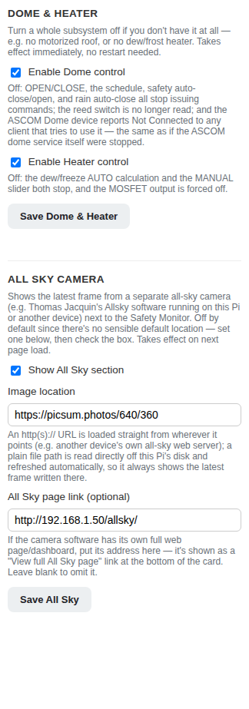
Figure 7 — Dome & Heater switches, and the All Sky Camera section.

5.4 Hardware Pins & Addresses
⚠ Changes on this form only take effect after the service is restarted (Section 5.8, or "sudo systemctl restart dome-safety.service") — every device is only ever initialized once, at startup.
Each sensor/actuator has its own enable checkbox, its GPIO pin or I2C bus/address, and an editable display name (the name shown everywhere that reading appears on the page). Unchecking a device skips setting it up entirely, so it's safe to leave unwired hardware unchecked rather than have it crash the service.
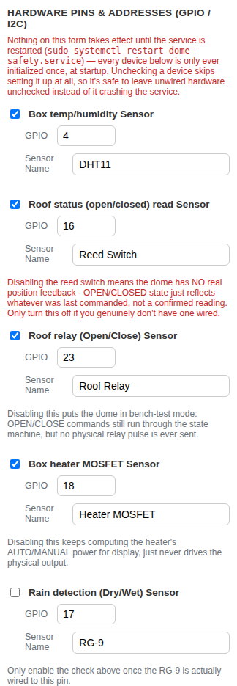
Figure 8a — GPIO-connected devices.
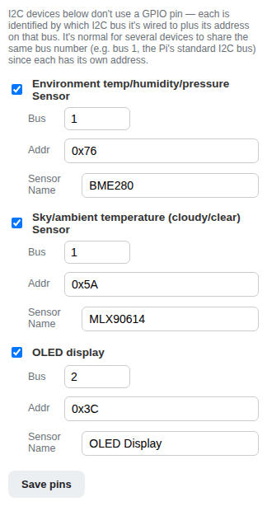
Figure 8b — I2C-connected devices.

5.5 Heater Thresholds
Lives inside the Dew/Frost Heater card itself (Figure 4 above) rather than the Settings card — the freezing threshold, dew-risk spread, and freeze power ramp range that drive the heater's AUTO power calculation.

5.6 Logging
Controls how long All Sky snapshot images and old weekly log files are kept, and — independently, per event type — whether an All Sky snapshot is attached when Day/Night, Rain, Sky/MLX90614, ML cloud detection, AI Sky Prediction, AI Cloud Detect, or the overall SAFE/UNSAFE state changes. All seven default to on, which is useful while a new setup is still being shaken out ("what did the sky actually look like when this changed"); turn any of them off once you're confident it's behaving as expected. A master Take images with logs switch sits above the seven — turning it off suppresses images for every event type at once (the checkboxes below grey out and keep whatever they were set to, ready to resume when the master is switched back on), without needing to uncheck each one individually. "Clear all log images" deletes every stored snapshot immediately, without touching the log text itself, and the section shows the current number of stored log images and their total size on disk, so the effect is visible right after a reload.
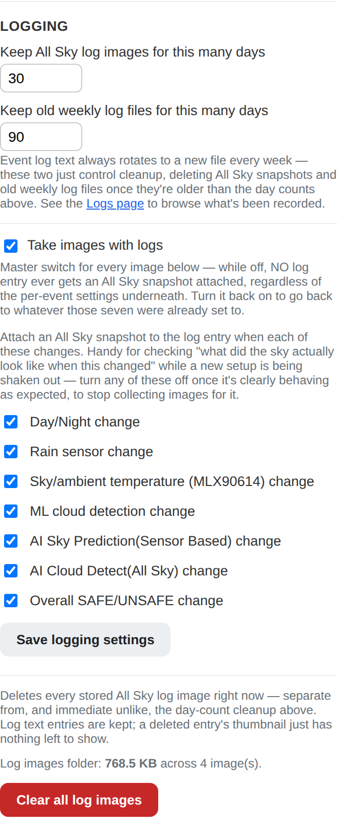
Figure 9a — Logging settings.

5.7 ASCOM Device Names
What shows up in an ASCOM/Alpaca client's device chooser list for the three devices this service exposes. Purely cosmetic — it never changes a device's UniqueID, so renaming one here is always safe even for an already-configured client (see Section 7).
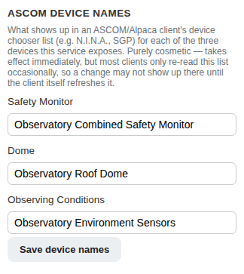
Figure 9b — ASCOM Device Names.

5.8 Service Control
Restart Service and Reboot Pi buttons, for when you don't want to open a terminal. Requires the one-time passwordless-sudo setup from Step 6 above.
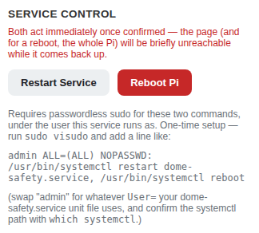
Figure 10 — Service Control.

5.9 AI Learning
Two capture switches feed the two AI checks below; the on/off switches that actually wire either trained model into the SAFE/UNSAFE decision live on the Safety Checks form instead (see 5.2), and turning one on never turns the other on for you. Enable AI Learning data capture starts saving a raw All Sky frame plus a full sensor snapshot on a timer (default every 15 minutes) — but only while All Sky Camera (Section 5.3) is also enabled and configured, since there is nothing to capture otherwise. Unlabeled samples older than the configured retention (default 45 days; 0 = never) are cleaned up automatically; once a sample is classified it's kept regardless of age. The classification labels list here (default: Clear, Partly Cloudy, Mostly Cloudy, Overcast, Rain, Snow, Freezing Rain, Ignore) is what shows up as buttons on the Classify page, and can be edited any time.
Separately, Predicted labels that count as SAFE (default: just Clear) decides which predictions from either model actually pass its check once turned on — both on/off switches themselves now live on the Safety Checks form (Section 5.2), alongside the other four checks, rather than on this AI Learning form.
Auto-train (off by default) kicks off a new cloud training run on its own once enough newly classified samples have piled up since the last attempt (both the sample-count threshold and the minimum interval between runs are configurable here); the same trigger also retrains the local sensor-based model, so both stay current together without a manual click.
Keep full resolution Images (on by default) controls what happens to a classified sample’s image once it’s been absorbed into a successful cloud training run: ON leaves the full-size file alone; OFF compresses it in place to save disk space. Compress already-trained images on the Classify page runs that same compression as a one-off backlog action for samples classified while the toggle was on. See Section 10 for the full training workflow — capturing, classifying, training either or both models, and exactly what happens if a check is turned on before its model exists — and Section 10, Step 5 for the cloud-trained image model specifically.

6. The Event Log
The Logs page (linked from the top of the dashboard) records every safety-relevant change: sensor connect/disconnect, individual check flips, overall SAFE/UNSAFE transitions, a genuine change in either AI check’s prediction, dome and heater actions, manual overrides, and settings changes. Log text rotates to a new file every week; filter by week, category, or a text search, and click a thumbnail to see the All Sky snapshot attached to that entry (when one was captured) — which, if the sensor-info overlay is enabled, also carries the readings that were current at that moment.
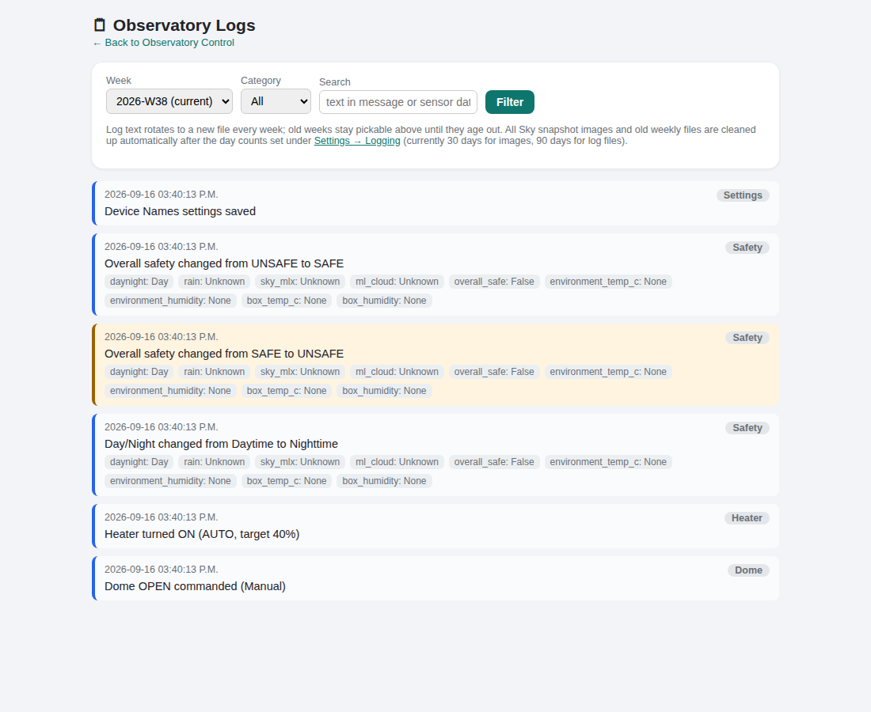
Figure 11 — The Logs page.

7. Connecting an ASCOM / Alpaca Client
This service is a standard Alpaca server — point any Alpaca-aware client (N.I.N.A., SGPro, and others) at the Pi and it will discover all three devices automatically.
Purpose | Port | Notes
Alpaca discovery | 32227 (UDP) | Used by clients to auto-find the server on the network.
Web dashboard & Alpaca API | 11112 (TCP) | http://<pi-ip-address>:11112/ for the dashboard; the same port serves the Alpaca REST API.
In your client's device chooser, you should see three devices — a SafetyMonitor, a Dome, and an ObservingConditions device — named whatever Settings → ASCOM Device Names currently has them set to (Section 5.7). Renaming one there is always safe: it never changes the device's underlying UniqueID, so an already-configured client won't treat a rename as a new device.

8. Updating the Service Later
After making any change to dome_safety_service.py, deploy it by copying the new file to the Pi (overwriting the old one) and restarting the service:
sudo systemctl restart dome-safety.service
Or use the Restart Service button under Settings → Service Control (Section 5.8) once passwordless sudo is set up. If the update also touched requirements.txt or the systemd unit itself, re-run sudo bash install.sh instead of just restarting — it re-installs any new dependencies and rewrites/restarts the service in one step, and is harmless to run even when neither changed.

9. Publishing the Project to GitHub
Keeping the project in a git repository on GitHub gives you version history and an easy way to pull updates onto the Pi later. These steps assume you already have a GitHub account.

Step 1 — Turn the project folder into a git repository
From inside the project folder (skip this if it's already a git repo):
git init
git add .
git commit -m "Initial commit"

Step 2 — Create an empty repository on GitHub
On github.com, create a new repository. Leave it empty — don't let GitHub add a README, license, or .gitignore, since your local folder already has its own history to push.

Step 3 — Connect and push
From inside the same project folder:
git remote add origin https://github.com/<your-username>/<your-repo>.git
git push -u origin main
If your default branch is called "master" instead of "main", use that name in the push command instead.

Troubleshooting: "fatal: not a git repository"
This means the command was run from a folder that isn't (or doesn't yet contain) a git repository. Two common causes:
- You're one directory level too high or too low — cd into the exact folder that contains the .git subfolder (run "ls -la" and confirm you see a .git entry) before running git remote / git push.
- If the project arrived as a .zip file, some extraction tools skip hidden folders like .git. Re-extract using "Extract All" rather than just browsing the zip, or use a git bundle instead ("git clone project.bundle project-folder"), which packages the whole repository — history included — as a single ordinary file that isn't affected by that problem.

10. AI Learning: Training and Using Your Own Sky Model
This is entirely optional, and everything about it defaults to off. It exists for one reason: the fixed clear-sky-delta threshold Section 5.2 sets is a single number that does not know about your local humidity or the season, so its accuracy can drift over the year. AI Learning lets you build a model from your own camera and your own judgement instead, and try it out safely alongside the existing checks before ever relying on it.

Step 1 — Capture training data
Turn on Enable AI Learning data capture under Settings → AI Learning (Section 5.9), with All Sky Camera already enabled and pointed at a real image. Every capture interval (15 minutes by default), the service saves the current raw All Sky frame together with a full sensor snapshot — outside/box temperature and humidity, rain state, and the MLX90614's raw sky/ambient/delta numbers — into an ai_training/ folder next to the service file. Nothing is used for anything yet at this point; this step only builds up a stock of images to classify.

Step 2 — Classify what you captured
Open the Classify page from the link on the dashboard (or Settings → AI Learning), which shows your captured frames as a grid of thumbnails, newest first — the frame you just captured is what you actually want to check right now (did the sky just clear up?), so it’s the first thing you see rather than buried at the end of the backlog. Select one or more that look alike (a run of clear frames from the same night, for example) and click the matching label button — it applies to every selected image at once, so a whole night's worth can be classified in a few clicks rather than one at a time. The label buttons come from the classification labels list in Section 5.9. Once every card on the current page has been classified (or deleted), the page automatically loads the next batch instead of leaving you looking at an empty grid. A Select ALL (N) button selects every matching sample across every page at once, not just the ones currently on screen, for applying one label or one delete to a whole backlog in a single click. Delete selected removes just the checked images (record and file together); Delete ALL classified images clears out every already-labeled sample in one action, leaving unlabeled ones untouched. A one-by-one view (the magnifying-glass link on any card) shows a single capture at full size with Prev/Next navigation and its own Delete button, for when a thumbnail is too small to judge a borderline frame. Once you’re done classifying, Export labeled images as .zip downloads everything labeled so far as a zip, one folder per label — the layout Google’s Teachable Machine expects, if you ever want to compare against or feed a browser-based classifier instead.

Step 3 — Train a model
Training needs at least 5 classified samples in each of at least 2 different labels (for example, 5+ Clear and 5+ Cloudy) — below that, the Classify page's Train model now button refuses with a message naming exactly which label needs more data, rather than producing a model that cannot really tell classes apart. Once trained, the model's prediction appears as a read-only line on the Safety Monitor card (“Model prediction: Clear”, for example), clearly marked as informational only — it does not affect SAFE/UNSAFE yet at this point, however long it's left running. Re-classify more images and click Train model now again any time to retrain it from your growing, curated set. Reset trained model, next to it, wipes just the model file — every classified sample is kept — for a clean retrain after a bad training run or a camera/mount change that invalidates what "normal" used to look like; it stays disabled until a model actually exists.

Step 4 — Turn it into a real check, when you're ready
Only once you've watched that informational prediction against reality for a while and trust it, check AI Model check under Settings → Safety Checks (Section 5.2) — alongside the other four checks, not on the AI Learning form itself. This adds one of the two optional AI checks from Section 1: a prediction not in Predicted labels that count as SAFE (just Clear, by default, set on the AI Learning form) vetoes SAFE the same way any other failing check does.
Turning this on can never itself make the roof less safe than before it existed. Two situations fail open — behaving exactly as if the check were still off — rather than blocking SAFE or crashing:
- No trained model yet — the check is on, but Step 3 above hasn't been done (or the model file has gone missing/corrupt).
- No fresh reading to predict from — a valid model exists, but none of the sensors it needs have a recent enough reading at this exact moment.
Neither case is silent: a banner appears at the top of the dashboard, an inline warning row appears on the Safety Monitor card itself, a matching note appears on the Classify page, and an Event Log entry is written the moment either state actually begins — not repeated every poll cycle. See “The dashboard shows a banner about the AI Model gate” under Troubleshooting (Section 11) if you see one of these and aren't sure why.

Step 5 — Cloud Training Server (AI Cloud Detect)
Unlike AI Sky Prediction (trained entirely on the Pi from numeric sensor readings), AI Cloud Detect is a real image-classification model — it looks at the actual photo, not just the numbers — trained by a separate, standalone Windows-side component in cloud-training-server/ using transfer learning on MobileNetV2. This keeps TensorFlow and its GPU/CPU demands off the Pi entirely.
Setup. Install the server on any Windows machine on your LAN (see cloud-training-server/README.md); install.ps1 -Service registers it as a real Windows Service via NSSM so it survives logoff/lock/RDP disconnect (recommended over the default logon-triggered task for anything left running unattended). Point the Pi at it under Settings → AI Learning (server URL + API key).
Training. From the Classify page, “Train cloud model now” uploads every labeled sample not yet absorbed into an earlier successful run (images are downscaled first, so even a large backlog uploads quickly over typical Wi-Fi), shows live upload progress, and then tracks the server's training job to completion. Every run after the first warm-starts from the previously-trained model — only the newly uploaded images are used to fine-tune it — so re-training regularly stays fast even as your labeled set grows. If the service or the Pi restarts mid-job, the next check picks the same job back up rather than losing it; “Cancel job” gives a manual way to abandon one instead of waiting.
Using it. Once a job finishes, the Pi downloads the trained model and runs it locally against the live All Sky frame from then on — the training server is not needed again until your next training run. Turn on the Cloud Image Model check under Settings → Safety Checks (5.2) once you trust its predictions (its live prediction shows on the dashboard as “AI Cloud Detect”); it fails open (see Step 4 above) exactly like the sensor-based model if no model has been downloaded yet or there's no current frame to classify.
Resetting. “Reset cloud model” on the Classify page clears the model downloaded to the Pi and best-effort tells the server to discard its own saved model too, so the next training run starts completely fresh — useful after the camera/mount moves or an old model's learning is actively wrong rather than just stale.

11. Troubleshooting & FAQ

A sensor reads "N/A" with a red "Disconnected" tag
That sensor hasn't reported a fresh reading recently (it stops being considered "fresh" after 30 seconds by default) — check its wiring, and confirm it's enabled under Settings → Hardware Pins. The dashboard also keeps showing the last known good reading in a lighter line underneath, so you don't lose the last real value.

Startup log shows "... init failed ... continuing without it"
This is expected and not fatal — a sensor that fails to initialize at startup (nothing wired to that I2C address, for example) is caught, logged, and skipped; that reading just shows N/A until the wiring is fixed and the service is restarted.

The Restart Service / Reboot Pi buttons don't do anything
They need the one-time passwordless-sudo setup described in Section 3, Step 6. Without it, the underlying systemctl command is refused silently from the web page's point of view.

My ASCOM client doesn't see the devices
Confirm the service is running ("sudo systemctl status dome-safety.service"), that the client machine can reach the Pi's IP address, and that nothing on the network is blocking UDP port 32227 (discovery) or TCP port 11112 (the API itself).

I renamed a device under ASCOM Device Names — will my client need reconfiguring?
No. The rename only changes the display name a client shows in its device chooser; it never changes that device's UniqueID, which is what a client actually uses to remember "this is the same device I configured before." Most clients only re-read the chooser list occasionally, so the new name may not appear there until the client itself refreshes it.

I set the Extra Text File path but Allsky isn't showing my sensor readings
Check three things. First, the exact same full path must be entered in both places — this service's Settings → All Sky Camera → Extra Text File path, and Allsky's own Settings → Overlay → "Extra Text File" field. Second, that path has to match where dome_safety_service.py actually runs from on your Pi — run "sudo systemctl status dome-safety.service" if you're not sure of the real folder (a common gotcha: this service's default path assumes a "pi" login user, but your Pi may use a different one, e.g. admin, which changes the home directory). Third, the service has to have been restarted since you set the path ("sudo systemctl restart dome-safety.service"). You can confirm the file itself is updating by running "cat <the path>" directly on the Pi — its first line (a timestamp) should advance every couple of seconds.

I don't see a Model prediction on the Safety Monitor card
That line only appears once a model has actually been trained — it stays hidden entirely until then, not shown as blank or N/A. Check Settings → AI Learning (Section 5.9) for the current sample count, classify enough of them on the Classify page (at least 5 per label, at least 2 labels), and click Train model now there.

The dashboard shows a banner about the AI Model gate
This means Use the trained model in the SAFE/UNSAFE decision is checked under Settings → AI Learning, but the check currently has nothing to work with — either no model has been trained yet, or none of the sensors it needs have a fresh reading right this moment. Either way it is failing open (see Section 10, Step 4): the roof is being judged by the other four checks exactly as if this one were off, not blocked by it. The banner clears itself as soon as a valid model exists and has fresh data to predict from.

I see “Ignore(Clear)” instead of a plain prediction
The model's current prediction is your configured “Ignore” label (Settings → AI Learning → classification labels) — the check is holding its last real prediction (shown in parentheses) rather than reacting to this frame, exactly as designed. This clears on its own once the model predicts something other than Ignore again.

The Cloud Image Model's “trained on N” and the Classify page's per-label totals don't match
“Trained on N” is the size of the last cloud-training upload — how many samples were newly absorbed in that specific run — while the per-label counts are the cumulative total ever classified. The Classify page shows both together (“N total classified so far”, “N new since this training”) so the two numbers read as a matched pair instead of an apparent mismatch.

Appendix — Where Things Live on the Pi
Item | Location
Service file | dome_safety_service.py, wherever you deployed it (e.g. /home/pi/)
Settings (persisted) | dome_config.json, created automatically next to the service file
Status-change history | status_history.json, created automatically next to the service file — the true last-change time behind every "Previously …" line, so it survives a service restart
Event logs | logs/ (one week-*.jsonl file per week), next to the service file
All Sky log snapshots | logs/images/, next to the service file
AI Learning data | ai_training/ (captured images, index.json, and sky_model.json once trained), next to the service file
Cloud-trained image model | cloud_model/ (downloaded model.tflite, classes.json, and the last cloud training job’s state), next to the service file
Allsky Extra Text File | Wherever you set it under Settings → All Sky Camera → Extra Text File path (default: allsky_extra.txt next to the service file) — rewritten every poll cycle for Allsky's own overlay to read
systemd unit file | /etc/systemd/system/dome-safety.service
dome_config.json and the logs/ folder are both created automatically on first run and are safe to delete if you ever want to reset all settings and log history back to defaults — the service recreates them with default values the next time it starts. status_history.json works the same way — delete it if you ever want the "Previously …" lines to start fresh.

