ABM Calendar System Requirements

1. **Creating Lesson Plans: (7 Day)**
   1. Select contact
   2. Select practitioners for each and view their calendar side by side to show availability (keep the last selection saved for future views)
   3. Select times
   4. Select Lesson Name
   5. Show multiple days and columns
   6. Create calendar events in Google for each time slot
   7. Add custom fields (LessonPlanID, Location, Room, Station) and tie all Google Calendar events to this Lesson Plan
   8. Select Status (Paid / Unpaid)
2. **Viewing Lesson Plans: (4 Day)**
   1. Show calendar of lesson plans via interface
   2. Update color of calendar appointments based on status (Unpaid is red, Paid is green)
3. **Edit Lesson Plans: (4 Day)**
   1. Editing lesson plans directly in Google Calendar: Do not allow practitioners to change calendar on their google calendar - share a locked calendar with each practitioner.
4. **Delete Lesson Plans: (2 Day)**
   1. Possibly look at deleting all via the interface
5. **Reporting Lesson Plans: (5 Day)**
   1. Generate a report similar to the one shown below for each lesson plan
   2. Store report results in Infusionsoft (maybe as image or as HTML code) so we can pull it into an email or Word Document
   3. Generate a report of all lesson plans within a time frame (date range)
6. **Updating Lesson Plans: (2 Day)**
   1. Update event color on calendar based on Paid Status
7. **Integration with Infusionsoft: (7 Day)**
   1. Pull contacts from saved search for list of Students
   2. Pull contacts from saved search for list of Practitioners
   3. Keep contact record’s events in sync with calendar events in Infusionsoft
   4. Under list of students - add a button to apply a tag to that contact

Other Items:

* Use List of Lesson Templates instead of Lesson Plans
* Ust List of Practitioners instead of Tutors
* Use ABM for logo
* Swap Sage Act to ABM
* Break out Add New Lesson Plan and Lesson Plans

**Report Plan Format for a Student:**

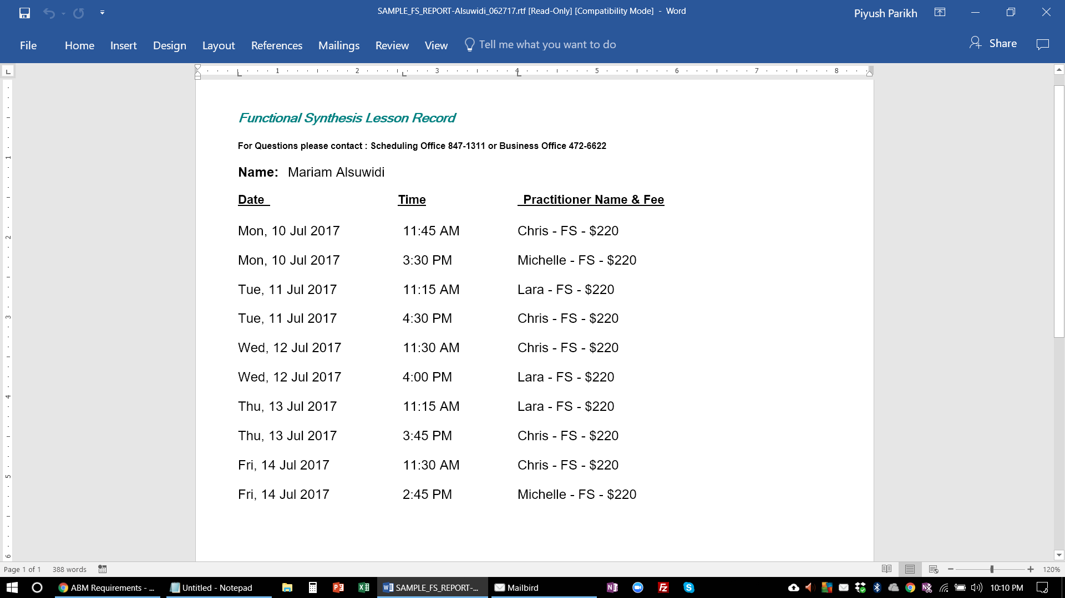

**Video of the current interface:**

[https://www.dropbox.com/s/qu9fe81av02v0mx/ABM-Scheduling.MP4?dl=0https://www.dropbox.com/s/qu9fe81av02v0mx/ABM-Scheduling.MP4?dl=0](https://www.dropbox.com/s/qu9fe81av02v0mx/ABM-Scheduling.MP4?dl=0)