# Report for Add Matrices Program

Nikunj Arora – 2646352

Dennis Goyal - 2627601

There are two functions implemented, one for adding the matrices in pure C and the other for adding the matrices using OpenCL.

Device info is printed on the console and execution time is measured.

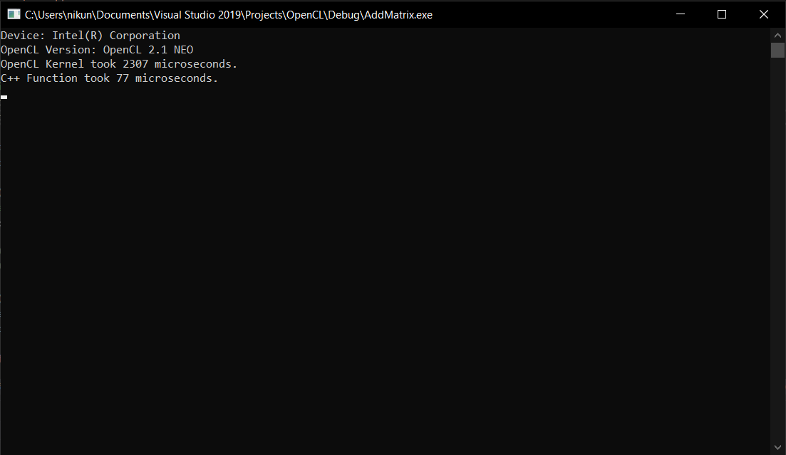

The OpenCL implementation takes longer than the C implementation. This is most likely due to the time it takes to copy the buffers to and from the device memory. In small size like 100*100, the memory read/write time outweighs the execution time. However, if we increase the matrix size, we find that the OpenCL kernel takes less time to finish all tasks including reading/writing memory.

The outputs of both functions is written to csv files.