# Report for Image Processing with OpenCL task with profiling

Nikunj Arora – 2646352

Dennis Goyal – 2627601

The kernel code was split into two functions as the grayscale needed to be ready before moving average filter could be applied.

Therefore, the execution time is profiled for each of the kernel functions and then the entire program including the time to copy the arrays back and forth between host and devices.

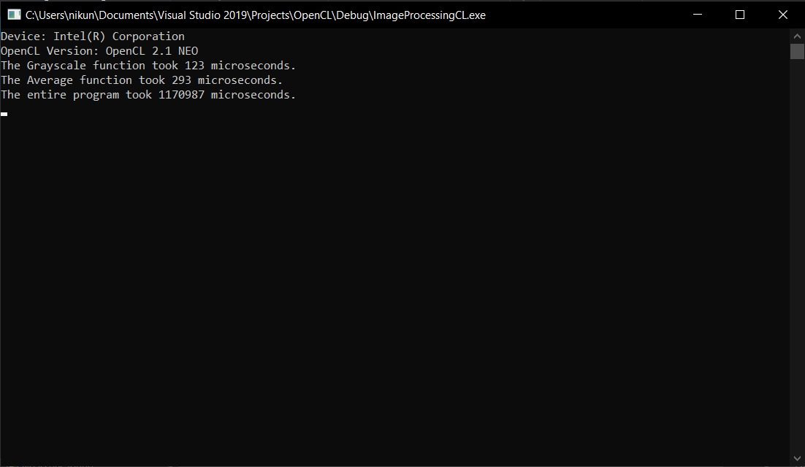

The Grayscale function took 123 microseconds.

The Average function took 293 microseconds.

The entire program took 1170987 microseconds (1.17 seconds).