# Report for Image Processing with OpenCL task

Nikunj Arora – 2646352

Dennis Goyal – 2627601

Library used for image reading and writing: lodepng

Input:

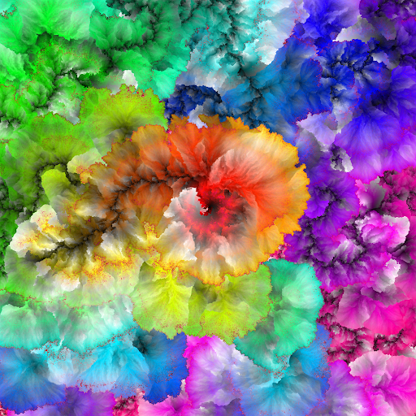

After applying grayscale and moving average filter of 5*5 window, we get:

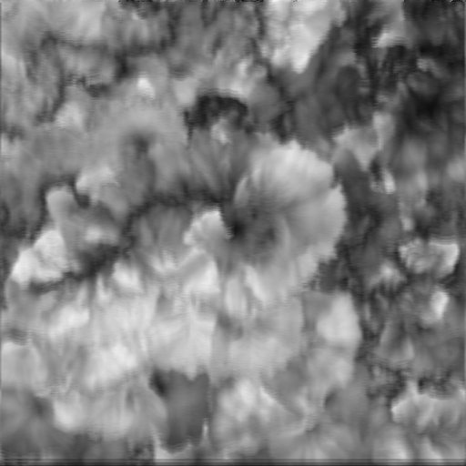

Since it was a 5*5 moving window average, two rows and two columns of pixels were left out along the edges. To get rid of these black borders, values from the grayscale image was copied over.