# Report for Low Pass Filter in OpenCL task

Nikunj Arora – 2646352

Dennis Goyal – 2627601

Library used for image reading and writing – lodepng

**Resource Usage:**

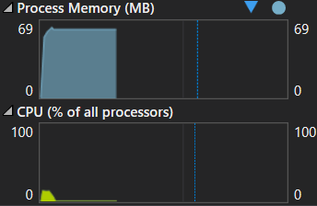

RAM: 61.0 MB

CPU: 13%

**Output:**

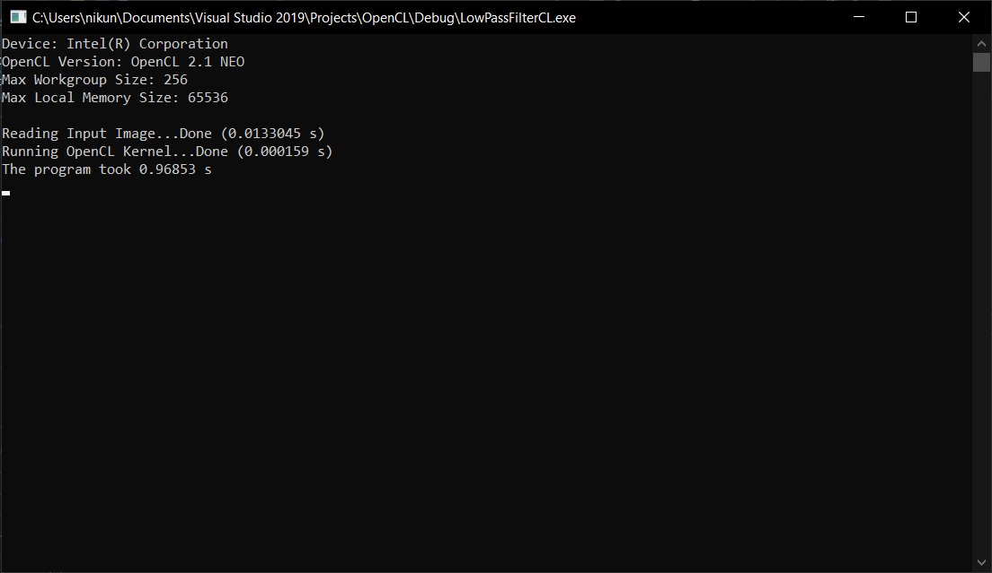

The image was divided into arbitrary rows of length less than or equal to the maximum work group size of the GPU.

Inside the kernel, we first copy each row from global memory to local memory and then perform the low pass filter operation before copying back to the global memory.